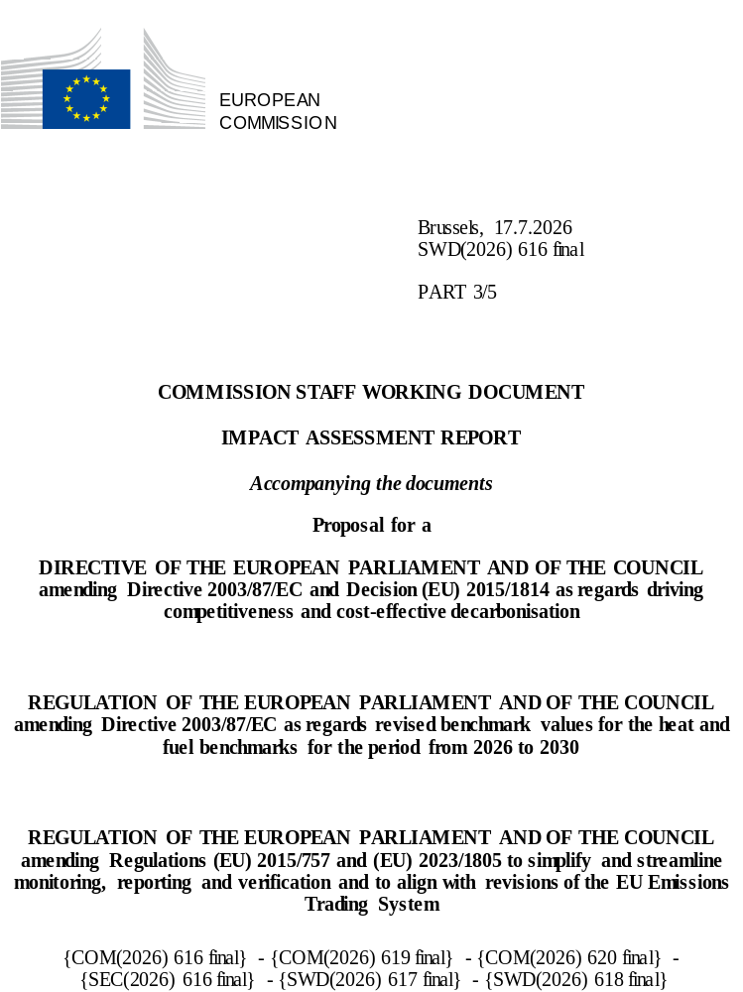

Table of contents
Annex 8: Part I – Cap 6
List of Tables 6
List of Figures 6
1. Introduction to cap setting 7
1.1. Legal default and Legal default with one-way aviation cap setting 7
1.2. Different trajectories for the 85% scope scenario with current scope and 50% incoming and outgoing international aviation cap setting 8
1.3. Net cap trajectories excluding international aviation 11
1.4. Caps for a trajectory towards 90% domestic reductions 12
1.5. Investment needs and system costs 13
1.6. Components of the policy options - Inclusion measures 16
1.7. Policy Options cap setting 17
Annex 8: Part II – Removals 21
List of Tables 21
List of Figures 21
1. Introduction 22
1.1. Context of the assessment of the integration of domestic carbon removals in the EU ETS 22
1.2. Considerations for the assessment of the integration 24
2. Policy measures 26
2.1. Measures under consideration 26
2.2. Measures discarded at an early stage 30
2.3. Assessment of the measures 33
3. Type of removals to be considered for integration 60
3.1. Minimum requirements on the removal types for integration 60
4. Cross cutting design considerations of the measures 69
4.1. Equivalence between CRCF and EU ETS GHG units 69
4.2. Unit differentiation 71
4.3. Who carries out the conversion in the private sector integration option (CR1-CR3) 74
4.4. Considerations on CDR limits 75
4.5. Timing and sequencing 79
4.6. Purchasing permanent carbon removals 81
Annex 8: Part III – Market Stability Reserve 85
List of Tables 85
List of Figures 86
1. Overview of the Market Stability Reserve (MSR) 88
1.1. Introduction and overview 88
1.2. Conclusions of the evaluation and future challenges for the operations of the MSR. 89
1.3. Challenges for the future operations of the MSR. 90
2. Parameters of the Market Stability Reserve 91
2.1. Upper threshold and upper buffer 92
2.2. Intake rate 95
2.3. Lower threshold 96
2.4. Release rates (general and Article 29a) 96
2.5. Invalidation threshold 97
2.6. Market Stability Reserve revision scope 98
3. Policy measures for the Market Stability Reserve 98
3.1. Description of measures 98
3.2. Discarded measures 109
4. Assessment of the measures 111
4.1. Modelling results 111
4.2. Sensitivity analysis on selected measures 125
4.3. Economic impacts 126
4.4. Social impacts 129
4.5. Environmental impacts 130
4.6. Summary 130
5. The Market Stability Reserve in overall policy options 131
5.1. Modelling results 132
5.2. Price volatility analysis 137
5.3. Modelling limitations on integration of removals and sectoral scope coverage 137
5.4. Adjustment of the official TNAC in 2025 138
5.5. Assessment of the timing of supply on MSR operations. 139
Appendix 1. MSR Sensitivity analysis on selected measures 140
A. Definition of the shocks 141
B. Results from the shock sensitivity analysis 144
C. Cyclical shocks 144
D. Structural shocks 147
Resilience of candidate MSR measures to shocks 150
Annex 9: Industrial Decarbonisation Bank 152
List of Tables 152
List of Figures 152
1. Introduction 153
2. Scoping 158
2.1. Problem definition 158
2.2. Objectives 162
2.3. Baseline 163
3. Policy measures 165
3.1. Measures on how the support should be allocated 166
3.2. Measures on what form the support should take 170
3.3. Measures on ensuring geographical balance in IDB 174
3.4. Assessment of the measures 176
Annex 10: Aviation 203
List of Tables 203
List of Figures 204
1. Description of the aviation measures 205
1.1. AS0: Baseline 205
1.2. AS1: Current scope prolongation contingent on CORSIA implementation 205
1.3. AS2: Departing flights with CORSIA offsetting cost deduction 205
1.4. SAF0: Baseline, support expires in 2030 206
1.5. SAF1: extension of support by medium amount 206
1.6. SAF2: extension of support by higher amount 206
1.7. AS general elements 206
2. What are the impacts of the measures 209
2.1. AS0: Baseline 209
2.2. AS1: Current scope prolongation contingent on CORSIA implementation 210
2.3. AS2: Departing flights with CORSIA offsetting cost deduction 211
2.4. SAF0, SAF1, SAF2 212
3. Further analysis on policy options 212
3.1. Analytical tables complementing the Impact Assessment 212
4. Impacts on the level playing field (focus on hubs) 218
4.1. Ticket prices 219
4.2. Risk of passenger shift 220
4.3. Risk of hub carbon leakage 220
5. Assessment of CORSIA pursuant to Art. 28b of the ETS Directive 221
5.1. Ambition 221
5.2. Accountability 231
6. Analysis pursuant to Article 30(8) 233
6.1. Short-Haul Flights and Their Impacts 233
6.2. Connectivity: outermost regions, islands and remote territories 235
7. Private & business jets inclusion 237
7.1. New threshold 239
7.2. Simplification 246
7.3. Summary of the design element on business aviation 249
7.4. Business flight definition 250
7.5. Other impacts 250
8. SAF support analysis 250
8.1. Current support 251
8.2. Extension of the support 252
9. Other considerations 257
Annex 11: Maritime 259
List of Tables 259
List of Figures 260
1. Support for emissions reduction in the shipping sector 261
1.1. Scoping 261
1.2. Policy measures 264
1.3. Assessment of policy measures 268
2. Measures to further mitigate the risk of evasion 270
2.1. Scoping 270
2.2. Policy measures 273
2.3. Assessment of policy measures 276
3. Simplification and other measures to enhance robustness and effectiveness of the implementation system for maritime 279
3.1. Scoping 279
3.2. Policy measures 280
3.3. Assessment of policy measures 284
4. Maritime derogations 287
4.1. Scoping 287
4.2. Policy measures 290
4.3. Assessment of the measures 290
5. Coherence with the implementation of the global IMO measure 294
5.1. Scoping 294
5.2. Policy measures 297
5.3. Analysis of design options and their assessment 297
5.4. Economic analysis 300
5.5. Environmental impacts 301
5.6. Social impacts 302
6. ETS or MRV as a Service 302
6.1. Scoping 302
6.2. Policy measures 302
6.3. Assessment of policy measures 303
7. Inclusion of emissions from ships below 5000 Gross Tonnage 305
7.1. Scoping 305
7.2. Policy measures 306
7.3. Assessment of policy measures 307

Annex 8: Part I – Cap

List of Tables
Table 1: Legal default baseline cap trajectory. 7
Table 2: Cap trajectories from the PRIMES model 10
Table 3: Cap trajectories for POTEnCIA 10
Table 4: Range of approximate cap trajectories 10
Table 5: Net caps trajectories for POTEnCIA excluding international extra EEA aviation 12
Table 6: POTEnCIA and PRIMES trajectory compatible with a 90% domestic EU target 12
Table 7: Annual investment expenditure, energy related excluding transport in CAP 3 “9085” scenario 13
Table 8: Investment needs in ETS sectors, deviation of the CAP4 “accelerated 9085” scenario and CAP2 “85%” scenario relative to CAP 3 “9085” scenario 13
Table 9: Energy system costs as % of GDP in the CAP 3 “9085” scenario 14
Table 10: Energy system costs in ETS sectors, deviation of the CAP2 ‘85’ and CAP4 “accelerated 9085” scenario relative to CAP 3 “9085” scenario 15
Table 11: Total eligible removals in the EU, PRIMES and POTEnCIA 16
Table 12: Table on PO1 in PRIMES and POTEnCIA, as well as approximate table 17
Table 13: Table calculating PO2 in PRIMES and POTEnCIA, as well as approximate table 18
Table 14: Table showing the cap for PO3 19

List of Figures
Figure 1: Trajectory Legal Default (incl. two-way aviation) 8

- Introduction to cap setting
This Annex provides more details on the impact each measure of scope expansion or removals inclusion would have on the cap setting, as presented in the Impact Assessment. It starts with a description of the legal default scenario, and a variant in which international aviation is only included for 50% of incoming and outgoing flights. Then, it explains different trajectories for reaching the target in 2040 cost-effectively. After explaining the scale of estimates for different scope extension and inclusion of removals, it summarises the way the caps for policy options have been estimated.
In general, the EU ETS cap is set with the geographical scope of the EEA. However, the modelling underlying the impact assessment is carried out with the geographical scope of the EU. This modelling is used to estimate the reduction rate of the EU ETS sectors and set the Linear Reduction Factor (LRF). The LRF is then applied to the EEA cap.
  - Legal default and Legal default with one-way aviation cap setting
    - Legal default
The legal default baseline is determined by the continuation of the linear reduction factor established in Article 9 of the ETS Directive, of 4.4 % from 2028 onwards, which applies to all EU ETS sectors. The current legislative framework does not yet recognise the generation of carbon removals.
It includes an estimated increase of 148 Mt in 2027 when including the emissions of incoming and outgoing international aviation in the EEA scope. This estimated increase of the linear trajectory to account for scope expansion is based on PRIMES EU near future emissions estimates for the EU scope. This estimate is uncertain, but it gives an indication. All international maritime navigation is included as per the current scope, but maritime non-CO2 emissions are added to the scope. Current stationary sectors are in the scope.
Applying the Linear Reduction Factor (LRF) of 4.4% to the total cap in the relevant base years leads to the following estimates.
- Legal default baseline cap trajectory.
EEA | Cap 2030 (Mt) | Cap 2035 (Mt) | Cap 2040 (Mt) | LRF | Budget 2031-2040 (Mt)
Legal Default | 975 | 485 | 69 | -4.4% | 4436
The graph below shows the rapid reduction pathway. The large kinks are due to the inclusion of international extra EEA aviation in 2027. The allowances due to the inclusion of aviation are still present under the cap in 2040.

- Trajectory Legal Default (incl. two-way aviation)
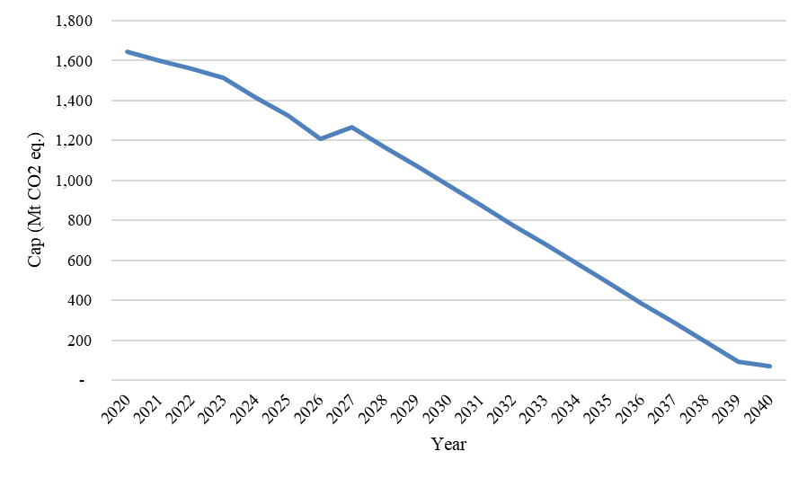
Source: Own visualisation
The following sections set out different options for cap trajectories reflecting varying levels of ambition and results for both PRIMES and POTenCIA models. Irrespective of the cap ultimately retained, a further point to be taken into account is described in section 5.5. of the MSR Annex. In particular, the section describes the use of the 3% free allocation buffer, which is expected to be fully used by industry operators between 2028-2030. This results in an earlier and more concentrated allocation of allowances than would otherwise have been in case of auctioning, as set out in the current ETS Directive. As a result, liquidity and industrial emissions will be likely higher in the short term compared to modelled trajectories.
  - Different trajectories for the 85% scope scenario with current scope and 50% incoming and outgoing international aviation cap setting
In this section the cap in 2040 is estimated based on the cost-effective gross emissions for those sectors included in the legal default scenario, but where only half of incoming and outgoing aviation is included. International maritime navigation (including non-CO2 emissions but not offshore vessels) and stationary emissions are included as under the current scope.
To estimate the emissions in these sectors, we use the modelling results for the scenario which achieves an overall domestic reduction of economy-wide (including international extra EU aviation) net emissions of 85% compared to 1990. This represents a domestic ambition level coherent with buying 5% of high-quality international credits to add up to a -90% ambition. It could be decided later that less than 5% of international credits are used, which would enable more investment in domestic action. Consequently, the domestic reduction of net GHG emissions could be higher than 85%. However, this target was chosen as the basis for the impact assessment to consider the maximum potential use of the international credit flexibility allowed in the European Climate Law. The costs and full impacts of purchases and use of international credits are not included in this impact assessment.
The modelling scenarios of the EU-wide 85% target are used to estimate emissions reductions for the ETS which are the basis of this impact assessment. The EU ETS should provide adequate funding for purchase of the high-quality international credits that it benefits from.
International credits integration into EU climate policy framework faces many similar questions and challenges as domestic permanent removal integration. These questions include detailed choice of policy integration, implementation, credit integrity, financing, quantification of credits. Integrating the international credits to future climate legislation should be done preserving the integrity and stability of the EU ETS (see section 1.2.2 on discarding the possibility of direct integration in the ETS in Annex 8 – Part II). The specific role and deployment of international credits outside the EU ETS will be based on a separate impact assessment and subject to the development of Union law further elaborating robust and high integrity criteria and safeguards. Important safeguards that complement those under Article 6.4 of the Paris Agreement must be ensured. There will be consideration of a pilot period in 2031-2035.
In any case, the point target for domestic emissions in 2040 itself does not fix the trajectory of the cap, and there could be at least three measures for the trajectory of the EU ETS cap from 2030 to 2040:
- CAP1: In this “Linear” measure, the cap follows a linear trajectory from 2030 to 2040.
- CAP2: In this “85 pathway" measure, the cap linearly follows modelled estimates from the 2030 legal cap estimate to the 2035 modelled emissions estimate, and from 2035 to the 2040 modelled estimate.
- CAP3: In this “90 – 85 pathway” measure, until 2035 the cap follows a trajectory towards the estimated cost-effective contribution of the EU ETS to the linear trajectory reaching a 90% target in 2040 and then flattens to move towards the estimated cost-effective contribution of the EU ETS to an 85% target in 2040. This reflects the fact that in this measure international credits will start contributing to the EU-target from 2036. A specific economy-wide modelling run was performed for the estimate of the EU ETS contribution to such a trajectory.
The sub-options all have the same end point in 2040, but they differ in terms of carbon budget over the period; they will differ as well in terms of incentives given to reduce emissions within a certain time horizon. The following tables illustrate the trajectories of the cap based on the 85 scenario. For these estimates we have assumed the inclusion of outgoing international aviation in the target. The caps presented are set at the level of gross emissions. The estimates translate EU modelling into an EEA estimate. The figure for 2030 is based on the legal cap extended for international aviation (one way). Note that the caps for policy options PO1, PO2 and PO3 below will differ as they refer to different scopes. The cap figures have been rounded to the nearest 5.

- Cap trajectories from the PRIMES model

EEA Caps (Mt), LRF (%) and Carbon Budget (Mt) | CAP1: Linear trajectory | CAP2: PRIMES 85 trajectory | CAP3: PRIMES 90-85 pathway
2030 | 911 | 911 | 911
2035 | 620 | 580 | 560
2040 | 330 | 330 | 330
LRF 2030-2035 | -2.7% | -3.1% | -3.3%
LRF 2036-2040 | -2.7% | -2.3% | -2.1%
Carbon Budget 2031-2040 | 5915 | 5705 | 5605
The following table shows the cap trajectories from the JRC POTEnCIA model.
- Cap trajectories for POTEnCIA

EEA Caps (Mt), LRF (%) and Carbon Budget (Mt) | CAP1: Linear trajectory | CAP2: POTENCIA 85 trajectory | CAP3: POTEnCIA 90-85 pathway
2030 | 911 | 911 | 911
2035 | 645 | 670 | 605
2040 | 375 | 375 | 375
LRF 2030-2035 | -2.5% | -2.3% | -2.9%
LRF 2036-2040 | -2.5% | -2.7% | -2.1%
Carbon Budget 2031-2040 | 6175 | 6295 | 5965
The table below shows the range of outcomes in the models, rounded to five, in order to represent the uncertainty range resulting from using the different models:
- Range of approximate cap trajectories

EEA Caps (Mt), LRF (%) and Carbon Budget (Mt) | CAP1: Linear trajectory | CAP2: 85 trajectory | CAP3: 90-85 trajectory
2030 | 911 | 911 | 911
2035 | 620-645 | 580-670 | 560-605
2040 | 330-375 | 330-375 | 330-375
LRF 2030-2035 | 2.7-2.5% | 3.1-2.3% | 3.3-2.9%
LRF 2036-2040 | 2.7-2.5% | 2.3-2.7% | 2.1-2.1%
Carbon Budget 2031-2040 | 5915-6175 | 5705-6295 | 5605-5965
The table above shows that, for a given model, the two-step trajectory would have smaller total emissions (i.e. carbon budget) over the 2031-2040 period than either the linear or modelled trajectories unconstrained in 2035. However, we see that there is overlap in the ranges, due to the different models used.
A two-step trajectory would stimulate innovation in the short term and could lead to a more balanced investment pathway. It is uncertain whether the benefits thereof would compensate the costs of a smaller carbon budget. The table also shows that the 85 trajectory as estimated in PRIMES is in between the linear trajectory and the 90-85 trajectory. In POTEnCIA the linear trajectory is very close to the 85 trajectory unconstrained in 2035.
For the further modelling-based analysis we have used the PRIMES 85 trajectory as PRIMES was used to assess the policy options, and this trajectory is the less constrained economy wide to reach an 85% target in this model.
This choice should not affect the relative impacts and rankings of the different policy options PO1, PO2, PO3 on most topics, such as removals, CCU, carbon leakage etc. The different behaviour of the two models provides an illustration of the intrinsic uncertainties involved in assessments on the longer-term technological future for different sectors. When, conversely, in this Annex, the two models show similar behaviour in response to changes to the cap, this provides evidence that a qualitative conclusion is robust.
The 90-85 pathway trajectory corresponds to including an extra emissions space that is created from buying international credits as of 2036. In comparison to the unconstrained 85 trajectory for a given model, it is a more ambitious trajectory.
  - Net cap trajectories excluding international aviation
All scenarios above assumed that (one-way) international extra EU aviation would be included in the EU target. If international aviation were to be excluded in the target, total emissions under the EU target would be lower. As international aviation is a hard to abate sector with lower reduction potential by 2040 than other sectors, this would nevertheless create additional emissions space of ca. 45 Mt for other sectors of the economy. Potentially, part of this emissions space could be assigned to ETS1, although it should be remembered that non-ETS1 sectors are expected to represent a larger share of emissions by 2040. In absolute terms the ETS1 cap would still be lower than in the numbers shown in this impact assessment; due to the absence of demand from international aviation the space for other sectors could still increase.
In addition, carbon removals could be introduced as a flexibility option to achieve the 2040 climate target in a more cost-effective way, since in some cases it may be cheaper to offset emissions through removals than to abate them directly. In particular, they can help compensate for residual hard-to-abate emissions in sectors covered by the EU ETS. If the EU ETS is assumed to benefit from the total amount of industrial removals in the models, the cap can be decomposed into a more ambitious cap set at the level of net emissions plus an amount of removals-linked allowances, which together add up to a total gross emissions carbon budget.
The precise result would depend on whether international aviation and removals are included in the EU target by co-legislators; and the way any additional emissions space due to its (partial) exclusion would be assigned across different sectors of the economy.
The table below shows the trajectory results for the different net cap options. It also includes an additional option in which the cap trajectory follows a 90-85 pathway as in CAP3 though with a higher ambition in the first half of the decade. In these options, the scope of the economy-wide target is limited to include intra-EU aviation (but not extra EU aviation) and current scope for maritime navigation.
- Net caps trajectories for POTEnCIA excluding international extra EEA aviation

EEA Caps (Mt), LRF (%) and Carbon Budget (Mt) | CAP1: 85 linear trajectory | CAP2: 85 trajectory | CAP3: 90linear-85 pathway | CAP4: accelerated 90-85 pathway
2030 | 847 | 847 | 847 | 847
2035 | 570 | 600 | 555 | 485
2040 | 290 | 290 | 285 | 285
LRF 2030-2035 | -2.7% | -2.4% | -2.8% | -3.5%
LRF 2036-2040 | -2.7% | -3.0% | -2.6% | -1.9%
Added removals-linked allowances | 320 | 320 | 320 | 320
Carbon Budget 2031-2040 | 5720 | 5885 | 5640 | 5290
CAP4 is comparable to a non-linear pathway towards the 90% target in the first five years, then flattens to be compatible with an 85% target for the second five years. In PRIMES the emissions space would be lower: as an example, the gross emissions carbon budget for the modelled 85% trajectory would be 5205 Mt, including 170 Mt of removals linked allowances.
  - Caps for a trajectory towards 90% domestic reductions
The above trajectories have assumed the EU decision to use its full ability to buy international credits up to the 5% and for the ETS1 to claim its fair share of the additional domestic emissions space. To illustrate the opposite extreme, in which no international credits are used, below tables show the modelled cap trajectory for a target of 90% domestic emissions reductions.
The table below presents two cap trajectories achieving the 90% domestic emissions target. Both options exclude international aviation emissions from the EU target and linear reduction is calculated to achieve net emissions target. However, the last option is designed to maintain the -4.4% LRF legal default until 2035. This was suggested by several stakeholders and is presented as a fifth option in this Annex.
- POTEnCIA and PRIMES trajectory compatible with a 90% domestic EU target

EEA Caps (Mt), LRF (%) and Carbon Budget (Mt) | PRIMES-based estimation 90 excl. extra EU aviation | POTEnCIA 90% excl. extra EU aviation | CAP5: 90% extended legal default aiming at POTEnCIA in 2040
2030 | 847 | 847 | 847
2035 | 485 | 505 | 390
2040 | 155 | 185 | 185
LRF 2030-2035 | -3.5% | -3.3% | -4.4%
LRF 2036-2040 | -3.1% | -3.1% | -2.0%
Added removals linked allowances | 210Mt | 360Mt | 360Mt
Carbon Budget 2031-2040 | 4785 | 5130 | 4560
The trajectory consistent with a 90% economy wide target extending the legal default LRF until 2035 has a significantly lower carbon budget than either the 90-85 or the 85% trajectory. This is because it requires a sharper reduction throughout the period in order to ensure that the EU ETS contributes its share to the attainment of the 90% target. A trajectory based on the accelerated 90-85 scenario would add an additional space of 730 Mt compared to the 90% trajectory extended legal default (compared to POTEnCIA).
  - Investment needs and system costs
The following table gives an illustration of investment needs and energy system costs in CAP 3 “9085” scenario. The numbers shown are a range of results from PRIMES and POTEnCIA models, illustrating the intrinsic uncertainties involved.
- Annual investment expenditure, energy related excluding transport in CAP 3 “9085” scenario

Annual Investment expenditure (energy related excl. transport) | EUR billion'25 |  | %GDP
 | 2021-2030 | 2031-2040 | 2021-2030 | 2031-2040
Industry | 40; 45 | 30; 40 | 0.2% | 0.2%
Supply side* | 110;120 | 140;175 | 0.6%;0.7% | 0.7%;0.8%
*includes power generation and production of new fuels.
Note: rounded to closest 5. Source: range over PRIMES and POTEnCIA models.
For the CAP4 “accelerated 9085” scenario, investments are estimated to be significantly higher in the first half of the decade than under the CAP 3 “9085” scenario, but lower in the second half of the decade. Over the whole decade (2031-2040), average annual investment needs on the supply side and in industry are slightly higher in the CAP4 “accelerated 9085” scenario.
- Investment needs in ETS sectors, deviation of the CAP4 “accelerated 9085” scenario and CAP2 “85%” scenario relative to CAP 3 “9085” scenario

 |  | 2031-2035 | 2036-2040 | 2031-2040
CAP4 “accelerated 9085” scenario relative to CAP 3 “9085” scenario | Supply* | +17% | -8% | +4%
 | Industry | +12% | -7% | +2%
 | Energy-intensive | +16% | -10% | +2%
 | Non energy-intensive | +4% | -1% | +2%
CAP 2 “85%” scenario relative to CAP3 “9085” scenario | Supply* | -9% | +5% | -2%
CAP 2 “85%” scenario relative to CAP3 “9085” scenario | Industry | -6% | +5% | -0%
CAP 2 “85%” scenario relative to CAP3 “9085” scenario | Energy-intensive | -8% | +8% | +1%
 | Non energy-intensive | -4% | +0% | -2%
*includes power generation and production of new fuels. Source: POTEnCIA model.
Under a CAP5 “90% extended legal default” scenario, much larger effects are expected: in the first half of the decade, investment needs are 50% higher for the supply side and 40% higher for energy-intensive industries (26% higher for industry on average). This level of investment would represent challenges regarding financing as well as from an industrial point of view. Over the 2031-2040 decade, this scenario would also require higher investment needs, as it achieves a more ambitious 90% GHG emissions reduction target compared to CAP3 and CAP4 which both achieve -85%. In CAP5, investment needs would be around 16% higher than in CAP 3 over the decade.
The steeper cap reduction under CAP3 up to 2035 incentivises a higher level of investment in decarbonisation technologies in the first half of the decade (2031-2035) than under CAP2. This is the case on the supply side (power generation and new fuels) as well as for industrial sectors on the demand side: the modelling analysis projects the anticipation of investment plans, with somewhat different degrees depending on the model, particularly on the supply side. Within industry, the anticipation of decarbonisation investment is stronger for energy-intensive industries than for non-energy intensive industries.
Given that both cap trajectories converge by 2040, the anticipation of investment needs under CAP3 translates into a flipside effect in the second part of the decade (2036-2040), where investment needs in the energy system are generally higher under the CAP2 than under [CAP3], both on the supply side and for industry.
On average over the whole decade, both models find that average annual investment needs in ETS1 sectors are not significantly affected by the cap trajectory, with relative changes within a narrow -2%/+2% range for supply side and very small for investment in industry as a whole.
The following table shows energy system costs (system costs are annual costs incurred for energy services of end-users including annualised capital costs, variable costs, and fuel costs) as a percentage of GDP for the CAP 3 “9085” scenario. Energy system costs take into account both the capital costs of investments and potential economic savings in (fossil) energy expenditures, as experienced by the economic actors in a given year, over their foresight period. The numbers shown are a range of results of PRIMES and POTEnCIA models, illustrating the intrinsic uncertainties involved.
- Energy system costs as % of GDP in the CAP 3 “9085” scenario

Energy system costs as % GDP (including auction payments) | 2030 | 2035 | 2040
Industry | 2.0%; 2.3% | 2.1%; 2.4% | 2.2%; 2.3%
Source: PRIMES and POTEnCIA models.
The overall energy-related costs in the first half of the decade in the CAP4 “accelerated 9085” scenario are around 5.7% higher than under the CAP 3 “9085” scenario for energy intensive industries and 2.6% higher for non-energy intensive industries. This is driven essentially by fuel costs, but also capital costs to some extent, due to the anticipation of some level of investment in the first half of the decade. Fuel costs over that period are higher in the CAP4 “accelerated 9085” scenario than in the CAP 3 “9085” scenario due to a more rapid uptake of new fuels and to higher ETS carbon values. However, the redistribution of ETS revenues to decarbonisation of the sector could be used to mitigate this effect (ETS allowances purchasing represents around 60% of the total increase in fuel costs between scenarios over 2031-2035 and around 25% over the entire decade).
The relative difference in energy system costs in the period 2036-2040 between both scenarios is limited to less than 2% for industry as a whole. This translates into an energy-related cost for the sector over the entire decade (2031-2040) being 3.4% higher in the CAP4 “accelerated 9085” scenario compared to the CAP 3 “9085” scenario. This includes about 0.8 pp related to ETS allowance expenditure by the sector itself, which could be recycled, as could, potentially, other ETS revenues.
- Energy system costs in ETS sectors, deviation of the CAP2 ‘85’ and CAP4 “accelerated 9085” scenario relative to CAP 3 “9085” scenario

 |  | 2031-2035 | 2036-2040 | 2031-2040
CAP4 “accelerated 9085” scenario relative to CAP 3 “9085” scenario | Industry | +5.1% | +1.8% | +3.4%
 | Energy intensive | +5.7% | +2.4% | +3.9%
 | Non-energy intensive | +2.6% | +0.1% | +1.4%
CAP 2 “85% trajectory” scenario relative to CAP3 “9085” | Industry | -2.6% | -0.9% | -1.7%
CAP 2 “85% trajectory” scenario relative to CAP3 “9085” | Energy intensive | -3.0% | -1.2% | -2.0%
CAP 2 “85% trajectory” scenario relative to CAP3 “9085” | Non-energy intensive | -1.2% | -0.3% | -0.8%
Source: POTEnCIA model.
A significantly larger impact can be expected for the CAP5 ‘90% extended legal default’ scenario, with increases in industry system costs scenario of 13% in 2031-2035 compared to the CAP 3 “9085”.
Energy system costs are lower in the CAP2 “85 trajectory” compared to CAP 3 “9085 scenario, -2% for energy-intensive industries and -1.7% for industry as a whole. The difference is notable in the first half of the decade (e.g. -3.0% for energy-intensive industry) and more limited in the 2036-2040 period (-1.2% for energy-intensive industry). This illustrates the higher costs related to energy purchases and higher ETS carbon values in a scenario which frontloads ambition and rely on more expensive new fuels.
The 2040 Climate Target Impact Assessment presented projections of electricity prices for industry in the context of electrification of the economy in different decarbonisation scenarios. Compared to the CAP 3 “9085” scenario, projections show that electricity prices for industry could be slightly higher in the CAP4 “accelerated 9085” scenario by around 1.5% in 2035 but would be similar in 2040 in both scenarios. In the CAP5 ‘90% extended legal default’ scenario, electricity prices in 2035 are higher by around 2.5% compared to the CAP3 scenario.
However, it should be noted the modelled impacts do not represent all the impacts, nor their potential mitigation through complementary policies.
System cost impacts could be mitigated through distribution of ETS auctioning revenues and supporting policies. Investments, when frontloaded in the decade, are lower in the last five years. The frontloading of investments would increase the probability of faster technological developments through scaling up and learning by doing. It would allow a fast electrification of the energy system and increase Europe’s energy independence. As pointed out in the 2040 Climate Target IA, this will also depend on Europe’s ability to secure supply chains for new technologies.
A further impact on the estimated carbon budgets, as well as on economic impacts such as costs, can be expected from the announced Investment Booster, that will be allocated for 2027-2030 (but paid out over a longer period) and the separate proposal on benchmark updates for 2026-2030 that will result in distributing more and earlier free allowances from the buffer before 2030. These are explained in more detail in the Annex on the market stability reserve. The investment booster of 400 million allowances represents a significant volume of allowances that will be introduced gradually into the market, which are not represented in caps for phase V set on the basis of modelled emissions. To have the most beneficial effect on decarbonisation and carbon values in the next decade, investments should be boosted and scaled up as soon as possible. This will have the double effect of lowering medium to long term emissions through investment support and of increasing supply on the carbon market also resulting in a price dampening effect.
  - Components of the policy options - Inclusion measures:
    - Removals
For setting the net ambition objective for the EU ETS including removals, we estimate the total volume of removals stored underground in PRIMES and POTEnCIA (EU) estimates for the 85% scenario. These include removals from Biogenic Emissions Capture with Carbon Storage (BioCCS) and from Direct Air Capture with Carbon Storage (DACCS). See section Annex 8 - Removals on the choice of removals considered for ETS integration.
The total eligible removals in the EU are estimated to be:
- Total eligible removals in the EU, PRIMES and POTEnCIA

85% PRIMES scenario EU | 2030 (Mt) | 2035 (Mt) | 2040 (Mt) | 2031-2040 (Mt)
Removals stored underground | 5 | 5 | 45 | 170

85% POTEnCIA scenario EU | 2030 (Mt) | 2035 (Mt) | 2040 (Mt) | 2031-2040 (Mt)
Removals stored underground | 10 | 25 | 60 | 330

85% ranges in models EU | 2030 (Mt) | 2035 (Mt) | 2040 (Mt) | 2031-2040 (Mt)
Removals stored underground | 5-10 | 5-25 | 45-60 | 170-330
Source: PRIMES and POTEnCIA models.
If removals are included in the EU ETS on top of the cap of allowances, then the cap of allowances would be set at the level of net emissions (i.e. the gross emissions estimate minus the estimate of removals). If removals are excluded from the ETS, or if they are included in a “one in, one out” system, then the cap of allowances will be set at the gross emissions level, unaffected by the estimated amount of removals (see the annex on Removals for a representation of the integration on top or under the cap).
Note that if all these removals are made available to the EU ETS to hit its target, they will no longer be available for other sectors. Conversely, if these are included in the net objective of the EU ETS, then the carbon price combined with complementary instruments for the support of removals will need to deliver on the implicit removals objective.
Finally, it should be clear that removals are a novel technology, just as the final abatement options for the hardest-to-abate sectors. The balance of reductions and removals in 2040 thus remains, to an extent, uncertain.
    - Waste
Emissions from waste management activities are complex to estimate. Based on the emissions reported by member states under the EU ETS MRV obligation, municipal waste incineration emissions in 2024 were around 38.0 Mt for the EU and 38.7 Mt at the EEA level. Taking these reporting data, taking into account a buffer for some missing reporting data and allowing for projected capacity growth (see Annex 13, section 1.2.1.) leads to an estimation of the increase in the cap “base level” due to the inclusion of municipal waste incineration by an amount of 41.5 Mt at EU level and 42.2 Mt at EEA level.
For hazardous waste incineration, comprehensive disaggregated data on emissions are not available. Based on the volume of hazardous waste incinerated and the standard emission factor, EU emissions have been estimated at around 9.5 Mt in 2022, with the cap increase modelled at 10.7 Mt taking into account a buffer for underestimation and new capacity.
For landfilling, the available EU-wide data on GHG emissions from non-hazardous landfills are mainly based on default emission factors, with limited availability of measurement-based data posing constraints on harmonised, robust and verified data. Based on UNFCCC GHG Inventory data, emissions from non-hazardous landfills were estimated to be around 73.9 Mt in 2023. Due to the policy framework in place policies to reduce landfilling and biogenic emissions from landfilling, the increase of the cap at EU “base level” is estimated to be around 65 Mt, and 67 Mt for the EEA, the reduction % compared to 73.9 Mt being estimated from the GAINS model.
  - Policy Options cap setting
This section explores the cap trajectories for the different policy options using the 85% scenario by primes and POTenCia models. The 85% model was selected to enable comparability across the different policy option elements (e.g. removals, waste inclusion), while avoiding constraining the LRF in 2035.
    - Policy option 1
The cap for PO1 is based on the gross emissions estimate for currently included sectors (excluding extra- EU aviation). The LRFs are calculated and ranges for the caps are given. Note that the modelling is based on an assumption that extra EU aviation is included in the EU target, if not in the ETS cap.
- Table on PO1 in PRIMES and POTEnCIA, as well as approximate table

EEA cap (Mt), LRF(%) and carbon budget (Mt) | 2030 | 2035 | 2040 | LRF 2030-2035 | LRF 2035-2040 | Carbon Budget 2031-2040
PO1 PRIMES | 847 | 520 | 280 | -3.1% | -2.3% | 5120

EEA cap (Mt), LRF(%) and carbon budget (Mt) | 2030 | 2035 | 2040 | LRF 2030-2035 | LRF 2035-2040 | Carbon Budget 2031-2040
PO1 POTEnCIA | 847 | 615 | 335 | -2.3% | -2.7% | 5775

EEA cap (Mt), LRF(%) and carbon budget (Mt) | 2030 | 2035 | 2040 | LRF 2030-2035 | LRF 2035-2040 | Carbon Budget 2031-2040
PO1 | 847 | 520-615 | 280-335 | 3.1-2.3% | 2.3-2.7% | 5120-5775
To attain the net objective, an instrument outside the EU ETS, the public purchasing programme, would need to attain the removals objectives.
    - Policy option 2
For PO2, the cap is set at the level of estimated net emissions, including extra EEA aviation. Therefore, the estimated removals are added to the gross emissions trajectory for the EU as estimated by PRIMES as well as POTEnCIA, and the LRFs are recalculated, leading to a somewhat higher reduction rate. This new LRF is then applied to the increase of the base cap due to the inclusion of Municipal Waste Incineration. It should be noted that this leads to a far lower total reduction of MWI compared to other ETS sectors between 2031-2040. It can therefore be seen as a relatively generous cap adjustment.
The total caps therefore represent stationary sectors, international maritime navigation (including non-CO2 emissions), all international outgoing aviation and municipal waste incineration.
With regards to maritime, the possible extension of the system to smaller ships (below 5000 gross tonnage but not below 400 gross tonnage) would lead to a cap increase estimated at around 11.3 MtCO2 for PO2.
- Table calculating PO2 in PRIMES and POTEnCIA, as well as approximate table

Caps (Mt), LRF (%) and Carbon Budget (Mt) PRIMES | Net emissions trajectory EU | Net emissions trajectory EEA | MWI allocations | Total EEA cap
2030 legal cap | 894 | 911 | 42 | 911
2035 | 565 | 575 | 36 | 610
2040 | 275 | 280 | 30 | 310
LRF 2030-2035 | -3.1% | -3.1% | -3.1% | -3.1%
LRF 2036-2040 | -2.7% | -2.7% | -2.7% | -2.7%
Carbon Budget 2031-2040 |  |  |  | 5890

Caps (Mt), LRF (%) and Carbon Budget (Mt) POTEnCIA | Net emissions trajectory EU | Net emissions trajectory EEA | MWI allocations | Total EEA cap
2030 legal cap | 894 | 911 | 42 | 911
2035 | 630 | 645 | 37 | 680
2040 | 305 | 310 | 30 | 340
LRF 2030-2035 | -2.5% | -2.5% | -2.5% | -2.5%
LRF 2036-2040 | -3.1% | -3.1% | -3.1% | -3.1%
Carbon Budget 2031-2040 |  |  |  | 6330

Caps (Mt), LRF (%) and Carbon Budget (Mt) Ranges | Net emissions trajectory EU | Net emissions trajectory EEA | MWI allocations | Total EEA cap
2030 legal cap | 894 | 911 | 42 | 911
2035 | 565-630 | 575-645 | 36-37 | 610-680
2040 | 275-305 | 280-310 | 30 | 310-340
LRF 2030-2035 | 3.1-2.5% | 3.1-2.5% | 3.1-2.5% | 3.1-2.5%
LRF 2036-2040 | 2.7-3.1% | 2.7-3.1% | 2.7-3.1% | 2.7-3.1%
Carbon Budget 2031-2040 |  |  |  | 5890-6330
    - Policy option 3
In this option, the cap is set at the level of gross emissions and includes MWI, hazardous waste and landfills. The approach for including the latter two sectors is similar, except that the lower reduction rates (LRFs) of the gross cap are applied, leading to the below result. The inclusion of MWI, HWI and landfill expands the scope by 120 Mt in 2030. From 2031 onwards, this additional sector is integrated into the cap. While the same LRF is being applied as for the other sectors of the ETS cap, the rate of decrease is comparatively slower, as its reference base is set at 120 Mt in 2030, whereas the remainder of the cap follow the reference base defined in Article 9 in the ETS Directive.
The total caps therefore represent stationary sectors, international maritime navigation (including non-CO2 emissions), all international outgoing aviation and municipal and hazardous waste incineration, as well as landfills.
- Table showing the cap for PO3

Caps (Mt), LRF (%) and Carbon Budget (Mt) PRIMES | Gross emissions 85% trajectory | MWI allocations | HWI and Landfill allocations | MWI, HWI and Landfills | Total EEA cap
2030 legal cap | 911 | 42 | 78 | 120 | 911
2035 | 580 |  |  |  | 680
2040 | 330 |  |  |  | 420
LRF 2030-2035 | -3.1% |  |  |  | -3.1%
LRF 2036-2040 | -2.3% |  |  |  | -2.3%
Carbon Budget 2031-2040 |  |  |  |  | 6715

Caps (Mt), LRF (%) and Carbon Budget (Mt) POTEnCIA | Gross emissions 85% trajectory | MWI allocations | HWI and Landfill allocations | MWI, HWI and Landfills | Total EEA cap
2030 legal cap | 911 | 42 | 78 | 120 | 911
2035 | 670 |  |  |  | 775
2040 | 375 |  |  |  | 465
LRF 2030-2035 | -2.3% |  |  |  | -2.3%
LRF 2036-2040 | -2.7% |  |  |  | -2.7%
Carbon Budget 2031-2040 |  |  |  |  | 7335

Caps (Mt), LRF (%) and Carbon Budget (Mt) Ranges | Gross emissions cost-effective trajectory | MWI allocations | HWI and Landfill allocations | MWI, HWI and Landfills | Total EEA cap
2030 legal cap | 911 | 42 | 78 | 120 | 911
2035 | 580-670 |  |  |  | 680-775
2040 | 330-375 |  |  |  | 420-465
LRF 2030-2035 | 3.1-2.3% |  |  |  | 3.1-2.3%
LRF 2036-2040 | 2.3-2.7% |  |  |  | 2.3-2.7%
Carbon Budget 2031-2040 |  |  |  |  | 6715-7335
For maritime, the possible extension of the system to smaller ships (below 5000 gross tonnage but not below 400 gross tonnage) would lead to a cap increase estimated at around 14,6 MtCO2 for PO3 (inclusion of all categories of ships).

Annex 8: Part II – Removals

List of Tables
Table 1: Design of the measures 27
Table 2: Summary of the net and gross emissions certainty in the measures: 29
Table 3: Quantitative assumptions for the inclusion of CDR in the EU ETS in PRIMES (EU) and POTEnCIA 33
Table 4: Technology costs assumptions 34
Table 5: CDR technology cost estimates in Euros 45
Table 6: PRIMES CDR cost estimates 46
Table 7: Comparison of measures against the baseline of no integration in the ETS (cap tending towards absolute zero). 56
Table 8: Overview of criteria applied to different domestic carbon removal activities 68
Table 9: Purchase timing strengths and weaknesses 81
Table 10: Purchase methods: strengths and weaknesses 83

List of Figures
Figure 1: Relationship of CDR with the cap in the measures 29
Figure 2: Dimensions for the inclusion of removals in ETSs 30
Figure 3: Cumulative PRIMES and POTEnCIA average costs 45
Figure 4: PRIMES and POTEnCIA revenue generation from removal-backed allowances 46
Figure 5: Final fiscal costs in PRIMES and POTEnCIA 47
Figure 6: Net emissions formula for CDR under the CRCF 69
Figure 7: Emissions included in life-cycle emissions calculation 69
Figure 8: Stage-gate approach with three governance stages of integrating CDR into the EU ETS 80

- Introduction
  - Context of the assessment of the integration of domestic carbon removals in the EU ETS
Reaching the EU economy-wide net-zero target by 2050 will require significant GHG emission reduction efforts by all sectors. There will, however, be residual hard-to-abate emissions remaining in the EU economy. In accordance with the European Climate Law, these emissions will have to be balanced out with carbon removals in order to achieve climate neutrality at the latest by 2050, thus reducing emissions to net zero by that date, and negative emissions thereafter. This sequential role for removals is aligned with view of the European Advisory Board on Climate Change and the IPCC. They emphasise, that whereas removals cannot substitute deep emission reductions, they can fulfil different, complementary roles, at different points in time.
Carbon removals are thus introduced as a flexibility for the near-term in the European Climate Law to allow the EU to reach its 2040 climate target in a more cost-efficient way, as some emissions will be more cost-efficient to offset through removals than to abate. In particular, they can contribute to compensate remaining hard-to-abate GHG in sectors covered by the EU ETS. In that context, the EU ETS should contribute to their uptake and financing, including because they can be generated by activities already under the EU ETS. Foregoing the flexibility provided by carbon removals would be at the cost of the EU's competitiveness and the environment, while the integration of removals can support competitiveness by keeping an EU ETS with a positive cap.
As the EU ETS cap reduces, the system may face a number of challenges that the integration of removals can address. The market for EUAs will be smaller, therefore possibly more volatile and with a lack of effective price discovery in the EU ETS, potentially undermining the effectiveness (and credibility) of the system (P2). As emissions across Europe are reduced, the remaining abatement potential of ETS covered entities naturally decreases and becomes more expensive. As the cap and abatement potential decreases, EUA prices could become very high, in turn undermining political support for the system (P1).
Removals could, together with other adjustments to the system such as on the cap and MSR, contribute to cost containment and improving liquidity in the EU ETS as its cap shrinks, in addition to providing an avenue to incentivise the development and deployment of nascent negative emissions technologies. From this perspective, removals contribute to the objectives of increasing additional gross emissions space without increasing overall net emissions (O1.2) and of avoiding carbon leakage (SO.1.1.3); and to the objective of increasing the size of the market (SO2.1.1.) to ensure efficient market functioning (O2.1). As a result, this impact assessment does not consider measures in which the ETS sets a cap at the level of the net target and includes removals under the cap – often called ‘maintaining the cap’ – which would not provide additional emissions space and instead increase ambition’.
In the long-run, removals may become a cost-optimal solution for residual hard-to-abate emissions in the ETS. Nevertheless, the current price-difference between removals and EUAs means that removals will need to be supported, to ensure their generation in line with the additional emission space that is considered in the ETS. Therefore, from an ETS perspective, a central question is how much space is assigned to the ETS and how removals are paid for. If the Union aims to grant the ETS-sectors the additional space to emit (via a higher cap) but removals are not integrated in the EU ETS or financed from auction revenues, then other sectors or the public budget will need to finance the purchase of removals (for example through a separate purchasing programme or a ‘removals trading system’). Those measures are discarded in 2.2. In a trajectory towards climate neutrality, it is considered fair that each policy instrument is made responsible for its own emissions space to the degree possible. This is also closest to the polluter pays principle.
Looking beyond 2040, alternative or complementary mechanisms to generate removals need to be developed to reach net-zero in 2050 and net-negative emissions afterwards (beyond the emissions still happening and that are offset by the emitting activities. See some examples in the section on measures which are discarded for this initiative, but which could be essential in the future in section 1.2.2.
This impact assessment assumes that:
- The EU ETS sectors are benefitting from the additional emissions space provided by the removals that can be integrated in the system because they meet the minimum requirements for such integration set out in section 3. These are all the BioCCS and DACCCS removals that are modelled. As a result, these removals are assumed not to be available to contribute to other sectors’ ambition level. The minimum requirements for integration are developed from the basic idea that the surrendering of a removal unit replaces the surrendering of an emission allowance, which represents the payment of the price for having emitted a tonne of CO2. Therefore, a removal unit needs to cancel out fully and permanently the effect of having emitted one tonne of CO2, to replace having to pay for that tonne of CO2.
- The net target of the ETS is the equivalent of the gross emissions minus the removals that are subject to integration.
- The EU ETS must ensure that an amount of removals equivalent to those it counts on for extra space is generated through the integration:
  - to ensure that ETS achieves its net contribution to the EU target and
  - to ensure that the ETS sectors have the emissions space that is represented by the relevant removals, ultimately to avoid carbon leakage and protect the EU's competitiveness.
- Financing measures will need to be developed to that effect, taking into account the price differential between carbon removals and EUAs.
  - Considerations for the assessment of the integration
The inclusion of carbon removals is subject to several challenges, such as the risk that necessary abatement action be delayed or replaced by removals (also known as ‘abatement deterrence’). A second challenge concerns the need to ensure that carbon removals are permanent and appropriately quantified. Article 30(5) of the ETS Directive requires that the Commission report on how negative emissions resulting from GHG emissions that are removed from the atmosphere and safely and permanently stored (see section 1.3 on definitions different types of removal activities) could be accounted for and how those negative emissions could be covered, if appropriate, by emissions trading. This consideration needs to include (a) a clear scope, (b) strict criteria for any such trading, and (c) safeguards to ensure that carbon removals do not reduce the incentive to reduce emissions as required by the EU Climate Law.
The Commission has developed the Carbon Removal and Carbon Farming (CRCF) Regulation (EU) 2024/3012, which entered into force in December 2024. The CRCF Regulation aims to create an EU-wide voluntary framework for certifying different types of carbon removal activities across Europe. Certified removal units will be issued for carbon removal activities that take place within the EU. The Commission has developed the methodologies to quantify and certify the carbon removals associated with three types of activities (BioCCS, DACCS and Biochar), adopted in a Delegated Act on 2 February 2026.
Units issued under the CRCF will be issued for permanent carbon removals, carbon storage in products, carbon farming sequestration and, in addition, for soil emission reductions (which do not represent removals but sit within the same framework). The CRCF is only a voluntary certification framework ensuring the quality of carbon removals and would require a clear source of demand for these certified units to help to incentivise and drive the development of carbon removal activities. The EU ETS could be that clear source of demand if CRCF-certified permanent carbon removals are integrated in the system.
In the open public consultation, 77% of respondents, mainly companies/businesses and business associations, disagreed or strongly disagreed with the statement “Removals certified under the CRCF should NOT be allowed for use by ETS1 regulated entities towards their compliance obligations”. There is thus very strong support among public consultation respondents to the integration of CDR in the EU ETS. In their answers, respondents in favour of CDR inclusion most frequently mentioned the need for CDR in order to achieve the EU's long-term climate objective, in addition to the need to support the development and deployment of such technologies, enhancing liquidity under the EU ETS and flexibility for operators in how to best achieve compliance. Those against the inclusion of CDR in the EU ETS (12%) mentioned concerns over abatement deterrence as well as the environmental risks associated with CDR that could undermine the environmental integrity of the EU ETS. In addition, during the stakeholder interviews, one of the market observers supported the need to scale up CDR while expressing concern that if integrated into the ETS, the impetus to develop other mechanisms to support the scale up of removals could be lost.
A first question considered in this chapter, thus, pertains to which types of carbon removals should be allowed into the EU ETS, so as to safeguard the environmental integrity of the system. The inclusion of removals into an ETS rests on the fundamental assumption that emissions and removals are, to some extent, fungible with (or equivalent to) each other. Yet this is subject to several challenges, foremost among them permanence and quantification, which create uncertainties in the carbon that is removed over time. It is necessary to clarify the relationship between the EU ETS and the CRCF, e.g., in terms of the types of units and methodologies (if any) that are deemed eligible, and of removal quantification, which includes the treatment of life cycle emissions in the CRCF methodologies versus the EU ETS MRV approach. The decision on which types of carbon removals should be allowed into the EU ETS is also impacted by the way in which carbon removals could be integrated into the EU ETS.
A second question pertains therefore to how carbon removals could be integrated into the EU ETS. Among several options, the EU ETS and the market for removals could be disconnected, connected through a public authority, or fully integrated. Several key considerations apply, including the challenge of balancing economic efficiency with the need to address abatement deterrence. This analysis considers the technical elements of the practical implementation of the options, such as the integration of removal units into the Union Registry, as well as the link with the planned EU-wide CRCF Registry. In terms of how CDR should be integrated, 56% of open consultation respondents (mainly from the energy and waste management sectors, with smaller shares from the manufacturing industry) agreed or strongly agreed with the statement “ETS1 regulated entities should be allowed to purchase CRCF removals directly from removal suppliers and use them to fulfil surrender obligations”, whereas only 15% disagreed or strongly disagreed with it. Asked whether “CRCF removals should be acquired by a central agency and inserted into the ETS1 under specific conditions”, 25% agreed or strongly agreed, with 36% disagreeing or strongly disagreeing. Respondents in favour of channelling removal units through a central authority mentioned that the body could act as a buyer, offering offtake agreements to help CDR developers secure predictable outcome. Respondents against the central agency cited concerns over competition distortion, unnecessary bureaucracy and reduced market predictability. The policy measures cover the mode of integration into the ETS and the relationship between removal inclusion and the ETS cap.
Setting quantitative limits on the amount of removals that are integrated in the ETS can be key in safeguarding the integrity of the system, especially in the early phases of removal integration. As part of the assessment on how to integrate removals, a question is whether there should be limits on the amount of carbon removals allowed into the EU ETS and how any limits could be implemented such as supply side versus demand side limits and the relationship between any limits and the overall ETS cap.
All these questions need to take into account that removals are a very young and innovative industry. Removals are not ready-made off-the-shelf-products, but rather products of an infant industry that still needs to scale-up and reduce the cost curve. Thus, some modes of integration may be more appropriate than others depending on the type of removals that could be integrated at each point in time, and some measures may be more suited for the short-run kick-off, others for the scale-up, and yet others for a longer-term framework towards net-negative. This impact assessment focuses mainly on those measures for the 2031-2040 period.
To address all of these questions:
- section 2 sets out the different policy measures with an assessment of their impacts.
- section 3 explores the question of which types of carbon removal could be considered for inclusion in the EU ETS, whilst ensuring the environmental integrity of the system.
- section 4 cross-cutting design elements for the policy measures, including the equivalence between the CRCF and the EU ETS accounting, and considerations on limits
- Policy measures
  - Measures under consideration
This section assumes a baseline in which CDR is not integrated into the EU ETS. The cap (expressed in the number of conventional allowances issued by the regulator) would continue decreasing in line with the present-day linear reduction factor and reach zero in year 2044. This section outlines the measures considered in this impact assessment, beyond this baseline. The measures explored below vary across three key dimensions:
  - Whether or not the flow of CDR into the EU ETS is subject to limits, exploring two possibilities: limited or unlimited. With the exception of CR2 (‘Unlimited operator integration on top of the cap’), all measures below would see a limit on the flow of CDR into the EU ETS. Note that issues related to limits are further explored in section 4.4. Considerations on CDR limits.
  - Mode of integration, or how the EU ETS is connected with the market for removals. The measures below explore two possibilities: integration through the private sector (‘operator integration’) or integration through a public authority. Operator integration means that regulated emitters purchase removal units directly from CDR suppliers. By contrast, under public authority integration, it is a public authority that purchases the removal units and distributes or auctions them in the EU ETS.
  - The relationship between removal units and the EU ETS cap: on top of the cap or under the cap. The EU ETS cap is the total number of conventional allowances⁵⁴ issued by the regulator. The cap sets the maximum net emissions allowed by the system. When removal units are used ‘on top of the cap’, gross emissions are limited by the cap plus the allowed number of removal units. In the case of a private integration under the cap, as in CR3, removal units are integrated through a one-in-one-out approach, whereby an EUA is cancelled for each removal unit used in the EU ETS. This one-in-one-out mechanism implies that gross emissions in ETS regulated sectors are limited by the cap from the outset. In the case of a public authority integration, removals are purchased by the public authority 1:1 for the allowances that are part to the gross cap that should be compensated by removals to reach the net target.
- Design of the measures
 | CR1 | CR2 | CR3 | CR4 | CR5
Limits | Limited | Unlimited | Limited | Limited | Limited
Mode of integration | Operator | Operator | Operator | Public authority (regular auctions) | Public authority (MSR)
Relationship with the cap of conventional allowances | On top of the cap | On top of the cap | Under the cap | Under the cap | On top of the cap
    - CR1: ‘Limited operator integration on top of the cap’: The regulator determines the total number of conventional allowances, which can be positive or zero. The number of conventional allowances determines net emissions from the system. There is a limit on the number of removal units that can be used towards EU ETS compliance obligations, which means that gross emissions from operators (that is, from regulated emitters in the EU ETS) are also subject to a limit. The limit on CDR supply applies to the entire phase (rather than, for example, a yearly limit). ETS operators buy removals directly from CDR providers and use them towards EU ETS compliance obligations. The CDR limit is assumed to be set at the range of the modelling expectation for CDR supply in the 85% scenario, between 175 and 330 Mt for the period 2031-2040 (see Table 3 further below).
    - CR2: ‘Unlimited operator integration on top of the cap’: The regulator determines the total number of conventional allowances, which can be positive or zero. The number of conventional allowances determines net emissions from the system. There is no limit on the number of removal units that can be surrendered by operators, such that there is no limit on gross emissions from operators. Operators buy removal units directly from CDR providers and can use them towards EU ETS compliance obligations.
    - CR3: ‘Limited operator integration under the cap (one-in-one-out)’: The regulator increases the number of conventional allowances by the same amount as the modelling expectation for CDR supply in the 85% scenario, between 175 and 330 Mt for the period 2031-2040, through an increase in allowance auction volumes distributed throughout the period. This increase is not conditional on removal units flowing in but does set the maximum number of removal units that can be used in the EU ETS for the period. The total number of allowances is adjusted following a ‘one-in-one-out’ approach whereby every removal unit used by an operator leads to the cancellation of an allowance by withdrawing it from a future auction. The use of a removal unit, therefore, does not affect gross emissions, but reduces net emissions compared to the (increased) number of conventional allowances because the total number of allowances declines. As such under CR3 gross emissions are determined by the number of conventional allowances, and are not influenced by the use of CDR. The volume of net emissions depends on the number of removal units that actually makes it into the system, with its upper limit at the gross emissions limit. To ensure there are sufficient allowances to cancel for every removal used, the use of removal units would also be limited by the auction volume of the following year – such that the maximum number of removal units that can be used in year X is equal to the allowance auction volume of year X+1. The auction volume would, moreover, also act as a safeguard limit on the use of CDR in the EU ETS in case removal units drop radically in price and/or increase in supply.
    - CR4: ‘Public authority integration through regular auctions under the cap’: The regulator determines the total number of conventional allowances, which can be positive or zero. The number of conventional allowances determines net emissions from the system. Removal units flow indirectly into the ETS through regular auctions by a public authority, which adds “removal-backed allowances” (RBAs) to the cap based on the commitment of purchasing the equivalent pre-set amount of removal units from CDR suppliers. Funding will need to be made available for the public authority to purchase the removals. The cumulative amount of removal units purchased is assumed to be set at the modelling expectation for removal unit supply in the 85% scenario, between 175 and 330 Mt for the period 2031-2040 and an equivalent amount of removals-backed allowances will be auctioned in the EU ETS. The auction of “removal-backed allowances” (RBAs) helps increase the total amount of allowances that can be auctioned and thus the emissions space in the system. The use of removal units is limited to the pre-set purchases of removal units by the regulator, such that gross emissions by operators are also subject to a limit.
    - CR5: ‘Public authority integration through MSR on top of the cap’: The regulator determines the total number of conventional allowances, which can be positive or zero. The number of conventional allowances determines net emissions from the system. The regulator purchases pre-set amounts of removal units, which are placed in the MSR in the form of removals-backed allowances added to the number of allowances already in the MSR. The amount of CDR purchased is assumed to be set at the modelling expectation for CDR supply in the 85% scenario, between 175 and 330 Mt for the period 2031-2040. When called into action, the MSR releases the units it holds in line with its parameters and rules at the time. When they are eventually released, the removal-backed allowances from the MSR allow for an increase in gross emissions while maintaining net emissions constant. The use of removal-backed allowances is limited to the pre-set purchases of removal units by the regulator, such that gross emissions by operators are also subject to a limit.
This graph represents the relationship between each measure and the cap. The red line represents the total number of allowances of the system (the ‘cap’ of allowances). Together with any removal units used on top of the cap, they provide the total emission space allowed in the EU ETS.
- Relationship of CDR with the cap in the measures

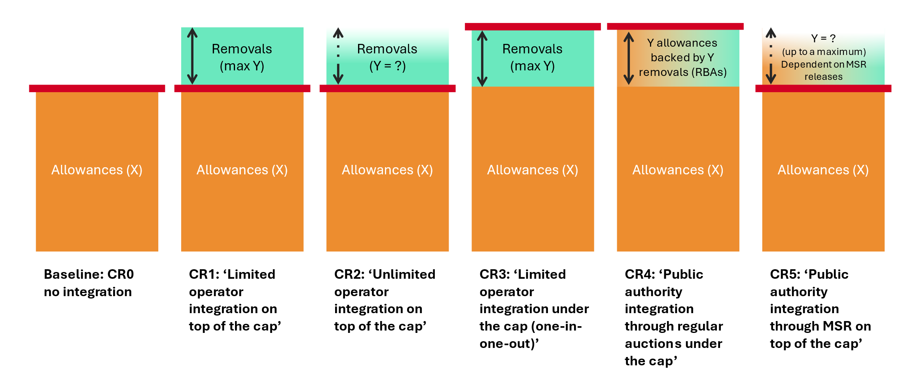
- Summary of the net and gross emissions certainty in the measures:
 | CR1 | CR2 | CR3 | CR4 | CR5
Net emissions | Certain, determined by the cap |  | Uncertain, dependent on removal units used.  Uncertainty can be reduced if financing is provided to support removals, e.g. through contracts for difference | Certain, determined by the cap,  conditional on the public purchasing program being provided sufficient funding to purchase the removals by which the cap is increased | Certain, determined by the cap
Gross emissions | Uncertain  Uncertainty up to the ceiling of the limit Uncertainty can be reduced if financing is provided to support removals, e.g. through contracts for difference | Uncertain and unlimited  Uncertainty can be reduced if financing is provided to support removals, e.g. through contracts for difference | Certain, determined by the pre-increased cap | Certain, determined by the cap | Uncertain, dependent on MSR releases, but limited
  - Measures discarded at an early stage
A number of measures have been proposed in the literature and in stakeholder consultations for the potential integration of removals and international credits into ETSs. Several dimensions are relevant to designing these options. This figure provides a few examples.
- Dimensions for the inclusion of removals in ETSs
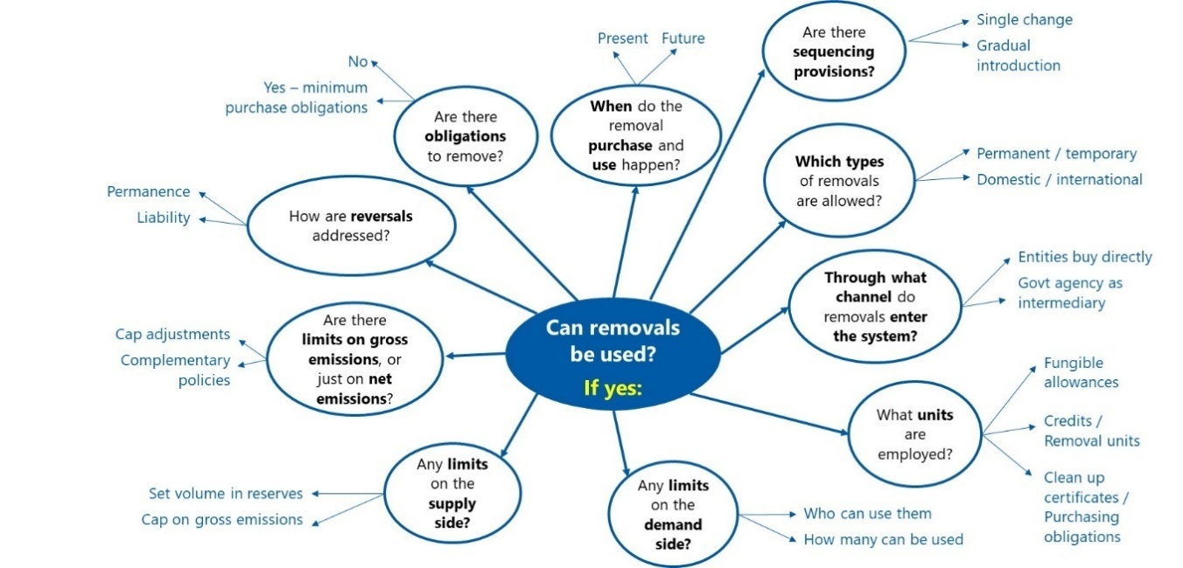
Source: La Hoz Theuer (2024)
A few measures and dimensions have been discarded for this impact assessment:
- Demand-side restrictions based on a sector-specific judgement of what emissions are ‘hard-to-abate’. For example, a restriction where only a particular sector or only a particular emissions source would be eligible to make use of removal units, thereby limiting the benefit from the additional space for gross emissions in the system. Establishing limits on who can use removal units entails implicitly defining which emissions are unavoidable and which of those should remain in society - which is highly disputed, subject to change and can be defined in myriad technical, societal, political and economic terms. Demand-side restrictions create substantial administrative complexity, requiring regulators to continuously assess and categorise which emissions qualify as "hard-to-abate" across diverse industries, whilst opening the system to lobbying pressure as sectors compete for preferential treatment and opening the door to political and technical disputes. They are also likely to fragment the market and reduce economic efficiency. Imprecisions in the decision-making by the regulator can further lower economic efficiency of the system. Such deliberations and decisions were considered to be politically unfeasible at this stage. In addition, as long as removals remain more expensive than conventional allowances, demand-side restrictions would not be binding, but they would nevertheless shrink the pool of potential buyers, so that removals may sustain higher prices for a longer period.
- Obliging entities to cover a percentage of their ETS emissions with removals. For example, requiring that ETS-covered entities cover a certain percentage of ETS compliance obligations with removal units. Removals are a way to provide flexibility to ETS operators, rather than as an obligation to purchase more expensive compliance units for their ETS-covered emissions. While purchase obligations may be an effective way of incentivizing removals and are aligned with the polluters pay principle if corresponding to the additional emissions spaced offered in the EU ETS by removals, they are considered unfeasible within the scope of the EU ETS review at this stage. In the long run, this may be reconsidered in the light of net-negative objectives.
- Establishing separate removal mandates or carbon take-back obligations, or extended emitter responsibility instruments through the EU ETS, e.g. establishing a separate ‘removals trading system’, imposing removal obligations on selected sectors/entities, or requiring that e.g. fossil fuel producers surrender removal units for their scope 3 emissions, i.e. the CO2 contained in their products. Such instruments are not considered viable options for EU ETS review at this stage, due to the lack of political feasibility of imposing new obligations on existing ETS-covered and/or on new entities. An analysis on the viability of establishing separate instruments for incentivizing removals outside the EU ETS lies beyond the scope of this analysis. In addition, regarding a removals trading system established over the wider economy based on an ‘ability to pay’ is considered contrary to the polluters pay principle. Such a system would enable the increase of the cap of EU ETS, thus allowing the sectors covered to benefit from the corresponding emission space, while imposing the cost of the removals on other actors that do not influence the emission being compensated. Nevertheless, it should be noted that the polluter pays principle will not be implemented perfectly as financial support is necessary to cover the price differential between removals and allowances. Such models should be analysed in the future as they may play a role in complementing towards net-zero and, more importantly, be essential towards achieving net-negative emissions.
- Establishing a central carbon bank (CCB). Proposals for the establishment of a CCB vary, but often include the tasks of managing the procurement of removal units, providing financial support to removal suppliers beyond the allowance price, acting as a warehouse for removal units, managing removal risks (such as from reversals), and managing price volatility and scarcity in the EU ETS by controlling the supply of compliance units, among others. Such an institution is not considered, among others due to the significant institutional and governance complexity. A rule-based system is considered favourable for market stability, transparency and avoiding political pressures. A simpler variant of this design, involving a public authority that manages a public purchasing programme, is envisioned as part of CR4 and CR5. The CCB has also been proposed as the institution to manage ‘clean-up certificates’, which would enable entities to emit while mandating future removal. These are discarded due to the lack of political feasibility as a result of their complexity (among others, requiring setting interest rates, collateral, and the creation of new credits); the environmental risk resulting from any mistakes in managing this complexity leading to an under delivery of the removals that justified increased emissions; and the delay in incentivising removals that could ensue.
- Using international credits for compliance in the ETS directly through operator integration. This was something often proposed in the open consultation but considered undesirable at this stage. Integrating the international credits to EU climate framework should be implemented preserving the principles of integrity and stability of the EU ETS. See section 3.1 on minimum requirements for removals integration. Allowing direct use of international credits for operators for their ETS compliance obligations as a means to create additional emissions space is an option which cannot be implemented simultaneously with the adjustment of the ETS cap to the EU-wide 85% domestic ambition target, which forms the basis for the impact assessment (see part I of this Annex on the cap). In other words, if a direct use of international credits through operator integration was allowed in addition to adjustment of the ETS cap, the 2040 EU domestic climate ambition would not be met. Thus, integrating the international credits by operators would require setting the ETS cap in line with an EU-wide 90% ambition target instead. Besides this first consideration, there are several drawbacks to direct integration into the EU ETS.
The EU has had direct experience of integration of Certified Emission Reductions (CERs) from the Clean Development Mechanism (CDM) into the EU ETS and discontinued this approach. Studies have raised concerns about the impact of this integration on the effectiveness and integrity of the EU ETS. The past experiences showed that allowing operators to purchase credits and use them directly for ETS compliance can be problematic. By contrast, adjusting the ETS cap equivalent to the amount of international credits that will be bought from projects outside of EU, is a straightforward approach that aligns with the fundamental principles of the system, ensuring a clearly defined cap, while still granting additional emission space.
Integrating international credits through operator purchasing involves considerable challenges. Firstly, under the Paris Agreement, all countries need to contribute adequately to efforts needed to achieve the Paris Agreement temperature goals. Private entities are not well placed to assess the issue of adequacy of the climate contribution of the countries. Economic theory would suggest that operators would seek to maximize their profits and acquire a maximum amount of the cheapest credits that they are legally allowed to use. Secondly, operators would need to navigate a complicated international credit market, expand their administrative capacities, and adhere to stringent often complex integrity criteria for credit purchasing. Additionally, it can be challenging for the public authorities responsible for the international credits to maintain rigorous oversight and compliance in relation to credit integrity. These issues would undermine the quality standards and other guarantees that the European Climate Law prescribes for the use of international credits. Also, once the credits would be acquired, a corresponding adjustment would need to be made in the emission balances and NDCs of the EU and of the third country: direct purchase by private entities would make ensuring this very challenging.

Moreover, smaller companies, in particular, may struggle due to limited administrative resources, creating an uneven playing field where only larger companies would be able to make use of this flexibility efficiently. Also, restrictions would need to be enforced, such as limits on the percentage of emissions covered by credits or a first-come-first-serve approach, increasing complexity, lack of predictability and administrative burden further. Lastly, when there is a difference in price between the EU ETS and international credits, there is a distributional issue as to who benefits from the difference in the price. In the past, the operator integration of international credits to ETS benefitted operators by giving them certain limited rights to exchange CERs and ERUs into allowances. Additionally, it can be challenging for the public authorities responsible for the international credits to maintain rigorous oversight and compliance in relation to credit integrity.

The overall objective of introducing the international credit as a flexibility to the EU 2040 climate target is to introduce flexibilities in the reaching the target by ensuring not the entire target needs to be met domestically (including ETS). Adjusting the ETS cap is more cost-effective and efficient than direct operator integration to achieve this, minimizing complexity and administrative load for market participants. Consequently, the option of integrating credits directly through operator purchasing has been discarded from this impact assessment due to the additional complications and uncertainties it introduces.
  - Assessment of the measures
This section assesses each of the measures along economic, social and environmental impacts. The analysis assumes that only permanent domestic CDR certified as BioCCS and DACCS are included in the EU ETS, as per the conclusions of section 3. Moreover, the analysis draws on the projections of removals in the 85% scenario in the PRIMES model.
- Quantitative assumptions for the inclusion of CDR in the EU ETS in PRIMES (EU) and POTEnCIA

Volumes per source of non-fossil CO2 stored underground | 2035 | 2040 | 2031-2040
Power generation | 5 ;20 | 30; 40 | 125 ; 240
Industry | 0 ; 5 | 0 ; 15 | 0 ; 75
Biomass processing | 0 ; 2 | 0 ; 2 | 0 ; 20
Air | 0 | 7; 12 | 20 ; 35
TOTAL | 5 ; 30 | 45 ; 60 | 175 ; 330
Removals % of gross emissions with cap at gross current scope | 1.5% ; 5% | 15% ; 18 | 3.5%; 6%
Removals % of gross emissions with cap at net current scope + waste | 1% ; 4% | 12%; 20% | 3%;6%
Removals % of gross emissions with cap at gross current scope + waste + landfills | 1% ; 4% | 10%; 13% | 2.5%; 5%
Sources: PRIMES and POTEnCIA
- Technology costs assumptions
Years | 2030 | 2031 | 2032 | 2033 | 2034 | 2035 | 2036 | 2037 | 2038 | 2039 | 2040
Average BioCCS removal unit price estimate (EUR) | 214 | 210 | 207 | 203 | 200 | 196 | 192 | 188 | 184 | 180 | 176
Average DACCS removal unit price estimate (EUR) | 428 | 403 | 378 | 352 | 327 | 302 | 297 | 292 | 288 | 283 | 278
Technology costs from European Commission: Directorate-General for Climate Action, Ramboll Management Consulting, Witteveen, E., Marton, C., Bert, N. et al., Carbon removals in the EU – Review of current carbon removal projects and early-stage financing, Publications Office of the European Union, 2025
Based on these technology costs, removal units from BECCS are expected to become cost competitive vis-à-vis the allowance price in 2036-38, whereas DACCS removal units would not reach cost competitiveness within the period.
It is important to note that the CDR supply figures in Table 3 present the modelled optimal supply for target achievement from the model runs (see Annex 4 Analytical methods for more information). They are related to but distinct from estimates on CDR supply potential. The CDR supply assumed above lies within the estimates of CDR supply in a recent Commission study, which estimates around 4Mt of BioCCS and DACCS per year in 2030 and 15-25 Mt per year in 2035, all of which will require the successful development of geological CO₂ storage capacity in the EEA.
Equally, it is important to note that (i) CDR cost and supply estimates are highly variable and uncertain – and thus on their cost-competitiveness and potential impact on the EU ETS – and (ii) can be significantly affected by policy support for CDR outside the ETS. An effective contract for difference scheme, for example, could create a compelling business case for CDR and bridge large cost differentials, enabling significant CDR inflows into the EU ETS where none would have existed otherwise. Such public subsidies will in particular be essential to scale-up removals. The assessment below thus tries to withhold judgement on the cost-competitiveness of removal units in the ETS, notwithstanding the figures contained in the table above. In particular, this means that the assessment below does not rely on the cost differential between removal units and the carbon prices as a potential ‘solution’ to any risks that an effective inclusion of CDR in the EU ETS would entail.
Those expected CDR volumes can be compared to the size of the cap in each policy option (including aviation and new sectors, incl. non-CO2 and offshore) PRIMES scenario (EEA), showing how much of the emissions space (gross emissions) of the EU ETS is covered by removals, which is between 2.5% to 5% of the cap during the period and between 10% to 13% in all cap options by 2040. The higher shares would correspond to PO1, followed by PO2 and then PO3.
Finally, it should be noted that the current cap of the ETS may be adjusted as part of this review in accordance with the future 2040 target and increased as a result of the potential expansion to new sectors. Changes to the Market Stability Reserve may also impact liquidity. Therefore, the full impact of the measures on integration of carbon removals analysed in this chapter can only be assessed in combination with the measures on MSR, cap and scope as part of the policy options.
    - Economic impacts
      - Conduct of business
Costs on the conduct of business stem from effects of changes to the allowance price (i.e., EU ETS compliance costs), from market dynamics, and from transaction costs.
        - EU ETS compliance costs
What are the expected costs on the allowance price? Affects the ETS compliance cost for businesses and the cost of essential and intermediate inputs.
The following compliance cost effects apply to CR1 ‘Limited operator integration on top of the cap’:
Removal units increase compliance unit supply and affect allowance prices depending on their price. This is primarily the case once abatement becomes more expensive than removal, although expectations of future CDR cost declines and availability can already lower EUA prices before parity is reached. Under current assumptions however, and in the absence of additional support to CDR suppliers through e.g. CCfDs, the compliance cost impact would likely be minimal in early years and increase as CDR technologies mature and costs decline. The need for financial support to scale up CDR was strongly advocated for by open consultation respondents, with many citing CCfDs. If and when removal units become cost competitive in the EU ETS, they can reduce the allowance price compared to a situation where no CDR is allowed in (under current assumptions, BECCS would become cost competitive in 2036-2038, with DACCS not reaching cost competitiveness within the period). This effect on compliance costs would be attenuated by the limit for CDR use (as the quantitative limit would restrict the extent of any allowance price reduction) and, more importantly, by the technical potential of the technology and the slope of its marginal cost curve. Regulatory uncertainty can play an important role in longer-term price expectations. For example, if ETS market participants expect the regulator to relax or remove the CDR limit in the future, then expectations for the future allowance price would approximate expectations on future CDR costs. It is worth noting that, given a certain scarcity level and assuming usual enforcement, under CR1 much of the risk from CDR technologies (e.g. under-delivery, price risk) would be borne by ETS regulated entities. This is because lower-than-expected CDR volumes and/or higher-than expected CDR prices (assuming that the cap is not relaxed and that compliance is enforced) could mean significant increases in the ETS price – such that ultimately, operators bear the risk of CDR not materializing.
Uncertainty on future CDR costs could also affect prices in the short term. With the inclusion of CDR in the EU ETS, the availability and price of removal units would become another uncertain variable in the compliance strategy of operators. Operators thus would need to estimate not only future EUA prices (in terms of abatement costs across industries) but also future CDR costs and availability. This could complicate investment decisions in long-term abatement projects.
The following compliance cost effects apply to CR2 ‘Unlimited operator integration on top of the cap’:
Similar to CR1 ‘Limited operator integration on top of the cap’, removal units would increase compliance unit supply and affect allowance prices if and when marginal abatement costs equal or exceed marginal removal costs, with much of the CDR risk borne by ETS regulated entities. Here, however, there would be no limit on CDR use. Removal units would thus act as a de-facto price ceiling, albeit a soft one that is determined by the slope of the CDR supply curve at volumes deliverable within compliance timelines. Expectations for the future ETS price would be anchored to expectations on future marginal CDR costs and delivery volumes, which could amplify the effects of uncertainty about future CDR costs and availability, complicating long-term abatement decisions as compared to CR1. While overall a broad majority of stakeholders in the open consultation (70%), from a diverse range of stakeholders, expressed support that the use of removals by regulated entities should be subject to some restrictions and not be unlimited, some stakeholders argued in favour of allowing for a limitless use of CDR in the EU ETS in order to address emissions in hard-to-abate sectors and to lower the cost of compliance.
The following compliance cost effects apply to CR3 ‘Limited operator integration under the cap (one-in-one-out)’:
Under CR3, the regulator would pre-increase the number of conventional allowances in circulation through an increase in allowance auction volumes distributed throughout the period. This increase in conventional allowances would not be conditional on removal units coming in. This would reduce scarcity in the EU ETS and exert downward pressure on the price - thereby reducing compliance costs compared to the baseline. Conversely, the use of removal units would trigger the cancellation of a conventional allowance from future auctions, thereby creating an upward price pressure. The time lag between CDR use and allowance cancellation could create temporal arbitrage opportunities. The net effect on compliance costs would depend among others on marginal abatement costs, on the removal supply curve and on complementary CDR support instruments.
It is important to note that the reduced scarcity from the increase in conventional allowances could affect the cost-competitiveness of removal units in the ETS.
- If removal units are not cost-competitive in the ETS before the allowance volume increase from CR3, then reduced scarcity under CR3 would reduce the allowance price, making removal units less cost-competitive and no removal units would enter the EU ETS (absent complementary support instruments for CDR).
- If removal units are cost competitive in the ETS before the allowance volume increase from CR3, then the effect depends on whether they remain cost-competitive even after the reduced scarcity from CR3. If removal units cease to be cost-competitive, then the previously described scenario applies. If removal units remain cost competitive, then some removal units would flow into the system.
The following compliance cost effects apply to CR4 ‘Public authority integration through regular auctions under the cap’:
The allowance price is expected to go down as compared to the baseline in line with the increased availability of allowances as removal-backed allowances become available. Under CR4, the risk of under-delivery (e.g. in the context of long￼term purchase agreements) and price risk from CDR technologies is borne by the regulator.
The following compliance cost effects apply to CR5 ‘Public authority integration through MSR on top of the cap’:
Under CR5, removal units are an instrument of market stabilization. While the same volume of CDR would flow into the MSR as compared to (the maximum volume allowed under) CR1, CR3 and CR4, the effect of CDR introduction on the allowance price would depend on if and when such MSR releases occur. The effect would thus depend on MSR design, including rules around invalidation and order of release of allowances and removals. This could mean that some of the removal units purchased by the regulator would not make it into the market.
In fact, as described in section Annex 8 Part III on the MSR section, under the parameters of MSR1 and of MSR3 (the two measures included in the modelled policy options for the MSR) the MSR is expected to release units only in the mid-2030s. Barring large releases due to sudden price increases, for both MSR1 and MSR3 there remains “sufficient” allowances in the reserve by 2040 – such that it seems possible that no removal units would enter into circulation in the 2031-2040 period. The inclusion of removal units in the MSR would affect market expectations, e.g. by prolonging the MSR and providing an additional inflow of units after 2040, although it seems possible that allowance prices would be higher than in other measures considered here, albeit lower than the baseline. Transparency and predictability are facilitated if the authority’s procurement strategy (volumes, types of CDR, prices paid if public) and MSR release rules are clearly communicated, but some uncertainty would remain. As under CR4, in CR5 the CDR under delivery and price risks are borne by the regulator.
        - Market dynamics
Will it be possible to ensure that the carbon market keeps functioning well with the integration of carbon removals into the ETS?
Expected impacts on the functioning of the market (e.g. trade volumes, market fragmentation, flow of allowances and regularity of supply, transparency and predictability for market participants) can affects the allowance price and, accordingly, the ETS compliance cost for businesses and the cost of essential and intermediate inputs. The impacts are assessed qualitatively. Modelling results are provided for the policy options in the main body of the impact assessment.
The following market dynamics effects apply to all measures that entail operator integration between the EU ETS and CDR suppliers - that is, all options where EU ETS operators can purchase removal units directly from CDR suppliers:
This applies to CR1 (‘Limited operator integration on top of the cap’), CR2 (‘Unlimited operator integration on top of the cap’), and CR3 (‘Limited operator integration under the cap (one-in-one-out)’).
There would be a clear market access pathway for CDR technologies in the ETS. This, however, would be contingent on removal units actually being used in the EU ETS. The actual flow of removal units would depend on the relative price between abatement and removal costs. As prices and costs stand (see Tables 3 and 4), and in the absence of additional support to CDR suppliers through e.g. carbon contracts for difference (CCfDs), very few if any removal units would enter the EU ETS before the end of 2031-2040. Nevertheless, even before significant physical removal unit inflows, expectations about future CDR flows and costs could reshape operators’ EUA banking and hedging, affecting liquidity and price formation.
The EU ETS supply of ‘permits to emit CO2’ would no longer be determined only by the public sector decisions on the issuance of allowances, but also by the physical reality of carbon removals for which certified removal units are generated. These would be two distinct sources of supply but lead to direct price competition between abatement in the ETS and CDR costs within the limits for CDR supply (if applicable). Market transparency and price formation in the CDR market would depend on how the primary market is structured. While over-the-counter (OTC) trades would provide for low transparency, exchange-based trading and centralized auctions (as currently planned in the UK) could improve price transparency as well as information about CDR technology costs and availability. It seems possible that the CDR market would see purchases not only for EU ETS compliance, but also for voluntary demand and, potentially, for compliance demand (e.g. by national governments) towards national target achievement and as a means of supporting the development and deployment of CDR technologies.
The functioning of the market for removal units would depend on the units employed (see section 4.2. unit differentiation) and on how limits are enforced (see section 4.4 on limits). If limits are enforced at the Union Registry ‘border’ and removal-backed allowances have the same compliance value as conventional allowances, the market should function as it does today. This holds when removal-backed allowances are indistinguishable from conventional EUAs. If, instead, removal-backed allowances are differentiated (e.g., tagged) and attract a price premium, the market could bifurcate into two instruments with potentially different liquidity and pricing.
CDR supply concentration (which is likely in early, small markets) could enable suppliers to exercise market power, which could among others impact prices and liquidity.
Operator integration would likely mean lower predictability of demand as compared to measures with integration through public authority. In absence of further CDR policy support, the revenue uncertainty could lead to slower and ‘lumpier’ capacity additions on the CDR supply side, thus also affecting the regularity of supply. This could lead to limited transparency and predictability for market participants on both ETS and CDR sides, because of the uncertainty on the ETS price on one side and on the CDR costs on the other. See further discussion on this under ‘Target achievement/environmental’.
The following market dynamics effects apply to measures that limit the volume of CDR that can flow into the EU ETS (that is, all options except for CR2 (‘Unlimited operator integration on top of the cap’)):
In the primary CDR market, the direct competition and fungibility between abatement and removal applies only within the limit. There would be limit-induced price distortions in the primary CDR market when constraints bind, preventing effective price discovery after that point. In that case, removal units would face a price discount vis-à-vis conventional allowances, as was the case when Kyoto credits were allowed in the EU ETS, due to the uncertainty on the possibility to use of the removal units that results from the limit. On the other hand, limits to the use of removal units can contribute to preventing cost-ineffective abatement deterrence.
If limits are enforced at the Union Registry ‘border’ and removal-backed allowances have the same compliance value as conventional allowances, the secondary market should function as it does today. This holds when removal-backed allowances are indistinguishable from conventional EUAs. If, instead, removal-backed allowances are differentiated (e.g., tagged) and attract a price premium, the secondary market could bifurcate into two instruments with potentially different liquidity and pricing.
Limiting the use of removal units means that the benefit to CDR suppliers is limited to the permissible volume; the extent to which this is relevant in the short and medium term will depend on how ‘tight’ the limit is compared to current CDR capacity. Absent robust policy instruments supporting CDR development and deployment beyond the ETS, a limit of between 175 and 330 Mt (85% scenario) applied to the whole phase is, however, very unlikely to bind the supply side during the 2031-2040 period. If removal units are cost competitive in the ETS such that the limit is binding, then it will be necessary to ration the (cheaper) removal units as demand for them could exceed the allowed supply. See section 1.4.4 Consideration on Limits for an analysis.
Particular market dynamics effects of CR1 (‘Limited operator integration on top of the cap’):
(See above on general market dynamics effects related to operator integration and to integration with limits).
The use of removal units could allow for a (limited) increase in gross emissions in the ETS, supporting higher trade volumes and higher liquidity. This, however, is contingent on removal units actually being used in the EU ETS – which, at the current price differentials, would require other CDR support instruments to bridge the gap.
Particular market dynamics effects of CR2 (‘Unlimited operator integration on top of the cap’):
(See above on general effects related to operator integration).
A lack of limits in CDR use in the EU ETS could mean a much higher inflow of CDR units if and when removal costs become competitive vis-à-vis abatement inside the ETS. An increase in gross emissions can increase the size of the market and make it more liquid, facilitating smoother market functioning.
A lack of limits would also mean that removal units would not trade at a discount vis-à-vis conventional allowances, which allows in theory for a cost effective mix between abatement and removal. This measure, however, presents a higher risk of cost ineffective abatement deterrence.
Particular market dynamics effects of CR3 (‘Limited operator integration under the cap (one-in-one-out)’):
An important characteristic of this measure is the one-off increase in the volume of conventional allowances through an increase in auction volumes distributed throughout the period. This is what creates the extra “space” for an increase in gross emissions by ETS regulated entities, in line with the expected flow of CDR units in the EU ETS. This increase in allowance volume allows for a (limited) increase in gross emissions, which can lead to higher liquidity and smoother market functioning. Unlike CR1 (‘Limited operator integration on top of the cap’), the additional space for gross emissions is created even if removal units fail to make it into the EU ETS. This is because the extra space for gross emissions is generated by the initial increase in allowances, rather than by the actual flow of removal units into the EU ETS.
The use of removal units in the EU ETS leads to one allowance being withdrawn from a future allowance auction. The reduction of future auction volumes (due to the ‘swapping’ for the removal unit) could generate uncertainty on future compliance unit supply, as the fluctuations will be hard to predict. It would also be necessary to align this with MSR provisions, e.g. if the one-in-one-out mechanics requires that an allowance be withdrawn from auction while MSR rules require that more allowances be made available. Market effects from the unit ‘swapping’ would be mediated by the volume of units flowing in, the transparency of unit flows, and the time to adjustment of the auction volume. Rules for the cancellation of allowances should be designed such that large players cannot strategically time CDR use to influence allowance cancellations and future prices. It is also worth noting that the yearly safeguard limit (set equal to the auction volumes of the following year and meant to act as a backstop in case removal units drop radically in price and/or increase in supply) can have effects on the latter years of the phase. This is because (a) auction volumes are set to decrease over time; (b) removal units may become more available in later years of the period and, potentially, (c) removal units may be cheaper and more abundant than currently envisaged by the regulator. Put together, this could mean that the safeguard limit may be binding towards the latter years of the phase. Given current assumptions (see table 3), however, this seems unlikely to be the case. Under the 85% scenario, the modelled total yearly CDR supply never surpasses the auction volume of the following year. A constraint would only apply if the total allowable CDR supply for the entire period were to flow into the ETS in the year of 2040 alone].
Particular market dynamics effects of CR4 (‘Public authority integration through regular auctions under the cap’):
The purchase of CDR units allow for the increase in cap and with it of gross emissions in the ETS, supporting higher ETS trade volumes and liquidity. Importantly, and unlike CR1 (‘Limited operator integration on top of the cap’) and CR2 (‘Unlimited operator integration on top of the cap’), this measure would not depend on CDR being cost competitive for the higher availability of units to be felt in the market. This is because the regulator ensures the supply and would subsidize the difference between the CDR cost and the ETS allowance auction price. This is an important advantage of CR4 as compared to e.g. CR1 and CR2. The difference on this matter between CR4 and measures such as CR1 and CR2, however, depends on the cost competitiveness of removal units in the ETS and the extent to which different measures are accompanied by effective support mechanisms that similarly bridge the cost differential between abatement and removal. In situations where removal units are cost competitive in the ETS, the intermediation by the public authority could reduce market efficiency. CR4 can reduce market uncertainty for both ETS operators and removals operators, as it decouples the inflow of removals-backed allowances from the relative price signal between abatement and removals, with procurement volumes and timing that are administratively chosen under (high) uncertainty. Several stakeholders in the open consultation mentioned the advantages of increased liquidity but also raised concerns over loss of market efficiency in cases of public authority integration.
The supply of removal-backed allowances into the ETS would be predictable, as it would be determined by the public authority's pre-set purchase volumes and auction schedule. This could support market stability. Rules (or unit buffers) would be necessary to provide clarity on auctioning schedules in case of CDR procurement delays or under-delivery by CDR suppliers.
Transparency and predictability for operators are facilitated if the authority’s procurement strategy (volumes, types of CDR, prices paid if public) and auctioning rules are clearly communicated. An effective CDR price discovery would require a well-designed CDR purchasing strategy.
There would be no fundamental change to the way the primary market for allowances works for operators. The regulator would remain as the sole provider of allowances in the primary market as it would centralize the interaction with CDR providers. Nevertheless, also in this case we would expect a market for CDR units to operate outside the EU ETS, e.g. for voluntary demand and, potentially, for demand by national governments towards target achievement and CDR support.
Particular market dynamics effects of CR5 (‘Public authority integration through MSR on top of the cap’):
This measure would see no immediate effect on trade volumes, as CDR units are kept in the MSR and only released in times of scarcity. As already mentioned under the CR5 analysis regarding ‘EU ETS compliance costs’, under current assumptions it is possible that no removal units would enter into circulation through the MSR in the 2031-2040 period.
By replenishing the MSR, CR5 would extend the MSR’s operational life beyond that implied by the number of (conventional) allowances in the reserve and current MSR’s rules and parameters. Consequently, CR5 prolongs the market stability service that the MSR provides to the EU ETS. Moreover, and compared to CR4, measure CR5 could be more responsive to market needs than a fixed and predetermined schedule.
As in the case of CR4, there would be no fundamental change to the way the primary market for allowances works for operators, as the regulator would remain as the sole provider of allowances.
It is worth noting that with the exception of CR2 (‘direct integration without a limit, net cap’), in all measures discussed above the limit for CDR use is the same, but measures differ in terms of when and how the extra compliance units (and thus the extra ‘space’ for gross emissions and the corresponding effect on market dynamics) flow into the ETS. Under CR1 (‘Limited operator integration on top of the cap’), gross emissions only increase if removal units are cost competitive vis-à-vis the allowance price (also taking into account support policies outside the EU ETS). By contrast, under CR3 (‘Limited operator integration under the cap (one-in-one-out)’), gross emissions increase as a result of the initial increase in the allowance volume and thus do not depend on removal units actually flowing in. Under CR4 (‘Public authority integration through regular auctions under the cap’), the increase in compliance units is reflected from the start in the increased cap, and their release is predictably scheduled alongside those of regular allowances via the auction calendar. Under CR5 (‘Public authority integration through MSR on top of the cap’), the increase in compliance units would occur in line with MSR rules and be less predictable.
        - Transaction costs
What are the expected transaction costs on EU ETS operators? Influenced among others by the channel through which operators procure compliance units, contract standardisation and market infrastructure, and risk management needs.
CR1 ‘Limited operator integration on top of the cap’: Direct market access through e.g. standardized contracts would minimize intermediary fees. However, higher transaction costs compared to a baseline of no CDR integration would nevertheless apply to the extent that operators would have to evaluate e.g. the reliability of CDR technologies and suppliers (due diligence costs) when engaging in forward purchase contracts. The inclusion of another compliance unit would mean that operators could face higher portfolio management complexity - optimizing between allowances, CDR types, and timing, including risk management costs.
CR2 ‘Unlimited operator integration on top of the cap’: Similar effects as under CR1, amplified by the fact that operators would potentially have to track a larger and more dynamic CDR market (if removal units are cost competitive in the ETS) and manage higher exposure to CDR costs.
CR3 ‘Limited operator integration under the cap (one-in-one-out)’: Similar as under CR1, with extra operational complexity from tracking the one‑in‑one‑out mechanics.
CR4 ‘Public authority integration through regular auctions under the cap’: For operators, transaction costs related to CDR purchases under this measure would be lower than under measures with operator integration (CR1-CR3) as operators would acquire all allowances (including removal-backed ones) through regular ETS auctions or the secondary market. There would be no need to engage in separate procurement of CDR units.
CR5 ‘Public authority integration through MSR on top of the cap’: same effect as under CR4.
      - Public authorities and budgets
What are the expected impacts on revenues and costs for the regulator, e.g. allowance auction revenues, removal unit purchase costs, and administrative costs?
The investment needed to support the development and deployment of CDR technologies does not a priori change materially across the measures assessed here, and public finance has a crucial role to play. Public disbursement can occur through the EU ETS (e.g. through measures CR4 and CR5) and/or through other support policies (e.g. CCfDs or a public purchasing programme). In either case, total expenditure could be similar if the regulator has a clear commitment towards procuring enough CDR that guarantees the extra gross emissions headroom for operators (CR1 and CR2) or to deliver the net emissions outcome (CR3).
That said, the measures do vary considerably in terms of risk distribution and upfront finance for CDR development and deployment – and this latter point can materially affect the viability of achieving the climate targets, especially if CDR technologies do not reach the scale required on time. For example, apparent ‘cost savings’ for the regulator from CR1, CR2 and CR3 (notably from not having to invest into the purchase of removal units) entail risk transfers to the private sector that could materialize as higher costs for the regulator later on, e.g. if CDR technologies do not scale as required in time for target achievement, and especially if the regulator is left with little time to react to a CDR supply shortfall.
Generally, fiscal costs across the measures considered here are different from the fiscal costs in the baseline of no CDR integration, in which the ETS would ultimately reach absolute zero emissions. This is because the measures considered here increase the regulatory ‘space’ for residual emissions under the ETS, which means that part of the mitigation costs that would have been incurred by regulated entities move onto the regulator in one way or another. This can happen in various ways. First, a decrease in scarcity is likely to lead to reduced allowance auction revenues to Member States. Moreover, using removal units rather than conventional allowances towards compliance obligations would mean that CDR suppliers are the ones receiving payments from operators, rather than the Member State through allowance auctions. Also, the integration of CDR into the EU ETS would require regulation and oversight on CDR eligibility and market surveillance, thus resulting in administrative costs.
CR1 (‘Limited operator integration on top of the cap’) and CR2 (‘Unlimited operator integration on top of the cap’), in theory, would entail lower direct EU ETS purchase costs for the regulator as compared to CR4 and CR5, although, in the absence of public investments in CDR through other policies, risks that the CDR development and deployment not take place in time for the CDR scaleup required and that the extra ‘space’ for residual emissions inside the ETS therefore not materialize.
CR3 (‘Limited operator integration under the cap (one-in-one-out)’) would see a similar effect as for CR1 and CR2 in lower direct EU ETS costs for the regulator not having to purchase the removals itself, again with the need for further support policies to ensure that CDR development and deployment take place in time for the CDR scaleup required. This is aggravated by the initial reduction in scarcity, which could reduce incentives for abatement and investment in removal by regulated entities – thus potentially requiring further investments in abatement and removal by the regulator outside the ETS. Effects are also expected on auction revenues. Under CR3, Member States would see an increase in the number of allowances for auction, but it is unclear whether this would entail higher revenues as the increase in the allowance volume may be offset by a price drop due to the reduced scarcity.
CR4 (‘Public authority integration through regular auctions under the cap’) would see the regulator purchase removal units even if they are not cost competitive vis-à-vis the allowance price. This would create an avenue to bridge the price gap between abatement and removals and thereby provide significant support to the development and scale-up of CDR technologies. Importantly however, this would entail arranging for a significant financial endowment from the ETS auction revenues, which could be politically challenging but necessary to ensure the necessary amount of removals is purchased. Thus, CR4 would likely entail significant costs for the regulator in e.g. the procurement of removal units, although it seems possible that procurement methods such as reverse auctions could yield lower overall transaction costs than if purchases were done by a large number of individual regulated entities in the primary CDR market, and would need to be compared with the administrative cost of complementary support measures needed under CR1 and CR2 (e.g. CCfDs). Compared to CR5, measure CR4 has the advantage of the predictability of the regulator in recouping some of the CDR purchase costs by auctioning removals-backed allowances in the market.
CR5 (‘Public authority integration through MSR on top of the cap’) would be similar to CR4 in that the regulator would purchase removal units even if they are not cost competitive in the EU ETS, providing material support to the development and deployment of CDR technologies but requiring a significant endowment of funds to do so. Different from CR4, in CR5 there is less predictability on the ability of the regulator to recoup CDR purchase costs through allowance auctions, as MSR allowance releases would follow MSR triggers, which provide for less predictability than pre-set schedules. It seems possible, however, that by the time the MSR kicks in, auction prices be higher than they would have been under CR4 – thus yielding higher auction revenues. Nevertheless, even if the difference were not as stark between CR4 and CR5 regarding the overall flow of expenditures and revenues, the predictability with which they happen would have a crucial impact. As already mentioned under the CR5 analysis regarding ‘EU ETS compliance costs’, under current assumptions it seems possible that the MSR would auction no removal units in the 2031-2040 period. Releases start in the mid-2030s and the MSR has an extensive number of allowances to support liquidity in the EU ETS in the 2030s, under the parameters examined in above.
Estimated fiscal costs in CR4
The fiscal cost for the public authority in CR4 is calculated as the investment requirements (i.e., tonnes procured) minus revenues from allowance sales made by the public authority to ETS participants. It should be noted that the following are illustrative calculations based on an 85% ambition scenario for 2031-2040. The investment requirements and final fiscal cost for a potential removal integration as per CR4, strongly depend on the price of removals, total volume of removals to be purchased, the final ambition level set out, the corresponding ETS prices, the ratio of BioCCS to DACCS in the portfolio, and timing of the purchase of the removals compared to the sale of the allowances. In particular, the timing of the purchase of the removals compared to the sale of the allowances can have an impact on the final fiscal cost, while it is likely that it cannot be fully optimised (e.g. delay in the sale of allowances to a time when ETS prices are highest and purchase of removals when the removal prices have decreased) due to the need to kick start the market, and the uncertainty in ETS and removal prices.
    - Total investment required for the purchase of CDR
The following graph represents the cumulative cost BioCCS and DACCS in each of the two models considered, PRIMES and POTEnCIA (see Table 3), based on the technology costs and tonnes demanded from each technology, (i.e. portfolio costs overtime). POTEnCIA models a higher volume of removals, thus shows higher upfront investment costs for the purchase by the public authority (EUR 55.5 billion) compared to PRIMES (EUR 35.7 bn) based on average costs, which include costs and thus revenues for CO₂ storage operators in the EEA.
- Cumulative PRIMES and POTEnCIA average costs

Source: PRIMES (in red) and POTEnCIA average costs (in orange)
These costs are based on technology costs set out below, with a range of estimates for 2030, 2035 and 2040 that were linearly extrapolated between given years with data. Cost decreases achieved by 2040 significantly shape the results, given how low they are relative to current removals costs and the expected future ETS prices.
Considering different technological costs, upfront investment needs amount to between EUR 46 and EUR 65 billion in POTEnCIA and between EUR 29 bn and EUR 43 bn in PRIMES (ranges based lower and upper bound of technology costs).
- CDR technology cost estimates in Euros
Technology costs (EUR) | 2030 |  |  | 2035 |  |  | 2040
Technology costs (EUR) | BECCS | DACCS | Biochar | BECCS | DACCS | Biochar | BECCS | DACCS | Biochar
Lower bound | 167 | 288 | 66 | 163 | 201 | 50 | 160 | 185 | 37
Average | 214 | 428 | 141 | 196 | 302 | 113 | 176 | 278 | 88
Upper bound | 261 | 567 | 215 | 228 | 402 | 175 | 192 | 370 | 138
Source: see footnote 21
For reference, PRIMES estimates the following unit costs of removals (includes transport, storage and capture), which are closer to the lower bound for BECCS, to the lower bound for BioCCS except in 2040, and to the higher and mid-point bound for DACCS, depending on the year:
- PRIMES CDR cost estimates
EUR 23/tCO2 | 2030 | 2035 | 2040
Cost of capture & transport & storage: DACCS | 518 | 375 | 251
Cost of capture & transport & storage: BECCS | 171 | 159 | 148
Costs of capture from biomass processing | 66 | 65 | 64
Source: PRIMES
    - Expected revenue generation from removal-backed allowances
Similary, the expected revenues from the sale of removal-backed allowances is higher in POTEnCIA, as it models higher removal volumes of BioCCS and DACCS than PRIMES.
- PRIMES and POTEnCIA revenue generation from removal-backed allowances

PRIMES 85% BioCCS and DACCS results are shown on the left (blue), and POTEnCIA 85% BioCCS and DACCS are shown on the right (red)
    - Final fiscal cost
Considering the results above, PRIMES and POTEnCIA result in final costs for the public authority between EUR 1 bn and EUR 0.37bn for 2031 and 2035, and both give negative costs for 2040, as seen in the following graph.
- Final fiscal costs in PRIMES and POTEnCIA

PRIMES 85% BioCCS and DACCS results are shown on the left, and POTEnCIA 85% BioCCS and DACCS are shown on the right.
Concretely, based on average technology costs, the purchasing programme under PRIMES would have an illustrative final fiscal cost of Euro EUR 3 bn and of EUR –1.7bn under POTEnCIA.
Negative fiscal costs result for 2040 mean that there are net revenues from the sale of CDR allowances into the ETS (i.e., overall removals costs are lower than the carbon price). This suggests that the sale of removals into the EU ETS could potentially cover the full cost of the purchasing programme and even raise additional funds to purchase more removals or contribute to other funds (e.g., Innovation Fund).
However, as mentioned at the start of this section, significant caveats and assumptions must be considered.
- .
      - Fiscal cost for CR1-CR3 and CR5
Assuming that it is decided to ensure the same emissions space to the ETS sectors under CR1–CR3, with the aim of avoiding carbon leakage and achieving the net-target contribution, the cost of CR1–CR3 should be similar to CR4, as the public authority would pay the full price of each CDR credit upfront but then recover the price difference with EUAs when the removal-backed EUAs are auctioned, covering only the price difference in the end. The exact amounts will depend on the timing of the purchase of the removals and the sale of allowances.
For CR5, the investment needs (i.e., fiscal cost) of the purchasing programme for the MSR option is equal to the investment needs calculated above, because we assume for this policy option that there is no release of MSR allowances into the EU ETS, and therefore no revenues are obtained from the sale of the removal-backed allowances to ETS participants (unlike the public authority option where revenues are collected and used to fund the purchasing programme – see below).
    - Social impacts
      - Employment
CDR integration into the EU ETS can influence employment positively, mainly through its impact on the pace and predictability of domestic CDR deployment and associated supply chains. The precise extent of the impact on jobs in the CDR industry can differ per measure.
- Measures that provide predictable demand and bankable revenue streams for removals (CR4 and CR5) are more likely to catalyse near‑term investment and job creation in the European CDR industry.
- Operator‑integration measures (CR1–CR3) can deliver similar employment benefits if complemented by CDR policy support outside the ETS. Unlimited integration in CR2 may create further benefits, as it removed the uncertainty generated by the limit (see section 1.4.4.1) and allows more removals to enter the system, if they are price competitive, although this effect may be counterbalanced by the mitigation deterrence impact on the ETS. Absent support measures, however, the weaker visibility of demand in CR1-3 may delay investment decisions and temper job growth.
Regarding jobs in ETS industries, the introduction of removals transforms the system from one that goes to absolute zero to one that can sustain a positive cap. While other ways of maintaining a positive cap exists, the choice to implement one of them (removals integration) supports the EU's competitiveness and thus employment. Nevertheless, if cheaper CDR displaces abatement action in certain sectors, it prevents the generation of jobs in ETS clean industries. As a result, some jobs in the CDR industry may represent a shift from cleaner industries rather than net‑increase.
Estimates from Boston Consulting Group conclude that the development of the CDR industry could bring substantial economic growth and also significant job creation. They conclude that by 2050, the CDR sector in Europe could support up to 670,000 jobs. This growth trajectory indicates substantial employment opportunities across various sectors involved in CDR, including engineering & manufacturing, energy, and (digital) services. Concretely, if CDR develops as modelled in the 1.5°C- and 2°C-compatible scenarios, the job potential in the CDR industry is expected to increase gradually, with a relatively modest growth in the next years. By 2035, however, the sector could already support 125,000-180,000 jobs in broader Europe. The job potential is estimated based on current sector ratios of jobs per EUR 1 million value added.
      - Income distribution, social protection, and social inclusion (of particular groups)
The assessment of the impacts on income distribution, social protection and social inclusion is undertaken quantitatively at the policy option level in main body of the impact assessment.
      - Fundamental rights
Fundamental rights afford basic legal protection for political, social, and procedural rights to individuals and legal entities. The Charter of Fundamental Rights of the European Union (the Charter) is an instrument of primary EU law that enshrines the fundamental rights people enjoy in the EU. All measures were assessed having regard to the relevant EU instrument and it was concluded that they maintain full respect for human and fundamental rights.
As discussed in section 1.2.3.3 below, the measures will have impacts on Article 37, which states with regards to environmental protection that a “high level of environmental protection and the improvement of the quality of the environment must be integrated into the policies of the Union and ensured in accordance with the principle of sustainable development”. Fundamental rights could be affected by measures’ impact on environmental target achievement and by an increase in competition for land-use to increased biomass demand, as discussed regarding climate target achievement in that and biodiversity in that section.
    - Environmental impacts
The assessment of environmental impacts assumes equivalent environmental quality between an abatement and removal and makes abstraction of the broader environmental impacts of the different removal types, which is a matter addressed by the CRCF Regulation and methodologies. This assessment focuses of the difference between the integration options against the baseline in terms of environmental impacts.
      - Climate target achievement
To what extent could the inclusion of CDR into the ETS affect the achievement of EU climate targets? Expected impacts on EU-level target achievement in terms of risk to the achievement of EU climate targets given the uncertainty in supply and cost of CDR.
The analysis below considers risks to target achievement along several dimensions: Net and gross emissions, certainty within them, and control by the regulator on the balance between abatement and removal; cost effectiveness in target achievement; abatement deterrence; support to CDR development and deployment as essential elements of achieving EU climate targets; and risk distribution on the achievement of environmental targets.
Climate target achievement effects of CR1 (‘Limited operator integration on top of the cap’):
Emissions, certainty levels, control levels: Under CR1 there would be a clear limit on both gross and net emissions, with constraints by the regulator on the balance of abatement and removals inside the ETS. For as long as abatement costs remain lower than removal costs, only conventional allowances would be used. Once abatement costs are equal to or higher than removal costs, then gross emissions could increase within the CDR limit. This would create some uncertainty on gross emissions, but always within bounds. For as long as CDR is too expensive or public CDR support is lacking, the extra ‘space’ for gross emissions would not be used and the gross limit would not be achieved.
Cost effectiveness: There is direct price competition between abatement in the ETS and CDR costs within the limit, with real-time market signals about CDR technology costs and availability and price visibility through direct market participation. CR1 would provide for cost-effective mitigation action as long as the limit isn’t binding (which, as discussed above, is likely to be the case except in the presence of robust CDR support measures). A cost-effective mix of abatement and removal could facilitate political support for the ETS even if compliance costs increase. If and when the limit becomes binding, the system would lose in cost-effectiveness, although this could be somewhat mitigated by the role of the limit in addressing abatement deterrence.
Abatement deterrence: The CDR limit would mean that the CDR cost would not act as a (soft) price ceiling for the ETS once CDR becomes cost-competitive in the ETS, thereby reducing abatement deterrence risks. This, however, would be valid only to the extent that there is policy credibility for the CDR limit. E.g. if ETS market participants expect the regulator to relax or remove the CDR limit, then expectations for the future price would approximate expectations on future CDR costs, such that CDR could be perceived as a soft price ceiling by market participants.
Support to CDR development and deployment: Under CR1, the operator integration of CDR in the EU ETS would expose CDR suppliers to the ETS price risk as well as to a lack of predictability in the timing of demand – both of which present challenges for investment decisions and project finance. This is a concern raised by several stakeholders in interviews and in the open consultation, where two thirds of respondents argued for the need for complementary measures, with CCfDs most often cited as a financial instrument to support CDR development and deployment and bridge the cost differential between removals and abatement in the EU ETS while safeguarding the competitiveness of European industry. The severity of these uncertainties would depend critically on whether CDR is cost competitive in the ETS and whether non-ETS policy measures are able to provide effective support to CDR development and deployment. Absent such policies and without a stable or predictable price, long-term planning and investment in CDR could remain highly risky. Similarly, leaving decisions on the timing of removal unit purchase to operators could mean very low support to CDR development and deployment in the early phases, leading to the risk that CDR technologies would not scale up as necessary. A policy mix – including bankable revenue streams and enabling infrastructure - will be necessary to make sure that CDR development and deployment ramps up in time not only to (a) achieve EU targets, but also to (b) ensure the extra ‘space’ for residual emissions in the EU ETS to enable cost-efficient abatement while mitigating carbon leakage risks. At the same time, some stakeholders in the open consultation cautioned against CDR limits as they can increase regulatory and demand-side risks for investments.
Risk distribution on environmental targets: given a certain EU ETS scarcity level and assuming that EU ETS obligations are enforced, under CR1 much of the risk from CDR technologies (e.g. under-delivery, price risk) would be borne by operators – such that if e.g. CDR turns out to be more expensive than expected, allowance prices would increase and ETS regulated entities would thus be subject to higher prices. This risk could be transferred to the regulator if EU ETS prices reach politically unsustainable levels, such that the regulator must intervene by e.g. purchasing removal units (potentially at higher prices) and making them available in the market, and/or by weakening climate targets. In such cases, carbon leakage also presents a significant risk.
Climate target achievement effects of CR2 (‘Unlimited operator integration on top of the cap’)
Emissions, certainty levels, control levels: The volume of conventional allowances would determine the maximum net emissions in the system, but there would be no limit on gross emissions (as there would be no limit the volume of removal units that could be used in the system). This also means that the regulator does not have control over decarbonization pathways within the ETS: in the absence of restrictions on the use of CDR in the ETS, the government would not be able to guide decarbonization pathways in terms of choices on abatement vs removals through the EU ETS, and use of removals outside the ETS. This, however, is only true once CDR become cost competitive. In the short to mid-term, public support could guide the choice between abatement and removal to a great extent.
Cost effectiveness: Direct price competition between abatement and removal, with real-time market signals about CDR technology costs and availability and price visibility through direct market participation. Incentives for abatement in ETS covered sectors would be fully merged with incentives for CDR, equalizing price signals and, in theory, enabling an economically efficient allocation of activities if CDR is deliverable at scale and in the absence of market failures. A cost-effective mix of abatement and removal could facilitate political support for the ETS even if compliance costs increase. However, economically ineffective abatement deterrence can arise from uncertainties in removal prices and quantities, and support to CDR development and deployment is very likely to require accompanying policy instruments.
Abatement deterrence: This measure brings the highest risk of abatement deterrence of all. As CDR functions as a de-facto soft price ceiling in the EU ETS once cost-competitive, operators would need to estimate the future price and availability of removal units in order to estimate the cost-effectiveness of long-term abatement investments. As CDR technologies are still in early stages of development and deployment, however, these figures remain highly uncertain. This uncertainty can lead ETS regulated entities to delay investments in abatement and lead to a high-emissions lock-in. This, in turn, could make long-term targets more expensive to reach, especially if CDR technologies perform worse than expected. This can undermine target achievement if mitigation costs become economically unsustainable. The risk of abatement deterrence was the most frequently cited reason by stakeholders in the open consultation opposing the integration of CDR in the EU ETS.
Support to CDR development and deployment: Same effects as under CR1 (ETS price risk and lack of early incentives from EU ETS demand towards development and deployment of CDR technologies). Compared to CR1, measure CR2 has the advantage that CDR suppliers would not face the uncertainty of a limit to the demand for removal units in the EU ETS.
Risk distribution on environmental targets: Same effects as under CR1 in terms of the risks of under-delivery and price from CDR technologies being borne by ETS regulated entities – with the aggravating factor that under CR2, the abatement deterrence effect could lead to higher gross emissions as compared to CR1, thus correspondingly increasing the risk of failure in meeting climate targets. As under CR1, this risk could be transferred to the regulator if EU ETS prices reach politically unsustainable levels and leakage risks would also apply.
Climate target achievement effects of CR3 (‘Limited operator integration under the cap (one-in-one-out)’)
Emissions, certainty levels, control levels: The regulator controls gross emissions and the maximum net emissions. Because the use of a CDR unit implies the cancellation of an allowance, the use of removal units reduces net emissions as compared to the (increased) volume of conventional allowances. Unlike CR1, under CR3 the increase in gross emissions occurs even if removal units are not cost-competitive in the ETS. As a result, a key risk of this approach is the achievement of the net contribution of the ETS, which is uncertain – there is a maximum level of removals that can be used (how low net emissions can go) but not a minimum (how high the net emissions can go) as there is no removal obligation). As long as removals are not cost competitive, the net would equal the gross, missing the target.
Cost effectiveness: Similar effects as in CR1 in terms of direct competition and cost-effectiveness, albeit with the disadvantage that ETS prices would fall as a result of the reduced scarcity in the system, which may undermine long-term cost effectiveness.
Abatement deterrence: Same effects as in CR1 in that limits to the use of CDR could help address abatement deterrence risks. Under CR3 however, the initial increase in the volume of allowances could lead to (a) lower prices, thereby dampening abatement action and (b) reduced political credibility by market participants of the willingness of the regulator to maintain the scarcity of the system – both of which could exacerbate abatement deterrence effects.
Support to CDR development and deployment: Same effects as under CR1 (ETS price risk, CDR usage limits, and lack of early incentives from EU ETS demand towards development and deployment of CDR technologies).
Risk distribution on environmental targets: Under CR3, the CDR under-delivery and price risks would be borne by the regulator, as the ‘space’ for additional gross emissions would be created through the initial increase in conventional allowances, before removal units become available. If removal units fail to enter the ETS at the scale of the CDR limit, then net emissions from the ETS would be higher than in all other measures considered here. A credible plan would be required for the regulator to ensure that EU climate targets are achieved despite the increased net emissions under the EU ETS. This effect is aggravated by the fact that the initial reduction in scarcity and accompanying downward price pressure could decrease abatement action and interest in supporting CDR development and deployment.
Climate target achievement effects of CR4 (‘Public authority integration through regular auctions under the cap’)
Emissions, certainty levels, control levels: The regulator would have control over both net and gross emissions, albeit subject to timely procurement and delivery of contracted CDR. The purchase of removal units and corresponding issuance of additional (removal-backed) allowances by the regulator would allow gross emissions in the ETS to increase, while maintaining the same level of net emissions. Assuming the procurement of CDR happens on schedule, there is thus certainty on the achievement of net and gross emissions targets. Smaller-than-expected CDR purchases would mean not reaching the net target emissions, assuming all else constant. Compared to measures CR1 and CR2, the increase in allowable gross emissions would be significantly more predictable, as the regulator would increase the cap by the amount of the removal units it sets out to buy, and auction them into the EU ETS even if removal units are not yet cost competitive vis-à-vis the allowance price (the regulator would thus bridge the cost gap between abatement and removal).. Predictability could in theory depend on rule‑based procurement schedules and adjustment measures (e.g. to reflect CDR supply growth), if the auctioning of removals-backed allowances was conditional on the delivery of the removals. However, the measure is designed so the public authority bears the risk of being able to buy the right amount of removals, and the market benefits of the transparency and predictability provided by the increased cap.
Cost effectiveness: under CR4 there would be no direct competition between abatement inside the ETS and removal outside the ETS, as the regulator would intermediate the relationship between both markets. This can lead to market inefficiencies. For example, pre-set purchase volumes might not always align with the dynamically optimal level of CDR use if abatement or CDR costs change unexpectedly, which could lead to welfare loss compared to a perfectly flexible market. In terms of overall target achievement however, while this can entail short-term welfare losses within the narrow scope of the EU ETS (due to high CDR unit costs as compared to ETS abatement), this effect could be compensated by a decrease in necessary public expenditures for CDR support through other measure.
Abatement deterrence: The introduction of additional (removal-backed) allowances at auction lowers ETS price compared to the baseline, inducing downward price pressure and reducing the incentive for abatement action inside the ETS. Nevertheless, the introduction of CDR through a public authority seems likely to face lower abatement deterrence effects than measures that make use of direct integration (CR1, CR2 and CR3); as operators would not need to purchase CDR units directly and they would not have the possibility to directly substitute abatement by CDR, so abatement signals could be less directly eroded.
Support to CDR development and deployment: The regulator can choose to (or be effectively obliged to) purchase CDR even if initial costs are high (e.g., for DACCS, bioCCS). This is much more likely to be effective in supporting CDR development and deployment than any measures with operator integration (CR1, CR2 and CR3) and was the most frequently cited reason by stakeholders supporting this option in the open consultation. The regulator can make strategic long-term investments in procuring initially expensive but promising engineered CDR to stimulate innovation and cost reductions, which could enhance overall economic efficiency in achieving deeper decarbonization goals in the future even if initially more expensive.
Risk distribution on environmental targets: Under CR4, the CDR under-delivery and price risks are borne by the regulator, who bridges the cost differential between abatement and removal. Assuming the procurement of CDR happens as planned, there would be certainty on the achievement of net emissions targets. This would also reduce carbon leakage risks compared to other measures considered here.
Climate target achievement effects of CR5 (‘Public authority integration through MSR on top of the cap’)
Emissions, certainty levels, control levels: The regulator has control and certainty over net emissions, as well as control (albeit not full certainty) over gross emissions. This is because the regulator controls the volume of conventional allowances that are released into the market, but the volume of removal-backed allowances depends on the rules and functioning of the MSR. The rules-based functioning of the MSR means the release of removals is neither entirely predictable nor is it under the control of the regulator other than through the initial setting of MSR rules. To the extent that the MSR does release removal-backed allowances, then this allows gross emissions in the ETS to increase, while maintaining the same level of net emissions.
Cost effectiveness: similar effect as under CR4, although under CR5 the effect takes place in response to MSR triggers rather than in a smooth fashion.
Abatement deterrence: Under CR5, the integration of CDR functions more as a safety valve through the MSR than as a routine source of additional compliance units. As such, the abatement deterrence effect of CR5 seems likely to be lowest across all measures considered here, as it is the measure that establishes the largest ‘distance’ between the ETS and the CDR market.
Support to CDR development and deployment: same effect as in CR4 (more likely to be effective in supporting development and deployment than any measures with direct integration, and the regulator can make strategic long-term investments).
Risk distribution on environmental targets: same effect as under CR4, albeit with the aggravating effect that under CR5, the regulator has less certainty on the timing of recouping of costs through allowance auctions. The uncertainty in the release of allowances means CR5 reduces the risk of carbon leakage to a lesser extent than CR4 or CR3.
      - Biodiversity and other land-use impacts of biomass use
Does the integration of removals in the ETS lead to an over incentivization of biomass?
The availability of sustainable biomass is constrained, and dedicating crops at scale for energy entails competing with food, materials, and conservation. Thus, large-scale biomass use (e.g. from bioCCS) for CDR can create significant land, water, and biodiversity trade-offs.The integration measures in this impact assessment can contribute to that negative impact to the degree they incentivise additional BioCCS., It is important to note, however, that the primarily levers in addressing risks from biomass over-reliance lie not in the choice of the measure for CDR integration, but primarily on the establishment of strict sustainability criteria, accounting for indirect land-use change, and effectively internalizing externalities from biomass use. The CRCF rules address partly these concerns (see section 3.1.2.4).
Broadly speaking, the more effective a measure is at incentivizing CDR deployment (see ‘Support to CDR development and deployment’ in the preceding section), the bigger the effect of additional biomass use is expected to be. Private sector integration routes CR1 and CR3 would likely see little effect on additional biomass use during the 2031-2040 period, except if further CDR policy support is put in place, as BioCCS is only expected to become price competitive from 2038. CR3 would have the additional effect of the reduced scarcity in the system – and lower prices – making technologies such as bioCCS even less competitive. If there is CDR support outside the ETS however, these measures would see an increase in biomass demand in line with biomass eligibility criteria and the relative cost competitiveness across CDR technologies, bounded by the CDR limit. The same would apply under CR2, albeit with the aggravating factor that the absence of limits on CDR use would mean that once bioCCS becomes cost-competitive in the ETS, CR2 could see a sharper increase in biomass demand compared to measures with CDR limits.
Meanwhile, the public integration routes CR4 and CR5 would provide more predictable support through the ETS, and thus affect biomass use accordingly. However, the purchasing facility can react better to cost developments as well as any emerging concerns related to the overuse of biomass and manage related sustainability risks. In addition, limiting CDR could increase the reliance on and consumption of biomass as bioenergy use may be the only abatement option for some emissions.
    - Summary
A summary comparison of the measures is provided in the table below. Measures are rated as compared to the baseline of no CDR integration. As highlighted above, the assessment suspends judgement on the existence of policy support for CDR outside the ETS, and, accordingly, on the cost-competitiveness of removal units in the ETS.

- Comparison of measures against the baseline of no integration in the ETS (cap tending towards absolute zero).
Criterion | CR1 (‘Limited operator integration on top of the cap’) | CR2 (‘Unlimited operator integration on top of the cap’) | CR3 (‘Limited operator integration under the cap (one-in-one-out)’) | CR4 (‘Public authority integration through regular auctions under the cap’) | CR5 (‘Public authority integration through MSR on top of the cap’)
Economic / Conduct of business /  EU ETS Compliance costs | +  Cost-reduction if CDR is competitive | +/++  Cost-reduction if CDR is competitive | +++  Initial downward price pressure due to reduced scarcity.  (Further) cost-reduction if CDR is competitive | +++  Downward pressure due to additional supply of (removal-backed) allowances | +/++  MSR provides cost-containment
Economic / Conduct of business /  Market dynamics | +  Increase in gross emissions and trade volumes only if CDR is competitive | +/++  Increase in gross emissions and trade volumes only if CDR is competitive; unlimited increase in gross emissions thereafter. | +/++  Increase in gross emissions and trade volumes in advance to CDR becoming cost-competitive  Reduction of future auction volumes due to swapping could generate uncertainty on future supply. | +++  Increase in gross emissions and trade volumes in advance to CDR becoming cost-competitive.  Most predictable across the measures. | +/++  Increase in gross emissions and trade volumes in response to scarcity triggers.
Economic / Conduct of business /  Transaction costs | -  CDR purchase costs and portfolio complexity | - -  CDR purchase costs and portfolio complexity; lack of limit increases CDR exposure. | - / - -  CDR purchase costs and portfolio complexity, with extra complexity from tracking the one‑in‑ one‑out mechanics | 0  Operators acquire all compliance units through regular ETS auctions or the secondary market | 0  Operators acquire all compliance units through regular ETS auctions or the secondary market
Economic /  Public authorities and budgets | 0  Low direct EU ETS costs for the regulator compared to CR4 and CR5, but requires public investments in CDR through other policies. | 0  Low direct EU ETS costs for the regulator compared to CR4 and CR5, but requires public investments in CDR through other policies | -  Low direct EU ETS costs for the regulator compared to CR4 and CR5, but requires public investments in CDR through other policies  Initial reduction in scarcity could increase pressure on regulator in ensuring target achievement. | -  High direct EU ETS costs for the regulator compared to CR4 and CR5, but relieves the need for equivalent public investments through other policies for CDR integration in the ETS.  Possibility of recouping some of the CDR purchase costs through allowance auctions | ---  High direct EU ETS costs for the regulator compared to CR4 and CR5, but relieves the need for public investments in CDR through other policies.  Low predictability of recouping CDR purchase costs through allowance auctions
Target: environmental | +  Certainty on net emissions (baseline conventional allowances). Gross emissions can increase up to the limit.  Abatement and CDR cost competition up to the limit.  Moderate risk of abatement deterrence  Little effective support to CDR development absent other policies.  Operators bear CDR risk. | 0/+  Certainty on net emissions (baseline conventional allowances). Gross emissions can increase without limit.  Abatement and CDR cost competition  Risk of significant abatement deterrence  Little effective support to CDR development  Operators bear CDR risk. | -0/+  Uncertainty on net emissions.  Use of CDR reduces net emissions, but pre- increased volume of allowances leads to uncertainty in net target. Gross emissions rise to the increased allowance volume (certainty)  Detrimental effects of reduced allowance price due to lower scarcity  Abatement and CDR cost competition up to the limit  Little effective support to CDR development.  Operators bear CDR risk re price impact, but not in terms of emissions space available. | ++  Certainty on net emissions (baseline conventional allowances), assuming the purchasing programme’s endowment is calculated correctly and is sufficient. Gross emissions increase up to the limit (certainty).  No competition between abatement and CDR  Low risk of abatement deterrence.  Effective support to CDR development. | +  Certainty on net emissions. Gross emissions can increase up to the limit (if MSR triggers are reached)  No competition between abatement and CDR  Low risk of abatement deterrence.  Effective support to CDR development.
Biomass | 0  Very low effective demand in medium term in absence of other CDR support policies | -  Very low effective demand in medium term in absence of other CDR support policies  Lack of limit to CDR supply once removal units are cost-competitive. | 0  Very low effective demand in medium term in absence of other CDR support policies  ETS price reduction from reduced scarcity could make bioCCS less competitive in absence of other CDR support policies | --  Regulator demand for CDR units increases demand for biomass, although the regulator can decide how much BioCCS it will buy | --  Regulator demand for CDR units increases demand for biomass, although the regulator can decide how much BioCCS it will buy

The inclusion of CDR in the EU ETS entails a complex set of variables and decisions, with wide-ranging impacts and trade-offs. None of the questions and design considerations considered here have obvious or undebatable solutions. CDR is a nascent industry with varied price and volume projections. This results in a risk of not assessing correctly the size of the removals cap increases and support measures, which is relevant for all options – what differs is the consequence, which can be either missing the gross or net target.
The baseline measure ‘no integration of removals’ is not considered for inclusion in the policy options because the premise of this impact assessment is that the EU ETS sectors should, as polluters, fully pay or at least contribute to the cost the additional emissions space provided under the cap due to the generation of removals. In addition, this impact assessment considers measures that ensure the ETS’s net contribution to emissions reductions. No integration, as a result, would lead to the ETS cap ultimately reaching zero if EU ETS sectors are not financing the removals they benefit from (‘no integration with an absolute zero cap’). This measure runs contrary to the EU’s competitiveness and the environmental objective of avoiding carbon leakage. A ‘no integration’ measure could be combined with ‘a positive cap’, whereby allowances are still issued and public budgets or other sectors purchase of the removals necessary to compensate the corresponding emissions. This measure protects the EU’s competitiveness and avoids carbon leakage. It could lead to the same costs as integration through a public purchasing programme (CR4), as Member States would withhold all the revenues from the auctioning of allowances (albeit lower due to the increase in supply). That revenue could be assigned to purchase removals. However, this disconnection between removals purchasing and the space in the cap risks breaking the link between the polluters and the removals necessary to compensate for the additional emissions. It leads to a higher risk of diverting public funding to competing objectives and thus not generating sufficient removals. To maintain a clear accounting and assignment of responsibility, CR4 is preferred and no integration with a positive cap is discarded.
On balance, measure CR4 seems to provide the best combination of environmental and economic impacts, which are the most relevant in the assessment of these measures.
CR4 provides the lowest cost of compliance for ETS operators as it guarantees the gross emissions (matched only by CR3), thus is best at avoiding carbon leakage and increasing liquidity, with the smoothest market dynamics and without transaction cost for businesses, who operate in the ETS market as usual purchasing only conventional allowances. At the same time, net emissions are guaranteed -conditional on the purchasing programme being endowed with sufficient budget and the purchasing happening according to schedule- and abatement deterrence is only lower in CR5. While the most important downside of CR4 is the public cost, the apparent ‘cost savings’ for the regulator from CR1, CR2 and CR3 (notably from not having to invest into the purchase of removal units) entail risk transfers to the private sector that could materialize as higher costs for the regulator later on, e.g. if CDR technologies do not scale as required in time for target achievement, and especially if the regulator is left with little time to react to a CDR supply shortfall. And while CR4 would likely entail significant administrative costs for the regulator in e.g. the procurement of removal units, it seems possible that procurement methods such as reverse auctions could yield lower overall transaction costs than if purchases were done by individual regulated entities in the primary CDR market, and the administrative cost would need to be compared with the administrative cost of complementary support measures needed under CR1 and CR2 (e.g. CCfDs).
Compared to CR5, measure CR4 has the advantage of the predictability of the regulator in recouping some of the CDR purchase costs by auctioning allowances in the market. The higher fiscal cost of CR5 and higher carbon leakage risk resulting from the uncertainty in release of removal units seems, combined with the high fiscal cost, seems only acceptable if the priority is to pursue the option with lowest abatement deterrence. However, it should be considered if avoiding abatement deterrence will have, overall, a worse environmental impact than the loss in public budget and increased carbon leakage risk, or the over dependence on biomass as alternative abatement option. Both CR4 and CR5 have an equally positive impact in providing a certain source of demand for CDR.
Regarding the measures with private sector integration of removals, the main choice appears to be between prioritising (a) achieving EU targets at the price of putting the risk from CDR technologies (e.g. under-delivery, price risk) on operators (net cap options CR1-CR2) or (b) ensuring the extra ‘space’ for residual emissions in the EU ETS to enable cost-efficient abatement while mitigating carbon leakage, at the risk for the EU that the ETS does not reach its net contribution (gross cap option CR3). To avoid facing this choice and ensure both the environmental impact and protect the EU’s competitiveness, removals would need to be financially supported outside the ETS in measures CR1-CR3. Although the net target achievement is certain, the abatement deterrence risk is highest among all options assessed in CR2. The abatement deterrence is lower in CR1 and CR3 as a result of the limit, which in turn leads to a loss of cost-effectiveness when the limit becomes binding. However, the limit is expected to be binding if at all, late in the period. All three options incentivise CDR only when price competitive with the ETS, so early incentivisation will depend on public support outside the ETS. CR3 will have a slightly lower incentivisation as ETS prices would lower in view of the increased cap.
In conclusion, CR4 seems to achieve the best balance of environmental and economic impacts. CR1 and CR3 follow, while CR5 seems less advantageous due to its uncertain result for gross emissions and high fiscal cost, and CR2 due to having the highest abatement deterrence and only a potentially better cost-efficiency in exchange compared to CR1.
- Type of removals to be considered for integration
  - Minimum requirements on the removal types for integration
This section explores the question of which types of carbon removal could be considered for inclusion in the EU ETS, whilst ensuring the environmental integrity of the system.
    - CRCF Regulation to certify EU carbon removals
The CRCF Regulation 2024/3012 came into force in December 2024. The Regulation’s aim is to accelerate the development and uptake of carbon removal activities in the EU by providing a consistent framework to recognise carbon removal (and soil emission reduction) claims that are of high quality, regardless of the type of carbon removal activity the claim originates from. The Regulation provides quality criteria for carbon removals, and rules for third party verification of the authenticity of those removals (or soil emission reductions). Furthermore, the Regulation foresees the setup of a CRCF Registry within 4 years from entry into force of the Regulation (therefore due 2028). Note also that currently the scope of the CRCF Regulation is carbon removal activities that take place within the EU only (not in third countries).
The European Commission (DG CLIMA) has developed implementing rules to support the third party verification of removals and ensure that carbon removal activities are following the requirements of the Regulation, and methodologies to set out in detail how different types of carbon removal activity comply with the quality criteria and specifically how to quantify the carbon removal units that can be issued. It is foreseen that verification under the CRCF will operate via Commission recognition of independent certification schemes, similar to the mechanism for the Commission to recognise voluntary schemes for bioenergy sustainability under the Renewable Energy Directive.
Since the CRCF Regulation has been developed after the last ETS revision, it is not explicitly mentioned in the ETS Directive review clause, but it is the key EU Regulation that aims to address the quality of carbon removals and to provide criteria and methodologies for how to quantify and certify those removals. Section 4.1 of this report discusses the relationship between the EU ETS and the CRCF and to what extent any carbon removals allowed in the EU ETS would have to be certified under and/or meet the requirements of the CRCF Regulation, noting that the quantification approach for carbon removed varies between the EU ETS and the CRCF.
The CRCF Regulation distinguishes three groups of carbon removal activities that can generate different types of carbon removal units: permanent carbon removals (such as direct air capture with carbon capture and storage (DACCS), or biomass with carbon capture and storage (BioCCS), and some applications of biochar); carbon farming (such as peatland rewetting, farming practices accumulating soil organic carbon or afforestation ); and carbon storage in products (e.g. carbon storage in construction products).
Note that the Commission, supported by the Expert Group on Carbon Removals, is developing CRCF methodologies for all the abovementioned carbon removal activities and is exploring the possibility to develop methodologies for other approaches such as Enhanced Weathering, Ocean Alkalinity Enhancement or Direct Ocean Capture. The latter two are, however, not included in this table due to their current significant uncertainties.
    - Requirements for which types of carbon removals to include in the EU ETS
The different types of carbon removal activities have different characteristics.
The inclusion of any removals into the EU ETS rests on the fundamental assumption that a negative tonne of carbon removed is equivalent to a tonne of carbon emitted within the ETS. An EUA is a right to emit one tonne of CO2e in the EU ETS, under the cap. A negative emission removes one tonne of CO2e from the atmosphere. Therefore, if considered equivalent, a tonne of carbon removal used in the EU ETS should be considered to cancel out the emission, therefore meaning that no right to emit (no EUA) is needed for that tonne of CO2e. The equivalence of a removal unit and an EUA means equivalence in terms of not only the quantity, but also the length of time and global warming potential (GWP) of the removal and allowance.
When considering the equivalence of EUAs and removals, the “like-for-like” concept is suggested as guiding principle, meaning a source of emissions and an emissions sink correspond in terms of their warming impact, and in terms of the timescale and durability of carbon storage. For example, fossil carbon is stable in the lithosphere over millennia if it is not extracted and burned, therefore mitigating measures (e.g. offsets) that aim to neutralise the effect of these emissions must persist for a comparable, geological-timescale. Although all CO2 once emitted, whether originally sourced from the lithosphere or biosphere, persists in the active carbon cycle for centuries to millennia, it may be appropriate to balance shorter-duration carbon released from biogenic carbon stocks (e.g. forests and soils) with comparably temporary storage in like stocks. This could imply that to cancel out an EUA, which represents a tonne of fossil CO2e, it is appropriate to have a “permanent” removal that can be stable over a similar geological timescale as the emission. This is also the reason for the Commission to require that removals considered for inclusion in the ETS can show the carbon is “safely and permanently” stored.
Ensuring equivalence is subject to several challenges to ensure that the exact same GHG impact is cancelled out by the removal. There needs to be certainty that the precise amount of carbon is safely and permanently removed and will not be re-emitted, and there are appropriate liability mechanisms in case it is. The approach to quantify and monitor, report and verify the carbon removals also needs to be robust and transparent. Furthermore, associated environmental impacts from the carbon removal project activity beyond the carbon removal itself, should be considered if carbon removals are to be allowed into the EU ETS, such as impacts on land-use or biodiversity. Finally, the level of technological maturity of each potential removal solution is relevant to consider, although mainly as it relates to uncertainty in terms of understanding the quantification and monitoring of removals and understanding any risks. As a result, the determination of which types of carbon removal could be allowed into the EU ETS should consider:
- Permanence of removals
- Monitoring and liability for reversals
- Minimum MRV requirements and uncertainty
- Environmental impacts
- Technological maturity
      - Permanence of removals
The ETS review clause states that carbon removed from the atmosphere should be “safely and permanently stored”.
In the open consultation, there was strong support for including permanent removals in the EU ETS, while integrating temporary CRCF removal units into the EU ETS proved very divisive, attracting the highest level of strong disagreement across all CDR-related options, leading to an overall larger share of respondents against their integration. 83% of respondents to the open consultation strongly agreed or agreed with the statement that “permanent removals certified under the CRCF should be allowed for use by EU ETS regulated entities towards their ETS compliance obligations”, whereas only 38% of respondents strongly agreed or agreed with the corresponding statement for temporary removals compared to 41%, from a diverse range of sectors and stakeholder types, strongly disagreeing or disagreeing, mainly citing unreliable quantification methods and risks to market stability.
Mechanisms to compensate temporary removals when they expire bring a significant risk to environmental integrity and mean that companies accumulate risks that they might have to compensate for those removals in future. Therefore, only permanent carbon removals that can demonstrate that the carbon will be safely and permanently removed and stored for a period exceeding several centuries should be considered for integration into the ETS.
The CRCF regulation provides a transparent and robust framework to identify carbon removal activities that can be considered permanent in European context. The CRCF regulation defines permanent carbon removals activities as the withdrawal of carbon dioxide from the atmosphere and its storage for several centuries, therefore for at least 200 years. It should be noted that the three permanent carbon removal methodologies currently established by delegated act (DACCS, BioCCS and biochar have been designed to ensure a duration of storage that goes well beyond 200 years, possibly beyond several millennia.
      - Liability for monitoring and reversals
Liability here refers to who is required to monitor the risk of reversal/leakage and what they are required to do if a reversal or leak is detected.
Liability requirements for DACCS and BioCCS in the CRCF methodologies are aligned with the liability provisions of the CCS Directive and ETS Directives. Those rules could be applied to any CCS-type removal activity but do not apply for biochar since these activities do not transport nor store CO2.
Similarly to the recognition of carbon permanently chemically bound in products by the EU ETS, the requirements from the biochar methodologies do not provide for monitoring of reversals (and thus attach a liability to them) because the production and use of biochar ensure the permanent storage of carbon in a stable and inert solid form for several centuries or millennia. A discount factor is applied to the unit generated, currently set at 2.5%, covers sufficiently the very low risk of reversal.
      - Minimum Monitoring, Reporting and Verification (MRV) requirements/Uncertainty
Different carbon removal project activities have different levels of uncertainty associated with monitoring and reporting the amount of carbon captured and permanently stored. The level of uncertainty largely depends on the MRV approach associated with each carbon removal activity type.
Removals into geological storage in general, provide higher levels of certainty in the volume of carbon removed because the CO2 captured and stored can be physically measured and monitored. By contrast, nature-based removals may rely on modelling of complex “open” natural systems to estimate the rate of CO2 removal and storage and are therefore associated with higher levels of uncertainty in the actual volume of carbon that is removed.
There is a question on what level of uncertainty could be tolerated if such a removal unit is to be used to cancel out an EUA which represents a tonne of actual measured emissions. Overall, DACCS, BioCCS offer a high level of certainty of the amount of carbon captured and stored Monitoring requirements for geological storage of CO2 are set out in the CCS Directive, which the CRCF also refers to.
The ETS has strict MRV requirements concerning reporting and verification of direct emissions to determine the number of EUAs that need to be surrendered. The Monitoring & Reporting Regulation (MRR EU 2018/2066) of the ETS already includes provisions for monitoring activities covered by the EU ETS which are linked to permanent storage of CO2 - CO2 transport and CO2 storage in geological sites. For CO2 transport, the sources included are – combustion, if not included already under the EU ETS Directive, fugitive emissions, vented emissions and emissions from leakage. For CO2 storage, the sources are venting, fugitive emissions and leakage. These same rules are applied to DACCS and BioCCS that involve transport and storage of CO2as they are part of the activities explicitly covered by the EU ETS.
For biochar, the main uncertainty is the degradation rate of the stored carbon over time. The CRCF methodology proposes two approaches to quantify the stable fraction of biochar in which carbon is stored for several centuries or millennia. The first one is based on conservative IPCC decay function parametrised by the hydrogen to carbon ration (H/C) of the biochar and the annual average temperature at its location of application. The second approach requires reflectance assessment of the biochar through thermochemical and microscopy analysis. There are no ongoing monitoring requirements after it has been demonstrated that the biochar has been applied to the land, or that it has been incorporated into a product.While research has shown that a part of the biochar is highly stable that can be characterised through reflectance assessment with confidence), some consider that this methodology is not yet sufficiently tested. Although it has not been proven wrong, there is a shortage of studies confirming its robustness. In particular, there is a lack of long-term field studies to have certainty on the potential release of stored carbon in biochar over long time periods.
      - Environmental impacts
As well as requiring all life cycle GHG emissions to be included in the calculation of net carbon removals, the CRCF Regulation includes additional criteria to ensure the sustainability of carbon removals.
Concretely, CRCF operators generating carbon removals need to comply with the do no significant harm principle and additional specific requirements related to the type of carbon removal activity they are operating, in particular:
- The use of biomass for any carbon removal activity should comply with the sustainability requirements set out in the Renewable Energy Directive.
- In order to ensure the avoidance of unsustainable demand for biomass raw material, operators of BioCCS activities should demonstrate that that any new facility processing biomass for heat or electricity production would still be economically viable without the carbon removal activity. This is to prevent that the revenues from CRCF make the economic case to build a new bioenergy plant. For existing facility processing biomass, the operator shall demonstrate that the nameplate energy generation capacity of the facility has not increased by more than the amount necessary to supply energy for the capture process.
- For biochar, there are explicit limits set for heavy metal and organic contaminant contents. The activity also needs to demonstrate that “the local agricultural context has been considered and that it is reasonable to expect no overall negative effect on agricultural production or soil health and no significant reductions in the storage of other soil organic carbon through positive priming effects from the application of biochar. Where significant loss of other soil organic carbon or deleterious impacts on agricultural productivity, on biodiversity, on ecosystems receiving the biochar and the ones located downstream in the watershed, soil health, or on any other environmental aspects are considered likely by the certification body, no carbon removal units shall be issued in relation to that applied quantity.”
- There is also a possibility for voluntary compensation for biomass used by carbon removal activities, to support the regeneration of natural carbon stocks used for the generation of permanent carbon removals.
- Legislative changes may be required to address the fact that, in the current legislative set-up, removals generated within the EU ETS and verified inside the ETS would have to comply with the RED sustainability criteria but would not automatically have to comply with the broader sustainability requirements of the CRCF.
Concerns for biomass sustainability were raised many times in the stakeholder consultations. In the interviews, several stakeholders mentioned that the current way the ETS treats biomass is problematic. Biomass is currently zero-rated under the ETS, which is in line with IPCC guidelines. The theory is that this is accounted for upstream when the biomass is harvested. However, there is no incentive to reduce biomass use and no limits on biomass use in the ETS and the accounting argument becomes especially tricky when biomass crosses international borders. Furthermore, the zero rating of biomass in the ETS eliminates downstream incentives for better biomass choices, and neither the ETS nor the CRCF distinguish between different biomass types, despite some biomass types having much shorter carbon cycles than others (e.g. food waste versus forest biomass). Several of the market observers interviewed felt that introducing additional rewards for capturing and storing biogenic CO₂ could create a "double incentive" on top of the already strong incentive to use biomass in the ETS, further increasing demand for biomass, despite declining land sinks and insufficient upstream incentives through the LULUCF Regulations. It was stated by several stakeholders that the current reliance on the RED (through the ETS and the CRCF) may not provide adequate safeguards to protect LULUCF objectives. Stakeholders recommended that the biomass accounting and incentive structure be reviewed more holistically before allowing biomass-based removals into the ETS.
Carbon removal activities that could be added to the CRCF in the future such as enhanced weathering, Ocean Alkalinity Enhancement and Direct Ocean Capture – for which no CRCF methodologies have not yet been developed– may have environmental risks and impacts that would need to be further assessed, and the CRCF methodologies should include requirements to mitigate any risks identified.
All “do no significant harm” and sustainability requirements and feedstock constraints for removals should be aligned between the CRCF and removal activities that take place within the EU ETS, to ensure a level playing field and high-quality carbon removals. Additional sustainability criteria beyond the CRCF methodologies are not considered for the removal units to be included in the ETS. However, in a wider context, the incentive structure for biomass should be reviewed.
      - Technological maturity
The different technological solutions for removing carbon are at different levels of maturity. While DACCS and BioCCS are at the demonstration stage, other novel approaches are still more theoretical and require further research and pilot project development to assess practical viability. A starting assumption to include a removal type in the EU ETS should be that there is a methodology adopted under the CRCF. CRCF methodologies should ensure that removals are quantified in a robust and conservative manner and that appropriate monitoring and liability requirements are in place and sustainability risks are addressed. Ensuring that the risk of reversal is well understood and there is appropriate monitoring and liability in place is especially important for more novel removal options for which the long-term carbon removal impact may be less well understood. If this is the case, the main remaining issue from including early-stage technologies in the EU ETS is that the volume of removals that could be generated would be very limited, which is not necessarily a risk but may not help to provide a significant new source of allowances in the EU ETS.
It should be noted that even when the CRCF methodologies are adopted, the whole Regulation is still new. Lessons will be learned as the methodologies are tested and scaled up in the market. Therefore, there will always be some risk that some elements do not work as expected. The CRCF regulation will be reviewed on a regular basis and at least every four years for what concerns permanent carbon removal methodologies. This review will have to account for technological and scientific progress and innovation, in particular improvements in monitoring, reporting and verification.
As a result, the existence of an adopted CRCF methodology is a fundamental and basic requirement before a removal technology can be considered for inclusion in the EU ETS. In addition, especially for the more novel carbon removal technologies, those methodologies should be allowed some time for wider scale roll out and further testing before allowing those units into the EU ETS.
    - Overview of conclusions on removal types
Table 9 shows an assessment of different removal activities against the criteria set out. As summarised there, DACCS and BioCCS could meet all the criteria to be included in the EU ETS, once the CRCF methodology for permanent removals is adopted. The main issue is biomass sustainability, for which stakeholders raised concerns that there are no limits on the amount or type of biomass that can be used in the ETS and the existing incentive structure (across RED, ETS, CRCF and LULUCF sectors) are not well aligned. Currently DACCS and BioCCS offer the lowest levels of uncertainty associated with carbon stored and captured and an MRV framework that is most compatible with the ETS approach.
Biochar will generate permanent removal units under the CRCF. It can meet many of the criteria in the table below. The draft CRCF methodology does include minimum criteria for the quality of biochar, which is considered a key factor for a high-quality biochar project. However, the CRCF does not include ongoing monitoring or liability provisions. Considering the low risk of reversal of the fraction of biochar that is identified by the CRCF methodology on biochar as stable, and the use of a conservative factor in the quantification of the permanent fraction of the biochar, no further monitoring is required beyond the point at which the biochar is demonstrated to have been applied to the land or incorporated into a product.
Depending on the type of carbon removal integration within the ETS, biochar can be an option to consider, as it is today the carbon removal solution most ready for near-term deployment. For instance, it could be easier to address the remaining concerns on MRV uncertainties through a public purchasing authority than through a direct integration at the level of the ETS regulated entities. However, removal units are likely to be lower cost than other permanent removal options, therefore the Commission should consider carefully if and how to allow biochar removal units to be integrated as this could have a larger impact on the ETS market than other removal options.On a global level, biochar carbon removal capacity could reach approximately 2.8 MtCO₂ per year by 2030 and 4.3 MtCO₂ per year by 2035, while EU biochar carbon removal capacity could reach 5–7 MtCO₂ per year by 2035.
The Commission should consider the full range of policy options to support the scale-up of biochar. Furthermore, as the research into biochar is relatively limited (although expanding all the time), we consider that there is currently insufficient long-term research to judge whether the decay functions are sufficiently conservative for all applications of biochar.
Other more novel approaches such as enhanced rock weathering could meet the criteria in future but currently requires further research.

- Overview of criteria applied to different domestic carbon removal activities
 | DACCS | BioCCS | Biochar | Enhanced Weathering
Permanent Storage | Yes | Yes | Yes | Yes
Liability provisions | Defined (CCS/ETS Directives) | Defined (CCS/ETS Directives) | Permanence of storage addressed by requirements at production. No liability provisions (as for permanent CCU under the ETS). | No CRCF methodology
Minimum MRV requirements/Uncertainty | Defined, measurement-based MRV, low uncertainty  Ease of MRV high | Defined, measurement-based MRV, low uncertainty  Ease of MRV high | Test biochar quality and monitor to point of application on soil or incorporation in products.  Ease of MRV high | Modelling involved; high uncertainty  Ease of MRV low
d  Environmental impacts (positive) | No | Yes - Energy production | Yes - If used for soil enhancement: Soil fertility, water, possible decrease of N2O | Yes - Soil amelioration, nutrient source
Environmental impacts (negative) | High energy use (competing with renewable electricity demand for abatement) | Biomass sustainability concerns – mitigated by compliance with RED and limit on additional biomass use | Biomass sustainability concerns – mitigated by limiting to wastes and residues (if primary product) and RED compliance | Challenges for scaling up rock extraction, potential risk of soil contamination
Technological maturity  Wide-scale testing | TRL 6-8  Well- tested quantification of technical solution mature | Well-tested quantification of technical solution mature | Most of the carbon removals currently delivered on voluntary market are from Biochar activities.  Decay function could benefit from broader testing after approval of the methodology | Requires further testing after approval of methodology
Overall recommended for inclusion in EU ETS | Yes | Yes | Depends on the type of integration of carbon removals with ETS | Needs further research

- Cross cutting design considerations of the measures
This section examines the remaining cross-cutting design considerations of all the measures.
  - Equivalence between CRCF and EU ETS GHG units
The CRCF Regulation provides a framework for quantifying and certifying carbon removal activities in the EU. This section discusses the equivalence between the GHG calculation in the CRCF and in the EU ETS.
The CRCF and the ETS take different approaches to calculating emissions. The CRCF Regulation (Article 4) sets out the high-level EU approach to quantify net carbon removals, i.e. deducting several emissions from the actual CO2 removed at the point of capture (gross removals). In practice the issuance of a CRCF certified unit should always mean that one net tonne of carbon has been removed from the atmosphere. The detailed methodologies, which will set out the exact scope of emissions per activity type, are in development, and due to be adopted during 2025.
The CRCF certifies the net removal credits generated by a specific activity over the certification period, by deducting the emissions generated during the lifetime of the project (life cycle assessment or ‘LCA’) and the baseline from the gross removals (the tonnes captured for storage). The following depicts the formula for net carbon removals resulting from the CRCF Regulation:
- Net emissions formula for CDR under the CRCF

- Emissions included in life-cycle emissions calculation
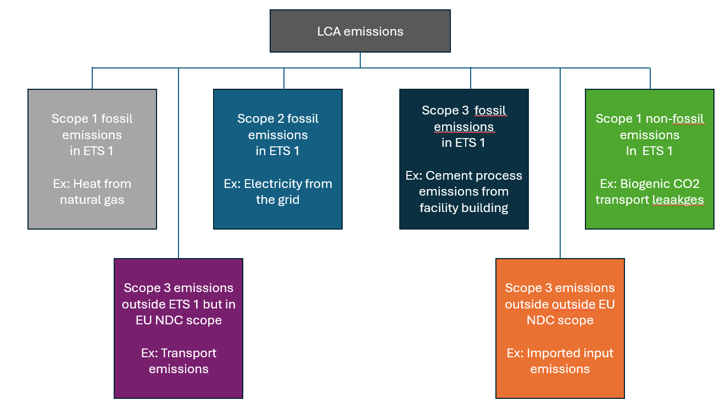
Some of these LCA emissions are subject to surrender obligations under the ETS:
- From the energy use (scope 1 fossil fuel use or scope 2 electricity)
- Scope 3 emissions e.g., emissions from the cement production used in building the facility
- Emissions from CO2 leaks in the transport or at injection of CO2 in geological storage sites.
If one CRCF unit is directly exchanged for one EUA, emissions already covered by the EU ETS (for which an EUA has been purchased and surrendered) would be quantified again in the CRCF calculation and deducted from the amount of carbon removal that can be claimed.
Emissions would be paid for through the ETS and not allowed to be counted towards the CRCF carbon removal quantification, thus decreasing the amount of carbon removal units that can be claimed and increasing the cost of that removal unit. Meanwhile, emissions under the ETS are subject to the cap, so that the emissions taking place to generate removals reduce the space for other emissions in the ETS, leading to a climate neutral impact if they are not accounting in the value of the removal when used in the ETS.
To avoid what can be considered ‘double counting’ of emissions, an exchange rate between removal units and EUAs could be implemented to ensure that the net carbon removals do not include ETS emissions.
Differently from applying a purely gross emissions calculation, this would still include the non-ETS LCA emissions and the baseline emissions if changed from zero as it is currently, which can be considered a fair calculation of the climate benefit of removals. Most of the time, this would mean more than one EUA being issued for one carbon removal unit, since the emissions covered by the ETS would have to be added to the net removal benefit to get the gross removal figure.
In this case, each carbon removal activity certified under CRCF should clearly identify the ETS counted emissions to allow for a simple adjustment. Trading of removals could be considered complex as there wouldn’t be a high degree of transparency on what 1tCO2 of carbon removal is worth in the ETS, because the calculation will be dependent on each project and certification period. Standardised conversion rates could avoid this complexity, but they do not seem suitable as the level of double counting will vary highly from project to project.
The different approaches between the CRCF and ETS is acknowledged in the CRCF methodology for DACCS/BioCCS. The methodology includes a specific reporting requirement to determine the amount of emissions that are covered and allows to identify those that are already within the EU ETS and quantify that on a project activity’s certificate of compliance.EU ETS. This could facilitate the exclusion of ETS emissions from the calculation of net removals and therefore allow a CDR supplier selling their removal units into the ETS to calculate a project-specific exchange rate for conversion of a removal unit into an EUA.
In most cases, the magnitude of this issue is expected to be small. The largest contributor is electricity use, and whilst technologies such as DACCS are electricity intensive, the CRCF methodologies encourage the use of renewable electricity. There could, therefore, potentially be a big difference for a DACCS plant if they are using grid electricity today, although noting that as the grid decarbonises, this difference becomes smaller. However, in an hypothetical scenario where taking the net approach would reduce the amount of removals that can be claimed by around 25% if using grid average electricity for DACCS, the DACCS plant would get 25% more EUAs in the conversion than a DACCS plant using renewable electricity, which could create a negative perception of unfairness and almost a perverse incentive not to use renewable electricity.
While the proposed reporting of emissions that are already covered by the ETS on CRCF certificates could be used to calculate the appropriate exchange rate, this approach would lead to the creation of individual exchange rates for each carbon removal project activity. Furthermore, since the basis for the issuance of certified removal units is periodic re-certification, a re-calculation of the project exchange rate will be required during each re-certification. As a result, exchange rates between removal units and EUAs may even differ for each issuance of removal units from each CDR project activity.
Without a standardised exchange rate, administrative burden will increase, and the functioning of the removals market will be affected as certified removal units from different projects will have a different values in the ETS, depending on the amount of ETS emissions covered. Furthermore, if a conversion factor is applied when removal units enter the ETS, CRCF units could have different values inside the ETS and outside, which adds to the market complexity and perception risk, on top of the un-level playing field for different CRCF uses.
Stakeholders interviewed and respondents to the open consultation questionnaire were rather split on the question of whether to allow gross removals into the ETS (with an exchange rate) or net (one-to-one CRCF unit for an EUA). The main argument for gross removals is to not pay for the same tonne of carbon twice. However other stakeholders argued for net, arguing mainly on the basis of not diluting environmental integrity, avoiding complexity and ensuring consistency with the voluntary carbon market.
Conclusion: The CRCF approach guarantees a net climate benefit as part of its quantification methodology since units issued consider net emissions, with any upstream emissions being deducted from the amount of removals that can be claimed. Therefore, allowing the direct exchange of one CRCF removal unit for one EUA would always be a conservative approach. A one-to-one exchange would also ensure minimum administrative burden and perception risk, regardless of how removals are integrated in the EU ETS. It would also support market functioning since all eligible units would have the same value for the purposes of the EU ETS.
  - Unit differentiation
It is necessary to decide how removal units will be treated under the Union Registry for ETS compliance purposes. The choice of unit impacts among others market design and price formation, as well as practical elements of the operation of registries.
ETSs worldwide differ in their approach to CDR-related units for ETS use. In the New Zealand ETS, CDR suppliers are included within the scope of the ETS and receive allowances that have equal compliance value, but that are distinguishable from other allowances in the market. This allows, among others, for a premium to be paid for removal-backed allowances (e.g. by voluntary buyers). Units from permanent forests, for example, trade at a premium as compared to other allowances. In all other ETSs currently making use of CDR units, CDR projects lie outside the scope of the ETS and receive carbon credits. Such credits are often only usable in the ETS subject to limits and restrictions. Jurisdictions, however, differ in how those carbon credits move within their registries. Under the California Cap-and-Trade Program, for example, carbon credits are issued by approved crediting programs (the Climate Action Reserve and the American Carbon Registry), which list projects and issue ‘registry offset credits’ (ROCs). ROCs are not compliance instruments in the Cap-and-Trade Program. Rather, ROCs must be reviewed and converted by the regulator (the California Air Resources Board) into ‘ARB-issued Compliance Offset Credits’ (often referred to as ARBOCs) to be usable in the Program’s registry (the Compliance Instrument Tracking System Service). ARBOCs are traceable to the original ROC, which is an important feature of the system’s approach to liability: in some situations (e.g. in case of fraud or over-issuance), the regulator may invalidate ARBOCs; if such ARBOCs had been surrendered for compliance, then the ETS regulated entity must replace them with valid compliance instruments. Other systems use different approaches. In Phase 3 of the EU ETS for example, certain units from Kyoto Protocol instruments were accepted but had to be converted into EUAs by the Union Registry before they could be used towards EU ETS compliance obligations. The converted EUAs carried equal compliance value as regular EUAs, and were fully fungible – that is, there were no restrictions on what regulated entities could do with those KP unit-backed EUAs as compared to regular ones.
Decisions on unit use are related to but distinct from decision on whether removal units are generated by the CRCF and/or inside the EU ETS. If units are generated by the CRCF, then a decision must be made on whether these units can be traded and surrendered as such by ETS regulated entities, or whether they should be converted into allowances for use inside the Union Registry. And to the extent that any allowances are generated for removals (e.g. for the conversion of CRCF units, and/or for allowances generated inside the scope of the ETS), then it is necessary to decide whether removal-backed allowances should be distinguishable from conventional allowances. Three broad options seem available:
- CRCF units are traded (and surrendered) as such by ETS covered entities.
- Removal units are converted into (or issued as) removal-backed allowances that are identifiable as a removal, and traceable to the activity that generated it.
- Removal units are converted into (or issued as) allowances that are indistinguishable to market participants from conventional allowances.
In all options, operators could use a unit towards their compliance obligation, albeit potentially subject to limits as discussed in (section 4.4.1. Considerations on CDR limits). We assume that all units would be equally bankable. Design choices on limits and units can interact – for example, unit differentiation can be a requirement if limits on CDR use apply at the moment of unit surrender, or if different limits apply to e.g. different CDR technologies. Here, we assume that CDR limits would be enforced upon the unit entering the Union Registry and would be technology neutral. Unit differentiation can also be a requirement for some permanence and liability provisions in case of reversals. Here, we assume that liability for reversals is addressed through the CCS directive and other CRCF provisions. Moreover, the analysis below suspends judgement on the cost competitiveness of removal units in the EU ETS market.
A key disadvantage of option (a) and, to some extent, (b) is that they would imply that different units can be surrendered for compliance, leading to market fragmentation and increasing complexity. This can have important market dynamics effects by fragmenting the ETS market, affecting among others the market liquidity (especially if multiple prices arise) and hedging complexity for operators. Unit differentiation can also create confusion in the market, especially if there is concern over the relative compliance value of different units. In the past, for example, auctions of fully fungible aviation allowances failed to clear because they were erroneously perceived by market participants as being different. In that regard, option (c) provides the simplest and most straightforward approach from the point of view of market dynamics as well as of regulatory complexity.
An advantage of options (a) and (b) is that they provide the market with information on how the allowance was generated, which can be valuable if, for example, there is a higher willingness to pay for (certain types of) removal-backed allowances. In interviews conducted for this impact assessment, stakeholders primarily supported option (b), in part because there is an expectation that removal units will fetch higher prices than conventional allowances, e.g. where operators choose to pay a premium for removal-backed allowances in order to make (voluntary) carbon neutrality claims. However, the opposite can also apply. Public concern over the quality of removal units could lead to a risk perception by market participants that removal units are or could be less valuable than conventional allowances, especially if there is a concern that the regulator amend rules for the use of removal units in the ETS. Unit differentiation can also enable the regulator to enforce demand-side liability and/or cancel allowances in case of e.g. fraud, as in the case of California.
The UK Government, in its consultations on the potential inclusion of removals in the UK ETS, did not consider option (a). Under option (b), they considered two options: (b1) generic differentiation (b2) differentiation by technology type. 84% of stakeholders in the UK consultation supported differentiation, with most supporting generic differentiation. Moreover, 76% of stakeholders believe that removal-backed allowances would see a price premium compared to conventional allowances. The UK government has concluded that there are important benefits to a generic differentiation of allowances, e.g. from increased transparency and the potential for price discovery. It considers that a generic differentiation provides a balanced approach, achieving the benefits of price discovery and transparency while mitigating potential impacts on liquidity. The UK government also noted that demand for removal-backed allowances over conventional allowances could come from ETS participants looking to meet corporate climate commitments through the purchase of high-integrity removals.
Conclusion: The analysis above portrays a complex picture of advantages and disadvantages. Still, it is preferred to follow option (c) – removal units are converted into (or issued as) allowances that are indistinguishable to market participants from conventional allowances. This avoids market fragmentation and reduces regulatory complexity, at least in the early phases of CDR integration into the EU ETS. This could be reviewed later on as the regulator and market participants gather experience with the use of CDR in the ETS. However, option (c) is most compatible with measures CR4 and CR5, where the regulator can enforce the CDR limit directly. This option is compatible with other measures in case a supply-side limit applies at the point of exchange in the Union Registry, as is assumed to take place, instead of at the time of surrendering. Demand-side limits would likely require unit differentiation to avoid the establishment of ex-ante quotas.
  - Who carries out the conversion in the private sector integration option (CR1-CR3)
If removal units are used for compliance in the EU ETS, and if units flow into the ETS through a operator integration (CR1-CR3), and if removal units are generated through the CRCF outside the ETS, and if the CRCF unit must be converted into an allowance at within the Union Registry, then the next question is who effects the conversion. This can be done by the ETS operator and/or by CDR operators, i.e., the CDR supplier (considerations on conversions by the regulator are covered under the supply side CDR limit, see ‘regulator control’). This wouldn’t affect dynamics on the secondary market, but could affect dynamics in the primary market.
Having ETS operators carry out the conversion has the advantage that the regulator would interact only with operators, without the need to have CDR suppliers engage with the Union Registry. Having more operators engage with conversion could reduce risks of market manipulation by CDR suppliers if CDR supply is concentrated.
Having CDR suppliers carry out the conversion has the advantage that the market is simpler for ETS operators, as they would purchase only EUAs (possibly tagged as removal-backed), remaining within a market with strong financial market safeguards and established controls. This would reduce the administrative burden for operators and eliminate the need for them to trade CRCF units, albeit by transferring part of the administrative burden to CDR suppliers. Depending on whether there are limits on CDR use and how they are applied, this approach could incentivize CDR suppliers to move quickly into converting CRCF units into EUAs as a means of safeguarding part of the ‘space’ under the limit. If the regulator chooses to address the net/gross accounting issue through an exchange rate (see section 4.1 Equivalence between CRCF and EU ETS), having the CDR suppliers make the conversion could facilitate market dynamics as suppliers would know the batch-specific CRCF-to-ETS equivalence ex-ante, removing uncertainty for operators about how many ETS-surrenderable units a CRCF batch yields. Moreover, having fewer counterparties performing conversion could enable a simpler approach to processes within the Union Registry. Finally, this approach could also yield more flexibility for the regulator in applying liability provisions directly to CDR suppliers (e.g. in cases of fraud), beyond CRCF provisions.
It is important to note that the choice of who carries out the conversion interacts with provisions on the enforcement of CDR limits (section 4.4. Consideration on limits) and with the differentiation of units (section 4.2. Unit differentiation). For example, demand-side limits without unit differentiation would require conversion by operators, but demand-side limits with unit differentiation would still be compatible with CDR supplier conversion. Supply-side limits (how many removal units can be into converted) seem compatible with both options.
  - Considerations on CDR limits
As discussed elsewhere in this analysis, CDR limits can be key in safeguarding the integrity of the system, especially in the early phases of CDR integration and also in the later phases when costs may come down. In the open consultation, 42% of respondents agreed or strongly agreed with the statement “The use of CRCF removals by ETS regulated entities should not be unlimited, but subject to restrictions” - several of them citing the need to ensure environmental integrity and market stability, as well as questioning the fungibility between CDR and abatement under the ETS. On the other hand, 28% disagreed or strongly disagreed with the statement, e.g. citing that limits would constrain cost-effective compliance options as well as increase regulatory and demand-side risks for investments. Interestingly, support for the question on limiting gross emissions (“There should be a limit on gross emissions by ETS1 regulated entities (not only net ones))” yielded somewhat different results, with 29% agreeing or strongly agreeing with the statement (often citing that a gross cap must be maintained to ensure real emission reductions) and 37% disagreeing or strongly disagreeing with it.
With the exception of CR2 ‘Unlimited operator integration on top of the cap’, all measures outlined above would see a limit to the flow of removal units into the EU ETS. Several important considerations apply. First, limits must be consistent with other design choices and be enforceable. Second, limits can create uncertainty for both sellers and buyers, in the sense that CDR suppliers and ETS operators may face uncertainty on whether they will be able to claim part of the ‘space’ within the CDR limit. Finally, they can affect market dynamics through their influence on the formation of current and expected future prices. It is important to note, however, that concerns apply mainly to the extent that the CDR limit is or is perceived to be binding, which, given current assumptions, would require significant support to CDR development and deployment outside the ETS to bridge the cost differential between removal units and abatement in the ETS.
CDR limits can be categorized as supply side or demand side.
- Supply-side CDR limits
Supply-side CDR limits control how many removal units can flow into the ETS, without any further regulation on who can make use of those units, or how many removal units each individual operator can use.
One supply-side approach is to have the regulator control the purchase and release of removal units, thereby ensuring adherence to the CDR limit. This is compatible with measures CR4 ‘Public authority integration through regular auctions under the cap’ and CR5 ‘Public authority integration through MSR on top of the cap’. This approach, however, is not consistent with the measures involving integration through operators (CR1 ‘Limited operator integration on top of the cap’ and CR3 ‘Limited operator integration under the cap (one-in-one-out)’. Regulator control has the advantage that uncertainties on the supply side could be mitigated through clear purchasing schedules as well as clear commitments on the balance of purchases across technologies. Rule-based and competitive removal unit purchases can promote transparency for the supply side, and the ability of the regulator to bridge the price differential between CDR costs and EU ETS prices is also a large advantage. Nevertheless, the intermediation by a public authority can introduce market distortions and inefficiencies, e.g. if the regulator can’t adjust to the evolution of CDR technologies sufficiently quickly – which, in turn, requires rules and clarity to enable predictability. On the demand side, regulator control can reduce uncertainties if removal units would be auctioned together with conventional allowances and following the same rules. As removal units would be sold at the same price and at the same time as conventional allowances, price formation there would likely remain largely unchanged as compared to the current situation.
Another supply-side approach is to employ a first come, first served approach. In this approach, the CDR limit would be used up as removal units flow into the system. This approach is in principle compatible with all measures considered here – albeit redundant for measures that involve integration through a public authority (CR4 ‘Public authority integration through regular auctions under the cap’ and CR5 ‘Public authority integration through MSR on top of the cap’). It would be necessary to define when the portion of the CDR limit would be considered to have been ‘used up’ – e.g. when a removal unit moves into the Union Registry, or when it is surrendered for compliance. Using up the limit as units flow into the Union Registry could advantage CDR technologies with higher technological readiness and shorter investment cycles, as those could move quickly to take the space under the CDR limit – albeit primarily if the CDR limit is or is perceived to be binding. Using up the limit as removal units are surrendered for compliance could allow more time for removal units to flow into the system, thereby however also pushing demand-side uncertainties on the available space within the limit towards the end of the timeframe to which the limit applies. Note that these options interact with other design considerations, e.g. unit differentiation.
In principle, a first come, first served CDR supply limit could be set for the whole period or on a yearly basis (a yearly limit could also be either constant or increase over time, e.g. to reflect the likely volume of available removal units in the market). Establishing limits by period could be simpler to implement than yearly ones and provide more flexibility to adjust to the deployment of CDR supply on the ground. The key downside of limits by period is the back-loading of the risk and potential for end-of-period volatility. This could potentially be managed through annual sub-limits that incentivize early surrender, although noting that such sub-limits could increase regulatory complexity.
A key advantage of the first come, first served approach is that it rewards the frontrunners, as they can secure a piece of the limit, which is also when removal units are expected to be less cost-competitive vis-à-vis conventional allowances (although this depends on the interaction with other CDR support instruments).
A key challenge of the first come, first served approach is that it can create uncertainty for both the demand and the supply. Notably, operators (and intermediaries) can engage in forward purchase contracts for removal units but end up not being able to use the units if, by the time they receive the units, the CDR limit has already been used up. As future contracts represent the vast majority of the traded value in the EU ETS, this uncertainty could significantly affect the market. Similarly, CDR suppliers could invest in CDR supply but fail to guarantee a slice of the CDR limit by the time their units are ready to reach the market. Moreover, a first come, first served approach could push smaller players out of the CDR market if large players move quickly to take the allowable CDR volume. Also, intermediaries could engage in speculation by capturing a share of the limit. It is important to note, however, that these concerns apply mainly to the extent that the CDR limit is - or is perceived to be - binding.
In order to address uncertainties for CDR suppliers, and in addition to either of the two options above, the regulator could potentially allocate a portion of the limit on the supply side (that is, to individual CDR suppliers) – thus guaranteeing to them access to the CDR market. For example, the regulator could guarantee a particular CDR supplier that it would be able to sell at least 1000 removal units into the EU ETS, should they become available. It would be necessary for the regulator to devise methods to allocate (a portion of) the limit to those CDR suppliers, perhaps similar to electricity capacity markets, although this would likely mean a significantly higher involvement by a public authority than a pure ‘operator integration’ approach, requiring transparent rules (including allocation criteria) and an ongoing process to fairly and efficiently allocate the portion of the limit to individual CDR suppliers. The development of such a mechanism lies outside the scope of this report and could be subject to high complexity – an initial investigation of options for this report yielded no viable result. Should a viable option be identified, then it may be important to address the risk of CDR under-delivery, as reserving the limit to CDR suppliers that under-deliver could mean that fewer CDR units are available in the EU ETS than originally envisaged. This could potentially be managed through an ‘overbooking’ of CDR supply, which in turn could lead to the limit being overshot if the overbooking is too large – presumably, the regulator could commit itself to purchasing the removal units (e.g. for use outside the EU ETS or in the next ETS period) even if they surpass the EU ETS limits.
- Demand-side CDR limits
Another option is to establish a limit per operator, e.g. by setting a maximum percentage of compliance obligations that can be fulfilled with removal units, as done in the ETSs in e.g. California and Québec. This approach is in principle consistent with all measures considered here. Again, in this case, this approach is redundant with regards to CDR limit enforcement for measures that involve integration through a public authority (CR4 ‘Public authority integration through regular auctions under the cap’ and CR5 ‘Public authority integration through MSR on top of the cap’), but it would provide the regulator the possibility to ensure equal access by operators to the removal units being made available.
Limits per operator would likely facilitate or force the participation of small and medium-sized regulated entities to participate in the CDR market as compared to the first come first served approach, allowing for a fairer distribution of the flexibility across regulated entities – which can be relevant in particular in a smaller market with dwindling liquidity. Establishing limits per operator would also avoid creating the uncertainty to the demand side on whether removal units purchased through forward contracts would be allowable towards compliance obligations. A potential disadvantage of this approach is that a CDR limit of between 175 and 330 Mt for the whole period and for 11000+ operators could be spread too thin to warrant the transaction costs of purchasing removal units, thus potentially leaving part of the ‘space’ awarded by removal units unused. This, however, seems unlikely to be the case; first, because the importance of the CDR market as in terms of unit supply in the EU ETS is expected to increase markedly during the period , such that we expect that small ETS operators also engage in removal unit purchases over time once units become cost competitive.
The volume of allowable CDR use could be set for the whole period and/or on a yearly basis. A limit by period could be simpler to implement than a yearly one, ensure better access to the extra ‘space’ by each operator, and finds precedent in the way international credit entitlements were allocated during phase III of the EU ETS. Limits per operator could also, in theory, be adjusted to reflect judgements on what constitutes ‘hard to abate’ emissions – which, as outlined below, is considered politically unfeasible at this stage. Nevertheless, making such a percentage number explicit could present a significant political challenge if sectors and/or Member States pressure to favour some sectors over others in the access to removal units.
Importantly, the application of a limit per operator is influenced by (a) where units are generated and whether they are differentiated; (b) who does the conversion, (c) when the limit is enforced (e.g. at conversion or at surrender) and (d) on what basis the allowable limit is calculated (e.g. ex ante on the basis of past emissions, ex-post on the basis of compliance obligations, etc). It will be important for the regulator to ensure the package of options is coherent. For example, setting a maximum percentage of compliance obligations that can be fulfilled with removal units would require that units be differentiated, as the limit would be enforced at surrender. If removal units are not differentiated for market participants, then the limit cannot be enforced at the point of surrender, as operators would not be able to tell different units apart. In this case, the application of the limit would have to be carried out upstream, e.g. at the point of conversion of CRCF units into allowances in the Union Registry. This in turn would likely require that the conversion be carried out by the operator, based on a pre-established quota, e.g. on the basis of past emissions as done for Kyoto units in the EU ETS phase III. Defining this pre-established quota, however, would require careful consideration to foster fairness and avoid perverse incentives, and could be subject to extensive political debate.
    - CDR limits if removal units are generated inside the EU ETS
A second key consideration pertains to the compatibility between the way that removal units are generated (whether inside the ETS and/or outside the scope of the ETS, under the CRCF) and the enforcement of CDR limits inside the EU ETS. This interaction will need to be managed, in particular if removal units can be generated inside the EU ETS (e.g. where a BECCS plant is regulated under the EU ETS and can certify removals through its EU ETS MRV process) and where CDR limits are or are expected to be binding. In such a situation, further regulations (such as entity-specific limits for the generation of removal units) must be in place to make sure that limits are enforceable and applied fairly across ETS-covered CDR suppliers. Most stakeholders interviewed strongly preferred a ‘CRCF only’ approach for the certification of removal units.
Under a first come first served approach, a first consideration is one of fairness in processing times and transaction costs – as large differences in the treatment of removals generated inside vs outside the ETS could lead to de facto preferential access to the CDR limit. Avoiding this situation could entail harmonizing rules across the EU ETS and the CRCF, and/or allocating a portion of the limit to individual CDR suppliers as described above. It could also be necessary to establish maximum limits on the volume that CDR suppliers can generate within the ETS – which would likely require provisions for the issuance of other units (e.g. through the CRCF) once ETS limits for CDR have been exhausted. This, however, can lead to significant complexity and uncertainty for CDR suppliers.
Enforcing limits per operator while generating removal units inside the ETS would likely entail high complexity. It would mean that operators would be limited in how many of their ‘own’ removal units they would be allowed to use – with other units sold to the market, but again under maximum limits on the volume that CDR suppliers can generate within the ETS and with accompanying provisions for the issuance of other (e.g. CRCF) units once ETS limits are breached.
In general, allowing for the generation of removal units inside the EU ETS while at the same time imposing limits to CDR use inside the ETS requires the establishment of an internal limit and seems likely to lead to high complexity for CDR suppliers. Such an approach could also be perceived to be unfair towards CDR suppliers if they are subject to the ETS (with what it entails in terms of monitoring and reporting plans and verification), to then allow only a portion of their removal units to be issued as EUAs.
Where the limit is only implicit through the public authority integration and inside generation is only allowed for existing ETS installations to compensate their own emissions, the set-out becomes less complex.
  - Timing and sequencing
The inclusion of CDR into the EU ETS requires a thoughtful timing and sequencing strategy, aimed at optimizing advantages while mitigating potential risks.
On timing, the CRCF Registry is due in 2028. With a buffer of one year for the CRCF Registry to operate, CDR integration into the ETS could start at the earliest in 2030 and would require a testing period for the registries to interface. In addition, the likely timely entry into force of changes needing transposition and adoption of implementing and delegated acts is 1 January 2029 at the earliest. Therefore, integration is proposed for 2031, noting that in the beginning the integration could be largely symbolic due to low volumes.
On sequencing, respondents to the open consultation leaned in favour of a speedy introduction of CDR in the EU ETS, with 38% of respondents disagreeing or strongly disagreeing with the statement ‘The use of CRCF removals by the ETS1 regulated entities should be phased in slowly over time’, mainly citing cost-efficiency, and 29% agreeing or strongly agreeing with it, citing the need to ensure market stability, environmental integrity, and a certain share of emission reductions before allowing offsets. By contrast, the overwhelming recommendation of the literature (see e.g. Burke and Gambhir 2022, Rickels 2022, Sultani 2024, ESABCC 2024, Verbist 2025) favour a gradual rather than immediate full-scale integration process. Gradual integration was also strongly supported by stakeholders in interviews. An incremental approach would enable the EU ETS to evolve alongside advancing CDR technologies and growing comprehension of their implications – inside and outside the ETS. The literature advocates for using early stages to develop comprehensive MRV frameworks (which in the EU’s case has been developed through in the CRCF methodologies) to guarantee fundamental quality standards for CDR credits under consideration.
Once essential quality control is in place - as is the case in the EU - many scholars endorse a progressive development of integration approaches over time. This could begin with more restricted interaction mechanisms, e.g. funding CDR advancement external to the ETS through targeted financing (potentially sourced from ETS revenues); as expertise accumulates and CDR technologies advance in cost-effectiveness, scalability, and environmental performance, the EU could advance with limited inclusion in the EU ETS, e.g. through a public authority and/or the MSR. The end goal of a sequencing strategy, as proposed by e.g. Sultani et al. (2024) and Verbist et al. (2025), could involve a more comprehensively integrated marketplace where high-quality, durable removals become fully interchangeable with EUAs. See Figure 9 for a concrete example, where panel (a) pictures the a sequencing of CDR into the EU ETS (from separated systems to full integration), and panel (b) describes the safeguards that must be fulfilled in order to progress across stages.
- Stage-gate approach with three governance stages of integrating CDR into the EU ETS
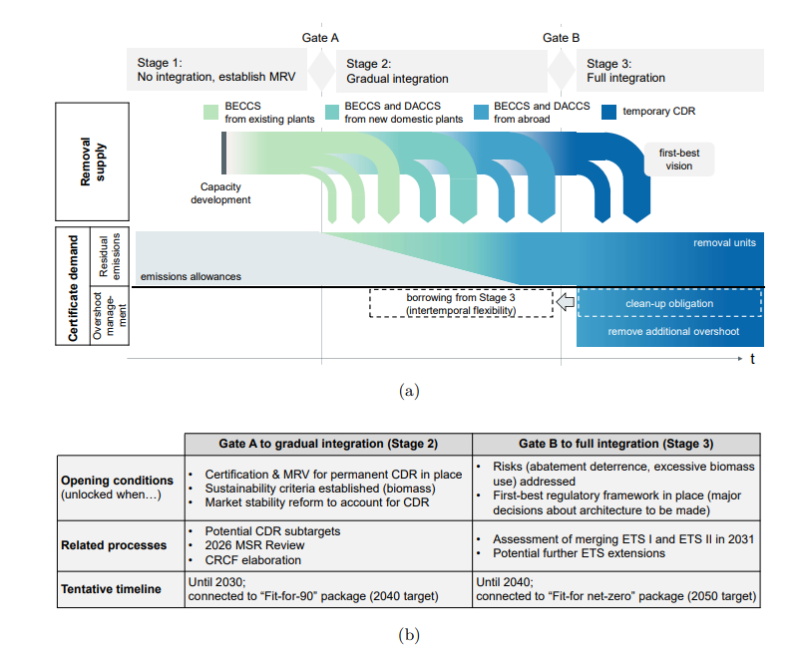
Source: Sultani et al. (2024)
A key element of sequencing thus pertains also to the impact of CDR inclusion on climate ambition in terms of both net and gross emission limits. Under the Danish proposal for CDR inclusion under the EU ETS, for example, the inclusion of CDR would initially see no effect on gross emissions from the ETS. In the UK ETS, the cap was set assuming that CDR would take place in the UK economy, thereby increasing the limits for gross emissions under the UK ETS vis-à-vis a baseline of no CDR in the economy. Generally, the recommendation from the literature is one of conservativeness with regard to CDR inclusion, which seems advisable in particular when it comes to effects to ETS ambition. Accordingly, limits to CDR use in the EU ETS are a key regulatory lever.
A staged implementation approach for incorporating CDR into the EU ETS could therefore start with an integration through public authority (CR4 or CR5) subject to stricter limits to collect information and evaluate governance structures. Advancing toward more extensive operator integration frameworks would ideally follow proven success in these initial phases, clear demonstration of CDR technology advancement (cost, scalability, environmental reliability), comprehensive impact evaluations, and ensuring the system's ability to effectively manage related risks and shocks. Therefore, this impact assessment has only considered measures for the 2031-2040 period as part of the sequencing step after MRV development in the CRCF. Beyond 2040, alternative or complementary mechanisms to the measures considered in this impact assessment, may need to be developed to reach net-zero in 2050 and net-negative emissions thereafter.
  - Purchasing permanent carbon removals
Purchasing permanent carbon removal needs a clear strategy on how and when to purchase this carbon removals. Option CR1, CR2 and CR3 constrain the type of removals to be used in an ETS context but the operator is free to decide on what to buy, among the types of removal allowed for compliance, on the timing of the purchase and to some extent on the contractual arrangements for the purchase of the removals. Options CR4 and CR5 would, on the other hand, require defining the timing and the approach for the purchasing of permanent carbon removals under a public authority.
    - Timing of purchasing
Three main types of contractual agreement can be identified for the timing of removals purchases:
- Pre-purchase agreement: The purchasing programme pays a CDR supplier upfront in exchange for a commitment from the CDR supplier to deliver carbon removal certificates in the future.
- Offtake agreement: The purchasing programme makes a contractual agreement with a CDR supplier, agreeing to buy a specific amount of future CDR credits at a specific price at a specific time in the future, with the payment made on delivery. Offtake contract duration can differ depending on technology and supplier, e.g. Frontier signs offtake agreements with delivery timelines of 2-5 years. Longer-term agreements are also possible, e.g., German industrial emissions reduction contracts offer a related model and have contract durations of up to 15 years.
- Ex-post payments: The purchasing programme purchases CRCF credits once the removals have occurred and have been certified.

These different purchase timings offer different strengths and weaknesses are summarised in the table below.
- Purchase timing strengths and weaknesses
Criteria | Pre-purchase | Offtake | Ex-post Payment
Buyer security (considering risk of non-delivery & underperformance) | Low – Buyer pays upfront; risk of project failure, delay, or supplier overestimation. | Low-medium – Payment only on delivery, but still risk of delay, non-compliance. | High – Payment occurs only after certification of removals.
Bankability for suppliers (provide or enable access to financing for investment) | High – Provides liquidity and upfront capital; enables investment in early-stage facilities. | High – EU-backed contracts are bankable and can be used to secure private financing. | Low – No guaranteed revenue; little support for high-CAPEX or low-TRL suppliers.
Administrative complexity (considering complexity and burden for administrator) | High – Requires careful due diligence, risk mitigation, and potentially complex liability. | Medium – Requires structured contracting and milestone tracking but less upfront financial risk. | Low – Simple transactional process with minimal administrative burden.

Developing the capacity within the EU to deliver a substantial amount of permanent removals will require several years, especially for BioCCS and DACCS. During the first phase of the purchasing program, offtake agreements could offer long lead-time carbon removal approaches the guarantees that investors demand to support the scaling up of permanent carbon removals and the delivery the quantity of removals necessary to achieve EU climate ambition.
Different payment timings can be combined. For example, offtake agreements could be established with a share (e.g. 25%) paid upfront, balancing the suppliers’ needs for funding and liquidity. This ensures that carbon removal suppliers can invest and develop their technologies and infrastructure so that they can deliver carbon removals in the future but poses additional risks of non-delivery for the purchasing programme.
    - Methods for purchasing carbon removals in public integration measures (CR4 and CR5)
Purchasing programmes can carry out their purchases using different approaches, including competitive project-based tendering, reverse auctioning and flat rate price. Each of these approaches can be adapted to meet the different needs of different CDR technologies. The strengths and weaknesses of these purchasing methods are summarised in Table 2.
- Competitive project-based tendering
Individual projects are competing for funding, in exchange for providing carbon removal units at agreed dates in the future. The selection of projects is based not only on the price per tonne removed but also additional criteria. Possible criteria include quality, permanent removal type, as well as broader criteria such as potential for regional development and job creation. Separate tenders can be run for different technologies, in order to ensure a diverse portfolio. Competitive tenders are generally run ex ante, before removals are delivered (or investments confirmed), and are therefore most appropriate for pre-purchase or offtake agreements.
- Reverse auction
The tendering procedure is awarding the removals contracts to the cheapest qualifying bids until the budget is exhausted. Suppliers that meet prequalifying criteria make bids, specifying the volume and price of removals they can provide. Reverse auctions can have open bids, incentivising suppliers to offer lower prices. The procuring authority then selects winning bidders, starting with the lowest price offers until the procuring authorities budget is exhausted (or CDR quantity target has been met). The ‘reverse’ aspect refers to the auctions structure, where multiple sellers compete to sell to a single buyer, rather than the other way around.
Similarly for competitive project-based tendering, it should also be possible to have separate calls for separate technologies under the reverse auction format. If this means that there are few suppliers per technology, the reverse auction may not be an efficient purchase method, as there would be limited competition to drive the price down.
The Swedish BECCS support scheme provides an example of a reverse auction for permanent CDR with the specificity that the scheme does not purchase the full removal but provides subsidies that allows suppliers to also benefit from carbon credit sales on voluntary carbon markets, though this is then factored into the decision of the subsidy that is paid.
- Flat rate price
A flat-rate price involves the purchaser committing to purchase ex post any number of removals that can be delivered at a given, pre-determined price. The available subsidy is awarded on a first-come, first-served basis until the available budget is exhausted. The price per tonne of CO2 set is paid to all suppliers who meet defined quality criteria. It may also be possible to differentiate flat-rate prices between different types of CRCF units, with different rates set for different CRCF activities. Flat-rate prices operate as a price floor for CDR suppliers, increasing revenue certainty and decreasing investment risk.
Similar to a Feed-in-Tariff (FiT), the flat-rate price can be agreed on through a long-term contract, potentially drawing on experiences with procuring renewable energy (e.g. including clause to adjust prices overtime). Denmark has these mechanisms in place for subsidies from its CCS fund.
- Purchase methods: strengths and weaknesses
Design considerations | Competitive project-based tendering | Reverse auction | Flat-rate price
Administrative complexity of the tool (and admin costs) | Medium: complex and time consuming to evaluate proposals | Medium: cheapest offers win the bids but some complexity in designing an effective auction | Low: simple transparent subsidy for removals. Less conflict with state aid and WTO rules
Fiscal burden / cost to the regulator of support | Medium: competitive process but with a financial risk from potential supplier default | Low: risk of financing upfront costs remains with the supplier | High: Misaligned rates could overcompensate suppliers
Ability to differentiate between different types of projects | High: can evaluate based on multiple criteria | Medium: different auction can be set for different types of removal | Medium: different rate can be set for different types of removals
Appropriateness for supporting different technologies | High: Scope to support a range of technologies through selection criteria | Medium-high: possible to have separate calls for separate technologies, but the main selection criterion is cost-effectiveness | Medium-high: possible by specifying rates per technology
To what extent does the method deliver least costs / drive down future costs | High: incentive to provide lowest price in offer | High: incentive to provide lowest price in offer | Low
    - Methods for supporting carbon removal markets when operators purchase removals (CR1-3)
Due to the expected gap between the ETS price and the cost of permanent removals until 2035 (for BioCCS, based on some price estimations until 2038; for DACCS, during the whole phase 2031-2040), options CR1, CR2 and CR3 with the purchasing of carbon removal directly by ETS operators could require a mechanism to support in early stage the development of carbon removal markets, such as carbon contracts for difference (CCfD) and fixed-premium support.
- Carbon Contracts for Difference
Carbon Contracts for Difference is an example of this support. In this model, and in the context of carbon removals, a counterparty (typically a public authority) commits to paying to the carbon removal supplier, the difference between an agreed minimum (strike price) in the future if the reference market price falls below this level over the duration of the contract, de-risking investments in carbon removal activities. A key challenge with CCfDs is establishing the reference price, which requires a functioning carbon removals market to determine it. Different CCfD reference prices could be established for different types of carbon removals.
An important design feature for CCfDs is that when the market price of the removal rises above the strike price, the public authority can potentially be compensated by the supplier (two-way CCfD), e.g. the supplier sells carbon removal credits at the market price but if this is in excess of the strike price, some or all of this difference is paid back to the public authority. This model can provide revenue stability for suppliers, while lowering financial risks for the public authority.
However, Carbon Contracts for Difference (CCfDs) can place financial risk on the public authority when long-term contracts promise a high price for carbon removals, and actual market prices stay low. To manage this risk effectively, it's crucial to have clear budgeting plans and mechanisms to cap potential liabilities.
- Fixed-premium support

Contrary to a CCfD, in a fixed-premium approach, the public authority provides a subsidy that is not impacted by the fluctuation of the market price, reducing uncertainty when budgeting the public support. In this model, the public authority organises an auctioning and carbon removal suppliers bid the lowest subsidy they require in euros per tonne of CO2 removed from the atmosphere. If successful, they receive this premium for up to ten years after the project begins producing certified removals. Payments are made only after the carbon removal has been verified (e.g. certified under CRCF). A similar approach is used by the European Commission to support the development of renewable hydrogen under the Innovation Fund.
To avoid withdrawal of project from winning bids after the auctioning, it is important to mitigate the risk of overly aggressive bid prices that turn out to be unviable at the finalisation of the project.

Annex 8: Part III – Market Stability Reserve

List of Tables
Table 1: Overview of the MSR design in MSR0 and MSR0+ 103
Table 2: Measure MSR2: dynamic parameters decreasing with LRF 4.4% in 2028-2030, 3.4% in 2031-2035 and 2.65% in 2036-2040 for the 90% target configuration) 106
Table 3: Measure MSR3: dynamic parameters decreasing at a yearly rate of 4 % per year 108
Table 4: Summary of the MSR measures definitions 109
Table 5: MSR measures summary dashboard 124
Table 6: Sensitivity analysis – key indicators for system resilience 125
Table 7: Summary of liquidity analysis 126
Table 8: Summary of volatility analysis 127
Table 9: Conduct of business analysis 128
Table 10: Summary assessment of cumulative emissions 2026-2040 130
Table 11: Key impacts of MSR1, MSR2 and MSR3 compared to MSR0+ 130
Table 12: PO summary dashboard 136

List of Figures
Figure 1: MSR since 2017 90
Figure 2: Estimated sources of hedging behaviour to 2030 93
Figure 3: Baseline scenario - EUA indexed price evolution 99
Figure 4: Baseline scenario - TNAC evolution 100
Figure 5: Baseline scenario - EU ETS emissions and cap 100
Figure 6: Measure MSR1: illustration of the parameter adjustments 105
Figure 7: Measure MSR2: illustration of the parameter adjustments 106
Figure 8: Measure MSR3: illustration of the parameter adjustments 108
Figure 9: MSR0 results - Evolution of the TNAC and MSR thresholds 112
Figure 10: MSR0 results - MSR operations 113
Figure 11: MSR0 results – Stock of EUAs in the MSR (January 1st) & invalidations 113
Figure 12: MSR0 results – EUA indexed price evolution 114
Figure 13: MSR0 results - EU ETS emissions 114
Figure 14: MSR0 results - TNAC-to-Emissions ratio 115
Figure 15: MSR0+ results - Evolution of the TNAC and MSR thresholds 116
Figure 16: MSR0+ results - MSR operations and invalidations 117
Figure 17: MSR0+ results – stock of EUAs in the MSR (January 1st) 117
Figure 18: MSR0+ results – EUA indexed price evolution 118
Figure 19: MSR0+ results - EU ETS emissions 119
Figure 20: MSR1 results - Evolution of the TNAC and MSR thresholds 120
Figure 21: MSR2 results - Evolution of the TNAC and MSR thresholds 121
Figure 22: MSR3 results - Evolution of the TNAC and MSR thresholds 121
Figure 23: MSR1-to-MSR3 results - MSR operations 122
Figure 24: MSR1-to-MSR3 results - stock of EUAs in the MSR (January 1st) 122
Figure 25: SR1-to-MSR3 results – EUA indexed price evolution 123
Figure 26: MSR1-to-MSR3 results - TNAC-to-Emissions ratio 124
Figure 27: PO1 results - Evolution of the TNAC and MSR thresholds 132
Figure 28: PO2 & PO3 results - Evolution of the TNAC and MSR thresholds 133
Figure 29: Policy options results - Evolution of MSR operations 133
Figure 30: Policy options results - stock of EUAs in the MSR (January 1st) 134
Figure 31: Policy options results – EUA indexed price evolution 135
Figure 32: Policy options results - TNAC-to-Emissions ratio 136
Figure 33: MSR operations and reserve volume for calculated and official TNAC 139
Figure 34: S1 shock definition - Additional exogenous net supply-demand balance 141
Figure 35: S2 shock definition - Additional exogenous net supply-demand balance 142
Figure 36: S3 shock definition - Additional net supply-demand balance 143
Figure 37: S4 and S5 shock definition - Additional net supply-demand balance 144
Figure 38: MSR sensitivity analysis - S1 & S2 - TNAC evolution for MSR1 (left) and MSR3 (right) 145
Figure 39: MSR sensitivity analysis - S1 & S2 – stock of EUAs in the reserve for MSR1 (left) and MSR3 (right) 145
Figure 40: MSR sensitivity analysis - S1 & S2 – EUA indexed price for MSR1 (left) and MSR3 (right) 146
Figure 41: MSR sensitivity analysis - S1 & S2 – EU ETS emissions for MSR1 (left) and MSR3 (right) 147
Figure 42: MSR sensitivity analysis – S3 to S5 - TNAC evolution for MSR1 (left) and MSR3 (right) 148
Figure 43: MSR sensitivity analysis - S3 to S5 – stock of EUAs in the MSR for MSR1 (left) and MSR3 (right) 148
Figure 44: MSR sensitivity analysis – S3 to S5 – EUA indexed price for MSR1 (left) and MSR3 (right) 149
Figure 45: MSR sensitivity analysis – S3 to S5 – EU ETS emissions for MSR1 (left) and MSR3 (right) 149
Figure 46: MSR sensitivity analysis – TNAC-to-emissions ratio, maximum spread across S1-S5 – MSR1 (left) and MSR3 (right) 150

- Overview of the Market Stability Reserve (MSR)
  - Introduction and overview
The Market Stability Reserve (MSR) was established in 2015 by Decision (EU) 2015/1814 of the European Parliament and of the Council (‘the MSR Decision’), as a structural mechanism within the EU ETS to address critical imbalances in the carbon market. Specifically, the MSR was designed with two primary objectives: first, to reduce the historical surplus of allowances that had suppressed carbon prices and weakened investment signals for low-carbon technologies; and second, to enhance the resilience of the EU ETS by introducing supply-side flexibility to respond to future demand shocks. Its design was revised in 2018, before becoming operational in 2019, and again in 2023 to align with the European Green Deal and stricter climate targets under the European Climate Law. The current annex is focusing on the next review of the MSR which is due in 2026, pursuant to Article 3 of the MSR Decision.
Under its original design in 2015, the MSR dynamically adjusted the supply of allowances in response to market conditions, using the Total Number of Allowances in Circulation (TNAC) as a key indicator. In broad terms, the TNAC in a given year, is calculated as the cumulative number of allowances issued and not placed in the reserve minus the cumulative tonnes of verified emissions, since 2008 and the end of that given year. When the TNAC exceeded an upper threshold of 833 million, the MSR withdrew 12% of the surplus annually from auction volumes and placed these allowances into the reserve. Conversely, if the TNAC were below a lower threshold of 400 million, the MSR released 100 million allowances per year from the reserve back into the market. These thresholds and intake rates provided a predictable, rule-based, and transparent framework for supply adjustments in the EU ETS. In practice, by 1 June every year (y), the Commission calculates and publishes the TNAC of the previous year (y-1), which can trigger MSR action in the form of intakes or releases of allowances spread over a period of 12 months, from September y to August y+1.
By 2018, it became clear that the MSR’s original design was insufficient to address the persistent surplus of allowances that had accumulated due to the financial crisis, complementary policies, and the inflow of international credits. This surplus continued to depress carbon prices and delay low-carbon investments. To strengthen its impact, the 2018 revision doubled the intake rate from 12% to 24% of the TNAC until 2023 and introduced a mechanism to permanently invalidate allowances held in the reserve above the previous year’s auction volume. These changes aimed to accelerate the reduction of the surplus and ensure the MSR could more effectively stabilise the market and support the EU's climate goals. With the first intakes starting in January 2019 based on the revised rules, the calculated values for TNAC declined from about 1694 million allowances in 2016 to about 1112 million in 2023. Moreover, about 2515 million allowances were invalidated at the beginning of 2023 (see Figure 1).
In 2023, the MSR was further revised to ensure it remains a robust tool for stabilising the EU carbon market and supporting the Union’s enhanced climate targets of the European Climate Law. The intake rate of 24% was maintained (instead of declining to 12% from 2024), reflecting the continued need for a swift decline in the surplus of allowances. To address the ‘threshold effect,’ where small changes in the TNAC can trigger disproportionately large MSR intakes, an upper buffer was introduced so that if TNAC is between 1096 million and the 833 million the MSR intake is calculated as TNAC-833 million, rather than 24% of TNAC which applies when TNAC is greater than 1096 million.
To reduce uncertainty and complexity, the invalidation threshold was fixed at 400 million allowances removing the dependence of this threshold on previous year’s auction volumes. Additionally, the calculation of the TNAC was simplified, and starting with the 2024 TNAC calculation, the supply and demand for allowances from the aviation sector is also incorporated to better reflect market dynamics. In the first year of reporting following the revision, the calculated value of TNAC remained stable at 1148 million in 2024. At the start of 2024 and 2025, 382 million and 271 million allowances were invalidated, respectively, bringing the cumulative number of permanently invalidated allowances to 3167 million at the beginning of 2025.
  - Conclusions of the evaluation and future challenges for the operations of the MSR.
In the current evaluation of the MSR and the EU ETS design, the Commission assessed the effectiveness of the MRS between 2018 to 2024 through two main specific objectives: (i) to reduce allowances surplus in the market built up over Phases II and III and (ii) mitigate the build-up of new demand-supply imbalances in order to strengthen the resilience of the EU ETS. The Commission concluded that the MSR has successfully achieved its first specific objective of reducing the historical surplus in the allowance market.
However, while the MSR helped curb the emergence of new imbalance from 2013 onward, it did not fully absorb the surplus of allowances. As a result, a demand-supply imbalances still exists, meaning it partly achieved its second objective of strengthening the future resilience of the EU ETS market. Moreover, the evaluation concluded that MSR has proven to be efficient with large benefits only a few direct costs. Finally, the evaluation concluded that the MSR has been largely coherent with complementary policies, with any counterintuitive actions being effectively addressed.
Based on the evaluation, this Impact Assessment does not suggest a complete redesign but rather proposes targeted refinements to ensure that the MSR remains fit for the future. Crucially, these refinements preserve the MSR’s core principle: across all policy options considered in this Annex, the MSR must remain a rule-based and transparent framework for supply adjustments in the EU ETS. This applies to intake and release rates, which should remain governed by pre-defined rules rather than discretionary, price-based interventions or political interference. Maintaining this rule-based approach helps avoid market distortions and ensures that market participants can anticipate how the system will respond, including where uncertainties may interact or combine. This, in turn, helps safeguard the credibility of the carbon price signal and the certainty needed to underpin long-term decarbonisation investments.
- MSR since 2017
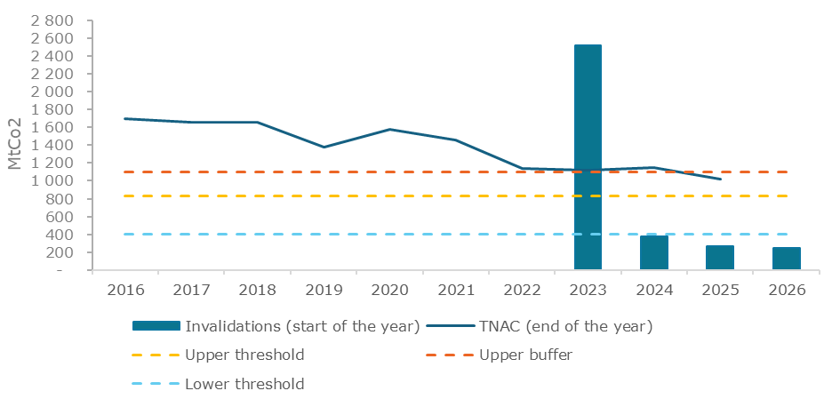
Source: Own illustration
  - Challenges for the future operations of the MSR.
Despite the reassuring conclusions of the effectiveness and efficiency of the MSR, there are several challenges for the future operations of the MSR. The EU ETS and MSR are currently undergoing a significant change, moving from a period of allowances surplus to a tighter market where allowances are becoming increasingly scarcer over time. This shift is driven by not only the current cap design, which rapidly declines the number of allowances in circulation, but also due to the current invalidation mechanism in place, which gradually decreases the volume of allowances held in the MSR over time as the need for releases arises. As a result, as the market becomes tighter, inefficiencies may become more pronounced and could lead to the following risks:
- Increased in price volatility: when fewer allowances are available, a small number of large market participants may be able to influence the market prices. These players may adopt strategic behaviour, such as buying and holding allowances to build inventory reserves or speculate on future price increases. As a result, this reduces even further the number of allowances actively circulating in the market, constraining liquidity and likely increasing price volatility.
- Higher bid-ask spreads: tighter markets naturally lead to wider bid-ask spreads. With limited allowances available for trading, sellers demand higher premiums to reflect greater uncertainty about future availability. This in turn results in a higher effective transaction cost for market participants.
- Less price transparency: in tighter markets, trading activity tends to shift away from transparent public exchanges to more transactions bilaterally, where prices, volumes and terms are not publicly disclosed. This contrast with on-venue transactions which operations tend to be more transparent, creating a clear, real-time price signal for the entire market.
Given the significant changes in the allowances market under the current design, the MSR faces a new set of challenges that necessitate revision. First, the key parameters of the MSR were set a long time ago and are fixed against a backdrop of a cap and emissions that declined rapidly since then. This is likely to create an unbalanced system.
Second, the composition and nature of allowance demand are shifting significantly. The power sector, whose allowance demand is relatively well-understood, has decarbonised rapidly, leading to a declining share in overall demand. This trend is set to continue. In contrast, the share of emissions from the industrial sector is growing, yet its allowance demand patterns remain rather opaque. Similarly, maritime transport has only recently entered the system, and international aviation and waste may soon follow, adding further complexity to market dynamics.
Third, the growing share of non-compliance entities as active participants in EU carbon markets introduces another layer of complexity. The allowance trading by these entities improves liquidity in the market, act as financial intermediaries for smaller compliance entities and provide financial derivative products that the compliance entities value. The European Securities and Markets Authority (ESMA) has been tasked to monitor the activities of financial entities to ensure highest level of market integrity and transparency and avoid any risks of abuse of market power that could potentially affect market stability. From a broader perspective, the likely integration of removals in the EU ETS, as well as the phase-in of CBAM and the phase-out of free allocations further reshape the market, while the 2040 climate target has important implications for the ETS contribution to decarbonisation efforts beyond 2030, reinforcing the need for a robust MSR. Recent studies highlight the benefits from a more dynamic, adaptive and simpler MSR to safeguard market stability, recognizing the limits of the instrument’s effectiveness in responding to higher frequency volatility in the allowance market. A forward-looking approach to revising the MSR is essential to address these emerging complexities.
- Parameters of the Market Stability Reserve
To establish a strong and rigorous foundation for revising the MSR and its parameters, a scoping exercise employing multiple methods was undertaken to guide the formulation of alternative measures systematically. The approach began with desk research and literature review, drawing upon recent academic studies, policy analyses, and technical reports on MSR performance with a focus on identifying emerging challenges and limitations of the existing MSR setup particularly in the post-2030 timeframe. This analytical foundation was supplemented by insights from the MSR Evaluation which has been part of a back-to-back exercise together with this Impact Assessment.
Additionally, targeted interviews were conducted with stakeholders from power, energy, industry, maritime and aviation sectors; financial actors; academic experts; public sector stakeholders; and civil society. Combined with input from the open public consultation (‘OPC’) on the ETS and MSR evaluation and review, the interviews aimed to capture the diverse perspectives and experiences on MSR functioning and gather insights on the evolving market landscape that may not yet be fully reflected in published academic and grey literature. This multipronged approach ensured that the formulation of alternative measures was grounded in both theoretical and empirical evidence as well as practical experience of market participants and analysts, providing a solid foundation for identifying the parameters requiring revision, developing approaches for their improvement, and formulating concrete policy measures to enhance the functioning of the MSR.
The MSR operates through seven key parameters that collectively determine the mechanism’s response to market conditions. Each parameter not only serves a specific function in the mechanism's operation but also interacts with other parameters in determining the response of the MSR to market developments. However, their current calibration reflects market conditions and policy priorities that may no longer be appropriate for the emerging challenges facing the EU ETS. Sections 2.1 to 2.5 briefly describe each parameter based on qualitative research and analysis as well as the stakeholder perspectives on whether they need to be revised to improve MSR functioning.
As regards the broader question of the role of the MSR going forward, the top priorities for most respondents to the OPC, mainly from companies/businesses and business associations, were to prevent excessive EU ETS price volatility (38% of respondents) and to increase market liquidity (26% of respondents), noting that multiple answers were possible by allowing respondents to elaborate on their selection. The third answer, supported mostly by NGOs and environmental organisations, was a continued use of the MSR as a tool to address the surplus in the market (18% of respondents). 6 respondents (2%) selected “None of the above” and 47 respondents (18%) were unsure. Going forward, there
  - Upper threshold and upper buffer
The upper threshold of 833 million represents the level above which the MSR begins withdrawing allowances from auction volumes, as TNAC values above this threshold indicate a high surplus in the allowance market (i.e. more liquidity in the market than is consistent with a healthy supply-demand balance). The value of the threshold was originally set based on the typical hedging needs of regulated entities in the early 2010s, particularly those in the power sector who sell their output forward and may choose to hedge their future liabilities by holding allowances beyond their immediate compliance needs.
This threshold, therefore, may no longer reflect a healthy balance between allowance supply and demand as the composition and nature of allowance demand change, as there will be increasing scarcity of allowances and as the climate policy landscape evolves. The 2021 MSR Review, recent academic assessments and reviews, as well as the recent horizon scanning exercise commissioned by the European Commission, all suggest that it may be time to recalibrate the value of this parameter. A recalibration can ensure that its value does not become misaligned as the cap and emissions decline according to the cap-and-trade logic combined with the ambitious EU climate targets.
When the MSR was legislated in 2015, co-legislators anchored its activation to the TNAC, using a band with an upper threshold (833 million) that would trigger intakes from auctions to the MSR, and a lower threshold (400 million) that could trigger releases from the MSR to the auctions. The original impact assessment carried out by the by the European Commission to inform the MSR design, set out the principles for the mechanism as follows. The trigger should be quantity-based, objective, and linked to a stock measure of market surplus, so that auction volumes reduced when the surplus is too high and increase when it is too low. The European Commission (2014) assessed alternative trigger concepts and sizes and concluded that fixed TNAC thresholds offered a transparent and rule-based way to respond to shocks without discretionary intervention, coupling those thresholds with intake and release rates sized to have a material effect on auction volumes. While the lower threshold was specified to anticipate future releases and maintain symmetry, at the time the most immediate task of the MSR was to reduce the historical surplus that had accumulated, and most attention was therefore focused on the specification of the upper threshold.
The 2021 MSR review’s supporting analysis of industrial hedging suggests that, unlike the power sector, industrial hedging is more heterogeneous across subsectors, driven by differing exposure to international competition, pass‑through abilities, and contract structures.
Quantitatively, Appendix 2 of the 2021 MSR review indicates that plausible ranges of industrial hedging could amount to a few hundred million allowances at most when aggregated EU‑wide over typical horizons, but with substantial uncertainty bands (see figure 2 reproduced from the review). In the figure, total hedging demand declines steadily toward 2030, with the power sector driving most of the reduction. Industry contributes a smaller, slightly increasing but uncertain portion, and aviation is smaller still but exhibits even greater uncertainty than industry.
- Estimated sources of hedging behaviour to 2030
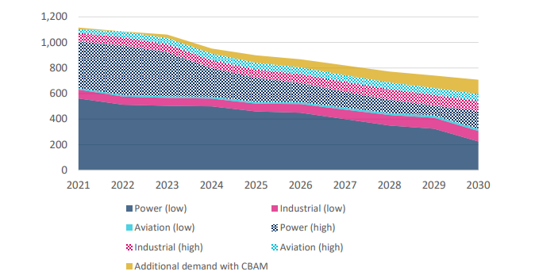
Source: European Commission (2021)
European Commission (2025), which surveys emerging challenges for the EU ETS, reinforces these findings. As aggregate hedging needs trend down and become more heterogeneous, a materially tighter cap and a changing market composition further increase the need to recalibrate the MSR’s upper threshold. Specifically, the cap rebasing in 2024 and 2026 and higher LRF shrink auction supply and overall market size, so that a given level of allowances in circulation accounts for a larger share of the market than before and, in turn, has a stronger influence on prices and liquidity.
Aviation within the EEA has been covered since 2012 but any future changes could concern a broader set of international aviation emissions being included in the EU ETS. The inclusion of maritime transport has been underway since 2024, increasing gross compliance demand and altering its pattern. Any further scope extensions would further reshape the composition and timing of allowance demand and associated hedging.
Non‑compliance entities (primarily financial actors) play a growing role in the EU ETS. They provide liquidity, enable forward hedging, and warehouse allowances, helping compliance entities manage risk. Their market participation also makes TNAC harder to read. Higher holdings can reflect liquidity provision and forward‑looking banking rather than an excessive surplus. In a tightening market, both the 2021 MSR review and European Commission (2025) note that TNAC can rise without indicating “excess.” If the upper threshold is too high or static, MSR action may be delayed.
Stakeholder interviews conducted for the current review also indicate that hedging behaviour is evolving as the market tightens and its composition may shift over time. Some stakeholders underscore that risk management covers pans both derivatives and physical banking, while available datasets (e.g., Union Registry, Commitments of Traders report) only partially reveal hedging volumes because intermediation obscures holdings.
Likewise, in the OPC, the second most frequently raised potential change to the MSR, mainly by businesses, was to make intake/release thresholds dynamic to reflect prevailing market conditions (15% of responses), while 7% of responses, largely from NGOs, supported adjusting fixed TNAC thresholds downward and 3% of responses, all businesses, upward.
The upper buffer is the newest feature of the MSR. It was introduced in 2023 and came into operation in 2024. It aims to mitigate the so-called threshold effect, whereby small changes in TNAC, just above the trigger, could trigger disproportionately large MSR responses. The upper buffer is currently set at 1096 million allowances but should in fact be seen as a function of the upper threshold and the intake rate, calculated as 'upper threshold / (1 – intake rate)'. The upper buffer creates a graduated intake mechanism: when TNAC is in the buffer zone defined by the upper buffer of 1096 million and the upper threshold of 833 million, intakes are calculated as the difference between TNAC and the upper threshold, rather than the standard percentage-based approach using the intake rate. It has not been applied as of 2025, as the 2024 TNAC remained slightly above the upper buffer.
While the introduction of the upper buffer addresses the concerns about undue market volatility due to the threshold effect, the specific parameter value will need to be reset if values of the upper threshold and intake rate change. This is because the current buffer zone of 1096-to-833 million is constructed to ensure that intake volumes decline smoothly towards zero as TNAC declines towards the upper threshold currently set at 833 million.
Stakeholders generally view the introduction of the upper buffer zone positively. Although it has not yet been activated, its presence reduces uncertainty arising from threshold effects. The OPC responses were not directly relevant to the upper buffer, but rather emphasised threshold effects and symmetry. In the design-change question, 5% of respondents proposed adding a buffer also on the release side to avoid threshold effects. This could be considered consistent with maintaining graduated intake around the trigger.
  - Intake rate
The intake rate determines the speed at which allowances are withdrawn when TNAC exceeds the upper threshold. Until the 2023 revision, the rate had been on course to decline to 12% in 2024 but instead was maintained at 24% of TNAC (and applied only when TNAC is greater than the upper buffer discussed above). Absent further revisions, the intake rate will remain fixed at 24% until 2030 and revert to 12% thereafter. Given that the intake rate implicitly determines the width of the upper buffer zone, the reversion to 12% implied by the current legislation would require the upper buffer to be reset to 947 million after 2030 from its currently legislated value of 1096 million.
The intake rate is not a fixed number of allowances but a fixed share of TNAC. This means that the volume of intakes changes in proportion to the TNAC and does not suffer from the potential misalignment mentioned in the context of the upper threshold. At the same time, it is useful to consider whether an amendment to the current arrangement is helpful. By adjusting the rate at which excess surplus is reduced and width of the upper buffer zone, the intake rate has important and complex implications for the auction volumes and the volume of allowances in the MSR, holding all else constant. However, these implications are only realised if TNAC is above the upper threshold. Moreover, it is difficult to gauge the extent to which the expectations of the market participants reflect the already legislated decline from 24% to 12% in 2030.
European Commission (2014) assessed establishing an MSR featuring a percentage‑based intake linked to the TNAC and analysed alternative trigger levels, intake sizes, and timing, in order to ensure adjustments would be sufficiently material to address surplus while avoiding excessive volatility. The 2021 MSR Review advised retaining a rule-based intake but reforming its operation to scale with the marginal surplus above the upper threshold, recommending that intakes remove roughly one third to one half of the marginal surplus in each intake period. European Commission (2025) notes that the co-legislators prolonged the increased annual MSR intake rate of 24% beyond 2023 and highlights that, as the cap tightens and hedging demand evolves, future calibration of MSR parameters should be considered to ensure responsiveness in a structurally scarcer market.
Stakeholder interviews conducted as part of this impact assessment indicate mixed opinions with some stakeholders favouring to maintaining the intake rate, at 24% for continuity and predictability, while others are open to amendments regarding how the rate is applied to improve responsiveness. Those favouring to maintain the intake rate at 24% consider that it provides reassurance that if a large excess surplus accumulates once again in the future, it will be removed rapidly. It should also be noted that the intake rate becomes a less relevant parameter over time, as the EU ETS moves from a period of surplus, where high intake rates allow for a fast reduction of the surplus to a period of market tightness where the MSR will start to release allowances to provide additional liquidity to the market.
In the OPC, respondents were overall more focused on adjustments to other parameters, with only a limited number of responses related to the intake rate. Overall, the OPC points to retaining a rule based intake and concentrating any revisions on threshold calibration and the timing of adjustments rather than altering the intake rate.
  - Lower threshold
When TNAC falls below the lower threshold of 400 million allowances, the release of allowances from the MSR back into the market is triggered. This parameter aims to prevent the emergence of a shortage (i.e. less liquidity in the market than is consistent with a healthy supply-demand balance) that could undermine efficient price formation and preclude the realisation of mutually beneficial allowance trades. As the composition and nature of allowance demand evolve and the market landscape changes with new sectors, participants, and rules, this threshold may require adjustment to maintain appropriate liquidity buffers.
Moreover, like the upper threshold, the notion of a healthy supply-demand balance also depends on the size of the market, which in turn is determined by rapidly declining annual caps and emissions of covered sectors. Therefore, keeping the lower threshold fixed at 400 million may imply that that in the future the MSR is called into action even when there is no shortage in the allowance market. Therefore, a dyn
amic and declining lower threshold can be considered in a manner similar to and consistent with the approach taken for the upper threshold. Another important consideration regarding the lower threshold is the potential emergence of destabilising threshold effects in the future, as in the case of the upper threshold and buffer discussed above.
Stakeholder interviews conducted for the review emphasise aligning the lower threshold with the logic applied to the upper threshold as the market shrinks and structural scarcity emerges. Interviewees propose that the lower threshold should decline over time to remain proportionate to market size and consistent with a healthy supply-demand balance.
  - Release rates (general and Article 29a)
The release rate of 100 million allowances per year governs the speed at which the MSR responds to shortages. While this rate was designed to provide liquidity relief by guiding the TNAC back towards a healthy supply-demand balance, there are three potential issues.
First, the release of 100 million allowances may become excessive relative to the declining overall market size. Second, the release of allowances may arrive too late to address demand changes particularly in a potentially more volatile post-2030 market environment. Third, the releases from the reserve are limited by the number of allowances in the MSR which are currently fixed at 400 million. Consequently, under the status quo MSR will be empty after at most four instances of TNAC being below the lower threshold or less if Article 29a release is also triggered at some point in the future. This is because there is currently no provision for replenishing the MSR.
The OPC did not contain questions directly related to the fixed release rate of 75 million allowances per year. The responses rather point to adjacent design elements that affect releases.
Article 29a of the EU ETS Directive outlines a mechanism for releasing allowances from the MSR when the carbon price increases rapidly or is subject to important price fluctuations. This release is triggered if the average price of allowances over a six-month period exceeds 2.4 times the average price of the preceding two years, provided no allowances are simultaneously being released due to TNAC being below 400 million. When triggered, 75 million allowances are released from the MSR and added to the quantity to be auctioned, unless the reserve holds fewer than 75 million allowances, in which case the entire amount is released. This release occurs gradually over three months, starting no later than two months after the Commission confirms the price trigger condition, and follows the same allocation among Member States as when the allowances were initially placed in the reserve.
The release volume being fixed may provide certainty and predictability to the market participants when the mechanism is triggered. At the same time, as the cap and allowance supply decline, the effects of the fixed volume become greater. Therefore, it could be argued that, in order to maintain the existing effect of article 29a when cap and supply decline, the fixed volume may need to be amended/reduced to avoid that too many allowances are released (overshooting, the intended correction) given the overall lower volumes. On the other hand, maintaining the current release rate, at least until the next review in 2031, could be justified by the fact that this mechanism is aimed at addressing exceptional circumstances of excessively high price movements, so the mechanism would need to be effective enough to tackle such situations.
A very large majority of stakeholders which expressed views on the EU ETS and the MSR through the OPC and position papers did not express a specific position on the Article 29a release mechanism, suggesting low or no need for a revision. The OPC did not contain questions directly related to Article 29a and as a result, direct references to Article 29a in the OPC results were limited.
  - Invalidation threshold
The invalidation threshold, fixed at 400 million allowances since 2023, determines the maximum number of allowances that can be held in the MSR. Permanent invalidation is a critical element of the MSR design as it influences the cumulative cap and auction revenues. This mechanism ensures that the MSR does not become an indefinite storage facility of an ever-growing number of allowances and establishes a fixed upper bound on the number of allowances that can be released to achieve the MSR’s objectives. However, the fixed nature of this threshold may not align optimally with evolving market needs, the declining cap trajectory, hence future scarcity of allowances. As outlined above, the invalidation mechanism directly interacts with the release rate to determine the maximum duration the MSR can provide future market interventions. Increasing the invalidation threshold or removing it altogether, all else constant, would allow for a bigger pool of allowances in the reserve and provide more flexibility in case of future liquidity problems. Given that it is projected that it there are only a few years of future intakes by the MSR in the period 2027-2028 that may be subject to invalidation, it is recommended that any changes to the invalidation mechanism are implemented in the short term to maximise the impact of preserving allowances in the MSR for future release beyond 2030.
The evaluation of the MSR finds that the invalidation mechanism has successfully fulfilled its original purpose of eliminating the historical surplus of allowances that accumulated in the early years of the EU ETS, thereby restoring confidence in the system and supporting a robust carbon price signal. Given the evolving market context, a case can be made for discontinuing the invalidation mechanism entirely because future invalidations may be counterproductive to evolving market stability needs. Allowing a greater number of allowances to remain in the MSR rather than invalidating them could provide an essential liquidity buffer for managing future market tightness in the mid-2030s and beyond.
The potential integration of carbon removals into the EU ETS further complicates the calculus around the invalidation mechanism. Maintaining a greater number of allowances as a strategic reserve could provide a more reliable backstop for market interventions than relying solely on uncertain removal deliveries. This approach would allow the MSR to serve as a stabilizing force during potential supply shortages in the late 2030s and early 2040s, when allowance scarcity may otherwise drive sharp price increases that could undermine market functioning and investment predictability.
Perspectives of stakeholders interviewed regarding the invalidation mechanism reveal disagreements about its continued relevance and implementation.
Likewise, in the OPC, the potential change to the MSR most frequently raised, in close to a quarter of responses, mainly by businesses, was to adjust the invalidation rule for holdings in the reserve above 400 million.
  - Market Stability Reserve revision scope
The accumulated evidence from recent academic as well as stakeholder outreach indicates potential benefits from revising the MSR to enhance its effectiveness in the evolving market landscape. However, the question on the extent of these revisions requires careful consideration of the trade-offs between preserving the MSR's proven track record and adapting it to fundamentally different market conditions and challenges.
Different conceptions of MSR revision can be organised along a spectrum from operational to fundamental changes, though this distinction represents a continuum rather than discrete categories. Moving towards the more fundamental end are novel innovations that would transform the MSR's core function. An important consideration in this context is the need for simplification and continuity. Therefore, the next section develops the measures which span this spectrum focusing on the operational end.
- Policy measures for the Market Stability Reserve
This section describes the specific measures assessed for the current review, to study the various MSR changes that may be implemented and become effective from 2028, i.e. the first realistic date by which the EU legislative process can reasonably be expected to conclude. The measures MSR1 to MSR3 presented below span the operational end of the reform spectrum introduced in the previous section. The impact of these measures must be assessed against two counterfactual scenarios MSR0 and MSR0+ which are motivated and described below.
  - Description of measures
    - Baseline
The baseline scenario for the current Impact Assessment forms the main reference point for the policy option-level analysis undertaken in this report. It represents a legal default configuration, strictly respecting the current legislation, in which the MSR parameters remain unchanged compared to today (a detailed definition is provided in the main impact assessment report). However, the currently legislated cap trajectory and MSR design could lead to a vastly over-constrained system in the 2030s. This baseline is therefore not well suited to be used as a starting point in the MSR measure-level analysis.
To demonstrate this, the baseline scenario was simulated using the POLES-Enerdata model, which calculates the EUA price evolution, based on a supply-demand equilibrium. Indexed price curves are presented to illustrate overall annual price trends compared to 2028. Such illustrations require careful interpretation as modelling relies on uncertain assumptions and may not capture actual short term price movements, which can be driven by other factors outside the scope of this assessment. The indexes are therefore used to show trends - such as relative annual price increases and directional movements - and to serve as a comparison framework across measures, rather than to deliver precise price forecasts. This approach applies to all measures modelled in Annex 8.
As shown on Figure 3 below, baseline scenario exhibits a modest price increase until 2030, followed by a steeper rise in 2035 and a significant price spike in 2040.
- Baseline scenario - EUA indexed price evolution
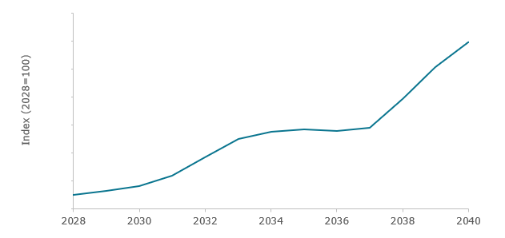
Source: POLES-Enerdata model run - baseline scenario
The TNAC evolution shows a counter-intuitive trajectory in this baseline, with a phase of slow increase between 2030 and 2036, before starting to significantly decrease. With a high constraint on the market, and with such a price, the expectations would be for the TNAC to drop more quickly. This does not happen because, in the POLES-Enerdata model, actors have an 8-year anticipation period, which forces them to plan for the future scarcity at all times. The increasing TNAC up to 2036 is therefore explained by actors anticipating that future scarcity will be harder to face than current scarcity, meaning that they prefer to decarbonise in the early future and save EUAs on their registry accounts for later use. This TNAC trajectory shows the limits of the current design, when combined with the 8-year anticipation of the modelling framework. The TNAC indicator remains high despite the general scarcity of allowances, because forward-looking actors are assumed to hoard allowances rather than surrender them. This in turn results in no MSR releases before 2040. MSR releases actually happen over 2041-2045, and the anticipation of this effect explains the plateau in the price trajectory around 2034-2037. In 2045, the MSR is empty and cannot continue to release allowances. In anticipation of this, the price increases sharply from 2037.
- Baseline scenario - TNAC evolution
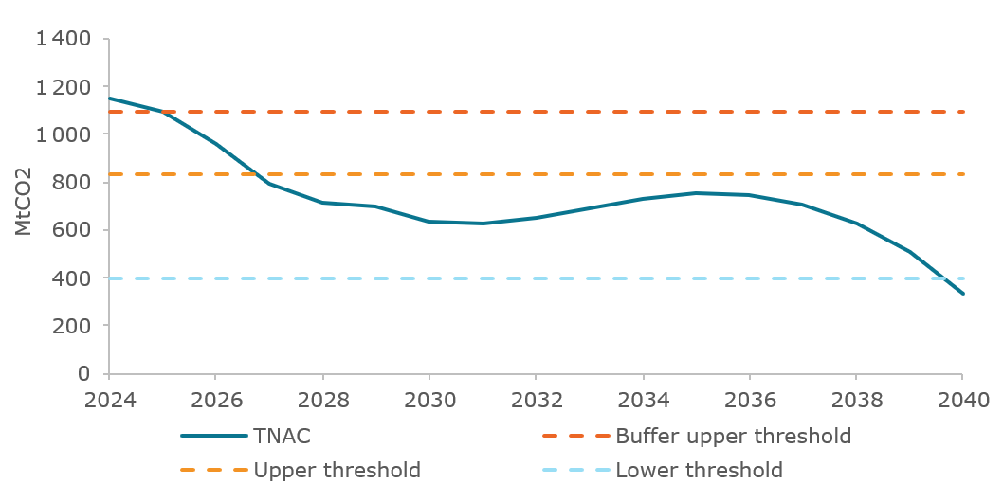
Source: POLES-Enerdata model run - Baseline scenario
The comparison of ETS-covered emissions and the corresponding cap also helps to understand the model results (Figure 5). By 2030, the EU ETS emissions are broadly in line with the cap (from a historical situation where they were below it). In the period 2030-2035, they have to decrease very quickly, even faster than the (already ambitious) cap, because the decrease rate of the cap after 2035 cannot be followed by emissions, as the model shows. Most easy-to-abate emissions have been reduced by then, and the remaining emissions require longer to further reduce. The annual decrease of emissions is progressively reducing, whereas the cap keeps linearly decreasing. Hence, after 2035, the emissions above the cap have to be covered by the surplus which was built by then (and after 2040, by the MSR releases as well).
- Baseline scenario - EU ETS emissions and cap
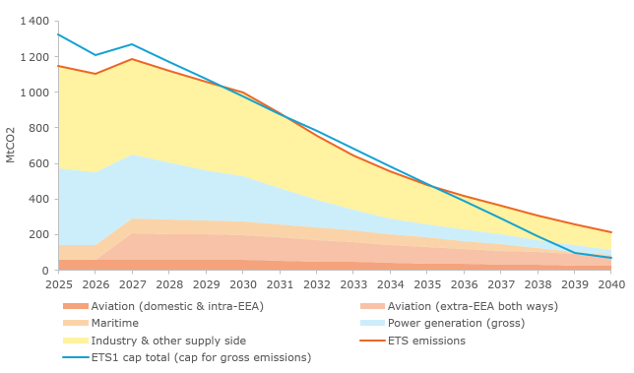
Source: POLES-Enerdata model run - Baseline scenario
The modelling results from this baseline scenario are insightful, but not necessarily realistic. In a more realistic projection, rather than hoard allowances for a scarcer future, we could expect actors to use up the historical surplus much earlier. This would lead the TNAC to drop quickly, and to release of allowances from the MSR earlier. This would in turn lead to slower price evolution in the short term, but even faster supply constraint from 2033, which could rapidly deplete the reserve and lead the TNAC to even become negative.
Yet, the baseline measure depicts a scenario in which no changes in the overall ETS design have been implemented. As a result, this might not provide a meaningful point of departure as different MSR design options should be appropriately tested against a future carbon market closer to what is being proposed in this impact assessment (i.e. changes in the size of cap, emissions reduction trajectory, the scope, among others).
Therefore, in addition to the baseline, the MSR0 presents a scenario in which the ETS is amended in line with the agreed 2040 target, but no changes are made to the MSR. This scenario - the Core Working Assumption Scenario (CWAS) - serves as a starting point and an appropriate comparison for all the MSR measures considered in the impact assessment.
    - Measure MSR0: Core Working Assumption Scenario (CWAS)
The MSR0 measure, also referred to as the Core Working Assumption Scenario, is defined as meeting a 90% economy-wide emission reduction target in 2040, and features the inclusion of 50% of the international extra-EEA aviation in the ETS scope. This enables the analysis to rely on a robust and meaningful starting scenario, with notably an adjusted cap trajectory, from which different measures will be incorporated and assessed.
The MSR0 scenario is first generated with the PRIMES model, within the same workstream as the preparation of the Baseline & Policy options scenarios. For the MSR measure-level analysis, the POLES-Enerdata model is calibrated to reproduce the main assumptions and equilibrium from the PRIMES model. More information about the production of the Core Working Assumption Scenario for the measure-level analysis of the MSR using the POLES-Enerdata model is included in Annex 4.
In terms of MSR design, MSR0 corresponds to the baseline configuration. The TNAC calculation and all MSR parameters remain as they currently are, e.g. the upper threshold stays constant at 833 million EUAs and the lower threshold at 400 million EUAs. In particular, the intake rate reverts to 12% after 2030 in the MSR0 measure. The upper buffer value from 2031 onwards is therefore adjusted to accommodate for this. While current legislation fixes this value at 1096 million EUAs, MSR0 and all following measures calculate the upper buffer parameter based on the below formula, depending on the upper threshold and the intake rate:
$$For each year y: upper buffer(y)=\frac{upper threshold(y)}{1-intake rate(y)}$$
    - Measure MSR0+: Augmented Core Working Assumption Scenario (ACWAS)
Building on MSR0, MSR0+ maintains all current MSR parameters and operational rules while implementing a few straightforward and targeted improvements:
- Technical correction of the TNAC to account for net aviation demand for the period 2012-2023.
- Introduction of a lower buffer to avoid threshold effects.
- Stopping the invalidation mechanism from 2027 onwards.
- Maintaining the intake rate at 24% beyond 2030.
Representing the most operational end of the reform spectrum, MSR0+ is effectively an augmented version of the Core Working Assumption Scenario against which further MSR measures should be compared.
While Article 1(4a) of the MSR Decision requires that net aviation demand be reflected in the TNAC calculation from 2024, no such requirement exists to account for the cumulative impact of net aviation demand over 2012-2023, hence there is no legal obligation for such correction. However, in order to bring the calculated TNAC more in line with the actual surplus on the market, the first improvement introduces a technical correction to the TNAC formula in 2028, effectively reducing the TNAC calculated for 2027 by 173 million allowances to account for this cumulative impact.
The second improvement introduces a lower buffer parameter, defined as the difference between the lower threshold and the release rate. The current MSR parameters therefore imply a lower buffer value of 300 million EUAs.
$$For each year y: lower buffer(y)=lower threshold(y)-release rate(y)$$
This lower buffer adjustment mirrors the logic behind the introduction of the upper buffer in the 2023 MSR revision. When the TNAC is between the lower threshold and the lower buffer, TNAC minus 300 million allowances are released from the MSR, rather than 100 million under the current rules.
$$For each year y: if TNAC(y)<lower buffer, EUAs released=release rate=100 million$$
$$if lower buffer<TNAC(y)<lower threshold, EUAs released=TNAC(y)-lower threshold$$
where ‘EUAs released’ corresponds to the releases defined based on TNAC(y), which will effectively be released between September y+1 and August y+2.
One potentially significant implication of this improvement is the lengthening of the time it may take for the MSR to be depleted. Under the current rules and assuming Article 29a release is not triggered, if TNAC drops below the current lower threshold of 400 million allowances four times, the MSR holdings will decline to zero. The adoption of a lower buffer, holding all else constant, allows MSR holdings to remain positive for significantly longer if TNAC remains between 300 and 400 million allowances. The OPC responses support measures to avoid threshold effects and sustain liquidity (5% explicitly proposed a lower buffer, 15% favoured dynamic thresholds, and volatility/liquidity were the top open text themes), consistent with adopting a lower buffer that would smooth releases and prolong MSR holdings when TNAC is between 300 million and 400 million.
The third adjustment featured in MSR0+ consists in stopping the invalidation mechanism as of 2027 (the last invalidations would be done by 31st December 2026). This proposed change is supported by a large majority of stakeholders. The idea is to enable the MSR to enter the scarcity-oriented future of the ETS with a larger number of EUAs in the reserve and therefore enable it to contribute more to a healthy market liquidity moving forward. Such adjustment is time sensitive as it can effectively lead to a larger reserve only as long as the MSR is still triggering intakes, hence the modelling considers such adjustment already as of 2027 to maximise its potential impact in the analysis. The OPC responses support ending invalidation as the most mentioned MSR change overall: 13% selected adjusting the invalidation rule in the design change question, invalidation was the - most cited theme in - follow-up- open text (47% of mentions, many calling for cancellation), and coordinated submissions pressed to pause or halt invalidation.
The modelling for the MSR0+ measure was done in a progressive manner, sequentially adding the different improvements. The intermediate analysis with and without the invalidation mechanism confirmed that maintaining the current invalidation mechanism leads to an extremely tight reserve of 400 million allowances, even with a lower buffer mechanism. The reserve would be fully depleted in 2040. As demonstrated in sections below, the removal of invalidation in measures MSR1 to MSR3, increases the reserve at the start of the period, allowing for more margin in the system in the late 2030s, to accommodate for shocks and to prepare for the post-2040 period.
Finally, the fourth improvement included in MSR0+ is related to the MSR intake rate, which is maintained constant at 24% after 2030, instead of decreasing to 12% as in the existing legislation. This change maintains the intake rate at its current value, which is now well understood and accepted by market participants and thus provides simplicity. It also maintains the current value of the upper buffer through the relationship between the buffer and threshold described in Section 2.1. Therefore, the intake rate only makes a difference when the TNAC is above the upper buffer, i.e. when a high surplus develops, which would then justify a stronger response by the MSR. The OPC responses provide some support for maintaining the 24% intake rate beyond 2030 (8%) and very limited support for reverting to 12% (2%), indicating a cautious preference to avoid lowering the rate.
MSR0+ therefore serves as an augmented baseline. Measures MSR1-MSR3, which all include the improvements in Measure MSR0+ in order to test the implications of specific additional changes. Table 1 summarises the specification of key MSR parameters in MSR0 and MSR0+.
- Overview of the MSR design in MSR0 and MSR0+
 | MSR0 (CWAS) | MSR0+ (ACWAS)
UB: upper buffer | Implied by UT and IR: $UB(y)=\frac{UT(y)}{1-IR(y)}$
UT: upper threshold | 833 Mt constant (unchanged)
IR: intake rate | 24% until 2030  12% after 2030 | 24% constant
LT: Lower threshold | 400 Mt constant (unchanged)
LB: Lower buffer | No buffer | Implied by LT and RR: $LB\left(y\right)=LT\left(y\right)-RR(y)$
RR: Release rate | 100 Mt constant
Invalidation mechanism | unchanged | Dropped as of 2027
29R: A29a release | 75 Mt constant (unchanged)
TNAC calculation | unchanged | Technical correction for 2027 TNAC
    - Measure MSR1
MSR1 builds upon MSR0+ and adjusts the level of two MSR parameters, the upper and lower thresholds, while maintaining their static nature. The upper buffer and lower buffer are therefore automatically adjusted as well, through the formulas presented above.
The upper threshold is lowered from 833 million EUAs to 650 million EUAs from 2028 onwards. The rationale for this change is based on updated estimates of hedging needs by regulated entities stemming from literature review and stakeholder interviews. The OPC responses indicate measured support for recalibrating fixed TNAC thresholds, with more selections for lowering than raising them (7% vs 3% in the design change question), and threshold adjustment recurring in open text (15% of mentions).
As detailed in Section 2.1, the initial value of 833 million EUAs was proposed and justified on the basis of estimated hedging needs at the time of its introduction. These needs have evolved since, leading to a necessary update of the threshold. Factors that explain the evolution of hedging needs include first and foremost the reduction (and expected future reduction) of the EU ETS-covered emissions, and particularly those of the power sector. The reduction in the corresponding hedging needs was only partially offset by progressively growing needs of hedging from other sectors (industry, aviation and maritime). Overall hedging needs are estimated to have reduced to around 650 million EUAs, a value consistent with expectations from different market analysts interviewed by the European Commission.
The reduction in the upper threshold value amounts to 183 million EUAs, which is in the same order of magnitude as the technical correction in the TNAC introduced in measure MSR0+ (173 million EUAs). Even if the modifications are not correlated, the level of the TNAC and upper threshold fall by similar amounts. The relative position of the TNAC compared to the upper threshold is therefore maintained, offering a form of continuity in the operations of the MSR.
In addition to the upper threshold adjustment, MSR1 also includes a recalibration of the lower threshold, with the same relative magnitude as the upper threshold (around 22%). This maintains the ratio between the upper threshold and lower thresholds, before and after the recalibration. It implies reducing the lower threshold to 310 million EUAs from 2028 onwards (down from 400 million EUAs up to 2027).
Both the upper and lower buffer are automatically impacted by these changes, but keep the same logic as implemented in measure MSR0+, with the same formulas. Figure 6 illustrates how the MSR thresholds and buffer are affected in measure MSR1.
- Measure MSR1: illustration of the parameter adjustments
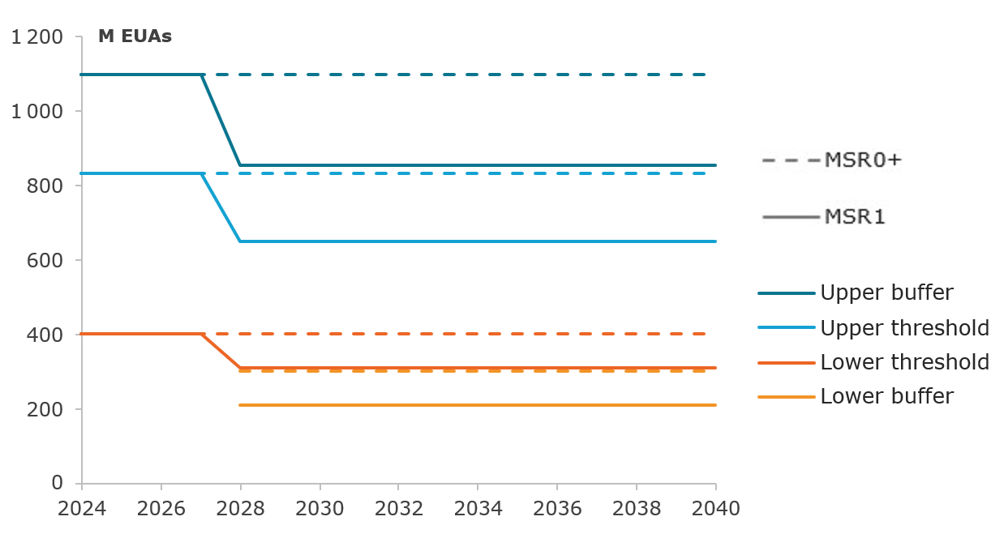
Source: Own visualisation derived from the POLES-Enerdata model
This minimalist approach, with limited changes compared to MSR0+ enables testing of whether targeted parameter recalibration can address key challenges in a smaller market, while preserving the predictability and rule-based nature that has made the MSR politically acceptable and operationally successful.
    - Measure MSR2
MSR2 introduces the same adjustments as in MSR1 in 2028 and then goes beyond by making some MSR parameter values dynamic after 2028, namely the upper and lower thresholds, as well as the release rate. These parameters evolve over time, with calculations based on the cap LRF, with the rationale that, for the MSR to fulfil its objectives with a market that progressively decreases in size, its parameters are also required to decrease to adapt to the market. This principle is backed by numerous contributions from stakeholders, who generally underline that having parameters evolving with a decreasing market is an important feature of an adequate and future-proof MSR.
As in MSR1, in MSR2, the upper threshold is lowered to 650 million EUAs in 2028, and the lower threshold to 310 million EUAs. As a reminder, the release rate stands constant at 100 million EUAs in 2028 (as in MSR1 and MSR0+).
Then, from 2029 onwards, these three parameter values are decreasing following the same LRF as the cap, with the formulas below:
$$For each year y:$$
$$upper threshold\left(y\right)=upper threshold\left(y-1\right)-upper threshold\left(2028\right)*LRF(y)$$
$$lower threshold\left(y\right)=lower threshold\left(y-1\right)-lower threshold\left(2028\right)*LRF(y)$$
$$release rate\left(y\right)=release rate\left(y-1\right)-release rate\left(2028\right)*LRF(y)$$
For the present measure-level assessment based on the MSR0 working scenario, the LRF values used are the currently legislated LRF until 2030 (4.4%), then 3.4% for the period 2031-2035 and 2.65% for the period 2036-2040. These values were calculated as implied LRFs in the period 2031-2040 based on the intermediate results of the PRIMES 90% scenario used in the calibration of POLES-Enerdata for the MSR0 scenario (see also the methodological Annex 4).
As previously explained for MSR1, the upper buffer and lower buffer are automatically adjusted based on these updated values for the thresholds and the release rate, with the same formula as presented before.
The remaining MSR parameters, and notably the intake rate, are not changed as compared to MSR0+. Since the intake rate is already expressed as a percentage of the TNAC, if the market (and hence TNAC) decreases, the potential volume of intake will also adjust accordingly.
Figure 7 illustrates how the MSR thresholds and buffer are affected in measure MSR2, as compared to MSR0+. The release rate is also adjusted in this measure (as explained above) but not depicted in the figure. The resulting levels of the annual buffers, thresholds and release rate for this configuration are also presented in Table 2 below.
- Measure MSR2: illustration of the parameter adjustments
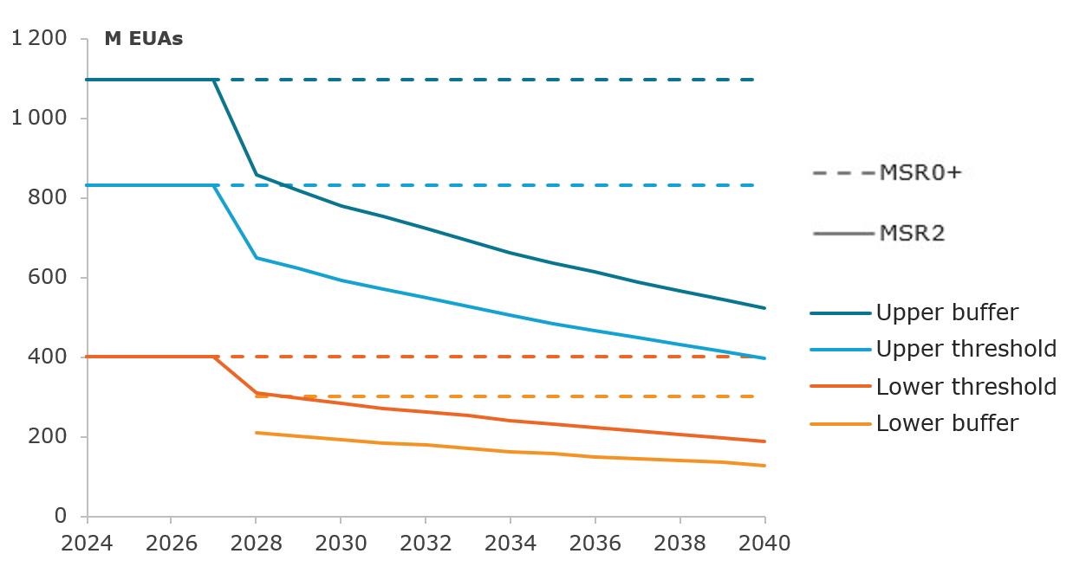
Source: Own illustration derived from the POLES-Enerdata model
- Measure MSR2: dynamic parameters decreasing with LRF (4.4% in 2028-2030, 3.4% in 2031-2035 and 2.65% in 2036-2040 for the 90% target configuration)
Million EUAs | 2028 | 2029 | 2030 | 2031 | 2032 | 2033 | 2034 | 2035 | 2036 | 2037 | 2038 | 2039 | 2040
Upper buffer | 855 | 818 | 780 | 649 | 623 | 598 | 573 | 548 | 528 | 509 | 489 | 470 | 450
Upper threshold | 650 | 621 | 593 | 571 | 549 | 527 | 504 | 482 | 465 | 448 | 431 | 413 | 396
Lower threshold | 310 | 296 | 283 | 272 | 262 | 251 | 241 | 230 | 222 | 214 | 205 | 197 | 189
Lower buffer | 210 | 201 | 192 | 184 | 177 | 170 | 163 | 156 | 150 | 145 | 139 | 134 | 128
Release rate | 100 | 96 | 91 | 88 | 84 | 81 | 78 | 74 | 72 | 69 | 66 | 64 | 61
This measure introduces rule-based responsiveness by replacing static MSR parameters with dynamic ones that decline with the same LRF as the cap, applied to their respective 2028 reference values. The rationale is that dynamic adjustment mechanisms could help ensure that the MSR remains balanced and effective as fundamental market conditions change over the assessment period. In addition to proposals to this effect in the literature and stakeholder interviews, MSR2 also addresses the review clause in Article 3 of the MSR Decision requiring the assessment of a potential adjustment of the thresholds in line with the LRF.
    - Measure MSR3
MSR3 keeps the same idea of having dynamic parameters adjust to a market decreasing in size. However, it has been built with a more empirical approach. Parameters were derived by testing numerous candidates iteratively with the objective of achieving a good balance between the following considerations:
- Progressively decreasing TNAC, in line with the decrease in EU ETS emissions.
- Enabling the MSR to release substantial amounts of EUAs to support market liquidity, with sufficient volume remaining in the reserve in 2040, to maintain its ability to operate thereafter, and to accommodate for possible unanticipated shocks.
- Smoothing price increases, with no strong peaks or fluctuations, indicating a healthy EUA supply-demand balance.
In practice, MSR3 introduces the following changes to the MSR parameters.
- The initial lower threshold stays at 400 million as in MSR0+.
- After 2028, the upper threshold, the lower threshold and the release rate all decrease at the same yearly rate of 4% per year, with the following formulas:
$$For each year y:$$
$$upper threshold\left(y\right)=upper threshold\left(y-1\right)*(1-4\%)$$
$$lower threshold\left(y\right)=lower threshold\left(y-1\right)*(1-4\%)$$
$$release rate\left(y\right)=release rate\left(y-1\right)*(1-4\%)$$
The 4% decrease rate has been calibrated to obtain a good balance across the considerations explained above.
In contrast to MSR0+, MSR1 and MSR 2, the intake rate is reduced to 12% compared to 24% after 2028. Both buffers are automatically adjusted based on the same formula as shown previously.
Figure 8 illustrates how the MSR thresholds and buffer are affected in measure MSR2, as compared to MSR0+. The release rate is also adjusted in this measure (as explained above) but not depicted in the figure. The resulting levels of the annual buffers, thresholds and release rate for this configuration are also presented in Table 3 below.
- Measure MSR3: illustration of the parameter adjustments
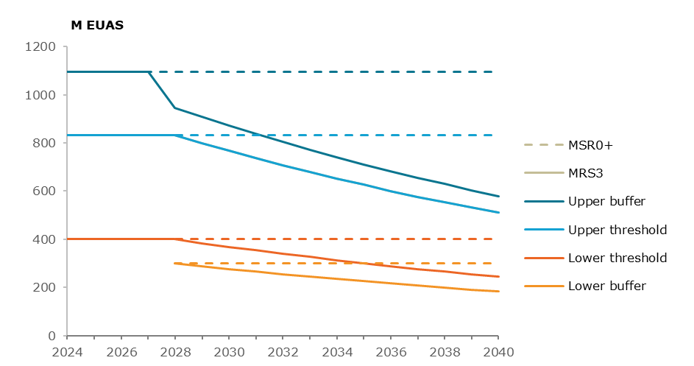Source: Own visualisation derived from the POLES-Enerdata model
- Measure MSR3: dynamic parameters decreasing at a yearly rate of 4 % per year

Million EUAs | 2028 | 2029 | 2030 | 2031 | 2032 | 2033 | 2034 | 2035 | 2036 | 2037 | 2038 | 2039 | 2040
Upper buffer | 947 | 909 | 872 | 837 | 804 | 772 | 741 | 711 | 683 | 656 | 629 | 604 | 580
Upper threshold | 833 | 800 | 768 | 737 | 708 | 679 | 652 | 626 | 601 | 577 | 554 | 532 | 510
Lower threshold | 400 | 384 | 369 | 354 | 340 | 326 | 313 | 301 | 289 | 277 | 266 | 255 | 245
Lower buffer | 300 | 288 | 276 | 265 | 255 | 245 | 235 | 225 | 216 | 208 | 199 | 191 | 184
Release rate | 100 | 96 | 92 | 88 | 85 | 82 | 78 | 75 | 72 | 69 | 66 | 64 | 61
The suggested approach allows to obtain similar upper threshold values as in MSR2, although with a slightly smoother trajectory as the percentage decrease is constant, which is not the case in MSR2 (with the LRF changing in 2031 and 2036). In MSR3, the decrease is applied year-on-year and hence it is progressive, constant and proportionate to declining levels of the thresholds. The decline trajectory in MSR3 is therefore simpler and more straightforward. In MSR2, with parameters decreasing over three periods (pre-2030, 2031-2035, and up to 2040), the yearly proportional decrease of the parameters exhibits ups and downs. This is not the case in MSR3.
Based on the same principles as MSR1 and MSR2, namely the introduction of dynamic parameters and taking account of hedging needs, the precise design of MSR3 was obtained through an iterative process, learning from successive simulations to find an optimal set of parameters. The formulation of the final design remains relatively simple, with a single percentage decrease for the three targeted parameters. The decrease rate is set empirically, and is not correlated to the LRF, which is calibrated for the cap decrease, and not necessarily optimal for the MSR parameters themselves.
Table 4 below provides a summary of the definitions of measures MSR0 through MSR3, in terms of MSR parameters and their respective values/formulas.
- Summary of the MSR measures definitions
 | MSR0 | MSR0+ | MSR1 | MSR2 | MSR3
UB: upper buffer | Implied by UT and IR: $UB(y)=\frac{UT(y)}{1-IR(y)}$
UT: upper threshold | 833 Mt constant (unchanged) |  | 650 Mt constant from 2028 | 650 Mt in 2028  Decreases with LRF after | 833 Mt in 2028  Decreases at 4%/year after
IR: intake rate | 24% until 2030  12% after 2030 |  | 24% constant |  | 12% constant from 2028
LT: Lower threshold | 400 Mt constant (unchanged) |  | 310 Mt constant from 2028 | 310 Mt in 2028  Decreases with LRF after | 400 Mt in 2028  Decreases at 4%/year after
LB: Lower buffer | No buffer | Implied by LT and RR: $LB\left(y\right)=LT\left(y\right)-RR(y)$
RR: Release rate | 100 Mt constant |  |  | 100 Mt in 2028  Decreases with LRF after | 100 Mt in 2028  Decreases at 4%/year after
Invalidation mechanism | unchanged | Dropped after 2027
29R: A29a release | 75 Mt constant (unchanged)
TNAC calculation | unchanged | Technical correction for 2027 TNAC
  - Discarded measures
The scoping exercise identified a of potential reforms ranging from operational parameter adjustments to fundamental institutional innovations. Three measures that concern fundamental reforms of the MSR (price-based triggers, higher-frequency indicators, and the creation of a European Carbon Central Bank ‘ECCB’) were ultimately discarded before undertaking the quantitative impact assessment.
While these measures have theoretical merit, they face significant institutional barriers, require multi-year preparation timelines, and represent departures from the MSR's established operational principles, hence are not feasible for implementation by 2028. The current revision therefore focuses on operational refinements that address potential parameter misalignments while preserving the rule-based, transparent framework that has made the MSR both politically acceptable and operationally successful so far.
    - Price-based triggers
A price-based MSR would replace or supplement the existing quantity triggers for TNAC with mechanisms that make the MSR respond to EUA price movements. Such approaches include price ceilings and tiers, cost containment mechanisms, auction reserve prices and have strong economic credentials: prices are observable continuously rather than calculated annually with a certain time lag, incorporate forward-looking market expectations about scarcity, and provide explicit planning parameters for investment decisions. Price-based market stability mechanisms are in use in California, the UK, and Washington State, among others. Through the Article 29a release mechanism, the MSR itself has a rule- and price-based element to respond to significant price movements.
Price-based triggers are discarded for the current review, as a quantity-based approach was deliberately chosen when establishing the MSR in 2015, grounded in the belief that prices of allowances should be determined by the market and not influenced by a price range set by the regulator. The OPC synopsis report indicates that while a majority respondents called for measures to improve MSR predictability and reduce price volatility, only a small minority explicitly advocated for a price-based mechanism.
    - Higher-frequency indicators
Higher-frequency indicators could complement rather than replace TNAC-based triggers, incorporating measures such as volatility indices, liquidity metrics, derivatives market data, and position concentrations to enhance MSR responsiveness. The OPC synopsis report indicates that 10% of respondents explicitly called for shortening MSR response time through more frequent adjustments. These views align with concerns raised about TNAC's limitations in an evolving market.
The development of complementary indicators and associated rules to trigger MSR intervention is discarded for the current review due to substantial practical barriers. Current data infrastructure suffers from significant gaps in granular understanding of trading, hedging, and banking activities, with regulatory and academic stakeholders acknowledging that existing systems were not designed for EU ETS monitoring purposes and have fundamental data availability issues. Developing robust indicators would potentially require expanded ESMA mandate and resources. Moreover, no consensus exists on which specific indicators to adopt.
    - European Carbon Central Bank
A European Carbon Central Bank (ECCB) would be a new EU institution modelled conceptually on the European Central Bank with authority over carbon market management. In principle, numerous ECCB design variants exist, differing substantially in scope of mandate and governance architecture. Existing proposals range from narrow rule-based mechanisms focused solely on allowance reserve management and market oversight to broader discretionary frameworks encompassing multiple market functions.
The ECCB option was discarded for two reasons. First, other stakeholders raised objections to discretionary ECCB designs and their political-institutional infeasibility. Interviews with market operators and industry associations revealed strong rejection of discretionary institutional approaches, with preference for the MSR's predictable, transparent, volume-based operation as central to political acceptability and market confidence. Second, establishing a new EU institution requires multi-year political processes to define mandate, governance structures, institutional composition, independence safeguards and accountability mechanisms, rendering implementation infeasible in the context of the 2026 review and highly ambitious even for the 2031 review timeline.
- Assessment of the measures
  - Modelling results
MSR measures were assessed quantitatively with the POLES-Enerdata model. The model allows to simulate the EU energy systems, and notably the ETS-covered sectors, with annual results up to 2050. An optimisation module is added on top of the energy systems simulation to model the EU ETS market operations, including an explicit representation of the MSR design. The tool therefore allows to analyse, under different MSR design configurations, the endogenous evolution of key indicators such as the ETS-covered emissions, the TNAC, the MSR operations and the EUA price evolution. It is important to recall that the MSR measures are assessed based on a scenario with an adjusted ETS cap trajectory meeting a 90% economy-wide emission reduction target in 2040 and featuring the inclusion of 50% of the international extra-EEA aviation in the ETS scope in addition to the current scope.
The MSR0 scenario (CWAS) is the starting point for the MSR measure-level analysis. Measure MSR0+ (ACWAS) is then introduced to envision changes considered necessary to the existing design of the MSR. It serves as the basis for the development of further measures, MSR1 to MSR3, which were implemented in the model. Their respective results are analysed in this section. A sensitivity analysis is also conducted to verify assess each measure’s robustness in the presence of EUA supply or demand shocks.
A more comprehensive description of the modelling approach is provided in Annex 4. As outlined in the methodological annex, for the purpose of the below measure assessment, MSR scenarios were assessed on the basis of a 90% economy wide reduction target.
The next section (Section 5), analyses of the most promising measures (MSR1 and MSR3) in the broader context of policy options: it tests how they perform when packaged together with the other elements of EU ETS design that form the policy options of the main impact assessment. For alignment purposes, it is important to note that the results for the policy options analysis for PO1, PO2 and PO3 which make use of the MSR1 and MSR3 scenarios, were assessed on the POLES Enerdata model to take account of the 90% emission reduction target for 2035 and 85% for 2040 in comparison with 1990 instead of a 90% economy wide reduction target.
The present measure level analysis does not incorporate the 2025 TNAC published on 28 May 2026 in the POLES-Enerdata model, which resulted in an intake of 190 million allowances in the MSR over a period of 12 months from September 2026 until August 2027. The POLES-Enerdata model estimates for 2025 a higher TNAC than the official TNAC as it projects greater emissions reductions than those observed in 2025. This, in turn, impacts results for future MSR operations and consequently EUA prices. A more complete description of the impact of the adjusted 2025 TNAC on the policy options results is provided in in section 5.4.
    - Results from measure MSR0 (CWAS)
Historically, the TNAC has always been above the MSR upper threshold and buffer, leading to continued intakes by the MSR since it started operating. In measure MSR0, as shown on Figure 9, the TNAC progressively drops, going below the upper threshold in 2027. After that, it continues to decrease, although remaining in the neutral zone (i.e. between the upper and lower thresholds) until 2035, after which it spends three years below the lower threshold, before coming back up in the neutral zone again in 2039.
- MSR0 results - Evolution of the TNAC and MSR thresholds
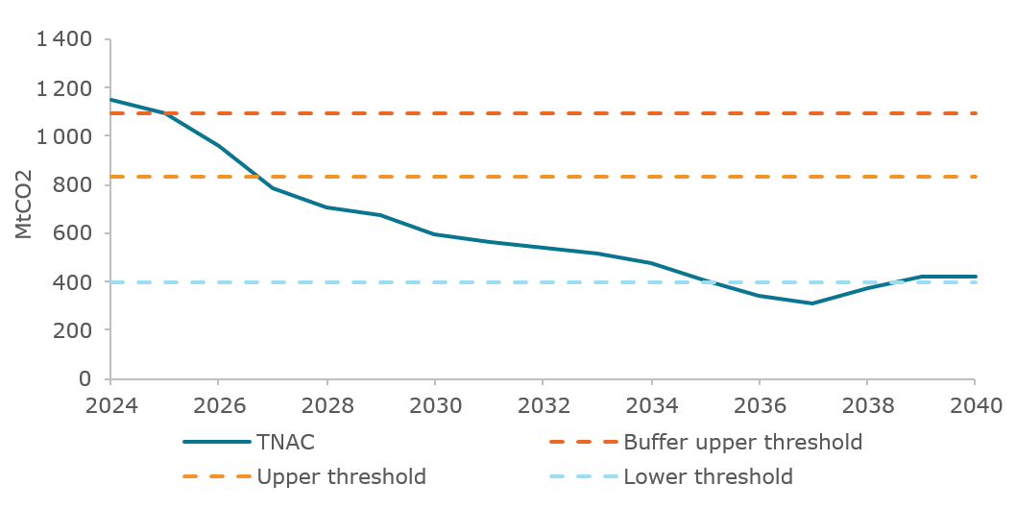
Source: Own visualisation derived from the POLES-Enerdata model
This TNAC evolution translates into the following operations carried out by the MSR (illustrated on Figure 10), specifically the curve ‘MSR decision based on current TNAC’, which corresponds to the quantity of allowances to be absorbed or released from the MSR. To recall, by 1 of June every year y, the TNAC of the previous year y-1 is published, which can trigger intakes or releases of allowances spread over a period of 12 months, from September y to August y+1. Therefore, the MSR operation in year y can be calculated based on the following formula:
$$MSR operation \left(y\right)=\frac{2}{3}*TNAC \left(y-2\right)+\frac{1}{3}*TNAC(y-1)$$
The last decision to intake additional EUAs is based on the 2027 TNAC. Considering the lag between the MSR decision and actual intakes, the last EUAs are absorbed by the MSR in August 2028. Then, the MSR become inactive until September 2037, time at which it starts releasing allowances, since the 2036 TNAC has crossed the lower threshold. The EUAs released over 2037-2040 enable the TNAC to get back to the neutral zone, as observed above. MSR operations are illustrated in Figure 10.
- MSR0 results - MSR operations
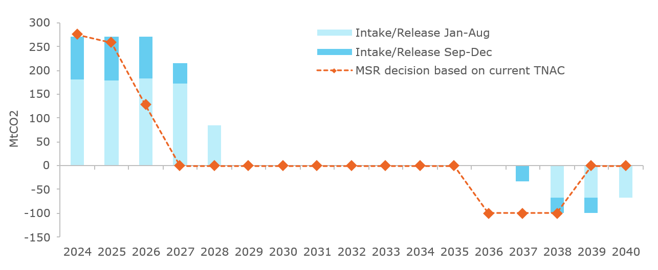
Source: Own visualisation derived from the POLES-Enerdata model
The amount of EUAs in the reserve (Figure 11) is capped at 400 million with the invalidation mechanism, which leads to a total of 1,111 million EUAs invalidated over 2024-2028. Cumulative releases between 2037 and 2040 amount to about 300 million EUAs, leading the remaining volume in the MSR to drop to only 100 million by 2040. This leaves a limited capacity for the MSR to keep operating in later years and keeps a relatively low margin in the case of an unanticipated event which could cause an EUA demand shock (only 1 year of additional releases available assuming no releases due to the Article 29a being triggered previously).
- MSR0 results – Stock of EUAs in the MSR (January 1st) & invalidations
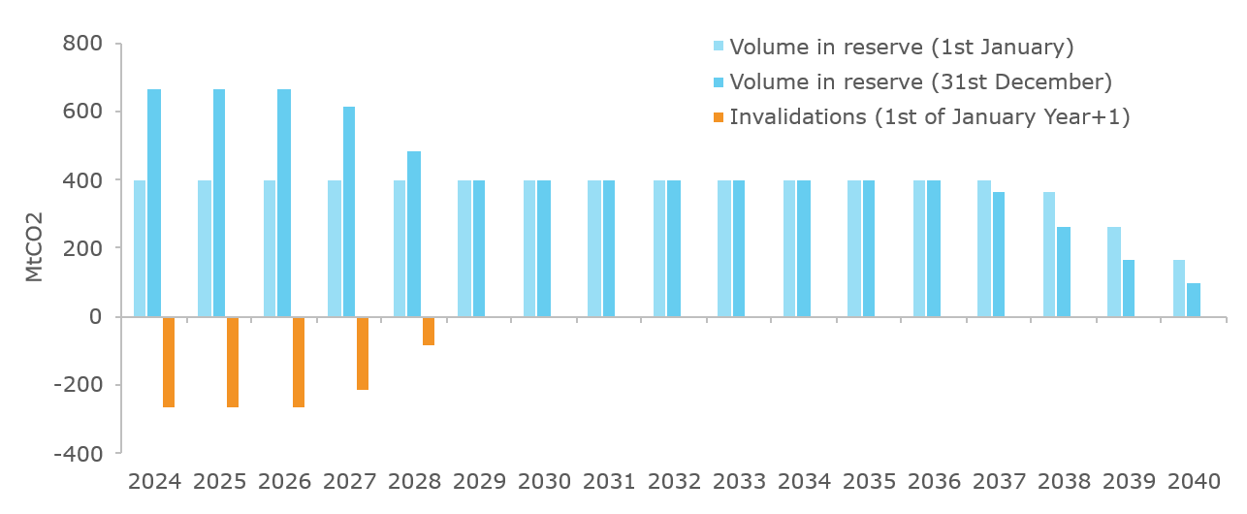
Source: Own visualisation derived from the POLES-Enerdata model
Figure 12 shows that EUA indexed price for MSR0 is expected to increase until 2029. Then, it stabilizes for about 3 years before starting to increase quickly in the second half of the 2030 decade. In other words, the market becomes tight relatively quickly after 2033, and the MSR release is not early or strong enough to counter that effect.
- MSR0 results – EUA indexed price evolution
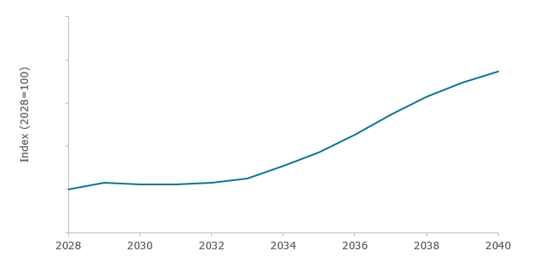
Source: Own visualisation derived from the POLES-Enerdata model
Figure 13 below shows the EU ETS-covered emissions resulting from the MSR0 scenario. These emissions are steadily decreasing through 2040, by 8%/year on average, despite the addition of the departing extra-EEA aviation emissions in the ETS scope in 2027. Emissions from the power sector are decreasing fast and reach low levels by 2040 (about 40 MtCO2), while industrial emissions reduce more progressively to 170 MtCO2 in 2040. Combined, aviation and maritime emissions amount to 110 MtCO2 in 2040, about half their 2027 levels.
- MSR0 results - EU ETS emissions
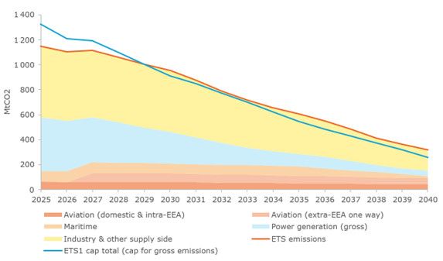
Figure 13 above shows a misalignment in the POLES-Enerdata model between the EU ETS emissions and the cap, which can be explained by two factors. First, there is a historical surplus of allowances on the market, part of which is held by market participants and part of which sits in the MSR. These allowances can later be used for compliance, on top of the allowances supplied through free allocations and auctions according to the yearly cap. Secondly, the model’s methodology solves the compliance problem with rolling anticipation periods of 8 years, allowing for some banking effects. Therefore, yearly emissions observed in the POLES-Enerdata model are not necessarily aligned with the cap, which can be seen as realistic for these two reasons.
Finally, an interesting indicator when considering the liquidity of the EU ETS is the stock-to-flow ratio between the TNAC and the annual emissions. This ratio is presented in Figure 14. It can be interpreted as the number of years’ worth of emissions that actors hold in their registry accounts in the form of allowances. These EUAs are notably used for hedging and banking, and it is therefore healthy for the market to feature some surplus.
If the stock-to-flow ratio is too low, it means that the surplus is too low and the market faces scarcity, and it could lead to a high price increase. Typically, less than 3-4 months of emissions in stock, i.e. a TNAC-to-emission ratio below around 0.25-0.3, is assumed to be too limited for market stability.
A stock-to-flow ratio that is too high corresponds to a situation of oversupply of allowances, which could also be unfavourable to the market. It takes in this situation time for the ETS-covered emissions to reach the cap, indicating that the price signal might be weakened. In modelled simulations (though not in historical observation so far), a high ratio could also indicate anticipation of future tightness (hoarding) as discussed in Section 3.1.1. A full year of emissions in stock (i.e. a TNAC-to-emissions ratio of 1) is considered much too high for a healthy functioning of the market. Hence, it is assumed that a sweet spot for the TNAC-to-emission ratio would be between 0.3 and 0.6, for the market balance to be healthy.
In MSR0, we observe a ratio declining towards this range in the beginning of the simulation period (around 2030), but then it rises again and ends around 1.3 by 2040, much higher than expectations for an adequate liquidity.
- MSR0 results - TNAC-to-Emissions ratio
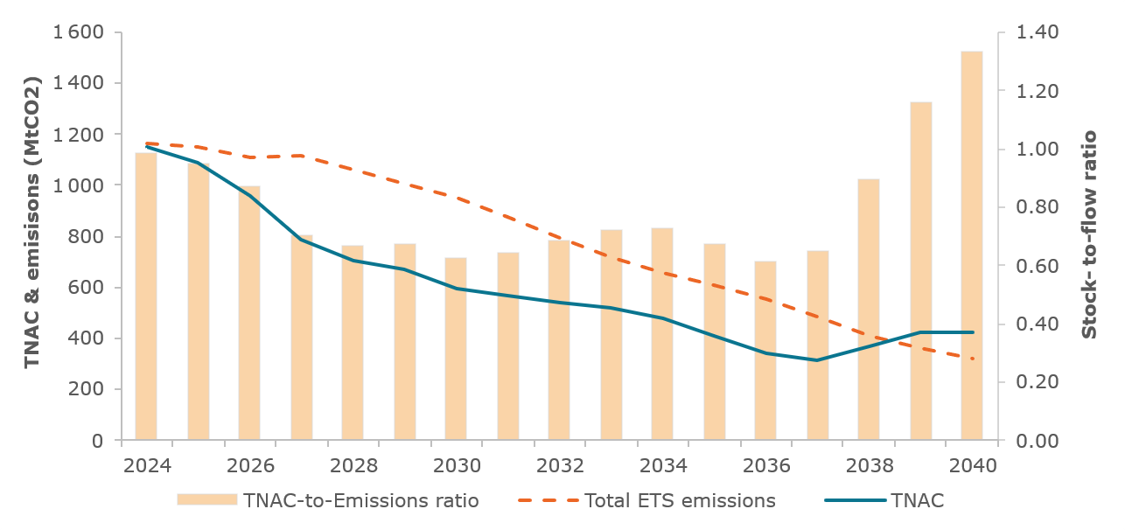
Source: Own visualisation derived from the POLES-Enerdata model
    - Results from measure MSR0+ (ACWAS)
Summary. Compared to MSR0, the improvements introduced in measure MSR0+ prove very useful in some ways, the lower buffer and removal of the invalidation mechanism improve market liquidity, prevent the TNAC from oscillating too strongly, and enable the MSR to have a higher number of EUAs in the reserve, thereby strengthening its ability to release allowances when these are required. However, the price trajectory in MSR0+ is problematic, with prices initially falling, then starting a steep climb as in MSR0 but even earlier. This risks jeopardising the short-term business case for the decarbonisation investments required in the long-term, and demonstrates the need for further adjustments to MSR design parameters.
Detailed results. Measure MSR0+ introduces a set of technical improvements to the MSR design, with a technical correction for the inclusion of the historical net aviation demand to the 2027 TNAC, the end of the invalidation mechanism as of 2027, the addition of the lower buffer as of 2028, and the continuation of the 24% intake rate after 2030.
Some of these adjustments have noticeable impacts on the TNAC evolution, as shown in Figure 15.
The TNAC technical correction brings the 2027 TNAC close to the middle of the neutral band (range between upper and lower thresholds in which the MSR is inactive), at around 600 million EUAs. Then it follows a decreasing trend as in the MSR0 simulation and crosses the lower threshold already by 2030. After this date, the MSR starts to release allowances, which supports the stabilisation of the TNAC. The TNAC does not leave the lower buffer zone until 2040 (i.e. stays between 300 million and 400 million EUAs for the whole decade), with limited fluctuations.
- MSR0+ results - Evolution of the TNAC and MSR thresholds
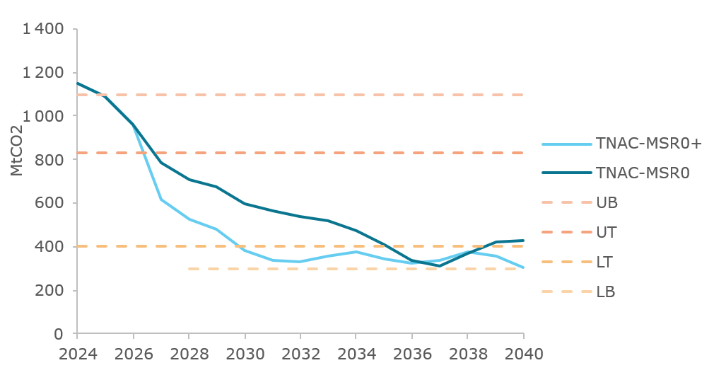
Source: Own visualisation derived from the POLES-Enerdata model
The changes included in measure MSR0+ do not affect the amount of intakes at the beginning of the period (up to 2028) as compared to MSR0, as shown in Figure 16. However, the releases start much earlier, in 2031 rather than in 2037.
- MSR0+ results - MSR operations and invalidations
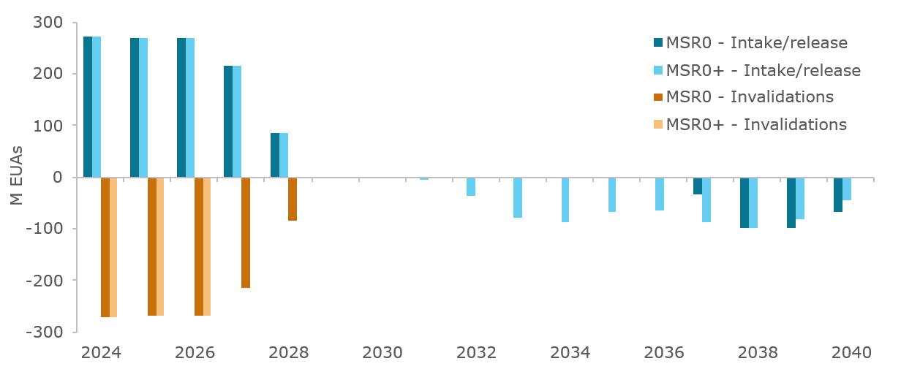
Source: Own visualisation derived from the POLES-Enerdata model
MSR0+ cumulatively releases more than twice as much as MSR0 by 2040. This is partly because the reserve is larger (by around 300 million EUAs) due to the suppression of the invalidation mechanism. Hence, the total EUAs sitting in the reserve in 2029 are about 700 million, as compared to 400 million in the MSR0 configuration. However, this larger stock is depleted at an even higher rate in the MSR0+ simulation than in MSR0. Therefore, by 2040, the remaining stock in the reserve is only of about 90 million EUAs. This leaves only a small room for additional adjustment in the event of an unanticipated demand shock and seems insufficient for the MSR to continue operating in the 2040s.
- MSR0+ results – stock of EUAs in the MSR (January 1st)
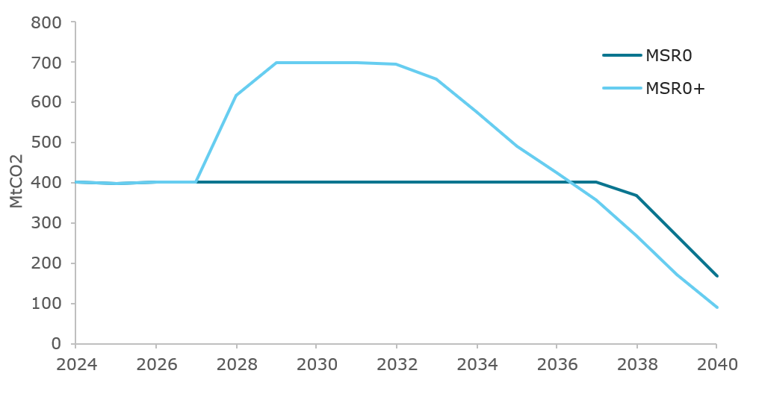
Source: Own visualisation derived from the POLES-Enerdata model
In Figure 18, MSR0+ leads to faster but similar price increases compared to MSR0 after 2034. However, in the shorter term, the additional and earlier releases by the MSR add supply and liquidity to the market and thus lead to a lower price between 2029 and 2031. Overall, there are two potential issues with the evolution of the price in MSR0+, both of which are related to the 8-year foresight assumption of the modelling framework.
First, the price tends to decrease until 2031 in relation to 2028 price, as actors anticipate the additional MSR releases in the early 2030s. In the real world, such a development would send mixed signals for the actors investing in the decarbonisation of their activities. However, the anticipation of a subsequently tighter market kicks in soon, increasing the price quickly and steadily after 2032, which could prove very challenging for the regulated entities, who would face rapidly rising carbon costs and have only little time to adjust and decarbonize their activities. The lack of a stable and progressively increasing price signal in MSR0+ constitutes a large obstacle to industrial decarbonisation investment, demonstrating the need to consider further MSR design adjustment measures.
- MSR0+ results – EUA indexed price evolution
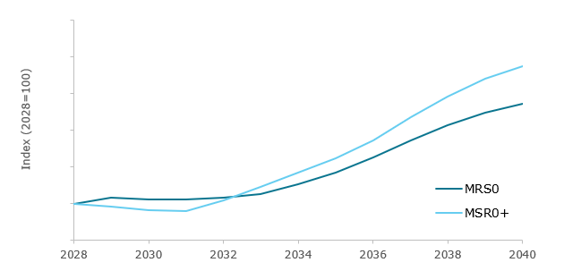
Source: Own visualisation derived from the POLES-Enerdata model
The EU ETS emissions are slightly higher in MSR0+ than in MSR0, especially around 2030, due to the factors mentioned above. Emissions then remain broadly in line with the MSR0 trajectory and tend to converge to its 2040 value.
- MSR0+ results - EU ETS emissions
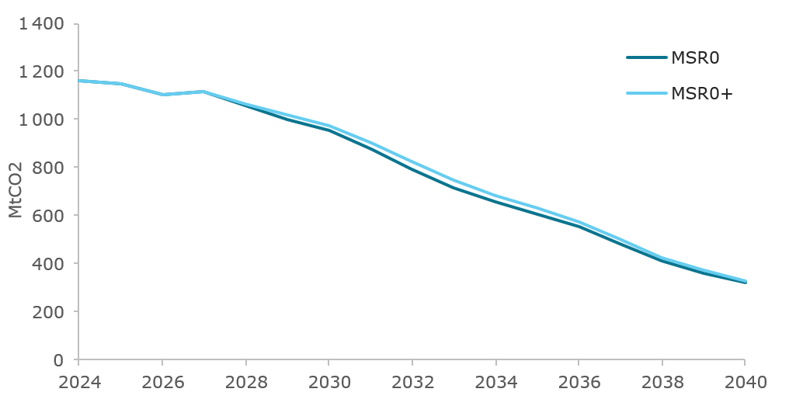
Source: Own visualisation derived from the POLES-Enerdata model
    - Results from measures MSR1 to MSR3
Summary. MSR1, which features a limited and simple adjustment of the MSR thresholds, improves some of the measured indicators compared to MSR0+. It smooths the price trajectory somewhat by delaying and dampening MSR0+’s short-term fall and subsequent sharp increase, thereby lessening concerns over the short-term case for decarbonisation investments. In addition, even though significant volumes of EUAs are released by 2040 in MSR1, the remaining 2040 stock remains above 300 million EUAs. This constitutes a useful margin for the MSR to keep intervening after 2040, and to further adjust the market balance in the case of a deviation from the modelled scenario, as studied in the following section.
MSR2 and MSR3 envision more fundamental changes to the MSR design with dynamically decreasing thresholds and release rate after 2028. This type of approach is called for by many stakeholders and allows to prepare the MSR for a future where the market will progressively decrease to a smaller size. Measure MSR2 aims to use an existing measure of the market decrease, the cap’s LRF, to adjust the MSR parameters, while MSR3 is calibrated empirically to obtain a satisfactory constant yearly decrease rate for those parameters.
MSR2 fails to deliver satisfactory results, with a very tight market in the medium term (2030-2035) and almost no releases by the MSR before 2040, despite the market tension. On the other hand, measure MSR3 allows for a smooth and progressive decrease of the TNAC, a smooth increase in the EUA price, and a release of appropriate amounts of EUAs before 2040, It also keeps a significant amount in the reserve allowing for its further operation in later years, thereby providing a margin in the case of unanticipated shocks. It also delivers are more stable spread over time of the TNAC-to-emission ratio, a good measure of market liquidity.
Based on the detailed analysis (below), two measures are brought forward for the sensitivity analysis in the Section 4.2: MSR1, as a simpler adjustment of the current design, and MSR3, which provided the most satisfactory results overall.
Detailed results. Measure MSR1 is based on MSR0+ and features an immediate and one-time adjustment of the upper and lower thresholds of the MSR in 2028, with constant values thereafter. This results in the lowering of the neutral band as compared to MSR0+. Therefore, the decreasing TNAC observed in MSR1 crosses the lower threshold in 2033, later than in MSR0+. MSR releases hence occur later in the period as well. The TNAC then keeps decreasing for a few years and drops below the lower buffer, before the EUAs released counter the decreasing trend. The TNAC then progressively starts increasing and gets back into the lower buffer zone between 2036 and 2040.
- MSR1 results - Evolution of the TNAC and MSR thresholds
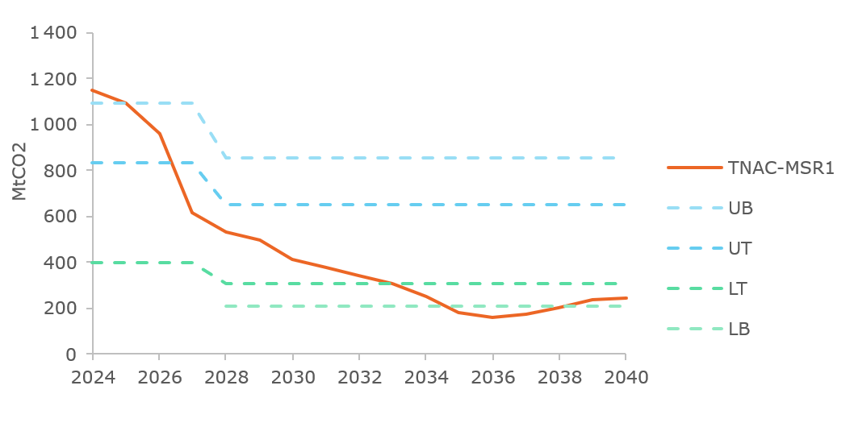
Source: Own visualisation derived from the POLES-Enerdata model
Measure MSR2 is based on MSR1, with the same adjustments on the thresholds applied in 2028. From that point, it introduces a dynamic component, with the parameter values of the thresholds and the release rate decreasing over time in line with the cap LRF. The decreasing lower threshold causes the TNAC to remain longer in the neutral band than in MSR1 or MSR0+ and crosses the lower threshold in 2039 (see Figure 21). It decreases throughout the period, but more slowly than in MSR1 because, in the absence of releases, actors are further incentivized to decarbonise their activities and hold allowances for future use, leading to sharper EUA price increases over 2030-2035, but ultimately avoiding MSR1’s even sharper increases in the late 2030s. With the additional emission reductions achieved, the TNAC decreases slower than in MSR1.
- MSR2 results - Evolution of the TNAC and MSR thresholds
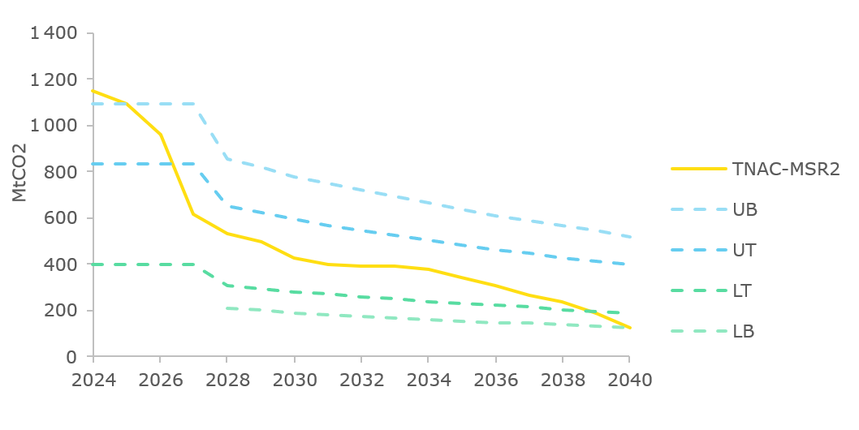Source: Own visualisation derived from the POLES-Enerdata model
Measure MSR3 envisions a different MSR design than MSR2, although also featuring dynamic decreasing thresholds. First, the lower threshold stays at 400 million EUAs in 2028; and second, the decrease of the thresholds and the release rate are based on a fixed yearly decrease rate, instead of the LRF-based mechanism. In MSR3 the level of the lower threshold remains above its level in MSR2 throughout the period to 2040. The TNAC progressively decreases and drops below the lower threshold in 2034. It then keeps decreasing until just below the lower buffer, before stabilizing for a few years and starting to decrease again in 2040.
- MSR3 results - Evolution of the TNAC and MSR thresholds
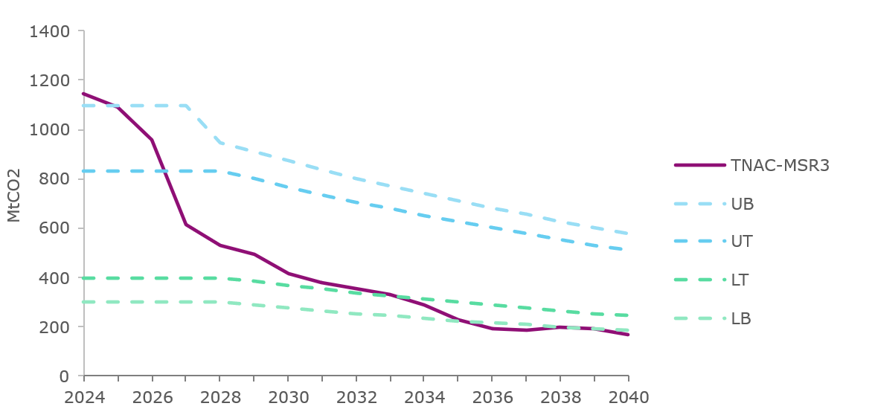
Source: Own visualisation derived from the POLES-Enerdata model
The TNAC evolutions in measures MSR1 to MSR3 lead to substantial differences on MSR operations. In all three measures, the adjustments induce a postponement of the first EUA releases, as compared to MSR0+. In MSR1, significant releases are triggered from 2035 onwards, with a cumulative volume of releases in the next decade of around 490 million EUAs. In MSR2, almost no releases happen before 2040, with only 3 million EUAs released in 2040. In MSR3, releases start in 2035 with lower values compared to MSR1 (and a fortiori MSR0+), reaching cumulative releases of about 320 million EUAs by 2040. MSR operations are presented in Figure 23.
- MSR1-to-MSR3 results - MSR operations
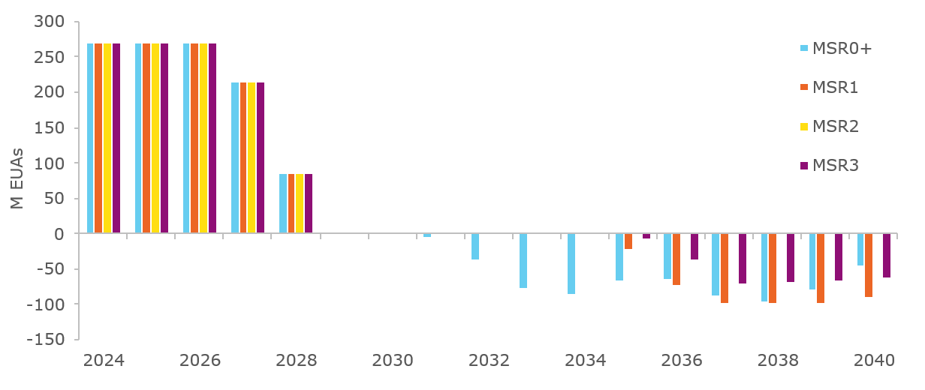
Source: Own visualisation derived from the POLES-Enerdata model
All of the measures from MSR0+ to MSR3 stop the invalidation mechanism as of 2027 and have similar intakes at the start of the period, leading to the accumulation of about 700 million EUAs in the MSR in 2029. By 2040, this initial stock depletes at a different pace in the different measures. With significant volumes released as soon as 2031 in MSR0+ (where there is no adjustment of the lower threshold), leading to a largely empty reserve by 2040. With the delayed EUA releases in measure MSR1-to-MSR3, the stocks remaining by 2040 are higher. In MSR1, the reserve volumes drop down to around 300 million EUAs by 1st January 2040, whereas in MSR3, this amounts to 450 million EUAs. In MSR2, with virtually no releases by then, the reserve stock remains around 700 million EUAs, as shown in Figure 24.
- MSR1-to-MSR3 results - stock of EUAs in the MSR (January 1st)
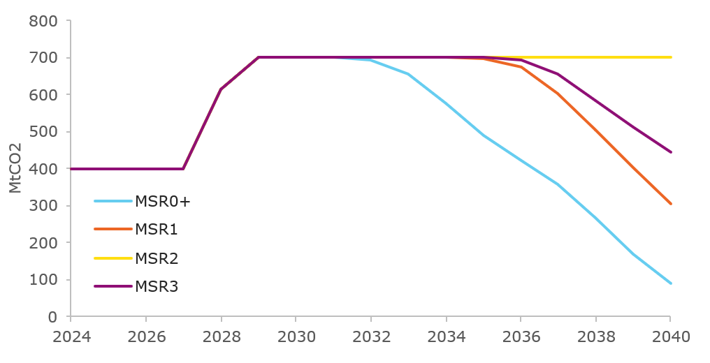
Source: Own visualisation derived from the POLES-Enerdata model
The previously presented TNAC trajectory and corresponding MSR operations have notable impacts on the indexed price trajectories produced by the POLES-Enerdata model. These are presented in Figure 25 below. With the delay in MSR releases, the MSR1-3 scenarios delay or postpone the immediate fall in EUA prices seen in MSR0+, thereby also softening that scenario’s sharp increase in prices from 2031.
In MSR1, the simple lowering of the thresholds delays the price fall and subsequent increase observed in MSR0+ by around 3 years. Despite this pause, the scenario is therefore exposed to the same criticism as MSR0+ regarding the weakening of decarbonisation incentives in the short-term, extreme market tightness in the long-term, and questions over whether such an outcome is credible outside of the modelled framework.
In MSR2, the absence of releases prior to 2040 leads to a relatively tight market in the early 2030s, with the price increasing much higher than in the other measures (over twice as high as the MSR0+ and MSR1 prices in some years). The sharp increase slows down after 2035, and the 2040 price in MSR2 is even lower than that in MSR1, with additional decarbonisation efforts triggered by higher prices paying off in the later years of the studied period.
Measure MSR3 allows for a progressive, steady increase in the price throughout the period, marking a healthy supply-demand balance on the market. It more generally brings a form of stability to the EU ETS price signal, with a slow and steady price increase, providing a well-balanced environment for actors to invest in the decarbonisation of their activities.
- SR1-to-MSR3 results – EUA indexed price evolution
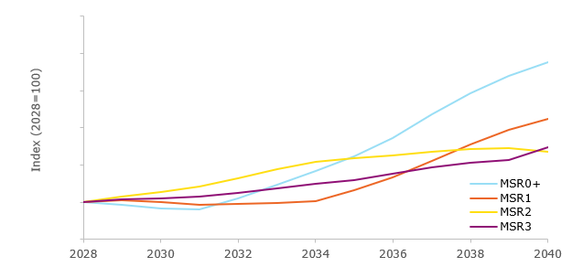
Source: Own visualisation derived from the POLES-Enerdata model
All measures present close trajectories in terms of EU ETS emissions. Measure MSR0+ leads to cumulative emissions over 2026-2040 of around 11,280 MtCO2. MSR1 to MSR3 all lead to slightly lower emissions than MSR0+, of respectively -0.6%, -3.9% and -1.5%. These variations are mostly due to the different cumulative release volumes, which are higher in MSR0+ and lowest in MSR2. By 2050, these differences in cumulative emissions reduce, as the remaining EUAs are released from the reserve, and differences in the cumulative volumes released converge to zero.
As a measurement of market liquidity, Figure 26 shows the TNAC-to-emissions ratio. In all measures, the ratio decreases from its high historical values to about 0.55 in 2027 with the TNAC technical correction. It then slightly decreases by 2029, after which the different measures start to substantially diverge.
As previously noted in the MSR0 case, measure MSR0+ sees its ratio skyrocket after 2036, which puts the market balance into question in this scenario. Adjustments made as part of measure MSR1 allow to reduce this effect, although not completely correcting it. The MSR1 ratio also features a lower minimum value in 2036, of about 0.28.
In MSR2, the stock-to-flow ratio increases over 2030-2034 and then stabilizes at around 0.6 for four years before sharply dropping over the last two years.
Finally, measure MSR3 features the lowest spread in terms of TNAC-to-emission ratio over time. The ratio is generally stable over the period, with a noticeable convex minimum around 2036. It remains between 0.34 and 0.55 over 2027-2040, confirming a healthy market balance, as observed through the indexed price evolution. MSR3 thus provides the most progressive and smooth evolution on the market.
- MSR1-to-MSR3 results - TNAC-to-Emissions ratio
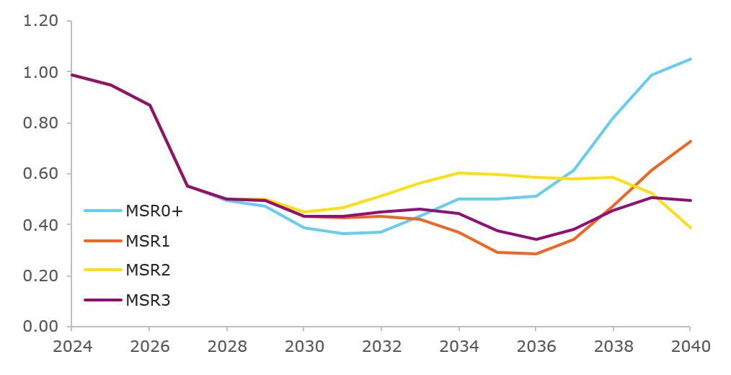
Source: Own visualisation derived from the POLES-Enerdata model
Table 5 provides a summary of the main results of the measures MSR0 to MSR3. The analysis starts from MSR0, a core working assumption scenario which maintains the current MSR design forward. A first set of improvements to this case are introduced in MSR0+. However, the results obtained, as well as the analysis of stakeholder’s input call for further adjustments to the MSR design.
- MSR measures summary dashboard
 | MSR0 | MSR0+ | MSR1 | MSR2 | MSR3
When is LT < TNAC < UT ? | 2027-2035 | 2027-2029 | 2027-2032 | 2027-2038 | 2027-2033
First year of release from MSR | 2037 | 2031 | 2034 | 2040 | 2035
Cumulative volume of release by 2040 (M EUAs) | 300 | 657 | 489 | 3 | 318
Cumulative emissions over 2026-2040 (MtCO2) | 11,016 | 11,282 | 11,214 | 10,845 | 11,117
Stock of EUAs in the MSR in 2040 (M EUAs) | 167 | 89 | 303 | 700 | 459
Stock of EUAs in the MSR in 2050 (M EUAs) | 0 | 0 | 0 | 265 | 8
TNAC-to-Emission ratio spread over 2027-2040 | 0.61-1.33 | 0.36-1.05 | 0.28-0.72 | 0.39-0.60 | 0.34-0.55
Note: values for MSR3 are based on 4.1% parameter instead of 4.0%.
  - Sensitivity analysis on selected measures
Measures MSR1 and MSR3 have been selected to be further tested with a sensitivity analysis, replicating a variety of techno-economic shocks that could impact the carbon market resulting in an increase or decrease in demand for EUAs over different time horizons. A full description can be found in Appendix 1 of this annex. Table 6 summarises the resilience of the MSR system (designs MSR1 and MSR3) in the face of these shocks.
As well as the liquidity spreads discussed in the previous section, the table considers two additional indicators. First, the convergence of the TNAC back to the no-shock trajectory, a few years after the shock is introduced, which is a good indicator of the MSR's ability to adjust to specific contexts. This convergence is more notable in MSR3. Second, the convergence of emissions back to their original trajectory is an interesting indicator to monitor. In that regard, both MSR1 and MSR3 lead to satisfactory alignments in emissions in the presence of shocks.
- Sensitivity analysis – key indicators for system resilience
 | MSR1 | MSR3
TNAC converging back to the no-shock trajectory | + | ++
Emissions converging back to the no-shock trajectory | ++ | ++
TNAC-to-Emission ratio spread over 2027-2040 | 0.28 - 0.75 | 0.33 - 0.63
Overall, the simpler MSR1 design already provides some resilience in the EU ETS, in particular up to 2035. However, the more refined MSR3 design shows stronger performance, allowing for the price impacts to be better kept under control, and leading to much improved indicators towards the end of the 2030s. MSR3 therefore seems to provide a more future-proof option.
  - Economic impacts
The design of the MSR directly affects how well the EU ETS functions through several economic channels, notably market liquidity (adequate allowance availability for compliance, hedging and banking), price predictability (stable signals for decarbonisation investment) and business planning certainty (manageable costs and foreseeable regulatory environment). This section assesses measures MSR0+ through MSR3 against these criteria primarily using the results from the POLES-Enerdata model in Section 2.1.
    - Liquidity in the EU ETS
Market liquidity in the EU ETS context refers to adequate allowance availability to meet compliance obligations and support hedging and banking activities. An MSR design which is fit for purpose should feature timely intakes and releases of appropriate size when the market experiences surplus or scarcity, maintain relatively stable liquidity in relation to covered emissions, and avoid premature reserve depletion, preserving shock-absorption capacity and post-2040 flexibility.
Liquidity is assessed through several indicators: TNAC levels and trajectories in relation to the upper and lower thresholds and buffer zones; the evolution of the stock of allowances in the MSR indicating capacity for future interventions; the TNAC-to-emissions ratio spread which is a proxy for liquidity consistency relative to compliance needs; and the timing and volume of MSR releases.
- Summary of liquidity analysis
MSR option | Description | Conclusion
MSR 0+ | Intakes into the MSR cease in the late 2020s across all modelled measures, as TNAC drops below the upper threshold. In MSR0+, releases begin earliest among the measures and proceed most aggressively, with substantial cumulative volumes released by 2040.  This improves near-term liquidity relative to MSR0, with allowance availability more consistent relative to compliance needs. However, the reserve depletes rapidly, leaving minimal intervention capacity for potential shocks and for post-2040 interventions. This is true even though stopping invalidations after 2027 increases the number of allowances for release. The lower buffer successfully enables graduated releases when TNAC enters the lower buffer zone, avoiding abrupt threshold effects and preventing an even more rapid depletion of the reserve. | In short, MSR0+ delivers strong near-term liquidity improvement at the expense of sustained intervention capability in the medium and long term.
MSR 1 | Releases under MSR1 start several years later than MSR0+. Nevertheless, substantial cumulative volumes are released by 2040. Critically, the measure preserves meaningful intervention capacity in 2040, while maintaining sufficient reserve stock for potential shocks and for multiple post-2040 releases. The TNAC-to-emissions ratio under MSR1 falls within a narrower range than in MSR0+ over the assessment period, indicating more stable liquidity in this measure. | MSR1 delivers balanced liquidity performance, adequate releases when needed, preserved long-term intervention capacity, and stable supply-demand dynamics through minimalist recalibration.
MSR2 | In MSR2, where key parameters decline at time-dependent LRFs, negligible releases occur before 2040 despite market tightening, as evidenced by significantly higher prices than in all other measures assessed. This measure also features the largest stock in the MSR in 2040, as this reserve will have remained largely inaccessible when liquidity is needed.  The TNAC-to-emissions ratio remains relatively narrow, but this reflects consistently tight market conditions during the first half of the 2030s rather than effective MSR intervention through releases. | In MSR 2 the LRF-based calibration prevents the mechanism from fulfilling its function to augment liquidity when needed.
MSR3 | MSR3 generates moderate releases starting in 2035, with meaningful cumulative volumes released by 2040.  The TNAC-to-emissions ratio under MSR3 falls within a narrow range over the assessment period, similar to MSR1 while maintaining greater reserve depth for potential shock absorption, including potential Article 29a activations during the 2030s, and for post-2040 operations. | Under MSR 3 the uniform decline across upper threshold, lower threshold, and release volumes creates internally consistent dynamics.  MSR3 avoids both MSR0+'s rapid reserve depletion and MSR2's locked reserve problem, providing timely liquidity provision while preserving intervention capacity. MSR3 has the advantage it adapts to a shrinking market as compared to MSR1.
Both MSR 1 and MSR3 measures demonstrate robustness under the tested shock scenarios, though through different mechanisms as further described in appendix 2 of Annex 8. MSR1 relies on recalibrated static thresholds providing predictable intervention triggers, supported by adequate baseline reserve capacity. MSR3 achieves a similar result through dynamic parameters that adjust intervention timing and release volumes to evolving market conditions, backed by deeper reserve stocks that sustain intervention capacity across scenarios.
    - Price Volatility
Price volatility affects regulated entities' ability to plan investments, manage compliance costs, and execute hedging and banking strategies. This analysis focuses on volatility patterns across years relevant for medium-term investment planning and compliance strategies.
Rather than formal statistical volatility metrics, the assessment relies on graphical analysis of price trajectories and their evolution under baseline and shock scenarios. The four measures exhibit markedly different inter-annual volatility patterns as outline in Table 8 below.
- Summary of volatility analysis
MSR scenario | Assessment | Conclusion
MSR0+ | MSR0+ demonstrates a non-monotonic trajectory, with prices declining from 2028 to 2031, before reversing direction and increasing rapidly by 2040. This directional reversal in the late 2020s represents volatility through both the sign change and the subsequent acceleration in price growth  The pace of price increases post-2031 is particularly pronounced, with year-on-year changes substantially larger than in other measures. | Price decline followed by steep year over year price increases as from 2031.
MSR1 | MSR1 exhibits a similar non-monotonic pattern to MSR0+, though delayed any price increase by approximately three years. Prices stabilise in 2030 and show limited fluctuation through the early 2030s before accelerating sharply after 2034. While partially avoiding the early decline observed in MSR0+, MSR1 still features a pronounced hiatus-to-surge pattern. The transition from relative price stability to rapid escalation after 2034 generates substantial year-on-year percentage changes similar in magnitude to those observed in MSR0+. | MSR 1 observes stabilisation followed by a relative rapid escalation of prices after 2034. MSR1 generates a hiatus-to-surge pattern vulnerable to amplification under certain shocks. Nevertheless, year over year volatility remains within reasonable boundaries.
MSR2 | MSR2 exhibits a non-monotonic trajectory distinct from MSR0+ and MSR1, with rapid early-period price increases followed by a decline at the end of the assessment period. Prices increase sharply from 2028 to 2030, substantially above all other measures, and continue escalating rapidly through the mid-2030s, before declining in 2040. The steep price escalation in the 2030-2035 period generates the highest annual price growth across all measures, with prices exceeding MSR0+ and MSR1 by factors of two during specific years. MSR2 surges first then reverses, representing an inverted non-monotonic pattern that combines rapid early acceleration with late-period reversal in direction. | MSR 2 provides for the highest annual price growth across all measures. MSR 2 that combines rapid early acceleration with late-period reversal in direction consequently higher level of volatility
MSR3 | MSR3 demonstrates the lowest inter-annual volatility across the assessment period. Prices increase progressively from approximately in 2030 up until 2040, maintaining consistent directional momentum without abrupt accelerations, plateaus, or reversals. Year-on-year price changes remain relatively uniform throughout the period, avoiding both the directional reversals of MSR0+/MSR1/MSR2 and the extreme early-period escalation of MSR2. This smooth, gradual trajectory provides the most stable inter-annual price evolution among the four measures. | MSR 3 provides for a smooth, gradual trajectory and the most stable inter-annual price evolution among the four measures. MSR 3 provides for the most stable and gradual price evolution over time. MSR3 also maintains progressive price evolution with superior shock resilience.
    - Conduct of business
Conduct of business considerations assess how each measure's liquidity and volatility characteristics affect regulated entities' operational decision-making. Two dimensions are central: market conditions that enable effective risk management, and mechanism predictability that supports credible price expectations.
- Conduct of business analysis
 | Market conditions for operational decision making | Predictability
MSR 0+ | Problematic market conditions: MSR0+ sends inconsistent signals for investment planning: prices decline when forward-looking entities would expect tightening markets, then surge rapidly | MSR0+ offers predictability through maintaining static thresholds.
MSR1 | More suitable market conditions: TNAC within the neutral band until the mid-2030s, MSR1 exhibits wider spreads and hiatus-to-surge price dynamics. | MSR1 offers predictability through recalibrated static thresholds.
MSR2 | Problematic market conditions: early-period price escalation followed by late reversal creates a non-monotonic pattern unhelpful to compliance and investment planning or hedging and banking strategies. | MSR2's LRF-based parameter dynamics introduce substantial complexity: thresholds and release rates decline annually at varying paces
MSR3 | More suitable market conditions: TNAC within the neutral band until the mid-2030s. MSR3 demonstrates narrower TNAC-to-emissions ratio spreads and smoother price trajectories. Better response to unexpected shocks. | MSR3 employs a single annual decline rate across relevant parameters, balancing adaptation to market shrinkage with relative simplicity and transparency. The constant percentage adjustment creates predictable parameter trajectories.
From a conduct of business perspective, MSR0+ and MSR2 exhibit significant weaknesses: problematic liquidity conditions combined with high volatility; early or delayed releases and non-uniform price dynamics. MSR1 and MSR3 perform better through adequate liquidity provision, directional price stability, and mechanism designs support forward planning: MSR1 through minimalist recalibration preserving familiarity and MSR3 through uniform adaptive parameters balancing responsiveness and transparency, as well as better response to shocks (see Section 4.2).
    - Recommendation based on economic impacts
Based on the economic impact assessment across liquidity, price volatility, and conduct of business dimensions, MSR1 and MSR3 are recommended to advance to policy option-level analysis. Both measures avoid problematic TNAC dynamics that trigger premature or excessively delayed releases, demonstrate adequate reserve capacity sustaining MSR intervention capability through 2040 and beyond, and generate directional price stability conducive to forward planning and risk management. MSR0+ and MSR2 are not recommended to advance to policy option-level analysis due to structural weaknesses identified across these dimensions.
  - Social impacts
Social impacts of MSR measures cannot be meaningfully assessed at the measure level for three principal reasons. First, the POLES-Enerdata model generates projections for allowance prices, emissions profiles for covered sectors, and MSR-related variables like TNAC and release volumes, but does not capture labour market dynamics, household income distribution, or social welfare indicators required for social impact assessment. Second, social impacts result from interactions across multiple thematic areas. Third, MSR measures influence social outcomes exclusively through indirect general equilibrium channels requiring integrated economy-wide modelling, available only at the policy option level.
  - Environmental impacts
This section assesses the impact of MSR measures on cumulative EU ETS emissions over 2026–2040, which are meaningful than annual emissions from a climate impact perspective. Across MSR0+, MSR1, MSR2 and MSR3, cumulative emissions over 2026–2040 are governed by how the MSR modifies net allowance supply in the 2030s through the timing and size of releases.
- Summary assessment of cumulative emissions 2026-2040
 | Assessment of cumulative emissions for distinct MSR scenario’s
MSR0+ | MSR0+ produces the highest cumulative emissions: early and comparatively large releases are sustained for an extended period, raising totals over the window relative to other designs
MSR1 | MSR1 lowers cumulative emissions relative to MSR0+ though a delayed onset of releases, although overall cumulative emissions remain higher than under MSR3
MSR2 | MSR2 yields the lowest cumulative emissions of all measures, but for reasons that are problematic for market functioning: dynamic thresholds retreat with the cap and suppress releases even under tight market conditions, effectively forcing early abatement via persistent scarcity.
MSR3 | MSR3 delivers a clearer reduction in cumulative emissions than both MSR0+ and MSR1: uniform annual declines in thresholds and release volumes provide timely liquidity while preserving credible scarcity while preserving intervention capacity, avoiding both premature depletion and locked‑reserve dynamics.
The above ranking on the basis of emission impacts implies a trade‑off: designs that release earlier and more forcefully raise cumulative emissions; designs that keep scarcity high reduce cumulative emissions but risk compromising market functioning if reserves become inaccessible.
On cumulative emissions grounds, MSR3 is the preferred design among the viable options. It delivers lower cumulative emissions than MSR1 while maintaining liquidity and intervention capacity, albeit by a small margin. MSR1 remains a suitable alternative, achieving a modest reduction versus MSR0+ but less than MSR3. MSR0+ is not recommended on emissions grounds, as early and comparatively large releases raise cumulative emissions over 2026–2040. MSR2 yields the lowest cumulative emissions but does so through locked‑reserve dynamics that compromise market functioning; it is therefore not recommended despite its emissions outcome.
  - Summary
This section synthesises the measure-level assessment of MSR1, MSR2, and MSR3 relative to MSR0+ across economic, social, and environmental impact dimensions, based on results across Section 4. Table 11 summarises the key impacts using a four-point scale: substantial improvement (++), moderate improvement (+), moderate deterioration (-), substantial deterioration (--), or no change/cannot be assessed (0).
- Key impacts of MSR1, MSR2 and MSR3 compared to MSR0+
Key impacts compared to MSR0+ | MSR1 | MSR2 | MSR3
Economic impacts
Liquidity | + | -- | ++
Price volatility | + | -- | ++
Conduct of business | + | -- | ++
Social impacts
Employment | 0 | 0 | 0
Income distribution, social protection, and social inclusion | 0 | 0 | 0
Fundamental rights | + | 0 | +
Environmental impacts
Cumulative emissions | + | ++ | ++
MSR3 delivers substantial improvements across all economic impact categories. It maintains narrower TNAC-to-emissions ratios through timely releases whilst preserving deeper post-2040 intervention capacity, demonstrates the lowest inter-annual price volatility with smooth trajectories resilient to shocks, and provides superior market conditions through uniform adaptive parameters balancing responsiveness with transparency.
MSR1 achieves moderate improvements through minimalist recalibration, though it exhibits wider liquidity spreads and hiatus-to-surge price dynamics vulnerable to amplification under supply-side shocks. MSR2 shows substantial deterioration: locked-reserve dynamics prevent releases when needed, generating the highest annual price growth and inverted non-monotonic patterns that severely complicate compliance planning.
Regarding social impacts, employment and income distribution cannot be assessed at measure level. However, MSR1 and MSR3 contribute positively to fundamental rights through viable designs that preserve carbon price signal effectiveness, enhancing environmental protection under Article 37 of the Charter. MSR2 maintains baseline respect for fundamental rights but may not deliver this enhancement due to compromised market functioning.
On cumulative emissions, both MSR2 and MSR3 deliver substantial reductions relative to MSR0+, with MSR1 achieving moderate reductions. MSR2's lowest cumulative emissions result from sustained scarcity that compromises market functioning. MSR3 achieves comparable emissions reductions whilst maintaining better economic performance.
Finally, in terms of simplicity of design, MSR1 is the closest to the current design with constant thresholds and release rate, while MSR2 and MSR3 both introduce a layer of complexity with dynamically adjusted thresholds and release rate. MSR3 is however slightly less complex than MSR2 as it uses a single annual decline rate for all dynamically adjusted parameters.
In conclusion, while MSR1 provides a viable alternative with moderate improvements, MSR3 is the preferred option. This is because its dynamic parameters better reflect the cap and are more responsive to the need of the EU ETS market. In addition, MSR3 delivers the clear environmental benefits while overall preserving a better economic performance and a positive social contribution. By contrast, MSR2 is not recommended despite greater emissions reductions.
- The Market Stability Reserve in overall policy options
In light of the results analysed in the previous section, MSR1 and MSR3 are taken forward as policy options, meaning that in the main impact assessment, they are bundled into policy packages with other elements of EU ETS design. MSR1 is part of policy option 1 (PO1) and MSR3 is part of policy options 2 and 3 (PO2 and PO3).
These designs are tested for an EU ETS contribution to the 90-85% economy-wide emissions reduction target, which allows to validate the parameters of the MSR configuration (including the decline rate of parameters in the MSR3 design) in the context of the final considered scenarios.
This section presents the detailed modelling results of the policy option level analysis (PO1, PO2 & PO3), with a more detailed specific focus on the MSR than in the MSR main Impact Assessment document. The results for PO2 and PO3 are identical given certain MSR modelling limitations as regards the integration of removals and the different sector scope in the two policy options, but a short qualitative assessment is included in Section 5.3.
  - Modelling results
The first policy option PO1 is based on the MSR1 measure for the MSR design. Under this measure, new thresholds are set as of 2028 (650 million for upper threshold, 310 million for lower threshold), release rate maintained at 100 million and these parameters are then kept constant over the time in period up until 2040. In the PO1 simulation based on the POLES-Enerdata model run, the TNAC steadily decreases from 2027 onwards, similarly to the MSR1 run. It crosses the lower threshold in 2034. Moreover, TNAC decreases below the lower buffer before staying at 237 million in 2040. Due to the static releases in MSR1, 100 million allowances are being released each year from 2036 until 2040.
- PO1 results - Evolution of the TNAC and MSR thresholds
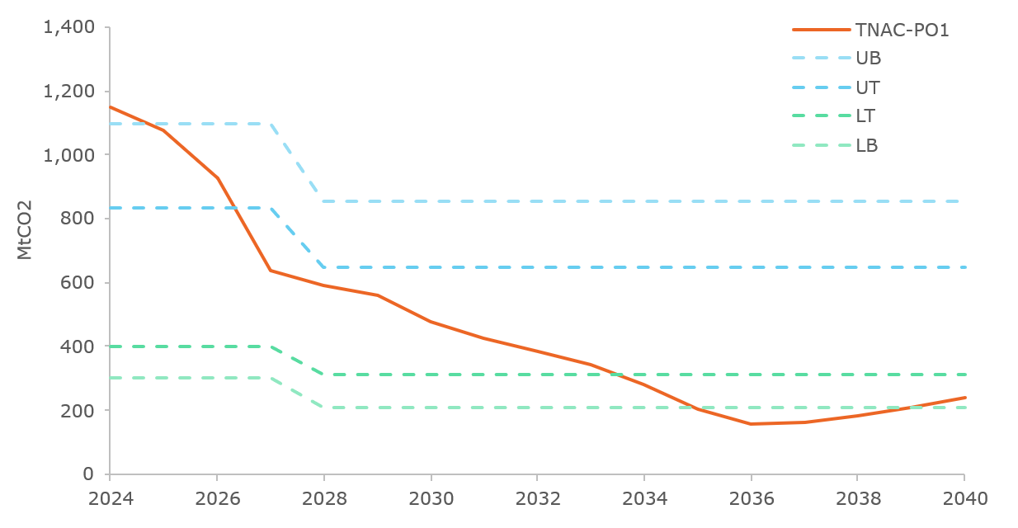
Source: Own visualisation derived from the POLES-Enerdata model
PO2 and PO3 are based on the MSR design from the MSR3 measure. Under this measure, new upper thresholds are set as of 2028 (650 million), 400 million maintained for lower threshold, release rate maintained at 100 million. All these parameters are then declining at a fixed proportional rate of 4%. In these policy option runs, the TNAC drops below the lower threshold in 2035. After that, TNAC further drops below the lower buffer until 2040. During this period, the MSR is expected to release between 18 million and 70 million EUAs each year, inducing progressive declines in TNAC at an average rate close to that of the thresholds.
- PO2 & PO3 results - Evolution of the TNAC and MSR thresholds
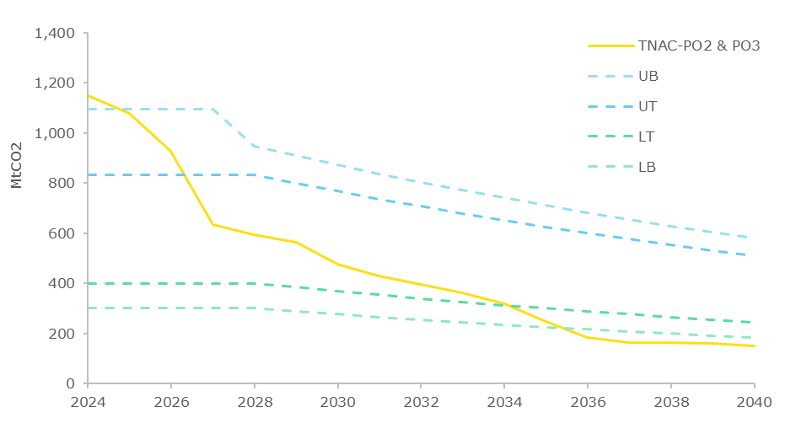
Source: Own visualisation derived from the POLES-Enerdata model
The TNAC evolutions in PO1 on the one hand, and PO2 and PO3 on the other hand, lead to significant differences in MSR operations relative to the baseline scenario. The releases start in 2035 in PO1, one year earlier than in PO2 & PO3. However, the cumulative amount of EUAs released over 2034-2040 is higher in PO1 than in PO2 and PO3, with a yearly average of 66 million EUAs for PO1 compared to 40 million EUAs in PO2 and PO3.
- Policy options results - Evolution of MSR operations
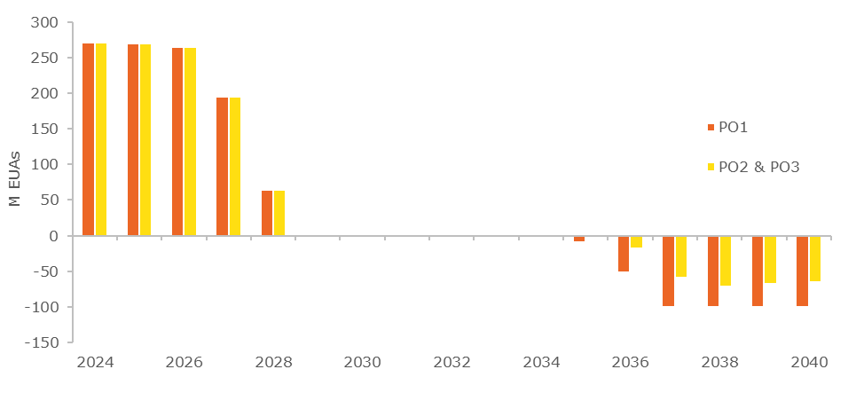
Source: Own visualisation derived from the POLES-Enerdata model
This mechanically leads to a difference in the evolution of the stock of EUAs in the MSR. All considered policy options include the termination of the invalidation mechanism after 2027 which implies an accumulation of about 659 million EUAs in the MSR by 2029. By 2040, this initial stock declines according to different profiles under PO1 on the one hand, and PO2 and PO3 on the other hand. The latter options see releases starting later than in PO1, but with lower quantities released. Eventually, the stock remaining by 2040 is higher for PO2 and PO3 than in PO1, with 442 million EUAs left in the MSR reserve compared to 298 million EUAs. These stocks determine the capacity of the MSR to continue responding to shocks to the liquidity beyond 2040.
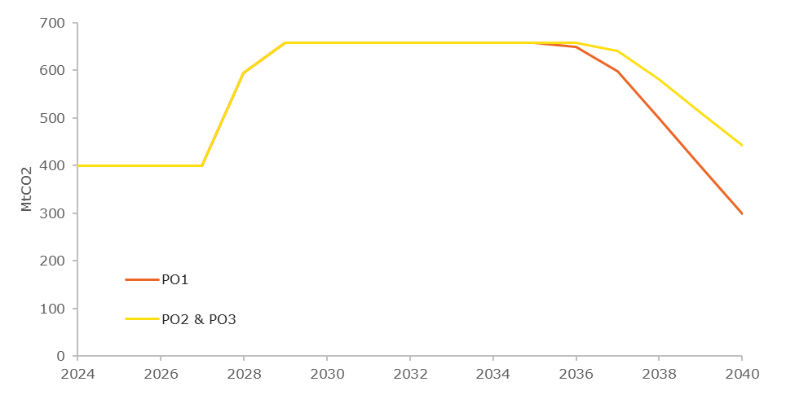
- Policy options results - stock of EUAs in the MSR (January 1st)
Source: Own visualisation derived from the POLES-Enerdata model
The previously presented TNAC trajectory and corresponding MSR operations have notable impacts on the indexed price trajectories produced by the POLES-Enerdata model. PO1 features the same hiatus in EUA indexed price in late 2020s already observed in the measure-level assessment of MSR1, as well as a small decline in early 2030 and the following rapid price increase after 2034. Accordingly, this policy option is undermined by the same drawbacks in terms of lack of continuity in market tightness across the studied horizon.
For PO2 and PO3, the MSR3 design allows for a monotonic and steady increase in the price throughout the period up, indicative of a healthy supply-demand balance on the market. Only a couple of years over 2030-2032 see a stagnation of the price and delay the overall steady increase dynamic. Thus, the MSR3 design remains broadly in line with initial expectations from the market in the PO2 and PO3 environment. More generally, as observed in the MSR3 measure before, the design used for PO2 and PO3 brings a form of stability to the EU ETS price signal, with a progressively increasing price signal, providing a well-balanced environment for actors to invest in decarbonisation activities while leaving them time to undertake the necessary transformations (i.e. not exposing them to rapid price increases).
- Policy options results – EUA indexed price evolution
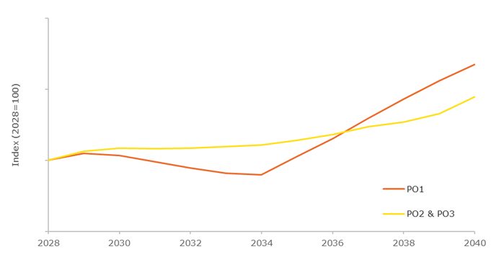
Source: Own visualisation derived from the POLES-Enerdata model
The TNAC-to-emissions ratio is calculated as an approximate measurement of market liquidity. In all measures, the ratio decreases from its high historical values to about 0.6 in 2027 with the TNAC technical correction. It then slightly decreases by 2039, after which the different policy options start to diverge. Starting in 2027, the PO2 & PO3 options include extra-EU aviation one-way emissions, not included in PO1, explaining the slight translation between their respective trajectories after 2027 (before other factors make them diverge further). Likewise, the inclusion of hazardous waste and landfills emissions from 2031 in PO3, not covered in PO2, creates the translation between their respective curves, otherwise comparable in evolution.
In PO1, the decrease continues slow until 2036 to 0.29, a year after the first release from the MSR takes place. After that, due to the continued annual releases, the ratio rises again and reaches its maximum value in 2040 (0.68), exhibiting a u-shaped pattern. For PO2 and PO3, the ratio starts to increase again in 2038, due to the first MSR releases, and then oscillates in a narrow band by maintained by ongoing releases by the MSR, suggesting a steady state for this indicator. The spread of the ratio for the 2027-2040 period is slightly lower for PO2 (0.28-0.59) compared to PO3 (0.25-0.59). although both are within an acceptable range. The PO1 spread is wider (0.29-0.68), and features values on the relatively high range in the last years of the period (above 0.6).
- Policy options results - TNAC-to-Emissions ratio
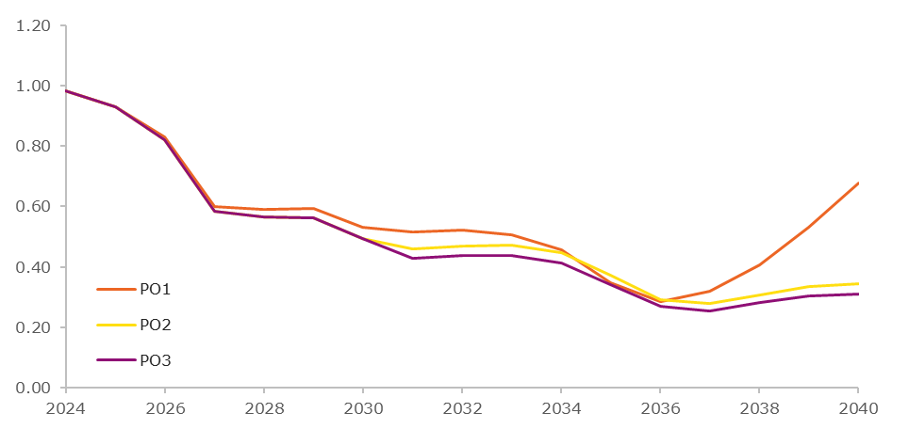
Source: Own visualisation derived from the POLES-Enerdata model
The following table provides a summary of the main results of the policy option analysis.
- PO summary dashboard
 | Baseline | PO1 | PO2 | PO3
When is LT < TNAC < UT ? | 2027-2039 | 2027-2033 | 2027-2034 | 2027-2034
First year of release from MSR | 2041 | 2035 | 2036 | 2036
Cumulative volume of release by 2040 (M EUAs) | 0 | 461 | 282 | 282
Cumulative emissions over 2026-2040 (MtCO₂) | 10,350 | 10,690 | 11,817 | 12,379
Cumulative emissions over 2026-2040 (MtCO₂) – excl. waste, landfills and extra-EU aviation for comparability | 9,687 | 10,690 | 10,598 | 10,598
Stock of EUAs in the MSR in 2040 (M EUAs) | 400 | 298 | 442 | 442
Stock of EUAs in the MSR in 2050 (M EUAs) | 0 | 0 | 0 | 0
TNAC-to-Emission ratio spread over 2027-2040 | 0.68-2.05 | 0.29-0.68 | 0.28-0.59 | 0.25-0.59
The liquidity indicators in the table above suggest that all policy options represent material improvements compared to the baseline. Notably, PO2 and PO3 perform better on the TNAC-to-Emission ratio, with a spread remaining within a narrower range of 0.25-0.59, closer to the generally accepted range of 0.3 to 0.6 for a balanced market with sufficient liquidity, compared to PO1's broader spread of 0.29-0.68. Moreover, the price increase towards the end of the assessment period is also more moderate and monotonic for PO2 and PO3 relative to PO1. Similar to the measure-level analysis, PO2 & PO3 offer a progressively increasing price signal that emerges from a market environment with sufficient liquidity and incentivises regulated entities to invest in decarbonisation. As for the environmental impact, cumulative emissions excluding waste, landfills and extra-EU aviation shows that all policy options have similar emissions reductions over the period, though slightly above the baseline. However, PO2 and PO3 appear to deliver marginally lower cumulative emissions than PO1.
On this basis, PO2 and PO3 under MSR3 are considered the preferred options, as they achieve emissions reductions comparable to PO1 while providing stronger economic performance.
  - Price volatility analysis
Regarding price volatility, it is important to note that within-year price volatility cannot be assessed quantitatively with the modelling approach employed in this analysis. Moreover, all the policy options assessed share the same Article 29a release mechanism, whose objective is to address high price movements, so cannot be distinguished in this regard. More generally, high price volatility, whether within-year or inter-annual, tends to occur in markets characterised by low liquidity. Nonetheless, the inter-annual variability of the price paths shown reveals information about the comparative stability offered by the different policy options. PO1 exhibits a notable price dip around 2032-2033, followed by a rapid and steep increase through to 2040, which would prove challenging for regulated entities facing first steady, then declining and then rapidly rising carbon costs with only little time to adjust their decarbonisation strategies. In contrast, PO2 and PO3 demonstrate a more progressive and monotonic price trajectory throughout the assessment period, offering a credible and steady price signal that facilitates long-term investment planning.
  - Modelling limitations on integration of removals and sectoral scope coverage
The PO2 and PO3 policy options consider different approaches for the integration of removals in the ETS, via a net cap or a gross cap. As explained in the methodological annex, given the use of exogenous values for removals in the POLES-Enerdata model, the results obtained above are identical in the two options. In practice, this is a simplification used for the modelling analysis, which does not take into account some effects presented below, which are assumed relatively limited by 2040 so that results are considered robust.
With time, the EU ETS will see its covered emissions decrease, along with a greater integration of removal units. Regardless of the approach to removals integration, this means that the volume of remaining emissions which corresponds to removal units will increase and become the dominant part of ETS emissions. The difference then lies in the question of who bears the risk that these removals will materialise and in the time dimension of pricing, as well as in the interaction between the price of EUAs and the cost of removals.
In PO2 and PO3, with direct integration of removals, the deployment of BECCS and DACCS is directly incentivised by the EUA price. This is therefore a situation of an endogenous development of removals, responding to the price signal generated by the EU ETS. It implies that the abatement cost of the removals technologies is taken into account in the equilibrium price formation, albeit under different cap levels. Consequently, the carbon price should reflect this development and progressively converge towards the marginal cost of removal technologies unless the removals would be supported by contracts for difference. This mechanism is not captured in the modelling developed in this study. The PO1 philosophy envisages a different approach. In this scenario, the removal units are expected to be available on the market with a set volume as determined by a public authority which procures and auctions a predetermined volume of removal units, regardless of their abatement cost. Consequently, it is the public authority, not the regulated entities, that face the price signal emanating from the removals market and reflecting the marginal abatement costs for removals.
In addition to these differences in the approach to removals integration, the three policy options differ in terms of sectoral scope coverage, with PO1 maintaining roughly the current scope, while PO2 expands the scope to municipal waste incineration and PO3 also includes hazardous waste incineration and landfills. In general, a larger ETS scope implies a larger supply of EUAs, but also a stronger demand from the additional sector covered. The market is hence larger, but differences in market tension and price formation depend on many factors, including also on the ability of the additional sectors to deliver emission reductions in line with their respective cap. Enlarging the coverage of the ETS also allows to access new decarbonisation potentials and therefore increase the potential for economical optimisation by leveraging the easiest-to-abate emissions first.
  - Adjustment of the official TNAC in 2025
The results for policy options PO1, PO2 and PO3 presented in Section 5.1 are based on a modelled TNAC on the basis of the POLES-Enerdata model, derived from the cap and projected future emissions reductions in line with a 90-85% target in 2040. According to the POLES-Enerdata modelling, the 2025 TNAC would stand at 1,078 million allowances, compared with the official 2025 TNAC of 1,023 million allowances published on 29 May 2026.
This gap of 55 million allowances is explained by the fact that the model simulation assumes stronger emissions reductions than those observed in 2025. As a result, this difference affects not only the future TNAC projections throughout the period but also the future operations of the MSR and, consequently, the EUA price developments. This section provides a qualitative assessment of the main implications for the policy option results when adjusting for the 2025 TNAC.
According to the modelled TNAC, the MSR absorbs 245 million intakes in 2025 and 96 million in 2026, with no further intakes after 2027 as TNAC no longer stands between the upper threshold and buffer. Adjusting to the official 2025 TNAC, the MSR operation results in lower intakes, with a 190 million intake in 2025 and 58 million in 2026. For the same reason explained for the model, no additional MSR intakes are expected to occur after 2027.
As a result, the MSR reserves using an adjusted TNAC would amount to 585 million allowances by 2030 compared to 659 million in the model, a difference of 74 million allowances. While this gap is not insignificant, it remains within acceptable boundaries and will have only a limited effect on MSR releases in the future. Importantly, the size of the reserve will remain sufficient to stabilise the market if supply tightens after 2030. The core trajectory of MSR operations remains in line with expectation and the conclusions of the POLES-Enerdata modelling.

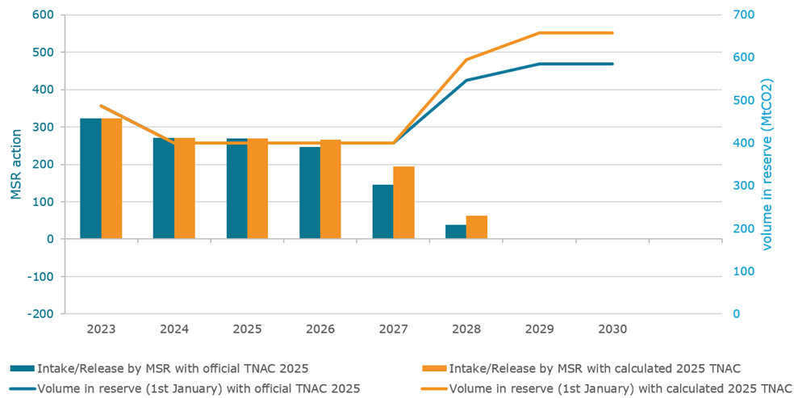
- MSR operations and reserve volume for calculated and official TNAC
Source: Enerdata calculations based on static MSR representation of PO2-MSR3+ with –4.0% configuration
  - Assessment of the timing of supply on MSR operations.
This section assesses the impact of the use of the remaining free allocation buffer 2021-2030 on the supply and consequently on MSR operations until 2040. The Directive establishes a buffer equal to 3% of the total quantity of allowances that would otherwise have been auctioned, to be used where demand for free allocation before 2030 would trigger the application of a uniform cross-sectoral correction factor. In the absence of such a trigger, the allowances concerned would have been auctioned gradually in Phase V.
However, as the buffer will be fully used for free allocation to industry operators between 2028-2030, this will result in a sooner and more concentrated allocation of allowances than would otherwise have been in case of auctioning and will have an impact on the functioning of MSR operations.
The starting point is the results for policy options PO1, PO2 and PO3 presented in Section 5.1, which are based on a modelled TNAC on the basis of the POLES-Enerdata model, derived from the cap and projected future emissions reductions in line with a 90-85% target in 2040.
The use of these free allowances by industry operators can be threefold: i) a part of these allowances will be used by industry operators to surrender against (additional) emissions during this period; ii) a part of these allowances will be monetised either to obtain funding for investments in decarbonisation of industrial process, reducing future emissions and demand for allowances or simply to raise capital for other costs; and iii) part of these allowances may be banked by industry operators for future usage in the next decade.
The effects of the full allocation of the 3% buffer to industry operators as free allowances in the period up to 2030 may delay industry decarbonisation in the short term by reducing the incentive to invest in emissions cuts. A higher TNAC and a weaker demand reduction may result most likely in downward pressure on ETS prices in the short term in the period 2028-2030 as compared to the scenario outlined in section 5.1. As regards the longer-term effects, the use of the earlier free allowances by industry operators, may result in higher emissions and higher TNAC over the period 2031-2040. Therefore, the downward pressure on ETS prices is likely to be prolonged while MSR releases are expected to be delayed compared to the results highlighted in section 5.1.
As part of this proposal and set out in Annex 9 of this Impact Assessment, 400 million allowances will be supplied to the industry stakeholders starting ahead of 2030 to finance industrial decarbonisation investments, known as the ‘investment booster’. These allowances are to be allocated based on a fixed carbon premium to eligible projects within the Union on a ‘first in, first served’ basis. It is then expected that these investment-linked allowances will scale up gradually in the early period 2030-2035, followed by a gradual phase out by 2040. The introduction of the booster also introduces a significant volume of allowances that will come to the market gradually in for a maximum period of 10 years subjective to project implementation. Consequently, this additional volume will likely further affect the liquidity and future ETS future prices.
The above assessment demonstrates that the proposed changes to the MSR to adjust parameters dynamically over time would still allow the MSR to deliver on its policy objectives: to address risks of an increased surplus, remain resilient to supply shocks and take account of a shrinking cap. This is because the effect of the increase in the TNAC combined with the changes in thresholds would ensure that the market is balanced for a longer period, resulting in the TNAC to reach the lower threshold at a later time and releases being delayed towards the late 2030s. The dynamic thresholds would also ensure that any surplus in the market would be addressed by the intake rates, followed by to the overall evolution of the shrinking market. Therefore, the current calibration of parameters as outlined in section 5.1 remains appropriate.

Appendix 1. MSR Sensitivity analysis on selected measures
Measures MSR1 and MSR3 have been selected to be further tested with a sensitivity analysis. Indeed, the results presented above are derived from a single scenario run, which depends on multiple assumptions. It is therefore important to verify that these designs still function in the event of deviations from the base case. These deviations originate from uncertainties in the diverse assumptions used: economic context, availability of decarbonisation technologies, structural imbalances, etc.
In practice, the sensitivity analysis consists in adding a number of “shocks” in the system, run the modelling, and observe the deviations in the results. The various shocks tested aim to represent different types of deviation to the base run and are presented below. The shocks are introduced in the model in the form of an exogenous net supply-demand balance, which impacts the market operations through either an additional demand or an additional supply of EUAs. This, in turn, impacts the TNAC trajectory, the overall supply-demand equilibrium and therefore the price formation and the operations of the MSR.
Some of the shocks represent discrete events such as an economic crisis and are therefore modelled as unanticipated shocks. This means that actors, over their modelled anticipation horizon, do not adjust to the shock before it is introduced. On the other hand, some shocks represent structural imbalances, happening progressively, and are therefore anticipated by actors, within their modelled horizon.
- Definition of the shocks
The first shock introduced in the model (S1) aims at representing a large economic crisis, which would typically lead to a cyclical drop in EU ETS-covered emissions, and therefore to a relative oversupply of EUAs. This type of shock is, by essence, unanticipated. The value used to model this type of shock is inspired from two historical events, which had a similar magnitude of impacts on the ETS-covered emissions: the 2009 crisis and the COVID pandemic. In both events, emissions have dropped by around 10% year-on-year (in 2009 and 2020, respectively). Then, as compared to a reference point, the recovery from the economic crisis happened over a couple of years and was not necessarily complete: the long-term absolute values for emissions remain below a reference case.
In the S1 shock, it is therefore assumed that a crisis happens in 2030 with a -10% impact on emissions (using the MSR0 emissions as reference). In subsequent years, emissions are lowered by 4% from MSR0 values in 2031 and 2% in 2032. Thereafter, it is assumed that the difference in emissions with the reference case remains constant. The obtained net supply-demand balance corresponding to S1 is illustrated in Figure 34 below.
- S1 shock definition - Additional exogenous net supply-demand balance
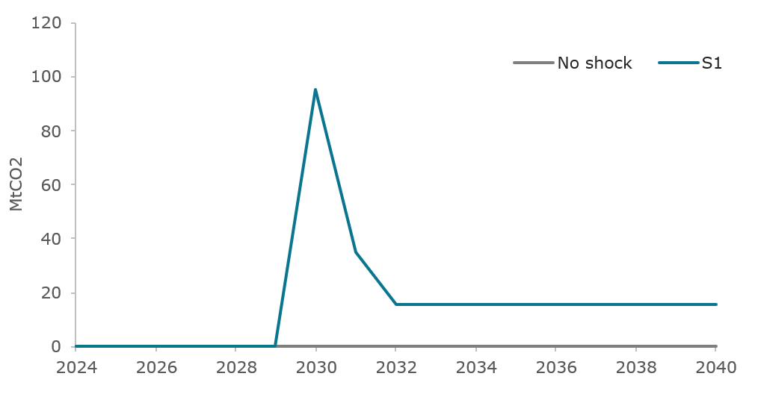
Source: Own visualisation derived from the POLES-Enerdata model
The second shock introduced, S2, envisions an unexpected cyclical shock in the opposite direction., i.e. a shock which creates a net demand of allowances, as compared to the base case. This can, for instance, echo the 2022-2023 gas crisis where additional coal-fired power generation was used, leading to higher emissions than initially expected. More generally, S2 can also represent a large-scale unavailability of decarbonized technologies (e.g. nuclear fleet unplanned unavailability, decarbonisation technologies massive supply chain disruption, etc.). Although the typical magnitude of such events is typically smaller, the envisioned shock introduces the following deviation in emissions from the MSR0 base case: +8% in 2030, +2% in 2031, and then back to normal from 2032 onwards. The corresponding net EUA demand input exogenous to the model is presented in Figure 35.
- S2 shock definition - Additional exogenous net supply-demand balance
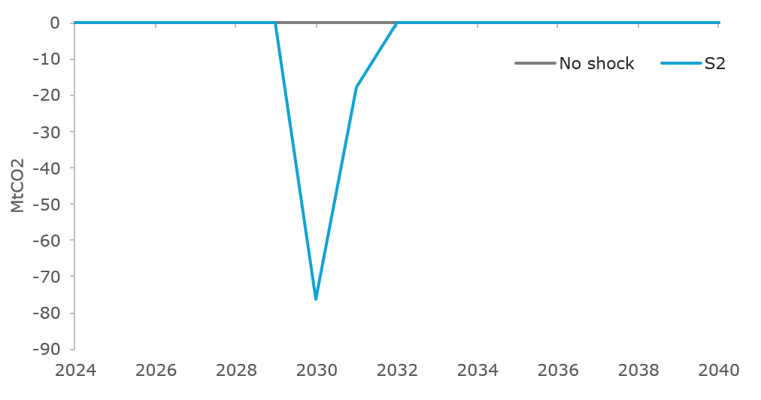
Source: Own visualisation derived from the POLES-Enerdata model
The third shock introduced, S3, represents a case of late availability of carbon removal technologies, namely BECCS and DACCS. It assumes that this delayed removals availability would be reflected on the cap for gross emissions in the EU ETS scope, without assuming an explicit integration of removals in the EU ETS scope. The additional net supply-demand balance introduced in S3 therefore corresponds to a delay of four years in the development of BECCS and DACCS, as compared to the MSR0 base case. It is illustrated in Figure 36. The non-monotone trajectory corresponds exactly to a four-years delay in the availability of removals and is therefore directly derived from the removal development pathways considered. This shock is assumed anticipated by actors, as removal development projects are regularly announced and publicized by their operators and developers.
- S3 shock definition - Additional net supply-demand balance
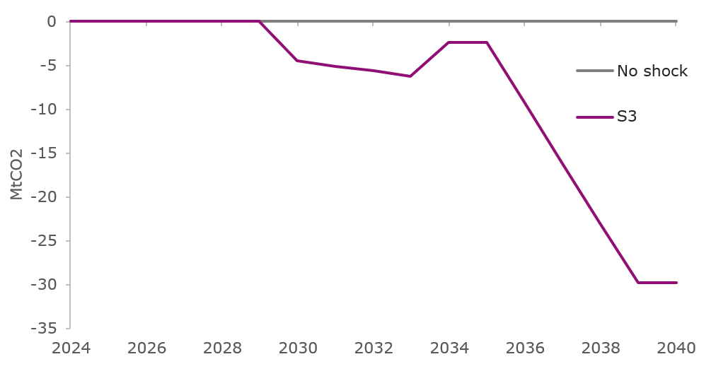
The fourth and fifth shocks, S4 and S5, represent progressive structural imbalances, as compared to the base case. S4 and S5 are symmetrical, with S4 corresponding to a positive supply-demand balance and S5 to a negative supply-demand balance. Both these shocks are anticipated by actors in the modelling. Shock S4 aims to represent any deviation from the base scenario leading to a decreased demand of EUAs, such as an accelerated decarbonisation through other policy instruments than the EU ETS, e.g. regulatory measures by Member states, or thanks to cheaper decarbonisation technologies than expected. It could also represent a slower economic growth, or a lower demand from the aviation and maritime sectors (considered exogenously in the model), etc. Conversely, shock S5 represents deviations leading to an increase demand of EUAs compared to the base case: slower decarbonisation (weaker regulatory policies, more expensive decarbonisation technologies), higher economic growth, higher emissions from aviation and maritime sectors, etc. The modelled net supply-demand balances for S4 and S5 are illustrated in Figure 37 and are assumed to increase linearly from 2027 to 2040, representing a progressive and continued deviation.
- S4 and S5 shock definition - Additional net supply-demand balance
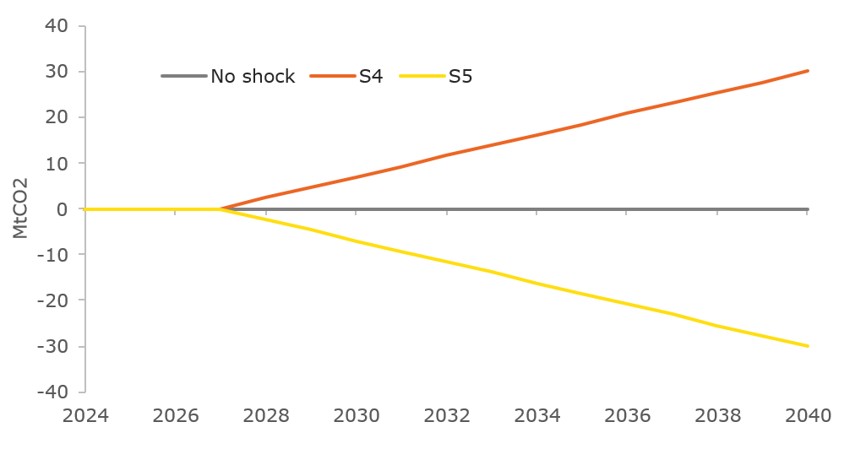
Source: Own visualisation derived from the POLES-Enerdata model
- Results from the shock sensitivity analysis
This section presents the main results from the analysis of the five shocks defined above. All five shocks are designed as high-magnitude events, hence allowing to consider large deviations from the base measure scenarios. It focuses first on the impacts of cyclical shocks S1 and S2. Shocks of a more structural nature, S3 to S5, are then analysed, before concluding on the system resilience induced by the two candidate measures.
- Cyclical shocks
Both S1 and S2 shocks are designed to represent punctual events perturbating the EU ETS, as compared to the base scenario. Their overall shapes are rather symmetrical, although it is assumed that S1 brings a long-term deviation in the emission trajectory, which is not the case in S2 (as presented above).
Figure 38 below shows the resulting TNAC trajectories, in the POLES-Enerdata model, when applying the S1 and S2 shocks on measures MSR1 and MSR3. For both measures, introducing shocks S1 and S2 has a substantial impact on the TNAC in the early 2030s. The date of the first MSR release is consequently shifted by a few years forward or backward. Differences are decreasing, yet remain, between the MSR1 original scenario and the shock sensitivities by 2040. In the case of MSR3, the TNAC seem to converge by around 2037 in the three model runs.
- MSR sensitivity analysis - S1 & S2 - TNAC evolution for MSR1 (left) and MSR3 (right)
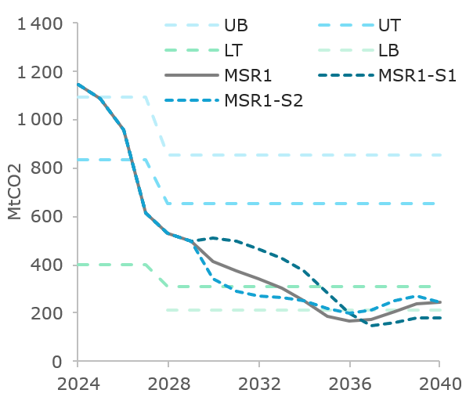
Source: Own visualisation derived from the POLES-Enerdata model
In both measures, the S1 shock leads to later releases by the MSR, and S2 leads to earlier releases. The MSR indeed helps the market to stabilize in the presence of these punctual shocks, in the intuitive direction. In the case of an economic crisis inducing lower emissions in S1, releases by the MSR are postponed, as the market has higher liquidity. Symmetrically, in S2, as the market gets tight quicker, the MSR releases earlier to ease market tension. The stock of EUAs in the MSR is shown in Figure 39, from which one can also derive the MSR operations. The cumulative releases by 2040 under the MSR1 configuration range from 258 million EUAs in S1 to 470 million EUAs in S2 (as compared to 398 million EUAs in the base MSR1 scenario). In the case of MSR3, these range from 105 million EUAs in S1 to 309 million EUAs in S2 (as compared to 255 million EUAs in the base MSR3 scenario).
- MSR sensitivity analysis - S1 & S2 – stock of EUAs in the reserve for MSR1 (left) and MSR3 (right)
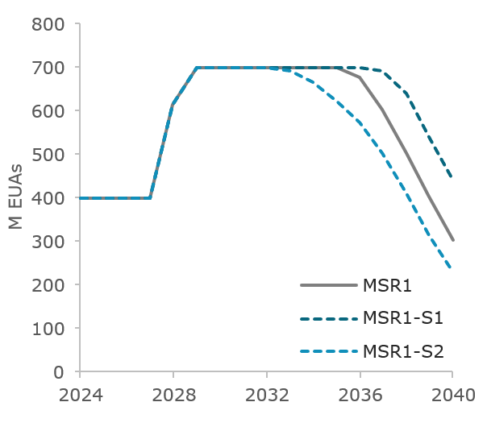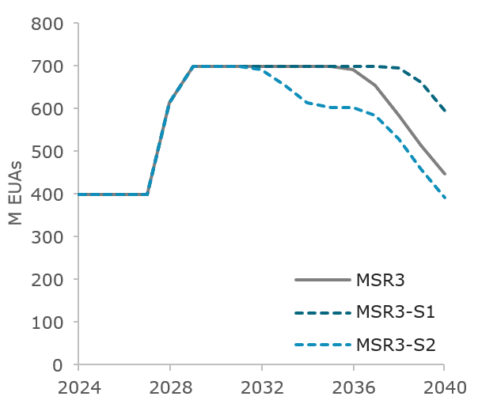
Source: Own visualisation derived from the POLES-Enerdata model
Figure 40 displays the indexed price evolutions with the S1 and S2 shocks, under MSR1 and MSR3. As expected, introducing high magnitude punctual shocks to the system leads to substantial impacts on the price trajectories. The price evolution is affected by different factors. Intuitively, the punctual deviation in the EUA supply-demand balance at the time of the shock shifts the price equilibrium on the market. In the case of S1, the effect is lasting over time, as the exogenous supply-demand balance remains constant after 2032. In the case of S2, the long-term impact is more limited but still exist.
Beyond that direct effect, there are dynamic effects which can further impact the price. First, a change in the price at the time of the shock impacts the incentives for actors to reduce their emissions. Hence, this leads to lower emission reductions for a period of time, which can in turn affect the future demand of EUAs and could temporarily drive down their price. Second, the actors are modelled as anticipating over a rolling time horizon of 8 years, which means that they adjust to a possible future scarcity in the system. In S2, with the MSR starting to deplete towards the end of the 2030s, a lower stock in the MSR could lead to an increased price, with actors beginning to anticipate for future scarcity, and conversely for S1.
- MSR sensitivity analysis - S1 & S2 – EUA indexed price for MSR1 (left) and MSR3 (right)
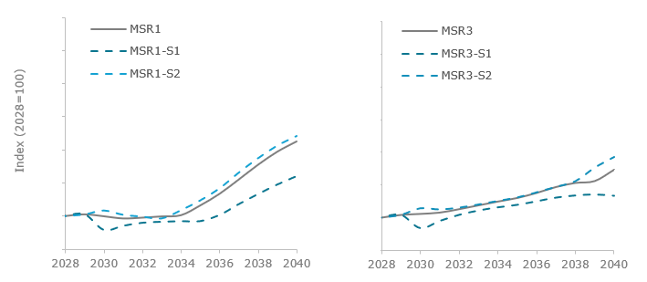
Source: Own visualisation derived from the POLES-Enerdata model
For both MSR1 and MSR3, the S1 and S2 shocks lead to broadly similar shapes for the price trajectories, as compared to the initial runs. In both cases, the S2 shock has lower impacts on the price than S1, which is explained by a slightly lower magnitude of the punctual shock, as well as no permanent effect. With MSR1, the S1 shock leads to a lower 2040 price than the base MSR1 scenario, and the S2 shock to higher price. With MSR3, the long-term price impacts in 2040 are lower in S1 and higher in S2, although up to 2037 the spread was much lower.
- MSR sensitivity analysis - S1 & S2 – EU ETS emissions for MSR1 (left) and MSR3 (right)
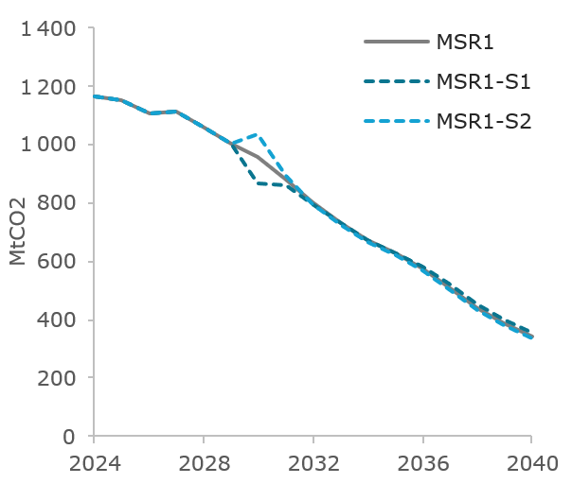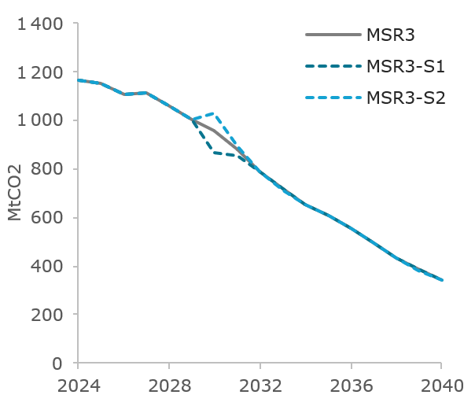
Source: Own visualisation derived from the POLES-Enerdata model
In terms of EU ETS-covered emissions, shown in Figure 41, the S1 and S2 shocks mostly lead to a two-year divergence, with emissions quickly aligning again on the base trajectory. Minor differences subsist in MSR1 with roughly 15 MtCO2 in 2040, while in MSR3 the differences are almost inexistant.
- Structural shocks
As opposed to the S1 and S2 shocks previously analysed, the S3 to S5 shocks are of a more structural nature. They lead to progressive and increasing deviation from the base run, in terms of exogenous supply-demand balance added to the POLES-Enerdata model, as explained previously.
The evolution of the TNAC trajectories, with the three shocks, under the MSR1 and MS3 configurations, are provided in Figure 42 below. For both MSR1 and MSR3, the trajectories slightly deviate from the base case, although to a moderate degree, and tend to progressively align with it by the end of the 2030s.
- MSR sensitivity analysis – S3 to S5 - TNAC evolution for MSR1 (left) and MSR3 (right)
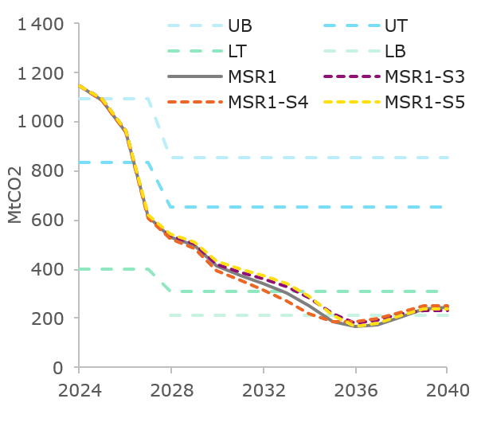 Source: Own visualisation derived from the POLES-Enerdata model
The MSR is adjusting well to the 3 shocks and supports market stability by releasing EUAs earlier or later in the system (depending on the direction of the shock). These adjustments can be observed by looking at the stock of EUAs in the MSR, presented in Figure 43. They lead to different remaining stocks by 2040, ranging from 230 to 350 million EUAs in MSR1 and from 370 to 540 million EUAs in MSR3.
- MSR sensitivity analysis - S3 to S5 – stock of EUAs in the MSR for MSR1 (left) and MSR3 (right)
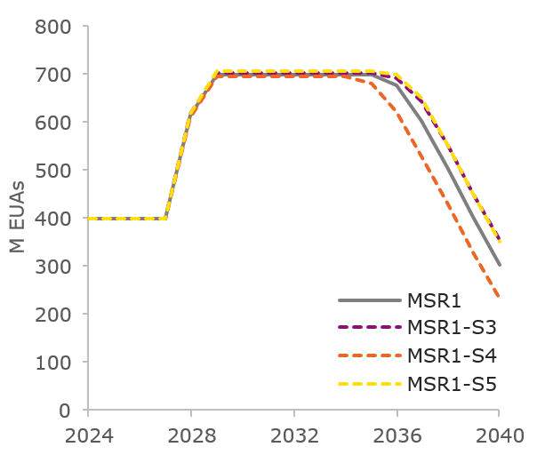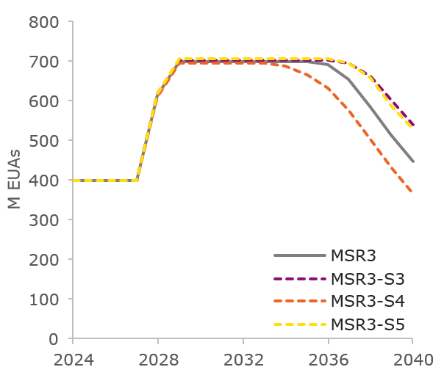
Source: Own visualisation derived from the POLES-Enerdata model
In terms of the EUA price, structural shocks S3 to S5 lead to substantial impacts, as compared to the base MSR1 and MSR3 runs. The structural deviations in the supply-demand equilibrium lead to significantly higher price trajectories for S3 and S5, and lower price trajectories for S4, in both cases (as shown in Figure 44)
- MSR sensitivity analysis – S3 to S5 – EUA indexed price for MSR1 (left) and MSR3 (right)
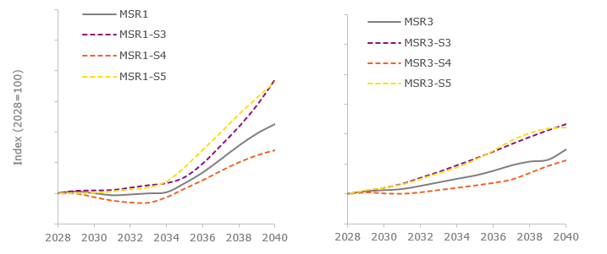
Source: Own visualisation derived from the POLES-Enerdata model
As shocks are implemented as an exogenous net demand for EUAs, i.e. inelastic to the price, and with an important magnitude, it is expected that they induce significant variations to the price trajectory. In the case of MSR1, the deviation between the base case and the shock sensitivities increases progressively up to 2035, and then quickly increases. With the MSR3 design instead, the price deviations are more progressive over the whole period, with smoother index curves by 2040.
- MSR sensitivity analysis – S3 to S5 – EU ETS emissions for MSR1 (left) and MSR3 (right)
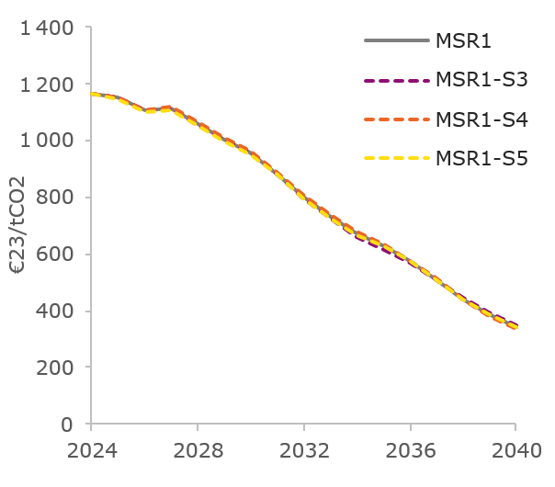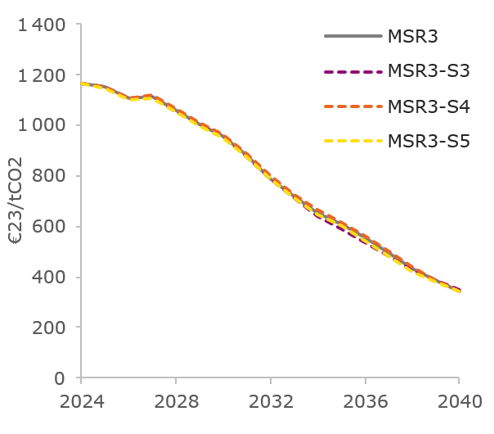
MtCo2
MtCo2
Source: Own visualisation derived from the POLES-Enerdata model
Finally, the impacts of S3 to S5 shocks on EU ETS-covered emissions is relatively limited, as illustrated in Figure 45. Under both MSR1 and MSR3, resulting emissions remain close to their respective base runs, with a difference in cumulative emissions over 2025-2040 of less than 1%. By 2040, maximum differences in emissions are about 11 MtCO2 in MSR1 and 4 MtCO2 in MSR3.

Resilience of candidate MSR measures to shocks
Both MSR1 and MSR3 designs enable the MSR to operate in the good direction when presented with shocks, as shown above. To conclude on their respective performance in terms of system resilience, a set of relevant indicators is examined below.
First, Figure 46 shows the maximal spread (over shocks S1 to S5) of the TNAC-to-emissions ratio for both MSR1 and MSR3. Up to 2037, the two measures present similar spreads, with values contained between 0.3 and 0.6, sign of a healthy surplus. In MSR1, the values then rise quickly and get mostly out of this zone by 2040 (0.52-0.75), which shows some limits of this measure already by 2040. On the other hand, MSR3 sees its ratio staying in the 0.3-0.6 zone, with a narrowing spread at the end of the period, which shows higher resilience. This design indeed manages to get the ratio to similar values in the presence of very different shocks.
- MSR sensitivity analysis – TNAC-to-emissions ratio, maximum spread across S1-S5 – MSR1 (left) and MSR3 (right)
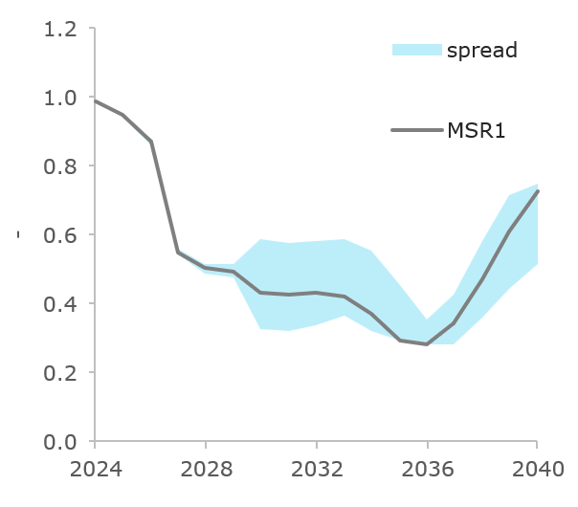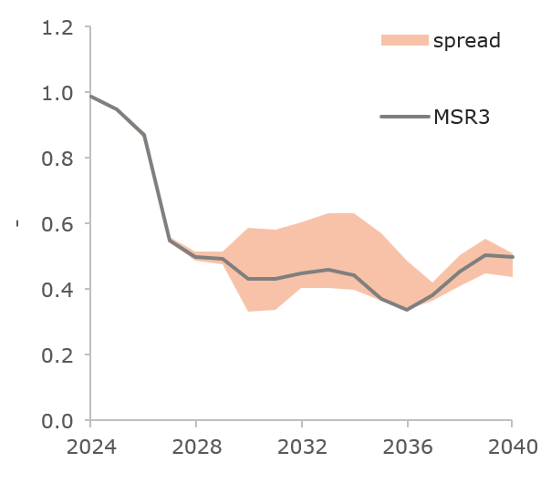
Source: Own visualisation derived from the POLES-Enerdata model
Regarding indexed prices over difference shock scenarios, while MSR1 satisfactorily manages to maintain a relatively close price spread up to 2034, it fails to contain divergences in the price trajectories obtained in different shock by 2040. The more elaborated design tested in MSR3 performs better, with smoother price trajectories and a smaller 2040 spread.
In addition to the TNAC-to-emission and price spreads discussed above, two additional items are brought forward. First, the convergence of the TNAC back to the no-shock trajectory, a few years after the shock is introduced, is a good indicator of the MSR's ability to adjust to specific contexts. This convergence is noticeable in the case of MSR1, although not entirely, and is further observed in MSR3. Second, the convergence of emissions back to their original trajectory is an interesting indicator to monitor. In that regard, both MSR1 and MSR3 lead to satisfactory alignments in emissions in the presence of shocks.
The sensitivity analysis focuses on MSR1 and MSR3 as these measures demonstrate greater viability regarding liquidity under baseline conditions. Testing shock scenarios serves to assess the robustness of viable MSR designs rather than further diagnosing the structural weaknesses already identified in MSR0+ (reserve depletion) and MSR2 (locked reserve dynamics). Five shock scenarios are examined (Appendix 1 for detailed descriptions). The shocks are introduced in the model as exogenous adjustments to the net supply-demand balance, impacting market operations through either additional demand or additional supply of EUAs. S1 and S4 increase the net supply-demand balance, while S2, S3, and S5 decrease it.
Under shock profiles S1 and S2, both MSR1 and MSR3 exhibit the expected and directionally appropriate liquidity responses as demonstrated by the evolution of TNAC in Figure 38 and Figure 39. S1's increased net supply-demand balance (loosening) elevates TNAC trajectories in both measures and delays releases. MSR3 exhibits greater TNAC sensitivity. It is important to note that despite the relatively large negative shock to the demand for EUAs under S1, no intakes are triggered even with the dynamic and declining thresholds of MSR3.
Conversely, S2's tighter net supply-demand balance (tightening) accelerates TNAC decline, triggering earlier releases in both measures that are cumulatively larger over the assessment period. Reserve stocks respond accordingly: under S1, MSR3 preserves approximately 600 million EUAs by 2040 versus MSR1's 450 million EUAs, while under S2 both measures experience faster depletion though MSR3 retains a higher stock in 2040. The differential reserve preservation reflects MSR3's larger baseline stock and adaptive release calibration, providing greater post-2040 intervention capacity across both demand scenarios.
S3, S4, and S5 produce more modest liquidity impacts than S1 and S2, with TNAC trajectories remaining closely aligned to baseline conditions in both measures. As with S1 and S2, these shock scenarios do not trigger intakes and release dates move forward or backward as expected by a few years relative to the respective baselines. S4, which increases the net supply-demand balance, exhibits the most pronounced effect on reserve dynamics. Under S4, both MSR1 and MSR3 experience accelerated depletion from the mid-2030s, with MSR1 reserves declining to approximately 250 million EUAs by 2040 compared to 300 million EUAs under baseline, while MSR3 maintains approximately 370 million EUAs versus 460 million EUAs under baseline. S3 and S5, which decrease the net supply-demand balance, produce marginally slower reserve depletion. MSR stocks in 2040 are moderately above baseline in both measures. The consistent TNAC evolution across S3-S5 scenarios despite varying shock directions reflects the relatively smaller magnitude of these perturbations compared to S1 and S2. MSR3's larger baseline reserve provides sustained intervention capacity advantage across all three scenarios, though the S4 combination demonstrates that sufficiently strong supply-side shocks can materially compress this buffer.

Annex 9: Industrial Decarbonisation Bank

List of Tables
Table 1: Effectiveness of measures on allocation mechanism 186
Table 2: Effectiveness of measures on type of support 189
Table 3: Effectiveness of measures on geographical balance 192
Table 4: Efficiency of measures 194
Table 5: Coherence of measures on allocation mechanism 198
Table 6: Coherence of measures on the type of support 199

List of Figures
TOC \h \z \t "Figure title" \c Figure 1: MS auctioning revenues and reported usage (in billion EUR) 156
Figure 2: Problem definition 159
Figure 3: Intervention logic 163
Figure 4: Proposed scopes of the IF and IDB 165
Figure 5: Overview of policy measures 165
Figure 6: Overview of policy options 166
Figure 7: Abatement costs assumptions 179
Figure 8: Modelled consecutive support logic for two consecutive funding rounds 181
Figure 9: llustration of impacts of the IDB funding rounds in 2030 and 2039 183

- Introduction
Abating industrial emissions in the EU represents important challenges. So far, progress has been moderate (17% reduction in 2023 compared to 2015), through energy efficiency and fuel switch and partly due to closure of industrial installations or reduction of the industrial output. The EU ETS evaluation indicates that in many industrial sectors (e.g. steel, cement or chemicals), the carbon price signal (together with regulatory framework) has not been strong enough to drive the transformational change. Reaching the 2040 climate target and climate neutrality in 2050 will require deep GHG emissions reductions of 70 to 85% by 2040 (compared to 2015) across all industrial sectors. Achieving these reductions while expanding and modernising the EU’s industrial base will demand significant capital investments (CAPEX) in decarbonisation - see section ‘Investment needs and system costs’ in Annex 8. These investments will also require even larger operational expenses (OPEX). Investments in decarbonisation technologies are essential to enable decoupling of the industrial emissions from the industrial output.
The carbon price signal from the EU Emissions Trading System (EU ETS) together with Free Allowances phase-out and Carbon Border Adjustment Mechanism (CBAM) phase-in, already provide strong incentives for industrial decarbonisation, while protecting against carbon leakage. In addition, carbon pricing works hand-in-hand with regulatory measures such as targets and requirements on energy efficiency, renewable energy or decarbonised mobility and industry. However, many investments for decarbonisation, in particular in energy-intensive industries (EIIs), today still lack a business case, at current and expected carbon prices and regulatory measures still need time to be fully implemented and firmly influence investment decisions. This is one of the central topics of the 2024 Draghi report. In reaction to growing carbon price, industry can respond by reducing output especially if the demand for ‘green’ products is low or uncertain. Upcoming initiatives concerning lead markets and green premium that they can offer will be alleviating this risk but in the short term the cost gap (‘green’ vs fossil technologies) needs to be covered.
In this context, the Innovation Fund (IF), whose first call for proposals was launched in 2020, has established itself as the key EU instrument to support commercial demonstration/first-of-a-kind (FOAK) deployment of innovative low-carbon technologies in energy-intensive industries (EII), renewables, energy storage and mobility. It has also successfully tested support mechanism for the roll-out of more mature decarbonisation technologies with auctions for RFNBO hydrogen and decarbonised industrial process heat. With over 200 projects in the portfolio, it has proved to play a crucial role in accelerating technological progress, bankability and deployment of innovative climate solutions across the EU, particularly for high-risk, capital-intensive, first-of-a-kind/early commercialisation industrial decarbonisation projects that private instruments cannot support at comparable scale or risk tolerance. At the same time, its continued oversubscription of call budgets (up to 20 times and on average nearly 5 times for all calls for proposals) highlights the private sector’s interest in investing in decarbonisation projects, provided a viable business case is enabled by subsidies that complement regulatory and carbon pricing policies. In recent years, the IF has also started to address more mature technologies via pilot and targeted auctions for renewable and electrolytic low-carbon hydrogen and electrified and direct-renewable process heat. Going forward there is a need to scale up this type of support in order to ensure a competitive selection of projects for cost-effective support of decarbonisation technologies.
As the EU ETS cap becomes more stringent, continued innovation support with broad sectoral coverage and capacity to address both technical and scale-up risks remains essential to address the emissions most difficult to abate and to further develop and diversify low-carbon solutions across EU industry. However, current IF resources are expected to be fully committed by 2028, resulting in a temporary ‘void’ (2028–2030) in support from EU ETS revenues to industrial decarbonisation until the next programming period begins.
In absence of the IF, there is no EU funding instrument that has the necessary resources to provide the necessary volume and duration of subsidies to support innovation and, even more so, for the broad deployment of industrial decarbonisation technologies. In part, this role could be taken up by the future European Competitiveness Fund (ECF), proposed as part of the next Multiannual Financial Framework. The ECF is proposed to allocate EUR 26.2 bn to support for Clean Transition and Industrial Decarbonisation out of the total EUR 234 bn budget. However, the ECF’s clean transition window is expected to have a broader scope than the current IF and are still dependent on the outcome of the legislative process. State Aid could be another source of funding, given streamlined requirements and procedures recently enacted in the Clean Industrial Deal State aid Framework (CISAF). However, national approaches will remain inherently fragmented, lacking the ability to exploit the economies of scale and efficient allocation of resources the single EU market can provide, and will be limited by national fiscal constraints.
Already in 2024, the Draghi report outlined very concrete recommendations as regards industrial decarbonisation:
- Reinforce relevant funding support for the decarbonisation of EIIs, starting by earmarking ETS revenues.
- Simplify, accelerate and harmonise subsidy allocation mechanisms. Adopt common instruments across Member States, such as the European Hydrogen Bank and Carbon Contracts for Difference.
This is why the Clean Industrial Deal (CID) Communication announced the Industrial Decarbonisation Bank (‘IDB’) to address the scale-up and roll-out of more mature industrial decarbonisation projects (notably in EIIs) across all Member States:
The Commission will propose an Industrial Decarbonisation Bank aiming for EUR 100 billion in funding based on funds in the Innovation Fund, additional revenues resulting from parts of the ETS as well as the revision of InvestEU (…). The Industrial Decarbonisation Bank will maximise emission reductions. It will use ETS allowances reserved for this purpose as part of the architecture of the EU ETS to support projects with carbon emission reduction as a metric to enable technology-neutral support across industrial sectors, including through carbon contracts for difference. It will be designed to ensure a competitive selection and a fair distribution of support across Member States. It will complement the ETS price signal and help bridge the funding gap in both capital and operational expenditures.
The proposal for the IDB in the CID makes a clear commitment to use a dedicated part of EU ETS allowances to support the business case for clean industrial transformation of the EII. This model has worked successfully for the IF as well.
The endowment of the IDB proposed in the CID is EUR 100 bn. If IDB supported the industrial decarbonisation projects at the intensity of between 50 to 100 EUR/tCO2 (on top of the EU ETS price), over 10 years, it could address between 40% and 20% of the industrial emissions in the EU (200Mt – 100Mt CO2). Beyond this very simple indication, the sections below provide a dedicated analysis on expected impacts. Comparing the IDB budget to the total investment needs in industry (EUR 30-50 bn/year) as well as their operational expenditure (around EUR 300 bn/year), the IDB represents only a fraction of expenditure. This is justified considering that it should only cover projects ‘funding gap’ and not the costs that can be covered by the market revenues or private investors and that there will be other instruments supporting the transition: ECF, State aid and Free Allocation.
Following the Clean Industrial Deal and meeting of the EU leaders in Alden Biesen on deepening the single market, reducing economic dependencies and boosting competitiveness, at the March European Council the ‘Investment Booster’ was announced. The ‘Investment Booster’ will be the first stage of the IDB. Starting ahead of 2030, 400 million ETS allowances will finance industrial decarbonisation investments with focus on speed and solidarity. Speed will be ensured as support will become available on a ‘first come, first served’ basis. Solidarity will ensure guaranteed access to a share of this financial support for lower-income Member States.
The source of the endowment of the IDB (including the ‘Investment Booster’ phase) and the continuation of the IF can build on the existing EU ETS distribution which assigns a fixed volume of allowances from Member State auctioning and from Free Allocation (including from the phase in of CBAM) or, alternatively, from a fixed share of the EU ETS cap which would ensure a more balanced contribution. The sourcing based on a share of the EU ETS cap would alleviate the dependency on the allowances from the CBAM phase-in and would allow a stronger Member State component in the IDB set up. It is clear from the EU ETS use of auctioning revenues reports that currently a very small share of the EU ETS revenues is used to support decarbonisation of EIIs. The IDB could offer a structural solution for returning the EU ETS revenues to the EII through investment support.

- MS auctioning revenues and reported usage (in billion EUR)
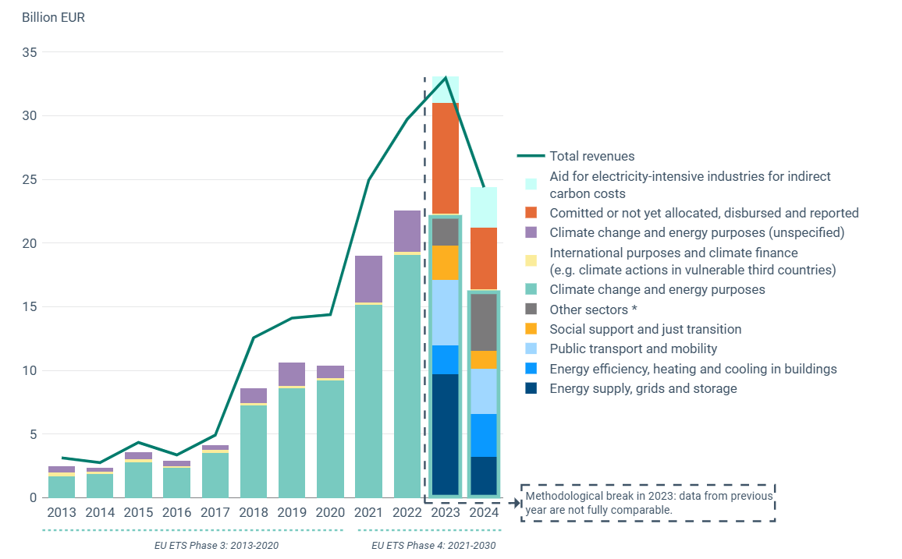
Source: EEA
The IDB could use different allocation mechanisms (e.g. auctions, administratively set schemes) to award support in different forms such as: Regular’ grants, Carbon fixed premia (CFP), Carbon Contracts for Difference (CCfD), fixed or variable premium per unit of green product credits or other types of support – see different options assessed in Section 3. With a budget of EUR 100 billion in funding, the IDB could significantly contribute to reducing industrial GHG emissions; leveraging private investment to modernise the EU industrial base and creating jobs; and boosting industrial competitiveness, especially if combined with stronger EU industrial policy – see impacts assessed in Section 3.4.
Additionally, the CID Communication indicates that a support instrument for CBAM goods at risk of carbon leakage, which can promote decarbonisation efforts and help maintain competitiveness. In view of the increasing rate of the CBAM phase-in and the proportional Free Allocation phaseout rate, a permanent solution for the period after 2030 is needed, which can leverage CBAM resources assigned to the IDB, as well as benefit from the Fund’s governance and allocation mechanisms and forms of support. The IDB’s support mechanisms should be adequate for the CBAM sectors; a consolidated approach (in contrast to a ‘patchwork’ of fragmented and overlapping instruments) would increase the impact of public spending and be more accessible for industry across EII sectors.
With the IDB addressing the scale-up and roll-out in the EIIs as well as the specific needs of the CBAM sectors, the IF would keep its key focus on addressing technical and scale-up risks of innovative technologies to a broader sectoral coverage (EIIs but also renewables, energy storage, clean tech-manufacturing, buildings, mobility). Both programmes would have distinct scopes, minimising the risk of overlaps, preventing ‘forum shopping’ by the projects and offering tailor-made solutions for all stages of the technology development, for all relevant sectors. Importantly the entire investment journey from R&I to industrial deployment of the EIIs is also proposed be covered under the European Competitiveness Fund (ECF). The IDB will be therefore placed within the governance of the future ECF to ensure that both funding instruments are complementary and operate with synergies notably when ECF work programmes are developed.
Importantly, the rollout of the decarbonisation technologies in EIIs will lead to a significant increase in electricity consumption and as a result an expansion of power generation capacities and infrastructure will be needed as described in the modelling work underpinning the climate neutrality scenarios. Power generation expansion and decarbonisation will also bring the investment needs. Innovative clean power generation technologies could be supported under the continuation of the Innovation Fund as well as ECF and clean power rollout could be supported under the ECF, National and Regional Partnership Plans, Modernisation Fund as well as State aid. The IDB, while focusing on the EIIs investment, should also ensure that decarbonisation projects foster the broader energy system integration. As example of such approach is the design of the IF auction for process heat decarbonisation that included the electricity consumption requirements.
As the EU advances on the climate neutrality pathway, technologies currently funded by the IF will have to be deployed more widely and at even larger scale (e.g. e-fuels, CCS, green steel) and with the technologies proven, public support could mostly address the commercial risks. At the same time, the IF will be needed to ‘go the last mile’ of the decarbonisation effort with technologies that are currently at low technology readiness levels (e.g. Direct Air Capture, electric cement kilns, alternative materials to steel, cement or chemicals) and yet are essential to achieve the EU’s net-zero objective. The IF could also bring alternative technologies to those known today to maturity that could be more cost-efficient, better abate GHGs or better diversify the technology portfolio to increase the resilience of the EU (e.g. in case there is a scarcity of some essential components/raw materials necessary for them). Such funding mechanism is essential for the EU to secure technological leadership and building the basis for competitive advantage on the global markets. While the proposed ECF also targets this stage of the technology development of the decarbonisation technologies, its resources will be allocated across multiple sectors and policy objectives, in accordance with work programmes, hence the IF that recycles EU ETS revenues back to ETS sectors and has a dedicated focus on innovative decarbonisation projects should continue.
The rational to continue the IF is also the clear conclusion from the IF Evaluation that is attached to the ETS Directive revision proposal. The evaluation clearly states that the Fund's attractiveness stems from its unique position to bring innovative low-carbon technology to commercial application (crossing the ‘valley of death’) and to overcome technical, commercial, regulatory, and infrastructural risks. The Fund’s additionality demonstrated in the evaluation report is very high.
While it is too early in the Fund’s implementation to draw the conclusion on the Fund’s efficiency in reducing GHG emissions, the expected GHG emission avoidance is very large. In addition, supported projects represent a diverse portfolio across sectors and technologies, driving large-scale industrial decarbonisation and the deployment of key mitigation technologies. The geographical balance of the IF portfolio is also constantly improving.
Finally, the IF has demonstrated high external coherence with EU climate and industrial policies. Its flexible design demonstrated a high degree of adaptability to future policy and responsiveness to market realities, based on a lean and efficient governance model, allowing it to remain highly relevant to evolving policy priorities and confirming its strategic role in delivering EU decarbonisation objectives.
- Scoping
  - Problem definition
The structural problem is that existing carbon price signal and perception of its future developments together with regulatory measures are not sufficient on their own to firmly enable the business case for investments in decarbonisation technologies for industries. This is for example illustrated in this Bruegel report which indicates clearly the lack of progress in deployment of decarbonisation solutions in energy intensive industries (notably steel, cement, chemicals). Industrial sectors continue to face significantly higher costs for producing low-carbon products, often due to lack of economies of scale. In the steel and cement sectors, estimates suggest that procurement cost for low-carbon steel could range from around 33% in a low-cost scenario to as much as 70% in a high-cost scenario, compared to conventional technologies and considering current CO2 costs. Public financing could help bridge this gap and create solid business case for the green products but is currently not available at a necessary scale, duration and effectiveness.
Innovative decarbonisation technologies, which are at first- or second-of-a-kind stage, face high technological and commercial risks, long investment cycles, infrastructure barriers and require significant upfront capital investment. Decarbonisation technologies have a funding gap throughout their operation or are perceived to have a funding gap at currently anticipated carbon price levels and therefore will not attract sufficient private investment enabling scale-up or roll out. There are several drivers of this problem, illustrated by the figure below.
- Problem definition
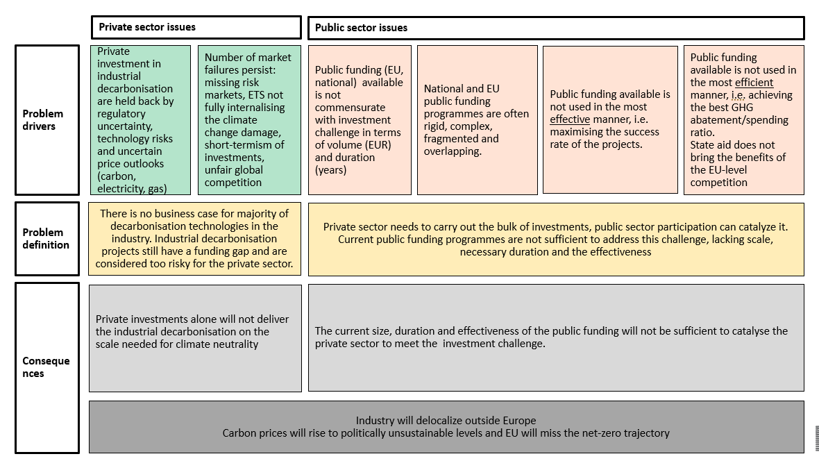
As illustrated above, there are the two problem drivers which relate to the private sector:
- Private investment in industrial decarbonisation is held back by a perceived regulatory uncertainty in terms of post-2030 climate and energy framework, technology risks and uncertain price outlooks for carbon price, energy vectors (notably electricity), raw materials/feedstocks and, to lesser extent, equipment costs. This reluctance to invest will delay and increase the costs (e.g. because of higher cost of equity or debt) for the decarbonisation of EIIs, particularly if financing is left solely to the private sector.
- A number of market failures is still present (missing markets for risk sharing/insurance, need for spillover effects, carbon price not fully internalising the climate change damage, short-term nature of investments decisions). In addition, European goods exported into global markets can be exposed to carbon leakage pressure from producers in countries that do not face comparable carbon pricing. Similarly, investments in decarbonized technologies may also happen elsewhere if investment conditions and long-term outlooks are not positive and supportive in the EU.
Other problem drivers concern the public sector:
- Public funding (EU, national) available is not commensurate with the EII decarbonisation investment challenge in terms of volume (EUR) and duration (years). Lack of such public funding undermines the private sector willingness to commit their part of resources as private actors need to ensure the return on investment over the entire project lifetime. Capital markets are not different from other markets in terms of competition for resources: if there are other activities which are less risky/with better return than industrial decarbonisation projects, the scarce resources will be committed to those other activities. Public support is needed to de-risk private investment and bring the risks/returns to the levels of other sectors that compete for investments.
- Public resources are scarce; there are many competing claims on them (e.g. defence) so they should be used effectively (making sure the industrial decarbonisation projects materialise and deliver GHG abatement).
- Public resources should be used in the most efficient manner (i.e. with the largest abatement achieved per each EUR spent, notably through a high leverage effect of private investment and smart risk-sharing). While State aid is a very efficient way of supporting decarbonisation projects (thanks to a number of safeguards against overcompensation), it does not bring the benefits of EU-level competition that the EU-level instruments can bring (as also highlighted in the recommendation of Draghi report) and does not provide support in all MS. The benefits of the EU-level competition are clearly seen in the results of the IF so far, which has a very high leverage of the private capital (4.5 multiplier effect) and abatement proportional to subsidies.
- National investment programmes are often rigid, complex and fragmented. With the exception of IPCEI and RRF, national funding programmes do not fully exploit the benefits of the EU single market (leading to subsidy races, a patchwork of requirements to comply with, national not EU champions supported etc.). The IDB, by working at a scale on the EU level, with streamlined procedures and opening ‘as a service’ feature developed for the Innovation Fund to channel also State aid, could help to make the EU funding landscape less complex.
It is clear that EU-level public funding that reacts to such market failures cannot simply replace the private sector. Instead, it can ‘catalyse’ the private investment, act as ‘seed’ funding and mitigate some of those investment risks. To achieve the best outcome, public sector funding needs to provide support in the most effective (i.e. will supported projects materialise and achieve the expected GHG abatement) and efficient manner (i.e. achieving the best rate of GHG abatement to spending) by leveraging the private investment. Considering that private sector tolerance of higher risk is aligned with expected profits, there can be a potential trade-off between effectiveness and efficiency. A very efficient scheme that maximises the participation of public funding, will necessarily push more risks towards the private sector and thus become less attractive for private sector. Even if public funding is secured by an efficient project, if that project faces difficulties, i.e. unexpected cost increases, it might be abandoned by private investors - putting at risk the effectiveness of support (the IF evaluation early findings suggest that 7 % of IF projects have terminated prematurely due to adverse changes in market fundamentals or corporate decisions that were not anticipated in the project proposals and could not be detected during the evaluation process).
Consequently, a balance needs to be struck and different ways of boosting efficiency can be explored, such as drawing on the benefits of the EU-level competition, adapting dynamically to market conditions (e.g. by support in the form of variable premiums), safeguarding against the overcompensation (e.g. upside sharing mechanisms via a CCfD scheme), and public support taking the form of guarantees rather than grants to achieve the best possible leverage of private capital. In essence, the necessary remuneration for the private sector’s investment in riskier projects needs to be ensured so that they can have a solid business case and materialise.
In absence of large (in terms of budget and duration) EU funding mechanism driven by the public sector, private investments alone will not deliver the industrial decarbonisation at the scale and within the time needed for achieving climate neutrality by 2050 and investments will be fragmented amongst the Member States. Certain technologies will not be deployed with a risk to resilience of the EU economy and its competitiveness. Lack of or delayed investments in industrial decarbonisation will lead to industry falling behind competitors who adopt cleaner technologies, potentially losing market share to more sustainable businesses, creating a technological lag that can result in industries being less adaptable to future disruptions and demands, lose out on opportunities for growth and leadership in emerging sectors and increase emissions contributing significantly to climate change and the EU missing the net-zero target as a result.
Affected stakeholders are all economic actors as they all consume products of industry (e.g. fertilisers needed for agriculture are produced by chemical industry, services rely on electricity that together with industry is in the EU ETS) and especially in the industry sector that will be confronted with increasing carbon prices and growing pressure of the international competition. Also, society as a whole is affected (as all society actors will consume products of industry, some will work in the industry, some will have part of their pensions linked to performance of industrial stocks and all will be affected by climate change).
The action to address this problem is best to be taken on the EU level. The Draghi report highlights that the differences in legislations between the EU and other countries aimed to reduce greenhouse gas emissions create near-term investment needs for EU companies that their competitors do not face. For example, the report states that for the four largest EIIs (chemicals, basic metals, non-metallic minerals and paper), decarbonisation is projected to cost EUR 500 billion overall over the next 15 years. In this critical situation, underinvestment by the private sector remains a persistent challenge in the EU, affecting a broad spectrum of investment types, including infrastructure, innovation, green and digital transitions, and industrial capacity. Despite a high level of private savings, the investments into are lagging behind.
Fostering decarbonisation investments advancing EU competitiveness needs to be coordinated at EU level to be truly effective. To decarbonise industry, the EU can develop a cohesive internal market for net-zero technologies and low-carbon products, enabling economies of scale, reducing costs and emissions, and fostering efficient deployment of new technologies across the single market. Climate change is a trans-boundary problem, the solution to which has important internal market dimensions, and EU action can effectively complement and reinforce regional, national and local action. Pooling resources at the EU level can maximise the impact and added value of investment on the ground, and lead to economies of scale in organising competitive selections of the best projects, leading to more impactful investments, reducing administrative costs, increasing efficiency by avoiding multiplication, fostering cross-border investments, and therefore making public funding more cost-effective than if each Member State acted independently.
By creating a strong and predictable business case for decarbonisation technologies across the single market, it strengthens the EU international competitiveness in industrial decarbonisation technologies, while supporting the preservation and transformation of energy-intensive industries and their jobs within the EU.
An instrument designed and implemented at EU level can effectively avoid intra-EU competition between national support schemes, which could otherwise lead to market fragmentation and subsidy races. Differences in financial capacity, economic structure and industrial profiles mean that some Member States are less able to finance large-scale decarbonisation investments, so relying on national financing alone would risk widening disparities. An EU-level IDB type instrument can help ensure a level-playing field between market participants by channelling support towards the most cost-effective and efficient decarbonisation solutions, irrespective of their location, and by enabling projects to reach scale at EU level. This avoids proliferation of smaller, fragmented national schemes that could distort competition, increase administrative complexity and ultimately lead to higher overall costs for achieving climate objectives.
Acting at EU level enhances the coherence of investment by aligning support with EU wide strategic priorities such as climate neutrality, the accelerated roll-out of clean energy and electrification, with completed interconnections and grids, as well as clean manufacturing, competitiveness, energy security and high‑quality employment, while ensuring fair competition for the best projects across Europe. It also supports high‑skilled industrial jobs, facilitates knowledge transfer and delivers risk-reduction benefits that spill over to competitors and society at large, therefore justifying an EU-level instrument.
  - Objectives
In the medium term, the general objective of the IDB is to enable the investments in the industrial decarbonisation projects, at the necessary scale consistent with longer term (2040/2050) climate objectives. Enabling those investments will allow to decouple industrial output from GHG emissions and decarbonize the EU economy while enhancing strategic industrial capacities and thus competitiveness of the EU economy. Deployment of such industrial decarbonisation projects, especially if coupled with effective EU industrial policy such as lead markets requirements, can help boosting competitiveness of EU EII in the transition to a net zero-economy.
The specific objectives of this initiative for both private and public sector are as follows:
- For private sector: creating the business case for private investment in the EU with public support counterbalancing the market failures, regulatory uncertainties and disadvantages compared to global competitors. This objective of creating the business case is the central element of the Clean Industrial Deal and the IDB can deliver it. In the longer-term perspective, the role of the IDB should diminish as industrial decarbonisation technologies are increasingly deployed on market terms. In the long term, all decarbonisation technologies should follow the footsteps of renewables in power generation that after years of subsidies are now competitive with fossil fuels in many regions without subsidies.
- For the public sector: creating a public funding instrument with the following features:
  - with sufficient budget and duration that are commensurate with the investment challenge and the funding gap that industrial decarbonisation projects will still have. This instrument needs to be able to support the critical mass rather than a handful of industrial decarbonisation projects in Europe.
  - operating in a simple and flexible way and thus attractive for supporting projects in EII sectors, technologies and company sizes in all Member States (because all industrial players need to decarbonise). Operating in a simple manner, will also reduce the administrative burden for the Commission.
  - promoting the large-scale deployment of low emission technologies in industry broadly speaking and including sectors producing CBAM goods exposed to remaining risk of carbon leakage
  - maximizing projects success rate considering the inherent trade-off with cost efficiency as described above.
Achieving the general and specific objectives will contribute to a significant share of industrial decarbonisation, while supporting the resilience of the EU industrial base. The deployment of industrial decarbonisation projects will support the modernisation of the EU economy, reduce dependencies and import costs of fossil fuels, build ‘new engines of growth’ with local manufacturing of decarbonisation technologies and make the EU economy more resilient by producing more ‘local industrial products and diminishing dependencies on third countries. If this effort is paired with more ambitious industrial policy, the development of the internal market for industrial decarbonisation technologies can also increase competitiveness of the EU on global markets. The figure below illustrates the complete intervention logic.
- Intervention logic
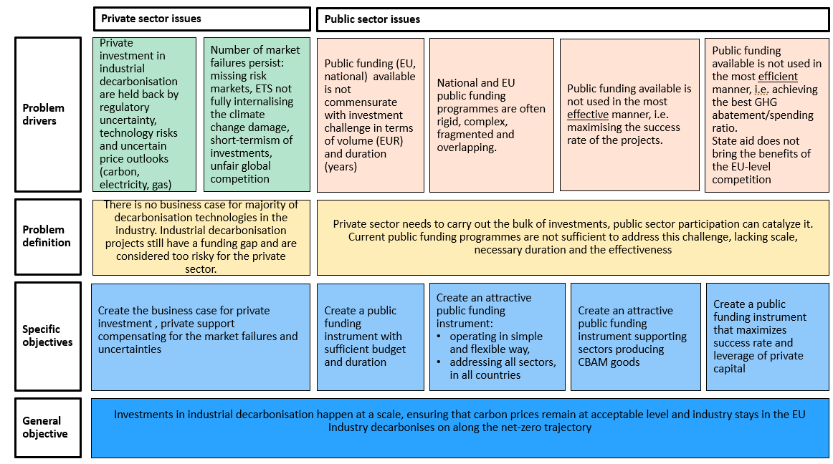
  - Baseline
There is a clear need to provide EU funding support to both innovative and more mature decarbonisation technologies in the industrial sector. The Clean Industrial Deal announced the IDB, aiming for EUR 100 billion in funding, so that a sizable impact can be made on decarbonising the EU industry. The policy options assessed in this IA will look at possible ways to allocate the support by the IDB, the different forms of support and the possibilities to ensure geographical balance in providing this support.
The baseline assumes a continuation of the IF for the period 2031-40 using the existing IF instruments (‘regular’ calls for proposals, auctions and financial instruments) and providing existing IF types of support (‘classic grants’ with lump sum payments, fixed premium grants linked to the low-carbon product output and loans) to a broad range of innovative decarbonisation technologies (beyond the EIIs). The IF would mostly address technology and scale-up risks. The IDB should thus focus on addressing the scale-up and roll-out of decarbonisation technologies in the EIIs only and address market risks of such technologies. The different scopes of the IDB and IF are proposed in the figure below.
The continuation of the IF should also address the European Court of Auditors’ recommendation to simplify and improve project evaluation methodologies to ensure more accurate evaluation of financial and technological maturity of projects, and GHG emission reduction potential, as well as for increased flexibility on the project implementation timeline.
The options analysed in this IA concern only the ways that the IDB resources can be used to best serve the decarbonisation objective.
Furthermore, as part of the next Multiannual Financial Framework, the European Commission proposed a Regulation to establish the future European Competitiveness Fund (ECF), with expected resources of EUR 234 billion to invest in strategic technologies and to benefit the entire Single Market. The ECF focuses on four windows, including the Clean Transition and Decarbonisation window (with proposed resources of EUR 26.2 billion for the period 2028-2034). The scope of this window is however much broader, in terms of objectives (not only decarbonisation but also other environmental objectives such as biodiversity and air, water and soil pollution), in terms of covered sectors (mobility, buildings, industry, agriculture, power generation), in terms of the kind of activities funded and the type of support (grants, loans and others). Continuation of the InvestEU programme is proposed to play a key role in the ECF delivery.
In the operation of both ECF and the IDB, a delineation should be sought to avoid the overlaps between the three programmes, ‘forum shopping’ by the projects and instead ensure that there is EU funding support for all stages of the technology development in the EU. While the final shape of the ECF will only be known at the end of the legislative process, complementarity will be ensured by IDB being placed in the ECF governance framework and by designing appropriate coordination mechanisms.
Likewise, State aid will continue to play a significant role in providing support for decarbonisation technologies but in a fragmented manner and without the full benefits of the EU-level competition. A promising way of bringing the benefits of the EU-level competition to national State aid is deploying ‘as-a-service’ feature, which was developed for the IF and should also be also enabled under the IDB.
- Proposed scopes of the IF and IDB
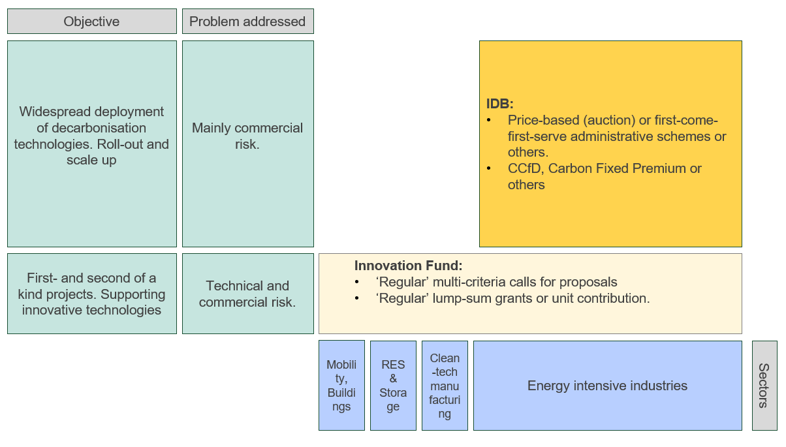The policy options in terms of possible allocation mechanism and form of support will be assessed against this baseline.
- Policy measures
The figures below summarises the policy measures assessed that in turn are combined into policy options
- Overview of policy measures
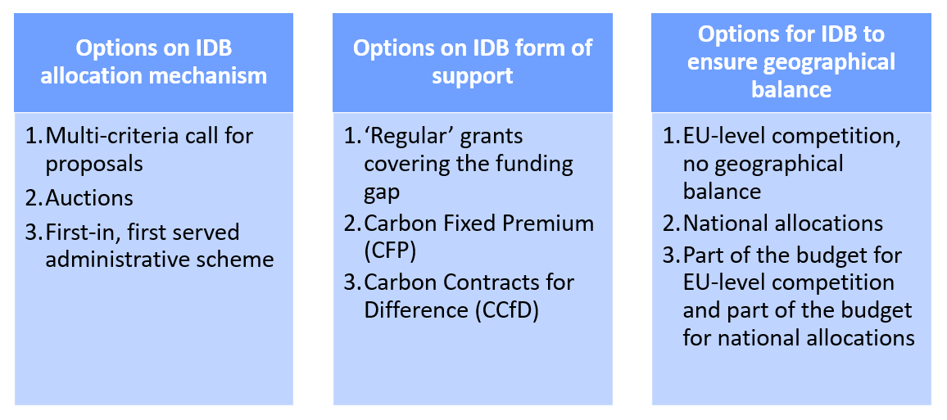
Across the entire IA, three policy options have been developed for each area of actions that combine specific policy measures into meaningful ‘packages’ fully addressing problem drivers and related objectives. The options differ in the degree of change that they entail to the current system. Policy option 1 Aligning ambition and improving incentives includes the measures that, overall, lead to least change compared to policies in place in 2026. Policy option 2 Aligning ambition and extending scope and corresponding incentives includes measures that introduce moderate innovations or changes to the system. Policy option 3 Aligning ambition and extending scope and incentives comprehensively alters most substantially how the system works.
For simplicity and comparability, all policy options focus on the same ‘good’ - carbon abatement be it as one of the award criteria in PO1 or through providing administratively fixed premium for each unit of abatement (PO2) or by providing Carbon Contract for Difference to mitigate the risks linked to carbon price changes.
- Overview of policy options
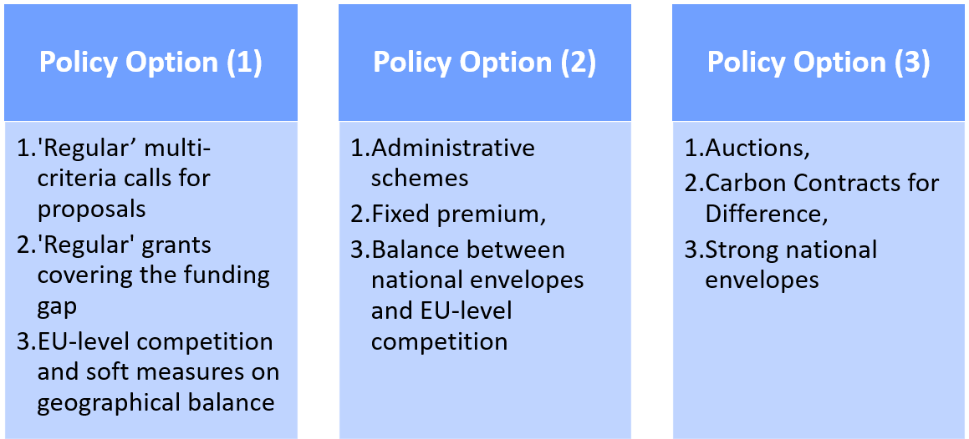
  - Measures on how the support should be allocated
There are a number of allocation mechanisms that can be deployed and in most of the cases they can be chosen regardless of type of support to be allocated (see Section 5.2). The measures selected below represent the most common type of mechanisms, reflecting the experience of the IF and the Modernisation Fund as well as the national support schemes for the industrial decarbonisation.
Measure AM.1 | Multi-criteria call for proposals
Measure AM.2 | Auctions
Measure AM.3 | First-in, first served administrative schemes
The following allocation mechanisms are not all mutually exclusive, e.g. auctions can be implemented as multicriteria-auctions and shortlists designed by MS may be subject to multicriteria assessments of the projects on the EU level.
    - Measure AM.1: Multi-criteria call for proposals
Example: IF current ‘regular’ calls for proposals
Multicriteria calls for proposals invite project developers across sectors to submit applications against a defined number of award criteria. Each criterion will be scored by evaluators and there is a possibility of weighting the criteria scores. On the EU-level, the Innovation Fund grant mechanism is a leading reference: it has used calls that score proposals on five award criteria i.e. GHG emission reduction, degree of innovation, project maturity, scalability, and cost efficiency - alongside call specific sub-criteria. This allocation mechanism allows selecting projects fulfilling a number of criteria and search for excellence across all of them.
Multicriteria calls provide a high level of precision of the project selection against tailored objectives. They are flexible instruments that can accommodate complex, integrated projects. They also allow qualitative factors to be recognised, e.g. resilience or innovativeness, in addition to price.
Multicriteria calls are particularly suitable for ‘regular’ grants allowing to account for various parameters beyond pure cost-efficiency. As such, multi-criteria award procedures are focused on the quality and excellence of project proposals and imply an extensive project proposal by the applicant, an external expert evaluation team to ensure a thorough and independent evaluation and a strong role of the executive agency to ensure a project delivers on all aspects that were assessed. While the application and evaluation processes are very demanding, they do not guarantee that projects will be delivered. High level of competition also elicits projects with very ambitious deliverables/high cost-efficiency that in the end may not materialise. Certain attrition in the awarded projects portfolio can happen with the negative impact on the overall effectiveness of the scheme.
    - Measure AM.2: Auctions
Example: IF current auctions for hydrogen or heat
While auctions can include other award criteria (as in the above multicriteria approach), their primary intent is to allocate support based on competition on price. Therefore, auction-based support requires the definition of a specific, homogeneous auction good on standardised terms as fixed premia or variable premia, possibly in relation to a market price (e.g. fixed subsidy or variable subsidy on top of market price per one kWh renewable electricity produced/one tonne of CO2 abated/one kg of RNFBO produced) so that bids can be ranked in a form of a merit order (with the lowest bids winning).
Auctions can be implemented on demand- or supply- side, as one-sided or double-sided auctions and include a wide range of design choices. Design choices include bid components, volume/budget caps, baskets/topics, eligibility criteria, monitoring, reporting and verification arrangements and potential non-price criteria such as minimum greenhouse gas improvement, sustainability or resilience criteria. All these elements constitute ‘auction design’ and are often presented as Terms and Conditions. These Terms and Conditions need to be determined and known at latest when the auction opens to guarantee a transparent bidding process, with applicants having full knowledge on all their rights and obligations.
Auctions are widely used in MS (e.g. for renewables in power generation) and at EU-level they have been pioneered under the Innovation Fund. Auctions can be designed with very broad objective (i.e. maximising GHG abatement) or to specifically cater to the needs of individual sectors (i.e. subsidising a specific product output).
As auctions allow less of in-depth due diligence on the financial maturity, a recommendable feature of auction-based support is that it is performance based: payments are only made upon delivery of the auctioned good. For that reason, auctions are best suited for mature, ‘near market’ industrial abatement options where the technical risk is limited (and is borne by the applicant), but the market risk is still relatively high. A specific feature of auctions are ‘bid bonds’ or ‘completion bonds’ (a penalty for the applicant in case the project does not sign a grant agreement or is not implemented), to avoid speculative bidding.
Auctions allow for competitive funding allocation and thus lead to high cost-efficiency. As above, high level of competition elicits projects with very high cost-efficiency sometimes linked to higher risk-taking that in the end may not materialise, especially if confronted with less positive market developments. This is to the detriment of the effectiveness of the scheme. Depending on its design, auctions can be administratively simple (one-sided, price-only) or become complex instrument, such as when multi-criteria are implemented or double-sided auctions are used. Auctions are best suited for awarding a premium linked to the unit of production or GHG abatement.
    - Measure AM.3: ‘First-in, first served’ administrative schemes
Example: tax credits under the US IRA programme linked to the output of green product
This type of allocation schemes offers a ‘first-come first-served’ funding window where all eligible applicants receive support until funds run out. The instrument is often used for standardised support measures (e.g. with fixed lump sum amounts or fixed premia linked to the unit of production) where the policy goal is quick market uptake rather than maximising cost-efficiency and price discovery (as in auctions) or excellence of the proposals in multiple aspects (as in regular grants). Administrative schemes are well-suited to favour front-runners because the limited budget is taken by those who are first to reach pre-defined milestone (application, Final Investment Decision, Entry into Operation, etc.). On the other hand, late-comers take the risks that funds run out.
This measure can have many features similar to the auctions, in particular: (1) definition of a homogeneous/standardised good, (2) establishment of Terms and Conditions, including completion or bid bonds (3) performance-based payments (upon delivery of the good). However, the fundamental difference with auctions is that the specific support amount is administratively determined ex-ante (and not via competition on price). As such this measure characteristic is similar to feed-in tariffs as used by Member States for renewable electricity in the past, or the tax incentives for a number of low carbon technologies (H2, CCUS) in the US Inflation Reduction Act. At the EU level some calls under the Connecting Europe Facility were similar, e.g. calls for installation of EVs charging points, as they offered multiple ‘cut-off’ dates for the submission of proposals and a fixed amount of support per charging point.
Consequently, such schemes work best for more mature, standardised technologies/products for which the costs can be estimated relatively accurately ex ante, rather than for more innovative projects. Such schemes provide limited precision of the project selection against tailored objectives. Since the objective is to award funding quickly, authorities typically apply a simple eligibility check and standardised grant once the project is delivered. Such approach is assumed for the evaluation of this measure. If there are project drop-outs it is easy to select a new project from the application queue. However, eligibility checks can also be designed in more complex manners and demand detailed documentation. Guardrails for such administrative schemes might be needed such as: ‘booking’ systems, per applicant- caps, technology baskets and clear MRV (monitoring, reporting, verification) requirements.
The administrative schemes may work with any form of support discussed in the Section 5.2. They require very little administrative effort and with an effective ‘booking’ system can deliver high level of effectiveness as it is very easy to replace the projects dropping out. Also, with an administratively set amount of support it is easier to establish higher returns for private investors, making projects more immune to adverse market conditions and thus increasing the likelihood of projects to be delivered. As trade-off such schemes provide very limited precision in project selection and have an implicit risk of overallocation of support. This risk of overcompensation would be detrimental to the overall efficiency of the scheme, as less efficient undertakings would be supported and this could increase the cost of the transition. Such risks can be mitigated by the upside-sharding mechanisms/claw-backs.
    - Other measures
MS proposing a shortlist of projects
Beyond those main measures, there could be others, notably MS proposing a shortlist of projects as is, for example, the case for the current Modernisation Fund
Under such a support allocation mechanism, MS create a pipeline of national projects and submit them for approval and funding under a common EU facility. The EU Modernisation Fund (MF) is an example. Like the IF, it uses EU ETS allowance revenues but focuses support on lower income MS. It allows varied forms of support (i.e. grants, premiums, guarantees, loans, capital injections) based on national investment proposals. Those proposals are reviewed against MF priority areas as well as its legal requirements (notably eligibility and State aid compliance) that are defined on the EU level.
This allocation mechanism relies on national planning through which MS can more easily cluster investments with enabling infrastructure, related value chains and their national industrial strategies. The ability to choose projects and instruments gives MS flexibility and provides a high level of precision to select projects based on specific objectives on Member State level. At the same time, the mechanism will not perform as well towards the EU-level objectives. It is highly dependent on the selection criteria, which can favour cost-efficiency or excellence across a number of criteria or alignment with other national objectives (e.g. is the project relevant for the National Energy and Climate Plan) and whether these selection criteria are developed on the EU or national level. If criteria are developed entirely on the national level, there is a risk of misalignment with the EU-level objectives. In terms of coherence with other EU funding programmes, it depends on the design chosen by the MS to identify the short-list and there is potentially a risk of overlaps with EU funding programmes. As with the administrative schemes, there is a risk of overcompensation, potentially detrimental to the overall efficiency of the scheme. Such risks can be mitigated by the upside-sharding mechanisms/claw-backs.
Shortlists curated by Member States may work with any form of support described in the Section below, however the implementation of more complex forms of support such as CCfDs is less likely due to fragmented MS markets and limited administrative capacity is smaller countries.
  - Measures on what form the support should take
There is a number of forms the public support can take and, in most of the cases, the form can be chosen regardless of the allocation mechanism (see Section 5.1) but will be influenced by the choice of technology/sector/product and whether they operate on a mature or on a nascent market (with a reference price or not). The measures selected below are not an exhaustive list but represent the most common types of support and are largely reflecting the experience with the Innovation Fund.
Measure FSFS.1 | Regular’ grants
Measure FSFS.2 | Carbon Fixed Premium (CFP)
Measure FSFS.3 | Carbon Contracts for Difference (CCfD)
    - Measure FS.1: ‘Regular’ grants
Example: IF ‘regular’ grants
‘Regular’ grants (also called ‘investment’ grants) provide upfront capital to cover part of the cost of low-emission installations or infrastructure. Grants are non-repayable forms of support. They are typically awarded through competitive, often multi-criteria calls for proposals or administrative schemes and disbursed in the form of lump-sum payments upon the reaching of pre-defined milestones. Grants are among the most widely used support tools for industrial decarbonisation. At the EU level, the most well-known grant mechanism for industrial decarbonisation projects are grants under the IF. These grants can address 60% of the funding gap and are disbursed in lump-sums upon achievement of certain milestones and at least 75% of GHG abatement claimed in the application. Grants can be also established to cover a given share of CAPEX/all eligible costs and can have monitoring arrangements with varying levels of strictness.If grants are disbursed ahead the entry into operation and some part of support is not retrieved in case technology does not work out, the grants can participate in shouldering the technology risks.
‘Regular’ grants are a common instrument and are generally applicable for a wide range of projects (simple and complex), technologies and sectors. ‘Regular’ grants are effective in addressing the initial investment barrier, which makes them well suited for capital intensive projects with high technology risk that need support in the early project phase (construction). ‘Regular’ grants, if covering a large share of the project’s funding gap, can make the project bankable but do not shield it from adverse market conditions (e.g. grants are rarely indexed to the inflation, do not cater to unforeseen changes in costs or revenues) or guard against overcompensation. On the flip side, there is no budgetary risk for the administration as the amount of support is fixed in advance.
    - Measure FS.2: Carbon Fixed Premium (CFP)
Example: IF heat auction
A Carbon Fixed Premium (CFP) provides a fixed payment per tonne of CO₂ avoided. As opposed to CCfDs (see below), CFP schemes are not linked to the actual carbon market price. The IF auction for heat decarbonisation is a simplified CFP scheme. Unlike the ‘regular’ grants, a CFP provides support once a project is operational, so the technology risk remains almost entirely with the project and there is no support during the capital-intensive investment phase. As ‘regular’ grants, CFP can make the project bankable but will not ‘shield’ it from adverse market conditions (e.g. lower carbon price than anticipated at the time of the application and – more importantly – changes in costs or revenues).
Consequently, CFPs are a relatively simple form of support with very limited budget risk as amount of support per tonne of CO2 avoided of support is fixed in advance and payments depend on the output volume (which can also be capped) but not on market/carbon prices. Their simplicity enables fast deployment of market-ready decarbonisation technologies. The static support level may lead to overcompensation or unforeseen cost gaps. CFPs are applicable across sectors and technologies, but technology baskets are required to account for structural cost differences.
    - Measure FS.3: Carbon Contracts for Difference (CCfD)
Example: German CCfD scheme
Carbon Contracts for Difference (CCfDs) are a form of support that guarantees a fixed carbon price for industrial decarbonisation projects. The instrument works by compensating for differences between a reference carbon price (the EU ETS) and a project’s strike price, aiming to level the cost difference between a conventional fossil-based production process and the alternative decarbonised process. If the reference price falls below the strike price, the administrative body pays the price difference to the project developer; if the reference price exceeds the strike price, the project developer repays the surplus to the support giver. In the case where the reference price falls below the strike price, the support paid to the project developer is meant to offset the additional costs of low-emissions production processes. Limitations and additional rules to modulate this basic principle may apply. It is possible to provide indexation to other (than carbon), which would however, further increase complexity of the scheme.
An example of application is the CCfD scheme in Germany under its program called Klimaschutzverträge in the first round, now announced to continue under the name CO2-Differenzverträge. The program offers 15-year contracts with payments linked to CO₂ and (to a limited extent) energy prices to compensate companies from the additional capital and operational costs of switching from fossil-based to climate-neutral technologies. Austria and France have also implemented CCfDs which differ in design and more European countries, e.g. Denmark and the Netherlands, have announced or are in the early stages of developing CCfDs.
As CFPs, CCfDs provide support once a project is operational, so the technology risk remains almost entirely with the project and there is no support during the capital-intensive investment phase. Unlike CFPs, they not only make the project bankable but also ‘shield’ it from adverse market conditions, i.e. unexpected carbon price developments and changes in energy prices if indexation is implemented in the policy design.
CCfDs can catalyse large and complex projects by bridging the carbon price gap and thus work hand in hand with the ETS market. The instrument implies a high administrative complexity for bidders and the administration. It is particularly suited for large-scale capital-intensive projects in EIIs. CCfDs offer high design flexibility, making them suitable for both simple and complex processes. Potential payback after carbon prices exceed strike prices may deter bidders or impact the operational phase but are an important element reflecting shared risks. Administrative bodies need to provide budgetary provisioning as there is uncertainty about price developments and consequently payouts to the projects.
    - Other measures
1. Fixed premium per unit of green product
Similar form of support to carbon fixed premium but, necessarily, more-technology specific is a fixed premium per unit of green product. An example is IF hydrogen auction.
This mechanism provides a fixed premium for each unit of low-emission product produced (e.g. tonne of steel or cement). The premium is independent from market prices of goods and is typically paid per unit produced, much like the auctions under the Innovation Fund allocate funds through a fixed-premium auction to support the production of renewable hydrogen. To some extent also the US IRA tax credit support was supposed to amount to the fixed support per unit of product (albeit delivered in the form of tax credits).
Similar to CFP, this form of support provides support once project is operational, so the technology risk remains almost entirely with the project and there is no support during the capital-intensive investment phase. Such support can make the project bankable but will not shield it for adverse market conditions (e.g. higher production inputs costs than anticipated at the time of the application or lower prices for the produced good).
Consequently, this is relatively simple form of support with very limited budget risk as amount of support per unit of green product is fixed in advance and payments depend on the output volume (which can also be capped) but not on market/carbon prices. This form of support is well suited to close the funding gap through predictable support payments to more mature technologies and thus for the scale-up of low-emission technologies and products. The instrument can be applied in various sectors and for different technologies, in which a specific homogeneous good eligible for funding can be identified. Due to a variety of green products, a sector-specific approach will be required.
2. Variable premium for the unit of the green product
Just like CCfDs are introducing variable premium into the CFPs, there can be also variable premium applied to support for the unit of the green product. An example would be national electricity CfD schemes for wind offshore projects.
A variable premium adjusts the support level based on market conditions-specifically: the difference between the cost of low-emission and conventional (end) product prices. A variable premium requires a product-specific design, such as a reference product price for a traded good, which consequently limits its applicability across different sectors. It could be applicable for final goods (e.g. steel, cement, aluminium, fertilisers, glass) as well as intermediate goods, such as heat. However, for heterogeneous final products or intermediate products without evident reference prices (or price index) such type of support would not be possible. This instrument is designed to ‘shield’ the projects from all revenue risks on the nascent markets where there is high volatility of the green products. For more mature markets, forms of support that leave more risks with market participants may be more justified. Finally, for this type of support, administrative bodies can face uncertainty about final payouts to the projects and needs to do provisioning (i.e. reserve the budget) accordingly.
3. Instruments other than grants
Beyond those main options, further support options designed to address very capital-intensive investments and to strengthen the financing side of projects may be relevant, such as guarantees, loans, and equity instruments. While such instruments alone cannot address projects with significant funding gap, they could be combined with grant options to create a more robust financial model.
3.A public guarantees for production of low-carbon product
Example: performance guarantees for clean-tech manufacturing projects.
Public guarantees reduce lender risk, improve access to private capital and lower the cost of capital. They can be a vital element to making projects bankable, but in contrast to operational support their impact on GHG emission reduction is only indirect. Guarantees do not directly close cost gaps to conventional production as they do not provide direct revenue support for CAPEX and OPEX costs.
3.B equity type of instrument and direct loans
Example: loans and equity taking
Equity-type instruments involve public investment in return for a share of project ownership or future returns. Similar to public guarantees, equity-type instruments and direct loans can improve access to private capital and lower the cost of capital. They can be a vital element to make projects bankable by absorbing early-stage risk (in the case of equity), but in contrast to operational support their impact on GHG emission reduction is only indirect. As public guarantees, equity-type instruments and direct loans do not directly close cost gaps to conventional production as they do not provide direct revenue support for CAPEX and OPEX.
Additional considerations
Monetisation of EU ETS allowances or payments in allowances:
Regardless of the option chosen from the menu of main options above, an overarching aspect of providing funds to projects covered by the IDB concerns the monetisation of EU ETS allowances. Normally, funding is provided in Euros, with their monetisation realised through the auctioning of allowances on the EU ETS Common Auction Platform e.g. as currently done under the IF. Most options discussed above use a performance metric linked to GHG abatement. It would therefore be possible to bypass the intermediate step of first monetising the EU ETS allowances but instead assigning such allowances directly to the successful projects, with their monetisation being left to the project owner. Different implementation options can be envisaged. Settlement of support directly in allowances is applied successfully already in the support of sustainable aviation fuels. Depending on the detailed design of the support scheme in question, this example could also be followed under the IDB.
  - Measures on ensuring geographical balance in IDB
In the design of the IDB, a balance needs to be struck between two partially conflicting objectives: on the one hand to support the most cost-effective projects (because these are often the least financially risky, and the most mature projects are in the best-suited locations) and on the other hand, to help projects in all Member States to decarbonise, providing related spillover effects (on employment, supply chains, knowledge-sharing) and maintaining political support across Member States for industrial decarbonisation.
The Clean Industrial Deal Communication indicates the importance of designing the IDB ‘to ensure (…) a fair distribution of support across Member States’. Fair geographical distribution (also called ‘geographical balance’) of funds is a key aspect for certain Member States. Several measures of addressing the geographical balance are assessed below.
Measure GB.1 | EU-level competition, no geographical balance measures
Measure GB.2 | National allocations for MS in terms of overall IDB spending
Measure GB.3 | Combing EU-level competition with national allocations
    - Measure GB.1: EU-level competition
In this measure, IDB funding would be allocated based on pure excellence, i.e. for projects that perform best on one or set of award criteria and based on the EU-level competition. This is how the Innovation Fund has been operating albeit with some soft measures aiming for more geographical balance (e.g. technical assistance provided to the National Contact Points). It has to be recognised that performance of projects in the EU-level competition is partly linked to their locations (i.e. considering infrastructure, economic/industrial structures, energy prices, presence of ‘national champions’, supply and demand centres, knowledge and workforce, innovation ecosystem, taxation etc) but performance is also driven by the project’s inherent features regardless of the location, notably in terms of technology deployed.
Benefits of the EU-level competition are clearly visible through observed cost-efficiencies of deploying decarbonisation technologies, GHG abatement to be achieved and contributions to achieving the EU climate and industrial policy objectives to be achieved by currently selected IF portfolio. Such approach could be reconducted to the IDB, but it would imply that projects in certain Member States can be less competitive, resulting in a geographical imbalance in terms of funding distribution. Based on the experience of the IF, the imbalances are more visible in certain sectors (e.g. if projects are dependent on electricity prices that are markedly lower in certain countries) rather than across the economy, and geographical balance improves over time as national project ecosystems develop (national administrations’ capacity to support projects, availability of consultancies, projects communities). In the longer term the balance might be improving without any dedicated measures. Nevertheless, in the short term dedicated actions might be needed, considering the importance of the EU cohesion and that all Member States need to participate in industrial decarbonisation, that subsidised projects have large spillover effects and can kickstart the new clusters and centres of excellence.
    - Measure GB.2: National allocations for MS in terms of overall IDB spending
In this measure, support from the IDB would be allocated still based on competition and funding would be awarded to projects that perform best on the award criteria, but projects would be awarded within the limit of pre-established national allocations (i.e. shares of overall IDB budget that are earmarked for spending on projects in a given Member State). Such national allocations could be defined based on Member States’ contributions to the IDB (e.g. in terms of EU ETS allowances contributed), industrial national GHG emissions to abate/already abated, GDP or industrial value added. The allocations could be defined for individual Member States or certain groups of Member States.
Compared to measure GB.1, this measure would ensure that support granted by the IDB achieves a geographical balance as defined upfront (and derived from metrics described above such as MS contributions in terms of EU ETS allowances). In essence, projects located in all MS can be supported and this is important knowing that all MS face the challenge of industrial decarbonisation and funded projects also have important spillover effects on national industrial structures.
As an example, if national allocations were linked to industrial emissions yet to abate, it would ensure that Member States with currently higher emissions, and thus greater needs for deployment of decarbonisation technologies, receive proportionate support. As an alternative, the sizes of national allocations could be linked to emissions abatement achieved, whereby Member States would be incentivised to reduce their emissions to access greater financial support. This would create a direct link between performance and funding.
Regardless of the specific method for defining national allocations, such an approach also has inherent shortcomings as it does not fully enable the benefits of EU-level competition. EU-level competition would be constrained by national allocations and disregard that certain MS offer more favourable locations in terms of renewables endowment, labour cost, or better proximity to industrial clusters. That would be partially missing opportunity for the EU as a whole to pursue a ‘smart specialisation’ of countries or regions, which offers a possibility to strategically use its strengths so that the EU can best compete on global markets. This approach also poses a risk of IDB ‘compartmentalisation’, i.e. having IDB funding opportunities fragmented into multiple national compartments which prevents economies of scale at EU level. This would be especially problematic if the IDB would also feature sectoral/technology or other compartments as the individual budget allocational would become small.
A variation of this approach is introducing a cap on an excessive number of projects from a given MS. This would not achieve a geographical balance upfront but would help to achieve a more balanced portfolio. The cap would only be triggered if a country starts to secure the funding for a disproportionately large number of projects.
    - Measure GB.3: Combing EU-level competition with national allocations
In this measure, a certain share of the IDB funding could be distributed to projects based on pure excellence, i.e. through an EU-level competition (like in measure GB.1), while the rest of the funding could be distributed also on the EU-level but respecting pre-defined national allocations (like in measure GB.2). There could be different splits between the two approaches, e.g. 50/50 or 70/30.
This measure would allow the EU to benefit from the advantages of both measures GB.1 and GB.2. While the EU-level mechanism leads to the best cost-efficiency, economies of scale and the optimal location of projects, national allocations allow a more balanced approach, providing funding to projects in all MS and delivering the resulting spillover effects.
    - Other measures
In addition to those main measures, other initiatives could be considered to increase geographical balance of projects to be supported by the IDB. Those initiatives can be implemented from the beginning of the operation of the IDB or at a later stage during its implementation when it is possible to take stock of the geo-balance as shaped by the early funding rounds and adjust it - as needed. As for the main measures analysed above, additional initiatives could aim at several funding rounds and the portfolio of instruments, or at a single funding round.
‘Soft’ measures, as currently implemented under the Innovation Fund, could be explored: (1) technical assistance for National Contact Points in Member States with low effective participation aiming to increase the overall quality of the Innovation Fund applications, (2) training sessions for Member States National Contact Points for outreach and communication, (3) including geographical balance considerations in providing Project Development Assistance, (4) bonus points/tie-breaker/similar mechanisms to favour applications from MS which are lagging behind.
The ‘as-a-service’ feature developed for the IF (both auctions and ‘regular’ grants) if also applied to the IDB could help to increase the geographical balance. In practice, it means for the IF that Member States can complement any IF call for proposals with national funding schemes which are dedicated only to projects located in their territory. This allows Member States to benefit from the IF’s evaluation process to identify and support promising projects on their territory that were not selected for funding. Participation of Member States is voluntary and dependent on the availability of budget at national level. The support is considered State aid and therefore has to be approved by the Commission. Thanks to close alignment between the evaluation under the IF and State aid assessment, the approval of the Commission can be streamlined and accelerated. Four MS have already opened an ‘as service’ schemes linked to the Innovation Fund. A similar approach could be enabled under the IDB on the condition that there is a close alignment of the IDB with the State aid requirements. This approach could be also a way to implement the national allocations.
A ‘right of first use’ of the EU ETS allowances could also be explored. In practice, it would mean that the IDB’s resources would reflect the contribution of Member States to the ETS and would be reserved for a certain period (e.g. 3 years) for applicants under the IDB selection process for the specific Member State. If fewer projects apply or are selected from that MS under the IDB than expected, the remaining budget returns to MS and it would be allowed to spend it under the general conditions for the use of EU ETS auction revenue set by the EU ETS Directive. This approach could be also a way to implement the national allocations.
MS could also be involved in the provisioning (in case the type of support chosen is the variable premium, e.g. CCfD). In practice, MS could create national or regional provisions or guarantee schemes that complement the EU mechanism, sharing the risk of adverse market conditions that would require higher payments for schemes that work with variable premium. This approach can increase the total amount of funding given a smaller part of the EU funding would need to be mobilised for the provisioning. Managing risk-sharing in a joint manner would require a clear legal framework and governance and coordination mechanisms.
MS could be involved in the governance of the IDB, participating in setting the priorities that the IDB can serve and defining the funding instruments, as seen in existing successful method developed under the IF Expert Group.
  - Assessment of the measures
    - Expected impacts
Assessment of impacts (in terms of abatement to be achieved and private investment mobilised) is limited to assessment of the Baseline only since Baseline already defines the size of the IDB (EUR 100 bn) and the policy options concern the ways IDB budget would be spent that would have negligible impacts on the overall impacts especially taking into account the trade-off between cost-efficiency (for very competitive calls for proposals) and effectiveness (for schemes that allow more robust financial model) – see also Annex 3 on summary of costs and benefits for the whole initiative.
The baseline assumes a continuation of the current Innovation Fund with for the period 2031-40, with the same instruments (‘regular’ grants and auctions) and the type of support currently provided (lump sum payments or fixed premium for the unit of low-carbon product/GHG abatement). In the past years, IF has been testing the support for scale-up/roll-out more mature technologies (i.e. going beyond the first-of-a-kind (FOAK) type of projects) by deploying auctions, awarding a fixed premium once projects enter into operation. While the IF has been clearly successful in deploying auctions for specific technologies (attracting impressive numbers of bidders and clearing at very low prices), it clearly lacks the ‘firepower’ to offer scale-up/roll-out support to all industrial sectors – at the necessary scale.
Given foreseen budget amounts, the IF cannot be a solution for both innovative and more mature industrial decarbonisation technologies. It would remain effective but at a small scale, limiting its impact on emission reductions and providing limited chances for the EU to secure technology leadership. Likewise, creating the IDB for mature technologies only and without a complementary innovation and FOAK support pillar would risk focusing on mature technologies only, neglecting the early, high technology risk projects that are needed to close remaining gaps in the decarbonisation portfolio and/or increase cost efficiency of decarbonisation in the longer term. Support for FOAK type of projects and scale-up/rollout of more mature technologies are necessary and complementary.
The impact of the IF portfolio of projects awarded so far was analysed in the IF evaluation report that is attached of the ETS Directive revision proposal and provides indication on the impact of the IF programme as a whole as well as of IDB.
Box: Impact of the IF
The IF evaluation report indicates that the current impacts of the IF grants awarded in the period 2020-25 (EUR 12.7 bn that covers 2020-2024 calls for proposals, including auctions) bring the GHG abatement of 871Mt (over the first 10 years of projects’ operation) with an average (potential) funding efficiency of EUR 13/tonne of CO₂. The Fund has leveraged around EUR 45.2 billion in total investments against EUR 11.08 billion in grants (a leverage ratio of about 1:4), with private financing accounting for most of the additional resources mobilised. The Fund also demonstrates the capacity to mobilise investments beyond direct project investments (in the supply chain, offtakers, logistics and transport), generating an additional EUR 4.33 of indirect investment in the EU per euro budget spent – corresponding to approximately EUR 49 billion over the programme period analysed.
The IF has also many spillover effects. Other projects can replicate the technologies that are demonstrated by the IF. For the purpose of the IF evaluation, the potential spillovers were assessed with a survey. In this survey beneficiaries reported that their projects are expected to trigger innovations and open new markets, with wider sectoral diffusion extending emission reductions beyond the projects themselves. Certainly, further replication of the decarbonisation technologies has positive impacts on growth and job creation in many value chains. Survey respondents stressed that, conversely, stopping the Fund would significantly constrain technology deployment, reduce EU competitiveness, and risk industrial relocation.
Assuming the same multipliers apply to the entire IF budget (EUR 40 bn), the fund is expected to deliver very large abatement, leverage of private investment and spillover effects. The impact of the IF could potentially be further enhanced by simplifying its procedures, expanding its administrative capacity, honing the fund’s focus on innovation only and enabling more flexibility in its financial design.
For the IDB and continuation of the IF, the current IF multipliers could also be applied to estimate the likely impact on GHG abatement and the impact on private investments, but that would require that IDB follows the same method of competitive calls for proposals on the EU level (no geographical or sectoral allocations) and sizing the support like the IF does (i.e. relevant cost methodology that is a simplified funding gap approach and allowing 60% coverage of this funding gap which requires projects to find additional private investment or other public support). It has to be stressed that the IF supports innovative technologies at the beginning of the diffusion phase. These aim at learning and scaling effects, and consequently project developers often invest their own resources or take corporate loans.
In order to maximise the attractiveness and effectiveness of the IDB support, this current approach of the IF could be revised making the IDB support to be awarded through administrative scheme and administratively fixed premium, allowing more robust financial model with higher returns for the investors and providing the final piece of the projects financial model so that after the IDB support the Final Investment Decision of the project can be taken.
On the other hand, the IDB would likely have even bigger impact in terms of GHG abatement and leverage, given that it would be operating in the context of higher EU ETS prices, a more established regulatory framework and more mature decarbonisation technologies. The IDB may deliver increased leverage and operate with even lower support levels by focusing on the scale-up/roll-out of decarbonisation technologies and uniquely addressing the commercial risks. However, there are many uncertainties on the horizon, no least in terms of carbon and energy prices in the EU, costs of feedstocks and raw materials, costs of the technologies that cover ‘the last mile’ of the net zero pathway in EIIs and other trends that could lead to additional cost increases.
Considering all the uncertainties and the fact that there is no clear preferred policy option that emerges from the analysis, in order to assess the impact of the IDB, a bespoke methodology was applied. A bottom-up, techno-economic model was developed allowing to follow a technology- and Member State-specific approach. For simplicity, the model simulates successive funding rounds under the IDB that reflect auction logic (i.e. ranking and awarding the bids representing the lowest abatement costs) and thus derives a ‘merit order’ in terms of GHG abatement costs across all relevant industrial sectors and Member States.
      - Methodology
As the first step, the model calculates GHG emission abatement costs for a wide range of energy-intensive industrial processes in each Member State on an annual basis until 2040. Each energy-intensive process considered in the model is representative of a specific industrial sector and reflects the current production capacity of that sector in the respective Member State. This approach ensures comprehensive coverage of all major industrial sectors relevant for industrial decarbonisation. Figure below illustrates the assumptions on abatement costs in selected MS.
- Abatement costs assumptions
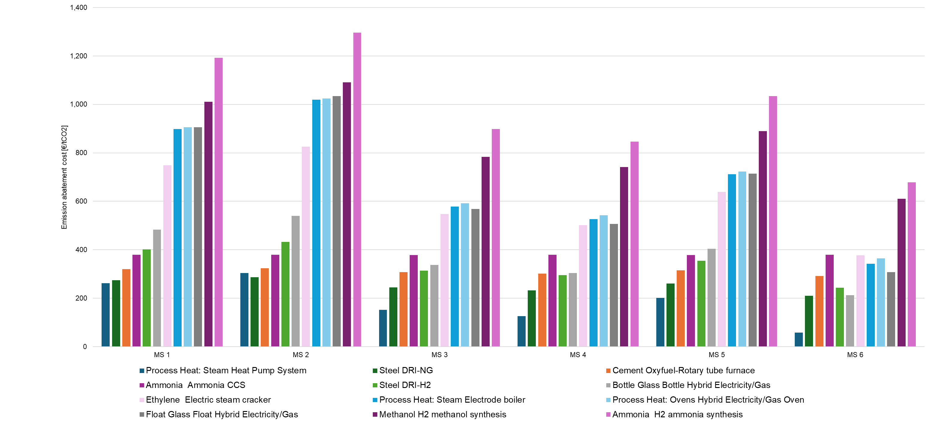
Source: Fraunhofer
GHG emission abatement costs are defined as the discounted total cost per tonne of CO₂ avoided when switching from a conventional fossil-based technology to a low-emission alternative. Discount factors play a significant roles in decreasing the future revenues and costs of the project, for projects with a funding gap typically increasing this funding gap. In economic terms, this cost corresponds to the level of subsidy a project would need to request per tonne of CO₂ avoided, i.e. a carbon fixed premium (CfP), to achieve cost parity with the fossil reference technology over a defined support period. A support duration of ten years is assumed. Accordingly, the model incorporates projected developments of the EU ETS and energy prices with perfect foresight over the full support period. The model outcome provides the cost gap of an investment in clean technology compared to the fossil conventional technology. Discount rate assumptions clearly influence cost-efficiency of the scheme, in most cases increasing the funding gap this, however, reflects the economic realities of decarbonisation projects needing either loans or equity to support their investments which increases the overall costs of the projects and thus the need of the support. Discount rate assumptions reflect optimistic assessment of investors on the risk profile of the IDB supported projects, which is justified by the design of the IDB modelled (a non-repayable subsidy, perfectly sized to the funding needs and guaranteed over 10-year period).
With the design of the IDB modelled as non-repayable subsidy, perfectly sized to the funding needs and guaranteed over 10-year period combined with moderate assumptions on WACC, the economic actors’ perfect foresight, this approach assumes maximum efficiency in the allocation mechanism of public support without transaction costs and results should be interpreted as an optimistic scenario.
The model assumes that the IDB subsidy fully covers the additional costs of the decarbonisation project (during the support duration) and does not account for potential additional revenues form green lead markets. There is also no assumption on possible upside sharing mechanism that could be attached to the support (e.g. in case project realises very high profit it would be shared with the public authority that operates the IDB). In this simulation and amongst the policy measures analysed in this Impact Assessment there are no fundamental differences in the risk distributions between the public and private actors. Different models could be envisaged but it would require different sets of instruments to be analysed (e.g. loans, guarantees, equity stakes, contract for difference for the green products) and on more granular level (e.g. remuneration and seniority of the debt, remuneration of equity, fixed premium addressing only a part of the funding gap etc).
Economic input parameters are taken from the impact assessment of the EU 2040 climate target modelling, while technology-specific assumptions are based on literature review as well as internal data and expertise from Fraunhofer ISI and for simplicity do not feature the learning effect (i.e. the reduction of technology costs over time).
In practical terms, the model first computes the levelised cost of production (LCOP) for both the conventional fossil and the most advanced low-emission alternative for each relevant EII sector per Member State. Based on the cost difference and the associated GHG abatement achieved by the low-emission technology, the GHG emission abatement costs are calculated as follows:
$$GHG emission abatement cost=\frac{LCOP_{Clean}-LCOP_{Conventional}}{{GHG emission intensity}_{Conventional}-{GHG emission intensity}_{Clean}}$$
To estimate a realistic pipeline of potential projects applying for the IDB support in each funding round, the model builds on data from installations registered under the EU ETS. These data provide detailed overview of existing industrial installations by activity and Member State that are expected to undergo transformation. Based on the technical lifetime of conventional plants, an annual replacement rate is calculated and assumed as the pipeline of projects potentially willing to invest in low-emission technologies.
For each simulated funding round under the IDB, the resulting project pipeline is combined with the GHG emission abatement costs to establish a merit order curve. Projects with abatement costs below the considered average EU ETS price are assumed to proceed with transformation without IDB support (i.e. assuming no windfall profits). The average EU ETS price reflects the price projections over a period of 10 years. For example, projects switching to a low-carbon technology in 2030, have to reflect the EU ETS price developments of ten years - consequently until 2039 - in their calculation of the cost gap of their business case. Projects requiring additional support are awarded in the IDB auction until the budget is exhausted. Thereby, the requested support per tonne of CO_{2eq} abated is considered as the difference between abatement costs and EU ETS price, as follows:
$$Requested specific support= GHG emission abatement cost-ETS price$$
To simulate the operation of the IDB over time, it is assumed that EUR 10 billion of support are allocated in ten consecutive support rounds (first round in 2030 until last round in 2039). Projects that do not receive support remain in the pipeline and are considered again in subsequent auction rounds. Unused budget is shifted to the following auction. Each year, new projects enter the pipeline, the merit order curve is recalculated, and the selection process is repeated. Figure below visualises this approach.
- Modelled consecutive support logic for two consecutive funding rounds
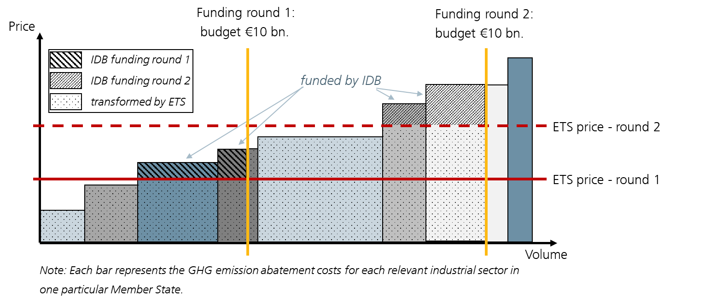
Source: Fraunhofer
To evaluate the support cost efficiency, the weighted average support per tonne GHG emission abated of each funding round is calculated as follows:
$$Weighted average support need [\frac{}{{}_{}}\frac{EUR}{t_{CO2}}]=\frac{IDB support \frac{}{{}_{}}[EUR]}{Total emission reduction [t_{CO2}]}$$
This figure provides the average amount of support for a ton of additional emission reduction, considering the different support volumes of each awarded sector and Member State in the particular funding round.
In addition to the IDB impact on GHG emissions reduction, the model enables the quantification of the direct leverage effect of public support on private investment. This factor is calculated as follows:
$$Direct leverage effect=\frac{IDB support}{Private investment expenditures}$$
The IDB support covers the total cost gap including CAPEX and OPEX, while the private investment expenditures only represent the CAPEX for the low-emission technology. For technologies with a high share of OPEX in total expenditures (OPEX-intensive technologies), typically in EII, the leverage effect tends to be smaller compared to CAPEX-intensive technologies such as renewable energy plants.
Besides the direct leverage effect, indirect leverage effects of the support are to be expected. However, the model does not allow quantifying them. To do so, further analysis on system- and macro level would be required. Consequently, indirect leverage effects can only be derived qualitatively: As the switch to low-carbon technologies in most cases is linked to a fuel switch from fossil to electricity, indirect leverage effects of IDB support are related to investments in the renewable energy system, i.e. renewable power generation, storage and infrastructure but also in establishing a hydrogen economy including electrolysers as well as CO₂ infrastructure.
      - Expected GHG abatement
The model results indicate cumulative GHG emission abatement of 1,630 Mt CO2 over a ten-year period, based on a total budget of EUR 100 bn allocated across ten funding rounds with EUR 10 bn funding volume in each annual round. Over the assumed support period of ten years, the resulting weighted average awarded support amounts to EUR 60/t CO2 abated.
This support is modelled to bridge the remaining cost gap - covering both CAPEX and OPEX - of the low-emission technologies deployed in funded projects, compared to the incumbent fossil-based technologies, after accounting for the average EU ETS price stemming from the scenarios underpinning the 2040 climate target.
The model simulates an auction and thus a merit order curve is established for each funding round that illustrates the remaining (after the effect of the EU ETS price) cost gap of the project pipeline. Each data point of the merit order curve represents a specific combination of industrial sector and Member State. Figure below presents the results of the first modelled auction round in 2030 and, for comparison, of the final round in 2039. The y-axis represents the GHG emission abatement costs, while the x-axis shows the cumulative cost gap of the project pipeline in the respective funding round. Applying the logic of an auction, the annual IDB budget of EUR 10 bn is allocated to the projects with the lowest GHG emissions abatement costs. Projects that are not awarded support in a given funding round remain in the project pipeline and are carried forward to subsequent rounds. As a result, the merit order curve expands over time, reflecting the growing pool of projects competing for support in each successive auction.

- Illustration of impacts of the IDB funding rounds in 2030 and 2039

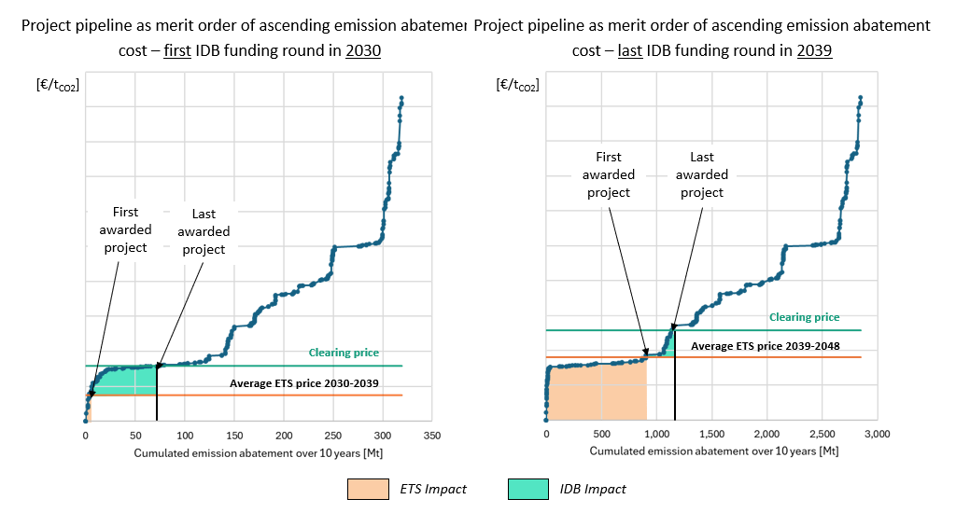
Source: Fraunhofer
Projects that reach cost parity with the conventional fossil-based technology solely through the EU ETS price development do not face any remaining cost gap in the respective year. These projects are therefore located below the orange horizontal line, which indicates the average EU ETS price applicable in the respective funding period. These projects are assumed to invest in low-emission technologies solely motivated by the EU ETS price.
The black vertical line represents the budget constraint of the IDB funding round, set at EUR 10 billion in every year. The auction clearing price emerges at the point where the merit order curve intersects with the available budget. The difference between the clearing price and the EU ETS price reflects the level of support provided through the IDB for the last awarded project. The green area depicts the total IDB funding volume of the respective auction round.
Comparing results in 2030 and 2039, it can be observed that as the EU ETS price increases it has an increasingly transformative effect on its own and the IDB support progressively addresses more and more expensive decarbonisation options. While the IDB impact is sizeable, the potential for decarbonisation also grows with each successive round as only share of the projects can receive the funding.
When evaluating the model results with regard to Member States and sectors, the results suggest a significant share of IDB budget would be allocated to a limited number of industrial sectors and Member States under a competitive bidding approach. In this context, the industrial sector, and more specifically the underlying production processes, prove to be more relevant for support allocation than differences in national energy price levels alone. Firstly, efficient electrification technologies in medium temperature processes (i.e. below 200°C), such as those commonly found in the paper industry, do not require public support in most MS when EU ETS prices are at levels assumed in the impact assessment for the 2040 climate target.
Most of the support is allocated to process heat electrification in medium temperature levels in MS with higher electricity cost and high temperature electrification in Member States with low electricity cost. Additionally, the application of direct reduction of primary steel, using hydrogen is supported in the model. Carbon capture and Storage (CCS) in cement & lime is another sector supported by the IDB.
In contrast, processes characterised by substantially higher cost gaps, such as the production of synthetic hydrocarbons for the chemical industry or synthetic fuels for maritime and aviation, are not awarded support in the purely technology-neutral auction simulation. An approach that prioritises projects with the lowest cost gaps inherently favours projects with smaller abatement cost, leaving higher cost but strategically relevant technologies unsupported unless budget earmarking for specific sectors is introduced.
At the same time, differences in energy prices across Member States also affect abatement costs and remaining cost gaps. While in some Member States the EU ETS price proved to be sufficient to close cost gaps in certain industrial sectors, this is not the case in others. This becomes particularly evident for processes such as primary steel production, electric steam cracking, and glass manufacturing.
Overall, Member States with comparatively low electricity prices would emerge as the most competitive. Geographical balancing could counteract these distributional effects. In turn, any geographical or sectoral steering of support under the IDB would therefore reduce allocative efficiency in this static modelling framework, and, as a consequence, lower the amount of GHG emission abatement achieved per euro of public support. It should be noted, however, that this assessment does not capture potential regional or sectoral learning effects, possibility of future electricity prices evolution and technology diffusion over time.
      - Direct leverage effect
For the analysed Member States and technologies, the direct investment leverage effect varies between 5% and 75%, depending on the sector and technology considered. Across all modelled supported projects, the weighted average direct investment leverage amounts to 45%.
The production of energy-intensive basic materials generally requires substantial upfront investments (CAPEX) in production plants with long technical lifetimes, typically ranging from 15 to 25 years. At the same time, operating costs, particularly energy-related OPEX, account for a dominant share of total production costs. This trend becomes even more pronounced for low-emission technologies.
Energy-related OPEX, in particular for electricity, hydrogen, and related infrastructure costs are not reflected in the direct leverage effect. Nevertheless, the IDB support creates stable demand signals for such energy-related investments beyond the boundaries of EII. As a result, an additional indirect investment leverage effect can be expected on system and macro level. However, this indirect effect cannot be quantified within the scope of the applied model.
      - Limitations
The model applies a generic approach to depict a broad range of emission reduction technologies and many countries. This comes at the expense of level of detail. The results do not include sensitivity analyses for EU ETS and energy prices. As EU ETS and energy cost dominate the LCOP, they have a significant impact on the overall results. Next, the model assumes perfect foresight, perfect economic efficiency and no transaction costs. Variation from these assumptions would reduce the impact of the available budget. The model does not reflect any effect of support on the EU ETS prices, which are anticipated but whose estimation would require full energy system modelling. Lastly, it is assumed that investments in production capacities are done in the MS where currently conventional production is deployed. Relocation within the EU in relation to the most favourable production factors and outside the EU would significantly change the pipeline of projects requiring support and would potentially impact the model results. The model reflects this aspect only partially by triggering investments at the most economic location first.
      - Limited differences in impacts across the policy options
The differences between the IDB options on allocation mechanism, form of support or geographical balance are too subtle to have sizeable impacts on GHG abatement or size of private investment, so only a qualitative assessment is proposed below. Certain options are expected to be more efficient (auctions, variable premia – see Section 3.4.2) so they could be expected to have larger positive impact on GHG abatement, greater leverage of private investments and larger spillover effects. But this is very much dependent on the specific design and circumstances (notably the level of competition). For example, in the operation of the Innovation Fund, it appeared that for RFNBO hydrogen production, the amount of subsidy requested via the ‘regular’ grants of the IF is as low as in the auctions (even though economic theory finds the auction to be a the most efficient instrument). Certainly, the high level of competition in the IF ‘regular’ grants and the fact that they cover only 60% of the relevant costs (i.e. simplified funding gap) has helped to increase the efficiency. Also, the desired efficiency of the tools must be weighed against the risk of portfolio attrition (i.e. projects dropping out to the detriment of the overall efficiency.
Establishment of the IDB will bring advantages for many sectors. All actors across the EU economy will benefit from the continuation of the IF and establishment of the IDB since all actors consume industrial products. In particular, actors in the industry sector will be confronted with increasing carbon prices unless decarbonisation solutions can be deployed at a scale. Finally, society - as a whole - will draw benefits from industrial decarbonisation supported by the two instruments as the entire society consumes industrial products, a part of society works in the industrial sector, some have part of their pensions linked to the performance of industrial stocks and all will benefit from climate change mitigation.
Though the EU is a front-runner in climate ambition, this does not guarantee that it will be competitive at the global stage in deploying decarbonisation solutions and securing a strong position in producing such solutions for the global markets. Building on the EU’s competitive advantage starts with establishing a business case and requires additional industrial policy measures to avoid building dependencies and promoting EU-made solutions. This goes beyond the remit of the IDB and will be partly addressed by the Industrial Accelerator Act (IAA). The IDB can apply the Union origin requirements of IAA, similar to the IF hydrogen auctions that applied the resilience requirements put forward by Net Zero Industry Act.
    - How do the policy measures and options compare?
The assessment is based on a system of rating, focussing on effectiveness, efficiency and coherence:
- (negative): the policy option/measure has a negative effect
= (neutral): the policy option/measure has no significant effect
+ (low positive): the policy option/measure has a modest positive effect
++ (moderate positive): the policy option/measure has a significant positive effect
+++ (high positive): the policy option/measure strongly advances effectiveness, efficiency or coherence.
First of all, measures are assessed in detail and then policy options combining measures are assessed in the synthetic manner.
      - Effectiveness
In the tables below policy measures are compered in terms of their effectiveness, i.e. likelihood of achieving the objectives. To be noted that in most of the cases the effectiveness or efficiency would be defined by combination of allocation mechanism with the form and size of support and would depend on much more granular features of the support mechanism (e.g. penalties for non-delivery, milestones upon which support is disbursed, level of due diligence applied to financial model at the stage of evaluation, etc.).
All main policy measures (that are later combined into Policy Options) are assessed and for allocation mechanism and form of support also one additional measure for more comprehensive overview.
- Effectiveness of measures on allocation mechanism
 | Measure AM.1: multi-criteria call for proposals | Measure AM.2: auctions | Measure AM.3: administrative schemes | MS propose a shortlist
SO1: creating the business case for private investment | ++ | ++ | +++ | +
SO1: creating the business case for private investment | Depending on specific design (e.g. how large share of the funding gap is covered) but in essence, sufficient to create business case. | Depending on specific design (e.g. presence of completion bond) but in essence, sufficient to create business case.  There are risks for the administrative body of non-delivery if penalty regimes and prequalification criteria are weak.  Strategic bidding by large players that may crowd out smaller actors can also happen.  Conversely if prequalification and penalties are too strict, underbidding may occur. | Depending on specific design (e.g. how application process is managed and at what stage (pre-FID) projects are sought) but in essence, sufficient to create business case and even allow the higher return on investment depending on level of compensation fixed.  A clear and simple mechanism so very easy to communicate and integrate corporate in planning and decision making. | Depending on specific design (e.g. how application process is managed and what selection criteria are applied by MS) but in essence, sufficient to create business case.  There is a risk of lengthy decision-making which makes establishing business case more difficult.
SO2: create an instrument with sufficient budget and duration | The choice of measure does not have an impact on achievement of this objective
SO3: create an instrument operating in simple and flexible way and thus suitable for addressing all sectors in all countries | + | ++ | +++ | ++
 | The design complexity of multicriteria calls is generally high, as the criteria need to be clearly defined and operationalised. Processes for potential multi-stage application procedures need to be defined and implemented.  The administrative burden is high for both applicants and authorities. Applicants must provide substantial documentation, align project details across a variety of document types, and provide robust contractual evidence from project partners.  Authorities must run multistage evaluations, due diligence, grant agreement negotiations, and long-term monitoring against milestones and verified abatement.  All sectors can be addressed in one call for proposals but depending on call design, some sectors of types of projects can be favoured. | The design complexity of auctions depends on the range of objectives.  Auctions tend to use bid prices as the main selection criterion, which simplifies the allocation mechanism.  Auction can be implemented as multicriteria auctions to pursue further goals beyond cost-effectiveness and price discovery. This increases complexity.  The exact administrative burden is strongly linked to the auction model, e.g. potential clawback or payback features. One-sided auctions are less complex than double-sided auctions (that need an additional administrative body involved that acts as a bridge between end-users and the auctioning authorities).  Standardised documentation and auction terms and conditions keep transaction costs for the auctioneer lower than in multi-criteria calls for proposals.  Addressing all sectors in one call is challenging since there is need for a homogenous auction good. This can be addressed by auction baskets or other discriminatory elements. | This measure is fast to deploy with low design complexity, minimal barriers to entry, making support disbursement quite predictable for applicants.  It can be effective in kickstarting supply for standardised low-emission technologies or products.  The administrative burden of this mechanism is low.  All sectors can be addressed in one administrative scheme, but level of support should be differentiated or there is a risk of windfall projects. | The design complexity of such an allocation mechanism is lower on EU level compared to a centrally managed mechanism, but higher on Member State level – and multiplied with the number of different designs applied in each Member State.  The administrative burden is distributed and significant at national level. MS must coordinate project selection, concrete instrument design, stateaid compliance, with the EUlevel governance and disbursement processes.  There is potential for excessive heterogeneity and fragmentation of project pipeline because selection criteria, standards and risk management can vary by MS.  All sectors can be addressed in one national shortlist but there is no control over the choice of projects or criteria set on the national level.
SO4: create an instrument that supports sectors producing CBAM goods | The choice of measure does not have an impact on achievement of this objective, it is the call design that has the impact.
SO5: create an instrument that maximises success rate of the projects. | + | + | ++ | -
 | Risk of high dropout rate/project dropouts (i.e. projects not materialising confronted with costs increases or other unforeseen difficulties) especially if call design does not allow some flexibilities in cost calculation, funding gap coverage etc.  Reserve list is usually limited so it is difficult to replace dropouts by the new projects. | Risk of highest dropout rate due to competitive nature of auctions that reward risk-taking by the bidders can be moderated by specific features as completion bonds and elements of due diligence as part of qualifications.  Reserve list is usually limited so it is difficult to replace dropouts by the new projects. | It is assumed that authorities would apply a simple eligibility check and provide a standardised grant once the project is delivered. If there are project drop-outs it is easy to select a new project from the application queue.  Consequently, while there is a high risk of dropout rate, an administration can operate a very long reserve list at a very low administrative cost that will enable to replace the dropouts seamlessly. | Risk of high dropout rate if projects are not duly vetted in terms of financial maturity and if the administrative process is longer due to interactions between MS and the EC.

- Effectiveness of measures on type of support
Effectiveness (likelihood of achieving the objectives) | Measure FS.1:  Regular grants | Measure FS.2: CFPs | Measure FS.3: CCfDs | Fixed premium per unit of decarbonised product
SO1: creating the business case for private investment | ++ | ++ | +++ | ++
SO1: creating the business case for private investment | Sufficient to create business case since (depending on the exact rules), grants are generally able to close cost gaps to conventional production.  Risks for projects are especially reduced at early stages (i.e. construction phase), while cost and price-related risks remain throughout the operational period. | CFPs effectively incentivise GHG reductions as support is only paid for operation and avoided emissions.  They are designed to close the cost gap. However, as the support is static, changing market conditions may open up new cost gaps or lead to windfall profits (mainly with a view to carbon and energy prices).  The level of risk for the beneficiary depends on the specific design. Theoretically, variable costs can also be mitigated via indexation in a fixed premium (which would run against the simplicity of CFPs though). | CCfDs effectively incentivise GHG reductions as support is only paid for operation.  Their link to the EU ETS price might disincentivise operation during longer periods in which the carbon price is above the strike price (due to the payback obligation albeit other market participants would need to face the same conditions).  They are designed to close the cost gap. Bidders define the height of their bid and can thus tailor their support need.  Fluctuation of input factors may affect the economic viability of supported projects. Indexation of input factors can mitigate these cost-related risks but imply additional complexity.  CCfDs provide floating de-risking regarding the carbon price. There is a cash-flow risk related to high carbon prices (and subsequent payback obligations).  Other than carbon variable costs can also be mitigated via indexation (which would further increase complexity of the scheme). | A fixed premium effectively incentivises GHG reductions as support is only paid for operation (production of low-emission unit).  While aiming to close the cost gap, a fixed premium per output unit is less certain to close the cost gap compared to floating support measures.  Changing market conditions may alter the actual cost gap, while the funding remains static.  This translates to some risk for the beneficiary, as the static support level may lead to over- or under-compensation in changing market conditions.
SO2: create an instrument with sufficient budget and duration | The choice of measure does not have an impact on achievement of this objective.  It has to be, however, noted that a variable premium will involve a sizeable budgetary risk on the side of the administration, which requires budgetary provisions and hence might diminish the budget available for the allocation.  In case of CCfDs, indexation to energy prices might also be needed which will require additional budgetary reserves.
SO3: create an instrument  operating in simple and flexible way thus  addressing all sectors in all countries | + | ++ | + | ++
 | The design complexity of the instrument depends inter alia on the exact procedure for project selection and performance requirements (i.e. multicriteria selection is more complex and performance requirements imply significant MRV efforts). Also, the administrative complexity of the instrument depends inter alia on the exact procedure for project selection and performance requirements that need to be monitored.  All sectors can be addressed. | CFPs have some design complexity, as a (specific) reference scenario is needed to determine the avoided emissions.  The administrative complexity for bidders and support givers is comparably low. However, depending on the actual support design, monitoring compliance and verifying emission reductions across diverse industries can be required.  All sectors can be addressed. | CCfDs generally come with a high design complexity, resulting from high data input needs, a large number of parameters, and the need for regular adjustments. Their design and related complexity can be adjusted according to the respective process / technology to be supported.  The administrative burden for bidders is generally high, requiring sophisticated financial modelling and carbon accounting, which may prevent some small and medium-sized enterprises (SMEs) from participating in the support mechanism due to capacity constraints. There is also high administrative complexity for the administration, as regular calibration (e.g. of energy price indices) is required and CCfDs require monitoring compliance and verifying emission reductions across diverse EII industries.  All sectors can be addressed. | A fixed premium per output unit has some design complexity, as the low-emission products need to be specified/defined.  The administrative complexity for bidders and support givers is comparably low. However, MRV is needed to verify low-emission production.  All sectors can be addressed.
SO4: create an instrument that supports sectors producing CBAM goods | The choice of measure does not have an impact on achievement of this objective, it is the call design that has the impact.
SO5: create an instrument that maximises success rate of the projects. | ++ | ++ | +++ | ++
There only sizeable difference is between (1) grants/fixed premia and (2) variable premium.
A static support level (for measures B1, B2 and B4) can lead to overcompensation and the price and cost risks remaining with the project will increase its cost of capital. A variable premium is the most efficient as it adapts to the market circumstances and actual revenues of the project. Some stakeholders, however, indicate that institutional investors have preference for the fixed premium as it provides more visible funding flows, simplicity and, depending on the design, can allow higher remuneration of those investors.
On the other hand, as the variable support measures decrease the investment risk (e.g. CO2 and energy price risk), they also decrease the return needs for investors. Low risk investments are cheaper (i.e. they have a lower cost of capital) and may attract more private capital.
On the contrary, fixed premiums do not alter the risk profile of the investment per se (WACC remains constant), and, therefore, may be less beneficial in terms of attracting additional investments.
It is possible that in the early years, the fixed premium would be preferable to create business confidence in the scheme and could progressively be replaced by a variable premium.

- Effectiveness of measures on geographical balance
Effectiveness (likelihood of achieving the objectives) | Measure GB.1: EU-level competition | Measure GB.2: National allocations for MS in terms of overall IDB spending | Measure GB.3: A part of the budget for EU-level competition and another part of the budget for national allocations
SO1: creating the business case for private investment | The choice of measure does not have an impact on achievement of this objective.
SO2: create an instrument with sufficient budget and duration | The choice of measure does not have an impact on achievement of this objective albeit if extreme approach to compartmentalisation is applied, the national allocations (GB.2) may turn out to be too small to support large-scale investments.
SO3: create an instrument  operating in simple and flexible way  thus addressing all sectors in all countries | + | +++ | ++
 | Competition on the EU level is a simple method but depending on different factors of competitiveness, projects in certain countries or regions might perform better and secure larger share of funding.  This approach might fail to address the specific needs and challenges of individual industries or regions, potentially leading to missed opportunities for targeted interventions, and it may exacerbate existing inequalities.  Due to strong variety in operational cost, esp. energy cost, across MS, EU wide competition may lead to systematic over- and under-compensation of recipients in such MS. | National allocations is a simple method.  National allocations ensure that project in all countries can benefit from the funding.  This approach offers the best alignment of funding with the scale and type of the decarbonisation challenges each Member State faces.  This approach ensures the best outcome in terms of the geographical balance.  Still to be noted that in case of limited amount of funding available for smaller Member States, it might not be sufficient to support the construction of any single commercial-scale project and to elicit the necessary level of competition (‘fragmentation of funding’) | Combination of the EU-level competition and national allocations is a simple method.  National allocations ensure that project in all countries can benefit from the funding albeit the EU -level allocation is still rewarding the pure excellence on the EU-level.  This approach ensures the second best outcome in terms of the geographical balance.
SO4: create an instrument that supports sectors producing CBAM goods | The choice of measure does not have an impact on achievement of this objective.
SO5: create an instrument that maximises success rate of the projects. | The choice of measure does not have an impact on achievement of this objective.
      - Efficiency
In the table below measures are compered in terms of their efficiency, i.e. relationship between the expected benefits of a policy measure and the resources required to implement it.
As discussed above, for the purpose of analysis of impacts it was assumed that the IDB support fully covers the additional costs of the decarbonisation project during the 10-year support period and does not envisage neither potential additional revenues form green lead markets nor possible upside sharing mechanism that could be attached to the support. Many of the assumptions taken reflect a favourable outlook and thus projected cumulative GHG emission abatement of 1,630 Mt CO2 over a 10-year period needs to be considered as an optimistic scenario. This result can be expected from the allocation mechanism structured as competitive bidding and would necessarily decrease if different method is chosen.
Amongst the policy measures analysed in this Impact Assessment there are no fundamental differences in the risk distributions between the public and private actors. Different models could be envisaged but it would require different sets of instruments to be analysed (e.g. loans, guarantees, equity stakes, contract for difference for the green products) and on more granular level beyond the scope of this IA (e.g. remuneration and seniority of the debt, remuneration of equity, fixed premium addressing only a part of the funding gap etc). Such models and their specific features would have also a significant bearing on the overall efficiency of the support.
- Efficiency of measures
 | Measure AM.1: multi-criteria call for proposals | Measure AM.2: auctions | Measure AM.3: administrative schemes | Measure: MS propose a shortlist
Comparison of measures on the allocation mechanism. | ++ | +++ | ++ | ++
Comparison of measures on the allocation mechanism. | Cost efficiency in multicriteria calls is likely limited, unless cost-efficiency is also an award criterion.  A recurring challenge in multicriteria calls is cost discovery. When responding to multicriteria calls for proposals, projects do not competitively bid on a single ‘price’ metric, meaning project pricing information may not reflect the true subsidy amount needed to support project realisation.  These ‘information rents’ can in turn result in higher subsidies per tonne of CO₂ avoided or per unit of low-emission product than necessary, especially for more mature decarbonisation technologies  Consequently, the likely expected on private investment mobilised and GHG abatement could be lower.  Highest administrative burden for application and evaluation stage (monitoring efforts depends on the call design). | Auctions by definition enable competitive price discovery and typically deliver higher cost efficiency per euro spent than the other allocation mechanisms.  The likely effect on private investment mobilised and GHG abatement is the highest.  Medium administrative burden for application and evaluation stage.  Production-based support typically operated with such a scheme performs less strong in the initial project phases, but incentivizes during the operational phase.  Production-based support typically operated with such a scheme performs less strong in the initial project phases, but incentivizes during the operational phase. | Lower cost-efficiency compared to other measures because there is no ‘discovery’ of the subsidy need and if administratively fixed levels of remuneration is high there is a risk of overcompensation/windfall profits.  Funds can be captured by the fastest rather than the most impactful or cost-effective projects and well-resourced applicants may ‘queue’ ahead of smaller players. Additionally, there is a risk that support will be given to projects that would have proceeded regardless of whether they received public support, creating a high risk of windfall profits.  The likely effect on private investment mobilised and GHG abatement is lower.  Low administrative burden for application and evaluation stage.  Production-based support typically operated with such a scheme performs less strong in the initial project phases, but incentivizes during the operational phase. | In principle, the mechanism would risk performing less well on cost-efficiency, but thorough check of costs and benchmarking can limit this risk.  Impact depends on the design made on the national level but it does not benefit from EU-wide competition.  Likely, lower cost-efficiency compared to other measures.  The likely effect on private investment mobilised and GHG abatement is lower.  Low administrative burden (on the EU level) for application and evaluation stage.
 | Measure FS.1:  Regular grants | Measure FS.2: CFPs | Measure FS.3: CCfDs | Measure: fixed premium per unit of decarbonised product
Comparison of measures on the type of support provided. | ++ | ++ | +++ | +
Comparison of measures on the type of support provided. | Lower level of cost efficiency because a static support level can lead to overcompensation and the price and cost risks remaining with the project will increase its cost of capital.  On the other hand, the investors see predictable funding inflows which provide simplicity and predictability. Efficiency will depend on very granular design features (how is the grant calculated, are there upfront payments, how is the premium defined etc). All of these features will influence the project’s risk profile and influence the cost of capital.  The likely effect on private investment mobilised and GHG abatement will depend on this more granular design.  Lower burden for the administration that provide the support. |  | Highest cost-efficiency compared to other measures as variable premium adapts to market conditions and avoids overcompensation.  The likely effect on private investment mobilised and GHG abatement is higher.  Highest administrative burden. | Lower level of cost efficiency.  A static support level can lead to overcompensation but if the market situation is adverse, price and cost risks remain with the project will increase its cost of capital. Depending on the granular design there can be very different impact.  The likely effect on private investment mobilised and GHG abatement is lower.  Lower administrative burden
Comparison of measures on the geographical balance | Measure GB.1: EU-level competition | Measure GB.2: National allocations for MS in terms of overall IDB spending | Measure GB.3: A part of the budget for EU-level competition and another part of the budget for national allocations
Comparison of measures on the geographical balance | +++ | + | ++
Comparison of measures on the geographical balance | The best efficiency achieved due to EU-level competitions that favours the most mature projects, with the best locations, benefiting from the favourable national industrial structures and national policies.  In the long term, this measure can lead to missing some opportunities in countries/regions that are hampered by lack of administrative capacity/lack of innovation ecosystem rather than structural factors of their industry/economy. | The least efficient measure because it does not benefit from the EU-level competition. | The ‘second best’ measure which draws to large extent the benefits of the EU-level competitions and yet safeguards part of funding for national project. Possibly it avoids missing opportunities in terms of unlocking the potential of all EU MS in terms of industrial decarbonisation.
      - Coherence
In general, there will be a strong interplay between the IDB and other climate and energy policies that will be implemented to reach the 2040 climate target and 2050 climate neutrality. The IDB will not be adding to the level of ambition of these targets and policies but will be an enabler, by addressing the lack of business case of the industrial decarbonisation projects. As a general rule, the stronger the policies and/or their implementation, the lighter the amount of support to be provided by the IDB. Typically, with strong carbon prices and mandates for energy efficiency and renewables, the support of the IDB will need to be less onerous and can shift more towards income stabilisation.
As to interaction with other enabling policies that support the investments, the synergies should be sought in order to maximise their combined impact taking into account the magnitude of the investment challenge. The main interaction will take place with other funding instruments on the EU and national level. On the EU level, the final design of the European Competitiveness Fund (ECF) will be of key importance and common governance of the ECF with the IDB will help to ensure synergies. An example of avoiding overlaps could be focusing the IDB on EII projects that require a grant and the ECF on EII projects that require other financial instruments. Another example could be assessment and necessary adjustment between the respective work programmes/funding rounds of the IDB and ECF that would minimise the interplay. The respective rules on combined support would ensure that there is no ‘double funding’. Interplay with national support mechanisms (mostly taking form of State aid) will also be important. This can be discussed at relevant fora with the MS and, as a minimum, the State aid/IDB rules on combined support would ensure no overcompensation. The most efficient approach has already been pioneered by the ‘as-a-service’ feature of the IF calls for proposals, whereby MS can use the IF evaluation process and benefit from the EU-level competition in order to support project located on their territory. Prioritisation of the use of EU ETS national revenues to support projects in the scope of the EU ETS, notably via ‘topping up’ the EU ETS funds (e.g. IDB, IF, MF) would also increase the coherence between the national and EU-level funding.
Finally, IDB will interact with other instruments that influence the business case of the decarbonisation projects, notably the (Conditional) Free Allocation (FA), CBAM and indirect costs compensation (ICC). All those instruments improve the business case of the decarbonisation projects, so they have to be considered when sizing the IDB levels of support. For example, today the IF (or many State aid schemes) require the funding gap analysis for projects to be supported that explicitly takes into account:
- costs of electricity (with ICC, if relevant),
- revenue from the sale of final products (with CBAM affecting the prices offered by importers, if relevant)
- Free Allocation (both for the project itself and its competitors)
Similar approach could be applied when sizing the fixed premia (based on funding gap estimation of an illustrative projects considering ICC, FA and CBAM) and would naturally happen in the competitive bidding process where projects are incentivised to reveal their true costs in order to put an attractive bid that is likely to be awarded. It can be expected that an implementation of the ICC, (conditional) FA and CBAM that is strongly oriented towards investment support will reduce the amount of support to be provided by the IDB. Consequently, IDB could support more projects with smaller amounts and deliver overall bigger abatement (than what is discussed in Section 3.4.1.2 Expected GHG abatements). Larger group of sectors could therefore become beneficiaries of the IDB earlier on with positive spillover effects on the downstream sector.
To be noted that the investments eligible under the conditional FA would be similar to ones eligible for IDB support. In such case, it could be envisaged that the installation that receives the IDB support is considered to automatically fulfil the FA conditionality.
In the tables below measures are compered in terms of their coherence with other EU initiatives. In terms of coherence the measures on geographical balance or type of support make little difference. Only possible unintended consequences are discussed for the type of support and coherence is not discussed for measures on geographical balance (too small differences to be highlighted). Some subtle differences depending on allocation mechanism are identified below.
- Coherence of measures on allocation mechanism
 | Measure AM.1: multi-criteria call for proposals | Measure AM.2: auctions | Measure AM.3: administrative schemes | Measure: MS propose a shortlist
Coherence with other EU funding programmes | ++ | ++ | ++ | +
Coherence with other EU funding programmes | Regardless of the instrument chosen, IDB will focus on:  - decarbonisation of EII  - decarbonisation technologies going beyond FOAK, i.e. scale-up and roll-out of technologies that have been already demonstrated and commercialised.  - and projects that have a funding gap.  This stage in the ‘investment journey’ (from research to deployment on EU-level) is currently addressed only in very small extent by the IF (with insufficient resources) and could potentially be addressed by ECF (also with insufficient resources).  The internal coherence with continuation of the IF can be ensured by restricting IF to FOAK kinds of projects. Also coherence with ECF can be ensured by, for example, focusing ECF for EII for funding instruments other than grants. |  |  | It depends on the design chosen by the MS to identify the short-list, there is potentially a risk of overlaps with EU funding programmes.
Coherence with other national funding programmes | ++ |  |  | +++
Coherence with other national funding programmes | Regardless of the instrument chosen, IDB can overlap with national funding programmes.  This risk can be minimised by deploying an ‘as-a-service feature’ redirecting national spending to the EU-level instrument (see assessment of measures GB.1-C.4) |  |  | It depends on the design chosen by the MS to identify the short-list but MS should be able to control better the risk of overlaps
Coherence with EU initiatives and policies | Regardless of measures chosen, IDB will work hand in hand with the EU ETS and other regulatory decarbonisation measures.  It can also align with objectives of industrial policy (e.g. on resilience)
Possible unintended consequences | - | - | - | -
Possible unintended consequences | Risk that multiple award criteria are used to pursue too many objectives at the same time. | Risk that uniform rules will not fully cater to the specificities of the different sectors. This could be mitigated by establishment of auction baskets. | Risk of under- or over-compensation albeit there could be mitigation measures put in place. | Risk that governance and strategic oversight could remain challenging.
- Coherence of measures on the type of support
Possible unintended consequences | Option FS.1:  Regular grants | Option FS.2: CfPs | Option FS.3: CCfDs | Options B.4: fixed premium per unit of decarbonised product
 | + | + | ++ | +
 | Risk of overcompensation or, conversely, insufficient subsidy once the market conditions change. |  | Risk of large liability in case carbon prices fall to very low level. | Risk of overcompensation or, conversely, insufficient subsidy once the market conditions change.
      - Assessment of policy options
 | Policy Option (1)  - 'Regular’ multi-criteria calls for proposals  - 'Regular' grants covering the funding gap  - EU-level competition and soft measures on geographical balance | Policy Option (2)  - Administrative schemes  - Fixed premium,  - Balance between national allocations and EU-level competition | Policy Option (3)  - Auctions,  - Carbon Contracts for Difference,  - Strong national allocations
Effectiveness | ++ | +++ | ++
Efficiency | +++ | ++ | +++
Coherence | ++ | +++ | ++
In terms of effectiveness: Moderate impact of PO1 is expected as it addresses well the funding gap of industrial decarbonisation projects but represents operational complexity, high risk of projects’ dropouts, administrative burden and geographical imbalances.
In contrast, strongly positive of PO2 is expected as it addresses well the funding gap of industrial decarbonisation projects and offers simplification, attractive financial model as well as clear rewards for ‘front-runner’ projects. The risk of unspent resources is minimised. There is a strong alignment of funding with the scale and type of the decarbonisation challenges and proposal strikes a balance between the EU-level competition as well as geographical balance.
Finally, moderate impact of PO3 is expected as it addresses well the funding gap of industrial decarbonisation projects but with some design complexity and incentives for more risky projects. There is a risk of projects’ dropouts and administrative burden while benefits of EU-level competition are less well pronounced.
In terms of efficiency: Policy Option 2 in theory is the less efficient that policy options working tools that require higher level of competition but other policy options there inherently attract more risky projects that in the end might not be implemented (if faced with adverse market conditions etc).
In terms of coherence: As climate action progresses and the hardest to abate emissions have to be reached, the EU ETS’s instruments to support investment become more relevant to ensure the investments take place. The strengthened support provided by the continuation of the Innovation Fund and new Industrial Decarbonisation Bank are coherent with the carbon price signal and regulatory framework (both also driving the investments but currently not fully sufficient) as well as with other EU-wide funding mechanisms (targeting other stages of the technology development or ‘investment journey’) as well as with State aid rules that enable the funding on the national level. In addition, the set-up of the ’as-a-service’ feature could enable even better integration of the State aid and EU-level funding if applied to the IDB funding instruments.
    - The preferred option
As the Innovation Fund would focus primarily on first- and second-of-a-kind projects in EIIs and beyond, the IDB would focus on more mature technologies in the EIIs. The IF would continue to focus on early-stage, high-risk projects with strong innovation and knowledge-sharing value, using primarily grants and performance-based payments. The IDB would build on the IF’s projects (or projects supported by similar national funding instruments) successfully demonstrating and commercialising technologies, offering a more tailored support mechanism to accelerate replication and full-scale deployment. Complementary and sequential instruments would ensure continuity of support and reduce the ‘valley of death’ between demonstration and market uptake.
After assessing the impacts, effectiveness, efficiency and coherence of the three sets of policy options for IDB, all options have their respective advantages and drawbacks, and some options perform better than the others on certain aspects. Ultimately, their merits and the shortcomings are also very much dependent on the complete and detailed funding instrument design (e.g. as is the case of the IF calls for proposal or IF auctions Terms & Conditions) as well as the realities of the industrial sectors, technologies or products the instrument wants to address and whether those sectors/technologies/products operate on mature or nascent markets with reference price or not.
The choice of sectors, technologies or products that are to be supported will have a significant impact on choice of certain options, notably of allocation mechanism. The IDB will aim to support all EIIs sectors, but its specific funding instruments will, most likely, need to have some more narrower focus (certain sectors or goods or technologies only) in order to be effective and answer to political priorities. Typically, auctions can only work with homogenous, well defined good. The choice of objectives for the funding instrument will be equally significant. Auctions and administrative schemes are less-well suited to pursuing excellence across a range of objectives (cost of abatement but also resilience, project maturity or others). Finally, the choice of sectors, technologies or products will have a bearing on whether the support mechanism seeks short-term efficiency (focus on the lowest cost will leave initially costlier options not developed) or more longer-term efficiency and more diverse technology portfolio by providing support to initially more expensive but otherwise promising technology options.
None of the options inherently have the best design to ensure the optimal combination of maximum efficiency (i.e. no overcompensation) and the maximum effectiveness (i.e. making sure the projects are delivered on time). Likewise, none of the options on geographical balance inherently have the best design to ensure the best efficiency (by drawing on the EU-level competition) and geographical balance in terms of ensuring that projects in all countries can secure a fair share of funding. This is why a careful balance will have to be struck in terms of choice of instruments over the entire lifetime of the IDB, and in the design of finer details of the instruments (completion/bid bonds, penalties for non-delivery, non-price criteria, potential for replication, reward for the front-runner, upside sharing mechanisms) and in considerations of interactions with conditional Free Allocation and Indirect Cost Compensation.
From the IF experience, it is clear the specific instrument design will be decisive for the final outcome in terms of efficiency, effectiveness and coherence. This has become apparent also in national contexts, where for instance auctions for renewable power have performed very differently across MS and in the context of changing market circumstances. For the past IF instruments, their success has been largely derived from designing IF calls together with industrial stakeholders, institutional and private investors and project developers themselves.
Considering the variety of national and sectoral circumstances, changing policy priorities and new challenges that might arise on the pathways to carbon neutrality, there can be no ‘one size fits all’ approach. Ultimately, funding mechanisms need to cater to a variety of national, sectoral and market circumstances. As a result, there is no preferred allocation mechanism, type of support or ways to ensure the geographical balance. Instead, a toolbox of funding instruments is needed under the IDB to keep full flexibility in adapting the tools to policy priorities and industrial realities. Across the IA, three policy options have been developed for each area of actions that combine specific policy measures into meaningful ‘packages’ addressing problem drivers and related objectives. The options differ in the degree of change that they entail to the current system. In addition, for the IDB the logic of the 2 phases in the IDB is reflected in Policy Option 2 and 3.
In the first phase of the IDB, there are many uncertainties for the industrial decarbonisation projects. Consequently, there is an urgent need to provide support that creates solid business cases against the backdrop of existing market failures, uncertain market outlooks and short-termism of the investment decisions. This is why the Commission in the early years of the IDB operationalisation could start with administrative schemes awarding a carbon fixed premium to all projects that enter into operation by a given date (within the budget available) and aim to strike the balance between the EU-level competition and national allocations (notably for solidarity purposes). Such approach would facilitate creating business confidence, avoiding high drop-out rate and risk of speculative bids that unnecessarily block public funding and providing the incentives for front-runner projects – which will be essential in the first year of the IDB operation. The main goal should be optimising the effectiveness of support (i.e. ensuring that projects happen on the ground). This approach would deliver the ‘Investment Booster’ that was announced at the European Council in March 2026 as the first stage of the IDB with 400 million ETS allowances made available starting ahead of 2030 to finance industrial decarbonisation investments with focus on speed and solidarity. This approach is integrated in the Policy Option 2 in the Impact Assessment.
In the second phase of the IDB, as technologies mature, EU ETS prices increase and regulatory frameworks fully take effect, the Commission could move to auctions for a variable premium in the form of Carbon Contracts for Difference in order to optimise the efficiency of the support. This could be combined with stronger national allocations, in the form of ‘as a service’ contributions or by applying by the Commission ‘right of the first use’ to ensure that decarbonisation projects materialise in all countries and bring positive spillover effects to them. This approach is integrated in the Policy Option 3 in the Impact Assessment. Other allocation mechanism, forms of support and tools to incentivise geographical balance explored in this Annex might be also needed in order to best stimulate the investment in the industrial decarbonisation on the way towards 2040 climate target.

Annex 10: Aviation

List of Tables
TOC \h \z \t "Table title" \c Table 1: 2024 vs 2019 traffic comparison by route, absolute actvitiy and as percentage of total aviation activity under the ETS. 207
Table 2: AS0: Aircraft CO₂ emissions for 2024, 2040, emissions from SAF are zero-rated 209
Table 3: AS1: Aircraft CO₂ emissions for 2040 and vs AS0, emissions from SAF are zero-rated 210
Table 4: AS2: Aircraft CO₂ emissions for 2040 and vs AS0, emissions from SAF are zero-rated 211
Table 5: Offsets to be bought for CORSIA for EEA departing flights in policy measures 211
Table 6: Costs for CORSIA for EEA departing flights in different policy measures 211
Table 7: Passenger demand, ticket prices, cargo demand and rates in 2040 for extra-EEA departing flights 212
Table 8: Cargo demand and rates in 2035 213
Table 9: Kerosene and SAF costs for airlines for extra-EEA departing flights 214
Table 10: Carbon costs as a percentage of fuel costs over time for intra-EEA and departing flights 214
Table 11: Carbon costs as a percentage of total operating costs over time for intra-EEA and departing flights 215
Table 12: Carbon costs as a percentage of fuel costs (incl. carbon) over time for extra-EEA flights 215
Table 13: Aviation EUA demand in million EUAs, aviation cap, cap net of SAF support, and compliance cost in EUR million 215
Table 14: Compliance costs for ETS and CORSIA – 2035 snapshot, for global international aviation (intra-EEA: domestic and non-domestic, extra-EEA: non-domestic only) 216
Table 15: EEA aircraft operator employment over time in policy options and the baseline 216
Table 16: EEA passenger demand over time in policy options and the baseline 217
Table 17: Additional analysis on abatement cost 217
Table 18: Passenger shift risk comparison by case study and by scenarios for 2035. 220
Table 19: CORSIA test results based on level of participation 225
Table 20: Difference between ICAO LTAG Integrated Scenarios’ cumulative emissions and Paris-aligned carbon budgets. 229
Table 21: Emissions and number of aircraft operators (AO) included in EU ETS based on emissions threshold on full scope 241
Table 22: Emissions and number of AOs exempted based on the new simplification de-minimis threshold based on surrender scope – figures for new common full scope threshold set at 500 tCO₂ 242
Table 23: Emissions and number of AOs exempted based on the new simplification de-minimis threshold based on surrender scope: figures for new common full scope threshold of 1000 tCO₂ 243
Table 24: Comparison of administrative costs and associated minimum ETS revenue for each simplification threshold in Tables 22 and 23. 245
Table 25: Emissions and number of AOs eligible to use simplified procedures based on the full scope threshold 247
Table 26: Additional (to table 23) emissions and number of AOs eligible to use simplified procedures based on the threshold on surrender scope 247
Table 27: Final summary and comparison of threshold options and policy options 249
Table 28: SAF price projections, by SAF type, 2028 to 2035 (EUR per tonne) 252
Table 29: Value of fuel price differential covered, by SAF type and support mechanism option 253
Table 30: Effective fuel prices in 2030 after considering ETS cost and the ETS support mechanism 254
Table 31: Cumulative number of allocated EU ETS allowances 254

List of Figures
Figure 1: Scale of exempted emissions by type 208
Figure 2: Ticket price difference between original and alternative itinerary for 2025-2035. Comparison of case studies 2 and 5, for PO1 and PO3, for economy and business class. 219
CS2: EEA to Asia via an EEA hub versus via Istanbul | CS5: EEA to Asia directly versus connection via Istanbul 219
When we only look at the impacts of POs (i.e., disregarding base ticket price differences), the differences in cost to passengers are smaller (ca. -10%), since the base ticket price also accounts for a share of that difference. 220
Figure 3: 2024 surrender scope exempted emissions from the business aviation 239

- Description of the aviation measures
For aviation, the measures vary on the geographical scope of application (AS) of the ETS carbon price, or on the availability of support for the uplift of sustainable aviation fuels (SAF).
  - AS0: Baseline
The EU ETS would apply to most departing and arriving flights from EEA from the start of 2027, if no amendment to the ETS Directive was adopted. Currently, the flights exempted from this scope are those incoming from Switzerland and the UK, which are covered by carbon pricing systems. The ETS Directive also permanently exempts flights to and from around 75 Least Developed Countries and Small Island Developing States. Other incoming flights could be exempted if this is considered optimal interaction. This is not assumed in the baseline, but it would reflect the EU’s fair share of emissions while maintaining equal treatment of aircraft operators on routes, with the EU regulating departing flights, while other countries would be responsible for flights to the EEA. AS2 acts as this variation. Costs from CORSIA offsetting could also be deducted, as described in AS2, although this variation is not modelled here.
  - AS1: Current scope prolongation contingent on CORSIA implementation
This measure applies in case the Commission assessment finds that CORSIA has been sufficiently implemented by key third countries and has been strengthened (see section 5 below). The EU would continue to apply the ETS and CORSIA according to the current scope, as long as CORSIA implementation is maintained and strengthened. This means that the EU ETS carbon price would continue to apply to flights within and between EEA States, as well as to departing flights to Switzerland and the UK. For countries that should be participating in CORSIA offsetting but are not doing so, the EU ETS would apply in both directions. Emissions between some countries would not be covered by a carbon price. CORSIA would apply to remaining flights between participating countries. Airlines would have to offset emissions above the negotiated baseline until 2035 when CORSIA is set to end. In 2032 the ICAO Council is set to consider the termination of CORSIA, its extension or any other improvements beyond 2035, which could be decided upon at the ICAO Assembly in autumn 2034. Should CORSIA end, a new solution to ensure meaningful carbon pricing of international aviation emissions would need to be found. The Commission would report on changes of CORSIA’s emissions coverage in its annual Carbon Market Report.
  - AS2: Departing flights with CORSIA offsetting cost deduction
This measure applies in case the Commission assessment of CORSIA is that it has not been implemented by key third countries and has not been strengthened (see section 5 of this Annex, Assessment of CORSIA pursuant to Art. 28b of the ETS Directive). In this case, EU ETS coverage would remain unchanged for 107 countries, and would apply to around 85 additional destination countries, with the possibility for airlines to deduct CORSIA offsetting costs. Where the ETS carbon price applies and the country participates in CORSIA, airlines can deduct CORSIA offsetting costs to avoid double charging. AS2 would entail cap adjustments proportionate to the extension in scope of the ETS carbon price. To preserve the environmental integrity of the ETS, the deduction would be accompanied by the cancellation of an equivalent amount of allowances. The geographic scope is expected to result in increased ETS revenues, part of which would be used to extend support for SAF uplift by an additional amount of allowances.
  - SAF0: Baseline, support expires in 2030
The ETS Directive reserves a maximum of 20 million allowances from 1.1.2024 until 31.12.2030 for the use of eligible fuels on routes covered by the ETS carbon price (Article 3c(6)). Without action by the European Parliament and the Council, this support would expire or run out.
  - SAF1: extension of support by medium amount
The support available in the ETS Directive would be extended by a medium amount from 2028 to continue providing the immediate incentive that the EU ETS gives for use of e-fuels and biofuel and ensure a smooth transition between the current support and the extension. The support focuses on the cleanest alternatives to kerosene. Support would be coupled with conditionalities, such as having a long term off-take contract agreement in place, to further incentivise lasting emissions reductions and support long-term investments in the decarbonisation of aviation. See analysis and amounts in section 8.
  - SAF2: extension of support by higher amount
The support available in the ETS Directive would be extended by a larger amount compared to SAF1 and focus on the cleanest alternatives to kerosene i.e. electrification and e-fuels. Support would be coupled with conditionalities to further incentivise and accelerate emissions reductions and support long-term investments in aviation decarbonisation. It would entail the same cap adjustments as in SAF1, proportionate to the extension in scope of the ETS carbon price. See analysis and amounts in section 8.
  - AS general elements
Several elements apply in a uniform manner across all options. On geographic scope, the ETS Directive as in force since 2023 permanently exempts flights to and from around 75 Least Developed Countries and Small Island Developing States. This exemption is maintained across all measures. In case of hub carbon leakage, the ETS would apply in both directions, on an equal-treatment-on-routes basis. This would mean that if displacement of emissions to a hub outside Europe were to be found, the aim would be to bring emissions back into the scope of climate measures by applying a meaningful carbon price. Impacts would depend on a case-by-case basis, applied in an equal manner on route(s) concerned. The linear reduction factor is set for the ETS as a whole and is 4.4% in the baseline and all options, for detail see subsection 5.1 of the Impact Assessment. In addition, the EU could provide “ETS-as-a-service” to interested third countries, which could receive a share of the revenues for climate purposes. However, this is not included in the modelling.
Outermost regions:
The EU ETS temporarily exempts domestic flights to and from outermost regions (e.g. Tenerife – Madrid; Madeira – Lisbon), as well as flights between two different outermost regions of the same Member State (Madeira - Azores) until 31 December 2030. From an environmental perspective, this exemption covers about 7% of EU ETS aviation emissions. CORSIA does not foresee any special status or exemptions for remote or outermost regions. The remaining exemption is set to expire, as all sectors of the economy must contribute to addressing the climate challenge. ETS carbon pricing applies on flights between any EEA country and outermost regions since 2024. Table 1 compares data between 2019 and 2024. For flights that have been covered by the ETS since January 2024, it shows an increase of activity of 22% since 2019 and of 10% since 2023 (when these emissions were not covered by carbon pricing). This suggests no correlation between ETS coverage of these flights and demand. See further analysis in subsection 6.2 below.
- 2024 vs 2019 traffic comparison by route, absolute actvitiy and as percentage of total aviation activity under the ETS.
 | 2019 |  | 2024
Route | Number of flights | % of total ETS flights | Number of flights | % of total ETS flights
Total under ETS | 9251097 | 100% | 8831184 | 100%
Non-domestic routes between an OMR and any EEA destination | 97197 | 1% | 118442 | 1%
+ OMR-UK | 60156 | 1% | 77209 | 1%
+ OMR-CH | 3024 | Negl. | 3806 | Negl.
Route between an OMR and its mainland | 91619 | 1% | 113000 | 1%
+ exempted under PSO | 409 | Negl. | 164 | Negl.
Route within the same OMR | 2448 | Negl. | 7433 | Negl.
+exempted under PSO | 104828 | 1% | 108764 | 1%
Route between two different OMRs of the same MS | 16171 | Negl. | 13916 | Negl.
+ exempted under PSO | 604 | Negl. | 843 | Negl.
Total exempted under PSO | 164853 | 2% | 129077 | 1%
Negl. Stands for negligible, for figures that would round to 0.0%.
Private & business jets inclusion: Currently the EU ETS provides for an exemption for aircraft with a total mass below 5700 kg; for flights of non-commercial aircraft operators with annual emissions less than 1000 tonnes; and for flights of commercial aircraft operators with yearly emission less than 10000 tonnes or less than 243 flights in each four-month period on full scope. The majority of emissions from business aviation come from flights to or from the EU. The combined effect is that the majority of business aviation is de facto exempted from any obligation of reporting or surrendering allowances. Business aviation flights which are exempted from the EU ETS amounted to 2% of emissions of the intra-EEA scope in 2024 but represent 34% of all exempted emissions. As demonstrated in Figure 1 below, only military flights achieve the same imbalance, while notably mainline and low-cost airlines show high emissions coverage with minimal exemptions applied to them.
- Scale of exempted emissions by type
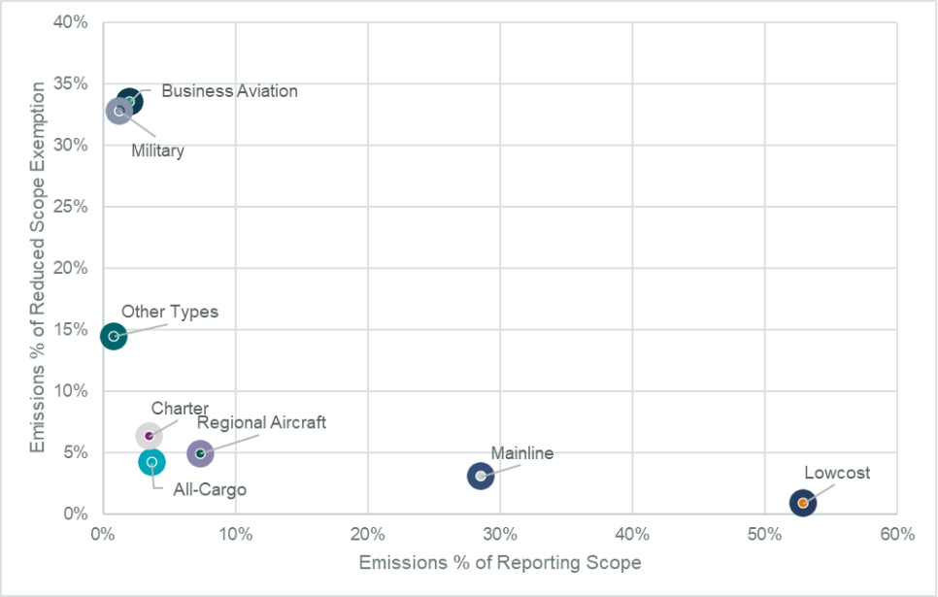
Source: Ricardo analysis of Eurocontrol data
A core complexity is that business aviation spans both commercial and non-commercial operations, making clear categorisation difficult. Therefore to ensure simplification and appropriate internalisation of the climate impacts (D2) of private and business aviation, all options include lowering the emissions threshold for all aircraft operators to 500 tCO₂ irrespective of their commercial status to increase the reach of carbon pricing.
This element introduces a “proxy” for defining private and business flight that is operationally precise for monitoring and compliance under the EU ETS and does not rely on the commercial status of the operator, which proved inefficient in identifying business aviation flights. These flights have not paid an ETS carbon price in the past, contradicting the polluter pays principle, as these planes usually have four to fourteen times higher per-passenger emissions than the average economy-class passenger, coupled with far superior financial resources. Every emitter and every person needs to contribute. Considering the large carbon footprint per passenger of these flights, it is appropriate to cover these in line with the geographical scope under all policy options.
The Commission proposes considerable administrative simplification for any newly covered aircraft operators as well as further simplification for low activity operators already covered. This includes simplified monitoring and reporting, a waiver of verification as well as exclusion for aircraft operators with very low EU ETS surrender obligation. Please see subsection 7.2 for details, including simplification measures applicable to all operators.
- What are the impacts of the measures
This section assesses the environmental, economic and social impacts of each aviation measure. To note, the measures SAF1 and SAF2 are assessed separately in the context of AS2 scope. This is because the revenues from AS2 scope are needed to finance SAF1 and SAF2.
  - AS0: Baseline
When accounting for the increasing use of SAF as mandated by ReFuelEU aviation and global SAF uptake projections by ICAO, global aviation CO₂ emissions should decrease to 590Mt CO₂ in 2040. Without accounting for the use of SAF, these emissions would increase: from 690 Mt CO₂ in 2024 to 763Mt CO₂ in 2040. See Table 2 for emissions modelling which accounts for SAF use, and further detail in the aviation support study. When comparing the measures, the biggest impact can be seen in the “Extra-EEA (outbound)” segment where the ETS either applies (AS0), CORSIA applies (AS1), or the ETS applies with a deduction of CORSA offsetting costs (AS2). For the economic impacts of the baseline, consult the Impact Assessment.
- AS0: Aircraft CO₂ emissions for 2024, 2040, emissions from SAF are zero-rated
Type of route | AS0 CO₂ emissions (MtCO₂)
Year | 2024 | 2040
Domestic | 16 | 10
Intra-EEA + departing to UK/ CH | 54 | 33
Extra-EEA (outbound) | 76 | 49
International non-EEA related routes | 466 | 436
Global: inside EEA: domestic & non-domestic; outside EEA: non-domestic | 689 | 589
  - AS1: Current scope prolongation contingent on CORSIA implementation
When accounting for the increasing use of SAF, global aviation CO₂ emissions should decrease to 599Mt CO₂ in 2040. Without accounting for the use of SAF, in AS1 global aviation emissions would increase 2% above the baseline to 775Mt CO₂ in 2040. See Table 3, and further detail in the aviation support study. As above, the biggest difference can be seen in the Extra-EEA (outbound) flight segment.
- AS1: Aircraft CO₂ emissions for 2040 and vs AS0, emissions from SAF are zero-rated
Type of route | AS1 CO₂ emissions (MtCO₂) in 2040 | Percentage change vs baseline
Domestic | 10 | +/-0% vs AS0
Intra-EEA + departing to UK/ CH | 33 | +/-0% vs AS0
Extra-EEA (outbound) | 54 | +10% vs AS0
International non-EEA related routes | 436 | n/a
Global | 599 | +2% vs AS0
Competition aspects: Competitive distortions for airlines may arise when policies do not apply equally on routes, and where they are not enforced equally, under whichever policy option. Enforcement has been crucial for the success of the EU ETS to date. All options apply uniformly per route to all airlines so do not create distortions. Airlines with a higher share of flights on ETS-covered routes may be less able to cross-subsidise from other routes, but this choice is not simple and comes at a price. Past studies argue that the risk of such cross-subsidisation is minimal. This is consistent with the 2021 Aviation ETS Impact Assessment. The application and enforcement of CORSIA is different from the EU ETS and assessed in section 5 below.
The 2021 impact assessment found that carbon leakage risks such as tourist destination switching, were low, due to the nature of air travel (passengers usually know where they want to go and prefer direct flights), also confirmed by external studies. Emissions reductions and the absence of carbon leakage, from the application of the Fit-for-55 policies, have been identified also when modelling these policies for global aviation, while carbon leakage to other sectors is mostly identified in case aviation fuel demand reduction leads to overall fuel price reductions. A previous study also concluded that demand has historically been relatively insensitive to cost changes. The aviation support study finds that AS1 can lead to distortion of the level playing field more than the baseline or AS2, when comparing a flight within the EEA versus a flight from the EEA to a third country. The opposite is true for an incoming flight to the EEA from a third country versus a flight between two third countries: AS1 results in a more level playing field than AS2 (no ETS application on routes under AS1 apart from flights to the UK and Switzerland).
  - AS2: Departing flights with CORSIA offsetting cost deduction
When accounting for the increasing use of SAF as mandated by ReFuelEU aviation, aviation CO₂ emissions should decrease to 595Mt CO₂ in 2040. Without accounting for the use of SAF, in AS2 global aviation emissions would increase 1% above the baseline to 768Mt CO₂ in 2040. See Table 4, and detail in the aviation support study. As above, the biggest difference can be seen in the extra-EEA (outbound) flight segment. There is no difference for those flights which are already covered by the ETS today, showing that an extension to departing flights is not expected to affect intra-European flights.
- AS2: Aircraft CO₂ emissions for 2040 and vs AS0, emissions from SAF are zero-rated
Type of route | AS2 CO₂ emissions (MtCO₂) | Percentage change vs baseline
Domestic | 10 | +/-0% vs AS0
Intra-EEA + departing to UK/ CH | 33 | +/-0% vs AS0
Extra-EEA (outbound) | 54 | +4% vs AS0
International non-EEA related routes | 436 | n/a
Global | 595 | +1% vs AS0
Competition: For competition between airlines and tourist destinations in AS2 please refer to the description and comparison in AS1.
Auction revenues: In AS0, auction revenues from aviation would be highest, as the ETS applies to incoming and departing flights. Total revenues would be projected at EUR 20bn in 2030, EUR 24bn in 2035, and EUR 38bn in 2040. In AS1, auction revenues would be lowest, as the scope of ETS application is smallest. Total revenues would be projected at EUR 6bn in 2030, EUR 7bn in 2035, and EUR 11bn in 2040. In AS2, which applies the ETS to departing flights and includes the possibility to deduct CORSIA offsetting costs, revenues would be projected at EUR 13bn in 2030, EUR 14bn in 2035, and EUR 23bn in 2040. To be noted, these are the auction revenues before any deductions for ETS-financed targeted support. As presented below, SAF2 would likely exhaust auctioning revenues of AS2.
CORSIA costs: Tables 5 and 6 show the amount of CORSIA offsets to be bought for EEA departing flights and the corresponding costs per policy measure. In AS0, CORSIA costs would be lowest, since the implementation of CORSIA is currently set to end by 2027. In AS1, CORSIA costs are highest, because appropriate CORSIA participation is assumed (all countries that should implement CORSIA from 2027 do so, and all countries that currently implement CORSIA continue to do so). In AS2 CORSIA costs are medium. In 2024, CORSIA costs were zero as aviation CO₂ emissions on international routes were below 500Mt in 2023.
- Offsets to be bought for CORSIA for EEA departing flights in policy measures
Policy measure - scope | Offsets for EEA departing flights (in million)
Policy measure - scope | 2024 | 2030 | 2035
AS0 (baseline) | 0
AS1 (clean cut) | 0 | 13 | 20
AS2 (departing flights) | 0 | 10 | 15
- Costs for CORSIA for EEA departing flights in different policy measures
Policy measure - scope | CORSIA Costs (in billion EUR2023)
Policy measure - scope | 2024 | 2030 | 2035
AS0 (baseline) | 0
AS1 (clean cut) | 0 | 0.4 | 2
AS2 (departing flights) | 0 | 0.3 | 1
  - SAF0, SAF1, SAF2
SAF support is analysed in more detail in section 8, including use of auction revenues. The level of SAF uptake is assumed to be in line with the legal mandate of ReFuelEU Aviation. Possible uptake levels above ReFuelEU mandates are not modelled, given large uncertainties in this nascent market, high price differentials with fossil kerosene, and to avoid overestimating available supply. Therefore, the environmental impacts under SAF1 and SAF2 are assumed to be the same. SAF is zero-rated under the EU ETS, meaning it is counted as if it had no emissions. However, in general SAF still results in emissions.
Competition between airlines: In all SAF measures, all commercial airlines operating flights covered by the ETS scope are eligible to access the SAF support, pending their demonstration of SAF uptake and available allowance volumes. This provides a level playing field to all airlines operating under the ETS. The ReFuelEU SAF mandates apply to all flights departing from Union airports, independent from their destination. Under AS1 geographic scope, part of the flights subject to ReFuelEU mandates would receive ETS SAF support with the mandates being the main reason for airlines to pay SAF costs. Under AS2 geographic scope, the scopes almost align and most flights would be subject to the mandate as well as eligible for the SAF support, ensuring a level playing field between airlines irrespective of whether they operate more intra-EEA or extra-EEA flights. Therefore, SAF1 and SAF2 improve the level playing field the most, SAF2 with higher amount of support reserved would additionally ensure this for longer. However, it comes with the opportunity cost of not using these allowances for other climate purposes.
Competition between tourist destinations: Considering SAF measures depend on the geographic scope, please refer to subsections 2.2 and 2.3 on AS1 and AS2. SAF2, due to the greater amount of support made available, suppports the level playing field more than SAF1.
- Further analysis on policy options
  - Analytical tables complementing the Impact Assessment
Please see below analytical tables to complement subsection 6.2.3.3 of the Impact Assessment. All numbers are based on the aviation support study, which contains further detail.
- Passenger demand, ticket prices, cargo demand and rates in 2040 for extra-EEA departing flights
Passenger demand in million passengers in 2040
Extra-EEA departing flights
 | Baseline | PO1 | PO2/ PO3
First/ business | 18 | 19 | 18
% change vs. baseline | n/a | +2% | +1%
% change vs. 2024 | +59% | +62% | +61%
Economy | 139 | 146 | 142
% change vs. baseline | n/a | +5% | +3%
% change vs. 2024 | +47% | +55% | +51%
Low-cost | 56 | 62 | 59
Vs baseline | n/a | +11% | +5%
Vs 2024 | +29% | +43% | +36%
Ticket prices in EUR(2023) per passenger kilometre in 2040
First/ business | 0.35 | 0.32 | 0.33
% change vs. baseline |  | -7% | -3%
% change vs. 2024 | +30% | +21% | +25%
Economy | 0.084 | 0.078 | 0.081
% change vs. baseline |  | -7% | -3%
% change vs. 2024 | +30% | +21% | +26%
Low-cost | 0.064 | 0.056 | 0.060
Vs baseline |  | -12% | -6%
Vs 2024 | +59% | +40% | +50%
Cargo demand in million tonnes in 2040
Cargo demand | 7 | 7 | 7
% change vs. baseline |  | 6% | 3%
% change vs. 2024 | +37% | +45% | +41%
Cargo rates in EUR(2023) per tonne kilometre in 2040
Cargo rates | 0.53 | 0.49 | 0.51
% change vs. baseline |  | -8% | -4%
% change vs. 2024 | 9% | Negl. | 5%
To show the effect of ETS scope and ETS-financed SAF support side by side for cargo, compare results for 2035 in table 8:
- Cargo demand and rates in 2035
Cargo demand in million tonnes in 2035
 | Baseline | PO1 | PO2 | PO3
Cargo demand | 6 | 6 | 6 | 6
% change vs. baseline |  | 4% | 2% | 3%
Cargo rates in EUR(2023) per tonne kilometre in 2035
Cargo rates | 0.519 | 0.488 | 0.501 | 0.497
% change vs. baseline |  | -6% | -4% | -4%
Source: Aviation support study
Table 9 shows kerosene and SAF costs over time. Kerosene costs decrease because the share of kerosene in the fuel mix decreases, while the share of SAF increases. SAF costs rise very significantly, because they start from a very low share of the fuel mix in 2024, and because SAF costs are higher than kerosene costs. See the aviation support study for detail.
- Kerosene and SAF costs for airlines for extra-EEA departing flights
Fossil fuel costs in billion EUR (2023) in 2040
Extra-EEA departing flights
 | Baseline | PO1 | PO2/ PO3
Fossil fuel | 15 | 17 | 16
% change vs. baseline | n/a | 8% | 4%
% change vs. 2024 | -22% | -16.2% | -19.2%
SAF costs in billion EUR (2023) in 2040
Extra-EEA departing flights
SAF | 199 | 215 | 207
% change vs. baseline | n/a | +8% | +4%
% change vs. 2024 | +9009% | +9698% | +9338%
Source: Aviation support study
The aviation support study finds different evolutions of the carbon cost compared to total fuel cost between 2023 and 2035/2040: the share of the carbon cost decreases under PO1 and increases under PO2/3 (modelling takes into account the CORSIA offsetting cost deduction). Carbon cost is defined as the cost that is internalised through carbon pricing, i.e. costs for ETS and CORSIA.
- Carbon costs as a percentage of fuel costs over time for intra-EEA and departing flights
Intra-EEA and departing (domestic, intra, and extra-EEA flights)
Policy option | Carbon costs as % of fuel costs (incl. carbon)
Policy option | 2024 | 2030 | 2035 | 2040 (87 %)
Baseline (full scope) | 8% | 25% | 24% | 29%
PO1 (clean cut) | 8% | 10% | 12% | 10%
PO2 (departing flights, medium SAF support) | 8% | 15% | 18% | 20%
PO3 (departing flights, larger SAF support) | 8% | 15% | 9% | 20%
Source: Aviation support study.
- Carbon costs as a percentage of total operating costs over time for intra-EEA and departing flights
Intra-EEA and departing (domestic, intra, and extra-EEA flights)
Policy option | Carbon costs as % of total operating costs
Policy option | 2024 | 2030 | 2035 | 2040 (87 %)
Baseline (full scope) | 2% | 7.4% | 7.8% | 10.3%
PO1 (clean cut) | 2% | 3% | 4% | 3%
PO2 (departing flights, medium SAF support) | 2% | 4% | 6% | 7%
PO3 (departing flights, larger SAF support) | 2% | 4% | 3% | 7%
Source: Aviation support study.
- Carbon costs as a percentage of fuel costs (incl. carbon) over time for extra-EEA flights
Extra-EEA flights (departing + incoming)
Policy option | Carbon costs as % of fuel costs (incl. carbon)
Policy option | 2024 | 2030 | 2035 | 2040 (87%)
Baseline (full scope) | 0% | 25% | 25% | 30%
PO1 (clean cut) | 0% | 2% | 6% | 0%
PO2 (departing flights, medium SAF support) | 0% | 12% | 15% | 16%
PO3 (departing flights, larger SAF support) | 0% | 12% | 8% | 16%
Analysis relating to SAF support and ETS revenues in subsection 6.2.3.3 of the Impact Assessment:
The figures in table 13 show annual snapshots, therefore the SAF support for the year 2035 shows as larger than the cap in that year. However, it would be financed by cumulative revenues from the previous years (therefore not resulting in a negative cap overall). Total EUA demand corresponds to all aviation CO2 emissions covered by the ETS. The aviation cap net of SAF support is what remains of the cap, once the SAF support is deducted. Compliance costs are what airlines have to pay in the end, i.e. total demand minus ETS-financed SAF support.
- Aviation EUA demand in million EUAs, aviation cap, cap net of SAF support, and compliance cost in EUR million
 | Total EUA demand (m EUAs) | Aviation cap (m EUAs) | Aviation cap net of SAF support (m EAUs) | Compliance cost (m EUR)
Baseline 2030 | 181 | 67 | 67 | 20
Baseline 2035 | 171 | 45 | 45 | 24
PO1 2030 | 54 | 21 | 21 | 6
PO1 2035 | 51 | 14 | 14 | 7
PO2 2030 | 119 | 44 | 19 | 10
PO2 2035 | 109 | 29 | 29 | 15
PO3 2030 | 119 | 44 | 19 | 10
PO3 2035 | 110 | 29 | -56 | 4
Table 14 shows the compliance cost for CORSIA, ETS and the total compliance cost for both combined for the year 2035. The ETS cost is net of SAF support, i.e. it shows what airlines have to pay in the end. CORSIA costs are shown for EU airlines on participating routes, but due to technical limitations they do not include costs for flights between two third countries outside Europe, such as a flight between Malaysia and Indonesia operated by an EU airline. For further detail, see Annex 4.
- Compliance costs for ETS and CORSIA – 2035 snapshot, for global international aviation (intra-EEA: domestic and non-domestic, extra-EEA: non-domestic only)
Compliance cost for ETS and CORSIA in 2035
In EUR bn 2023 | CORSIA | ETS | Total
Baseline | 0 | 24 | 24
PO1 | 3 | 7 | 11
PO2 | 3 | 16 | 18
PO3 | 3 | 4 | 6
Additional analysis on subsection 6.3.1.4, impact on employment and skills
Tables 15 and 16 show that there is a positive relationship between passenger demand and employment: higher passenger demand goes hand in hand with higher EEA airline employment. However, employment is not directly proportionate to passenger growth.
- EEA aircraft operator employment over time in policy options and the baseline
EEA aircraft operator employment in 1000 employees
Flight segment: EEA departing flights
 | Baseline | PO1 | PO2 | PO3
2024 | 560
2035 | 630 | 640 | 636 | 641
% change vs. baseline |  | 2% | 1% | 2%
2040 (87%) | 699 | 715 | 706 | 706
% change vs. baseline |  | 2% | 1% | 1%
Change over time: 2040 (87%) vs 2024 | 25% | 28% | 26% | 26%
Source: Aviation support study.
- EEA passenger demand over time in policy options and the baseline
Passenger demand in million passengers
Flight segment: EEA departing flights
 | Baseline | PO1 | PO2 | PO3
2024 | 823
2035 | 943 | 951 | 948 | 958
% change vs. baseline |  | 1% | 1% | 2%
2040 (87%) | 1069 | 1083 | 1076 | 1076
% change vs. baseline |  | Negl. | Negl. | Negl.
Change over time: 2040 (87%) vs 2024 | 30% | 32% | 31% | 31%
Source: Aviation support study.
Additional analysis on abatement cost
Table 17 below shows the cost of reducing one tonne of CO₂ emissions with SAF and e-SAF in Europe. Firstly, the cost is shown based on conservative SAF/ e-SAF price assumptions, which were used for all aviation-specific modelling. Then the cost difference is shown using PRIMES price assumptions. This could give an upper and a lower bound for abatement cost using SAF. Emissions can also be reduced through technology and operational improvements, the cost of which varies widely, and their potential to reduce emissions can be limited (e.g. operational measures). The ETS price incentivises any such efforts chosen by operators. For comparison, in the maritime sector, the marginal abatement cost for using hydrogen is EUR 763 in 2025 and modelled to decrease to EUR 247 by 2040 taking into account the carbon price. For maritime biofuels, the marginal abatement cost is EUR 190 in 2025, modelled to decrease to negative EUR 93 by 2040, i.e. those fuels are expected to be cheaper than conventional fossil fuel by then. For methanol, the marginal abatement cost is EUR 924 in 2025, modelled to decrease to EUR 329 by 2040.
- Additional analysis on abatement cost
Cost of CO₂ reduction using SAF (in EUR'23/tCO₂)
 |  |  | 2025 | 2030 | 2035 | 2040
Kerosene price assumptions |  |  | 824 | 886 | 949 | 969
Conservative fuel price assumptions
Bio SAF | 1 | Price difference | 543 | 512 | 469 | 451
 | 2 | Remaining price difference after ETS | 455 | 391 | 313 | 182
 | 3 | Final price difference incl. SAF support | 228 | 362 | 235 | 104
E-SAF | 4 | Price difference | n/a | 2468 | 2449 | 2443
 | 5 | Remaining price difference after ETS | n/a | 2355 | 2304 | 2193
 | 6 | Final price difference incl. SAF support | n/a | 942 | 922 | 877
PRIMES fuel price assumptions
Bio SAF | 7 | Price difference | 404 | 358 | 305 | 352
 | 8 | Remaining price difference after ETS | 315 | 237 | 149 | 83
 | 9 | Final price difference incl. SAF support | 158 | 219 | 112 | 47
E-SAF | 10 | Price difference | n/a | 880 | 769 | 689
 | 11 | Remaining price difference after ETS | n/a | 767 | 624 | 439
 | 12 | Final price difference incl. SAF support | n/a | 307 | 250 | 176
Source: Aviation support study and own calculations
- Impacts on the level playing field (focus on hubs)
Aviation operates in an international competitive environment. Generally, changes in operating costs, ticket prices and demand affect the level playing field for example:
- If airlines pay different carbon costs when operating on the same route or if certain airlines bear a high proportion of costs because a larger share of their operations are in higher carbon cost routes;
- If a reduction in demand due to higher carbon costs affects some airlines, but not others with which they are in competition;
- If carbon costs lead to investment in airports outside higher carbon cost areas instead of within the higher cost area;
- If policies implemented equally across routes are not enforced equally e.g. because different actions are taken by different states.
Airport hubs with large shares of transfer passengers may face an unlevel playing field compared with other hubs subject to laxer rules, causing differences in operating costs, ticket prices, itinerary choice, etc. The aviation support study finds that the impact of policy options on ticket prices and demand may, in certain cases, lead to passenger shift from EEA hubs to non-EEA hubs. Passenger shifts may lead to carbon leakage if they cause an overall increase in global emissions.
Ticket prices, risk of passenger shifts and carbon leakage at airport hubs: The aviation support study defined a set of case studies for quantitative analysis. All case studies cover flights to destinations outside the EEA. They compare a return trip with a transfer at an EEA hub, direct flights to/from EEA airports, or a transfer at a hub outside the EEA (‘non-EEA hub’). Routes differ on whether they are covered by the ETS carbon price and/ or ReFuelEU or not. The resulting ticket price differences help assess impacts on hub-switching and CO₂ emissions.
- Case study 1 (CS1): EEA to Asia via an EEA hub versus via London
- CS2: EEA to Asia via an EEA hub versus via Istanbul
- CS3: North America to EEA via an EEA hub versus via Algiers
- CS4: North America to Asia via an EEA hub versus via Dubai
- CS5: EEA to Asia directly versus connection via Istanbul.
  - Ticket prices
Key findings are that some routes that use a hub outside the EEA are already today cheaper than routes using an EEA hub. This is true for CS2, CS3, CS4. This is independent from the ETS scope, as the ETS does not apply on any of these routes, but ReFuelEU does. Figure 2 below shows cumulative effects: it adds the effect of policy options on top of the existing price differences. For example, if the itinerary using a non-EEA hub in CS3 is today EUR 90 cheaper than using an EEA hub, then any cost/ benefit of the policy options is added to that (e.g. an extra cost of EUR 10 is shown as a EUR 100 difference, not as a EUR 10 difference). For simplicity, Figure 2 covers PO1 and PO3 only, in the 2025-35 time period. PO2 is similar to PO3, slightly less favourable towards EEA-hubs, since it offers less ETS-financed SAF support. See detail in the aviation support study.
The biggest ticket price differences for all case studies are found in the baseline, because there is added carbon cost for both flight legs, and no SAF support. For PO1 and PO2, the price differences are 3 and 1.5 times smaller than in the baseline for all case studies, meaning they reduce the price gap between the original and alternative routes. In all case studies, first class ticket price differences are higher than economy class price differences, because premium class travellers are less sensitive and airlines generally pass on a higher share of costs to them. In PO3, the results are similar but higher SAF support in PO3 reduces relative prices more than in PO2.
- Ticket price difference between original and alternative itinerary for 2025-2035. Comparison of case studies 2 and 5, for PO1 and PO3, for economy and business class.
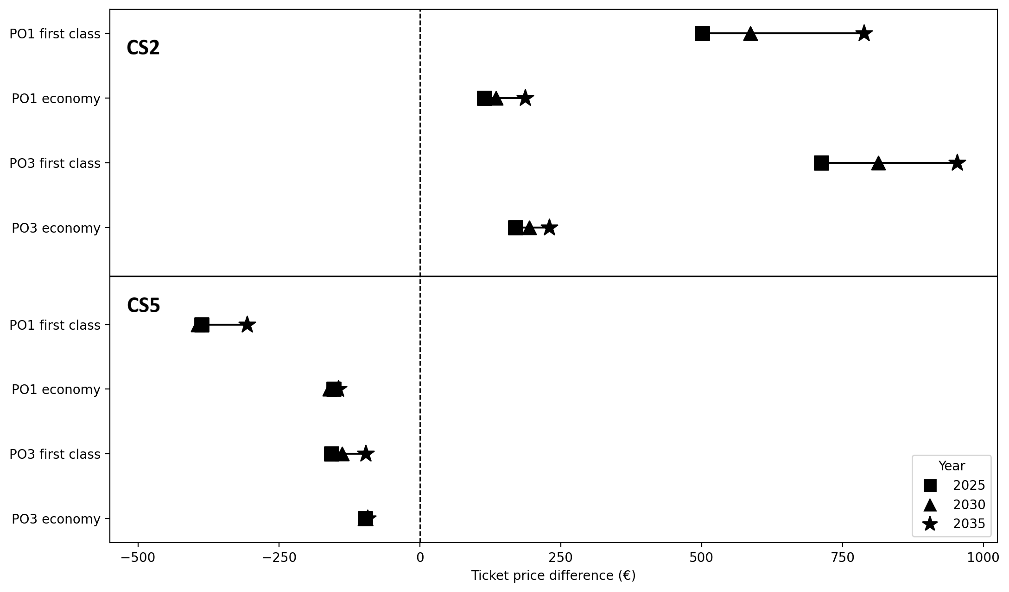
CS2: EEA to Asia via an EEA hub versus via Istanbul | CS5: EEA to Asia directly versus connection via Istanbul
Reading key: In CS2, for an economy ticket in PO3, the price was EUR 170 cheaper with the alternative route in 2025 compared to the original route (via EEA hub/ direct from EEA), while it would be about EUR 195 cheaper in 2030 and EUR 230 cheaper in 2035. In general, where a plot goes below zero, the original itinerary is cheaper.
When we only look at the impacts of POs (i.e., disregarding base ticket price differences), the differences in cost to passengers are smaller (ca. -10%), since the base ticket price also accounts for a share of that difference.
  - Risk of passenger shift
The risk of passenger shift depends on ticket price differences, but also on factors that are more difficult to quantify, such as preference of service (at certain airports or airlines) and timing of available flight alternatives. The below analysis focuses on price sensitivities, while considering value of change in flight time.
The impact of policy options on the risk of passenger shift is most visible in 2035, where SAF support continues to be available in PO3, but the medium amount of SAF support in PO2 is modelled to have run out. Table 18 shows that passenger shift risks are similar, but smallest in PO1, followed by PO3 (higher amount of SAF support) and PO2 (medium amount of SAF support).
Across policy options, some risk of passenger shift is found in CS2, CS3 and CS4, with very small risk in CS1 and CS5. Concretely, extending the scope to all departing flights (be it under PO2 or 3) would only slightly affect the competitiveness of EEA hubs and airlines by potentially causing a shift of passengers to non-EEA hubs. In PO1, these shifts remain below baseline levels; CS1 shows neither shifts nor hub carbon leakage because the original route is cheaper.
- Passenger shift risk comparison by case study and by scenarios for 2035.
 | Million passengers | CS1 | CS2 | CS3 | CS4 | CS5
Baseline | Baseline | 13 | 13 | 16 | 13 | 24
Baseline | Reduction | Negl. | 1 | 1 | 1 | 0
Baseline | Reduction | 2% | 9% | 6% | 6% | 0%
PO1 | Baseline | 13 | 13 | 16 | 13 | 24
PO1 | Reduction | 0 | 1 | 1 | Negl. | 0
PO1 | Reduction | Negl. | 7% | 5% | 4% | 0%
PO2 | Baseline | 13 | 13 | 16 | 13 | 24
PO2 | Reduction | 0 | 1 | 1 | 1 | 0
PO2 | Reduction | Negl. | 8% | 5% | 5% | 0%
PO3 | Baseline | 13 | 13 | 16 | 13 | 24
PO3 | Reduction | 0 | 1 | 1 | 1 | 0
PO3 | Reduction | 0% | 8% | 5% | 4% | 0%
  - Risk of hub carbon leakage
The risk of hub carbon leakage behaves differently from the risk of passenger shifts. If passengers shift from a European- to a non-European carrier, this does not necessarily increase emissions, it may decrease emissions, for example if the overall route is shorter, more efficient aircraft are used. However, if all other aspects are equal and less SAF is used on the overall route, this would increase emissions.
CO₂ emissions decrease most in PO2 and the baseline, and decrease least or remain unchanged in PO1. Limited hub carbon leakage is observed in specific case studies at specific moments in time under PO1 and the baseline. Overall, there is hardly any hub carbon leakage, although in most cases emissions are displaced outside of Europe. The risk of passenger shift is lower than in the baseline for all policy options, as the baseline extends carbon pricing without additional SAF support. In PO1, CS1 shows no hub carbon leakage because the original route is cheaper and passenger behaviour is expected to remain unchanged. In CS2 and CS3 (and, to a lesser extent, CS4), CO₂ emission reductions due to the ETS make up for CO₂ emissions increases outside the ETS scope, so there is no hub carbon leakage in CS2 and CS3 and minor hub carbon leakage in CS4 (versus -2% under the baseline). PO1 also reduces the minor leakage under the baseline in CS1 and CS5. PO2/3 show no hub carbon leakage in CS2, CS3, and CS4; and similar to PO1, PO2/3 mitigate the negligible leakage under the baseline in CS1 and CS5. See detail in the aviation support study.
- Assessment of CORSIA pursuant to Art. 28b of the ETS Directive
Article 28b(2) of the ETS Directive requires the Commission to assess CORSIA and progress towards the Long Term Aspirational Goal. A short assessment is below, with more detail in the aviation support study.
  - Ambition
CORSIA ‘baseline’: How and at what level the CORSIA ‘baseline’ is set is decisive for ambition, because emissions below this threshold are not addressed. Since September 2022, the CORSIA ‘baseline’ has not changed. It is set to 85% of 2019 international aviation emissions for the emissions covered by offsetting (i.e. the absolute amount of the baseline is not fixed, it is recalculated and for example higher if more countries participate).
The initial CORSIA baseline from 2018 has been revised twice, in 2020 and 2022. The initial baseline foresaw compensating international civil aviation CO₂ emissions growth (‘carbon-neutral growth’ from 2021 to 2035) compared to average CO₂ emission levels in 2019 and 2020. The first revision, i.e. excluding 2020 from the baseline definition for 2021-23, was made in response to the COVID-19 pandemic. The second baseline revision in 2022 sets the baseline at 100% of 2019 CO₂ emission levels for 2021, 2022 and 2023, and establishes a baseline at 85% of 2019 CO₂ emission levels for 2024 to 2035. This is higher than the average of 2019-2020 emission but lower than 2019 emission levels. Beyond the baseline, the calculation of the Sector’s Growth Factor also takes into account the individual growth of airlines from 2033 onward. In 2021-2023, emissions remained below 2019 levels, thus no offsets were required. For the period 2024-26, the ICAO Secretariat calculated CORSIA Annual Sector’s Growth Factor (SGF) for 2024 at 15.4%.
Level of participation: The Commission is required to assess whether non-EEA states considered to be participating in CORSIA represent more or less than 70% of international aviation emissions, based on the most recent emission figures (ETS Directive Article 28b(3), point (b)). This approach aims to incentivise all countries which should participate in CORSIA when it becomes ‘mandatory’ to implement the scheme. Overall, the EU encourages all countries to participate.
The assessment mandated by the ETS Directive sets out clear parameters for the calculation of the 70% threshold, using the most recent available data. The numerator counts international aviation emissions represented by “states listed in the implementing act adopted pursuant to Article 25a(3)”, meaning states other than EEA countries, Switzerland and the United Kingdom. The numerator therefore includes emissions from routes between the States listed in the implementing act, as well as routes between an EEA Member State or Switzerland or the United Kingdom and these states. The assessment follows the route-based principle, i.e. assuming that any flight on these routes is subject to CORSIA offsetting, even if it is operated by a carrier hailing from a non-participating state. This prevents underestimation. The denominator of this calculation is all “international aviation emissions”, meaning all emissions on routes between two ICAO countries. Figures published by the ICAO Secretariat are used for this calculation, which are either directly reported by countries, or else gap-filled by the ICAO Secretariat according to an agreed methodology. The calculation is as follows:
$$\frac{CO2 emissions relating to non-European States on routes between countries participating in CORSIA offsetting}{CO2 emissions on international routes}$$
CORSIA implementation by third countries in national law: The submission of ICAO to the UNFCCC COP30 expects 134 countries to participate in CORSIA offsetting in 2027. This includes the 130 countries volunteered for 2026, and also Brazil, Russia, India and China.
Concerning the biggest emitters, China (12.35% of 2018 global Revenue Tonne Kilometre or RTK) has never publicly confirmed its intention to participate in CORSIA offsetting. To date, no formal legislative processes or regulatory activities could be traced on CORSIA compliance.
China openly challenged the fairness of CORSIA several times. In 2016, China considered carbon neutral growth, the basic principle of CORSIA, “is short of scientific justification, fairness and feasibility” and is “constituting de facto prejudices against developing countries in their growth of international air transport in the future”. China also questioned ICAO’s jurisdiction to set standards for emission units in its 2016 and 2019 Reservations (“ICAO can recommend offsetting products for preferred consideration, but should not make decisions for sovereign States”) and stated that units established by the UNFCCC should be used (“As the UNFCCC is the main arena for global actions against climate change, States should be encouraged to give priority to the use of emission units endorsed by UNFCCC and the Paris Agreement. There is no need for ICAO Council to make different decisions in this regard.”). In 2019, China (together with Russia) called carbon neutral growth “unfair and unequal”. In its 2019 Reservation China challenged again the principle of carbon neutral growth: “China opposes to using the goal of carbon neutral growth from 2020 as the baseline of CORSIA. We affirm that States should determine the CORSIA baseline by themselves and reinforce their actions gradually based on national circumstances.” China also notified differences to CORSIA, where they reserved the right to decide on their participation in the offsetting. In this 2019 Reservation, China questioned the exclusivity of CORSIA: “ICAO has no right to prohibit Member States from using other market measures for addressing aviation emission.”. China repeatedly expressed their wish to acknowledge the common but differentiated responsibilities (CBDR) principle for CORSIA as well, a principle the application of which the US continuously refused in ICAO. In its 2019 Reservation, China considered that “emission reduction in international aviation is an integral part of the global climate governance”. In the 2022 Reservation China reiterated this statement, and its wish to apply CBDR, while announcing reservations towards the goal of carbon neutral growth and also towards the net zero carbon emissions by 2050, meaning a reservation towards the full text of the Resolution on CORSIA. The latest expression of China’s wish to apply CBDR was in their submission to the ICAO Assembly session in September 2025. In the same submission, China proposed an initiative called Green Air Silk Road and insisted that CORSIA implementation is voluntary, involving voluntarily defining the baseline and the eligible credits for offsetting. In accordance with this submission, China submitted a Reservation to the Assembly resolutions on climate change and CORSIA, where it significantly reduced the number of reservations. Unlike previous reservations, this latest reservation is not against the CORSIA Resolution A42-22 in its entirety, but it maintains reservations towards the key principles of CORSIA like carbon neutral growth or the exclusive use of CORSIA eligible units. In 2018, China submitted to ICAO differences listing diverging implementation of monitoring, reporting and verification rules, on definition of sustainable aviation fuels, on emission unit definition and on the timeline for implementation, among others, also stating that China will decide on its own when it will join CORSIA (submitted differences are not publicly available).
The US (11.35% of 2018 global RTK) has no legally binding implementation in place. The US Federal Aviation Administration (FAA) reports emissions of all aircraft operators that are to report under the CORSIA rules to ICAO, but airlines are not obliged under US law to report to FAA, thus the FAA estimates the emissions for those who do not report. Accordingly, CORSIA is explicitly voluntary in the US, where there is no implementation of the offsetting in their national law, neither can any relevant legislative initiative be identified, although the US has never officially filed a reservation on the ICAO resolutions on CORSIA itself. At ICAO, the US has the standing position of refusing the application of CBDR viewing it as inconsistent with the Chicago Convention's non-discrimination provisions for international aviation. The US expressed this objection first in their reservation in 2013: “For reasons that are well known, the United States does not consider that the principles of the United Nations Framework Convention on Climate Change, including the principle of «common but differentiated responsibilities and respective capabilities» apply to ICAO, which is governed by its own legal regime”. This was confirmed again in 2016 and repeated this again in 2019. At the latest ICAO Assembly session in September 2025, the US referenced their objection to the application of this principle. At the latest Assembly session, the US expressed its explicit wish that ICAO returns to its core responsibilities, because ICAO “has extended itself far beyond its proper mandate - wasting critical resources on social programs or climate financing initiatives work that has nothing to do with the safety, security, and efficiency of the global air transportation system.”, and therefore making the US contribution to the ICAO budget dependent on the fulfilment of these core responsibilities. The US approach towards CORSIA and ICAO’s climate policy is also influenced by its most recent National Security Strategy that states “We reject the disastrous “climate change” and “Net Zero” ideologies that have so greatly harmed Europe, threaten the United States, and subsidize our adversaries.” ICAO’s Long-Term Aspirational Goal ‘LTAG’ is a net-zero emissions target. In January 2026, President Trump ordered the US administration to withdraw from the United Nations Framework Convention on Climate Change (UNFCCC) and the Intergovernmental Panel on Climate Change (IPCC), UN’s scientific body.
The Russian Federation (2.91% of 2018 global RTK) has never reported emissions to the ICAO Secretariat. Russia announced its reservation towards the entire idea of a global market-based measure in 2016: “the Russian Federation does not see a way to announce its participation in the proposed version of GMBM implementation”. Russia expressed the same refusal at the Assembly session in 2019: “The Russian Federation declares that it does not find affordable to join this Resolution as whole” and intends to file differences to the SARPs when it finds it fit. After the 41st session of the ICAO Assembly it stated again that “the Russian Federation does not consider itself bound by the provisions of the […] ICAO Assembly resolution [on CORSIA]”. Accordingly, it is not expected that Russia would apply the MRV or the offsetting of CORSIA to their airlines unless circumstances would significantly change.
For other biggest emitters, Brazil (0.78% of 2018 global RTK) has legislation in place for the mandatory CORSIA MRV from 2022 and also for offsetting from 2027 (Agência Nacional de Aviação Civil (ANAC) 743 of 15 May 2024). India (1.35% of 2018 global RTK) has legislation in place for both the MRV and for the offsetting as of 2027 (Civil Aviation Requirements, Section 10 – Aviation Environmental Protection, Series ‘C,’ Part I 2018).
Share of emissions covered by CORSIA offsetting obligation: ETS Directive Article 28b(3), point (b) describes the test to evaluate the level of participation in CORSIA. This point requires that the “most recent available data” is used for this purpose. Therefore, the data from the CORSIA Central Registry (CCR) for the reporting year 2024 is used. Level of participation of ICAO contracting States applies only to the year for which those States participate in. In 2024, 93 States were considered to be applying CORSIA for the purpose of the ETS Directive and were included on the list adopted pursuant to Article 25a(3) of the ETS Directive. Table 19 shows the relevant total emissions for 2024 to be applied in the calculation. Using these figures, the level of participation in 2024 stands at 51% coverage of international aviation emissions. Accordingly, the condition is not fulfilled. As shown in Table 19, the result is the same if the 2024 emissions data is used with 2026 participation (that is already known).
- CORSIA test results based on level of participation
Total CO₂ emissions on international routes in 2024 MtCO₂: 597
Level of participation | Results
 | Emissions (million tCO₂) | Impact of States Participating
Best Case Scenario (BCS): 2026 volunteer list + all mandatory countries | 446 | 75%
BCS without United States | 288 | 48%
BCS without United States and China | 208 | 35%
BCS without Russian Federation | 438 | 73%
BCS without China | 344 | 58%
2026 volunteer list | 302 | 51%
Source: Commission analysis based on CCR 2024 emissions
Quality of offset credits: The quality of the carbon credits under CORSIA was initially assessed pursuant to Article 28b of the ETS Directive in Annex 10 of the 2021 Commission Impact Assessment. In line with the Emissions Unit Criteria (EUC), to fulfil the CORSIA requirements, the credits must: represent emission reductions that would not have occurred otherwise (additionality); be accurately measured, reported, and verified (MRV); be permanent; ensure that they will not lead to any increase in emissions elsewhere (carbon leakage); and only be claimed once towards any climate target (avoidance of double counting). These criteria are cumulative.
The 2021 assessment clarified the central role of the Technical Advisory Body (TAB) as the ICAO expert group that evaluates and recommends to the ICAO Council the eligibility of programmes to generate CORSIA-eligible credits. It has also identified a number of shortcomings undermining the quality of the approved credits.
Some of these shortcomings have structural nature (e.g., Emission Unit Criteria applied by TAB on programme level, rather than on project or type of activity level) and are still unaddressed. It is to be noted that no revision of CORSIA’s EUC took place so far, in the ICAO triennial periodic review, in 2022 and 2025. The associated guidelines have however been updated and embedded into the TAB application form. At the CAEP/13 meeting the results on Article 6.2 and Article 6.4 of the Paris Agreement at the UNFCCC COP29 were discussed and it was agreed that task C.04 (EUC Management) will present its recommendations in SG2026 (October 2026), in order to ensure that relevant developments under the Paris Agreement are taken into consideration by the Emissions Unit Criteria and/or the related Guidelines for Criteria Interpretation.
Other, newer shortcomings relate to how ICAO accounts for the developments on offset credits in other UN fora, for instance, the progress of international climate negotiations on operationalisation of Article 6 and related provisions of the Paris Agreement.
The 2021 UNFCCC Glasgow Climate Conference (COP26) agreed on a set of rules for Article 6. Accordingly, TAB updated its interpretation of the CORSIA criteria to reflect the Article 6 operationalisation, complementing the information contained in the EUCs, and the Guidelines for Criteria Interpretation. TAB recommended that the CORSIA written attestations from project host countries national focal points should correspond to the content of the authorizations as agreed under Article 6. This alignment demonstrated the ICAO willingness for coherent approach towards double counting even if it did not prevent the risk of host countries double claiming the emission reductions, the latter going beyond the capacities of the UN to regulate how countries implement their climate targets.
Another prominent example is the definition of the baselines of the projects generating carbon credits. At COP26, countries agreed that baselines must be conservative and below ‘business as usual’ emission projections. In 2022, TAB resolved to interpret the reference to “conservative” in CORSIA criteria accordingly. The ICAO Council agreed to update the Guidelines for Criteria Interpretation, meaning the requirement on baselines is a mandatory provision.
While the finalisation of the Article 6 rulebook took place at COP29, there is still some on-going work (e.g. consolidated registry for the centralised trading mechanism under Article 6.4 - the Paris Agreement Crediting Mechanism, PACM). TAB resolved to monitor on a regular basis all Article 6 developments, and these should continue to inform further the TAB interpretations, but in practice, these interpretations are not applied consistently.
Despite full operationalisation of the PACM (including adoption of foundational standards, first crediting methodologies, governance, interim registry, etc.), its eligibility to supply CORSIA eligible credits, is still to be decided upon in the upcoming meetings of the ICAO Council. The TAB is tasked to report back on its progress of its assessment of the PACM in the 239th session of the Council (November 2026). Until now, the ICAO Council approved ten programmes to supply CORSIA eligible credits for the 2024-2026 compliance period (first phase of CORSIA), and more recently, in November 2025, it approved the first four programmes for the first three years (2027-2029) of the second phase of CORSIA (2027-2035). As there was no offsetting required during the pilot phase of CORSIA (2021-2023), our assessment is therefore not focused on this pilot phase.
Three of the eligible programmes, Architecture for REDD+ Transactions (ART), Gold Standard (GS) and Verra Verified Carbon Standard (VCS), issued the first CORSIA-eligible carbon credits, respectively for High-Forest Low-Deforestation (HFLD) activities by ART and mostly for cookstoves projects by GS and VCS. At present, these credits are the only eligible credits that are available for CORSIA compliance (part of eligible CORSIA programme and subject to Article 6 authorization letter), but there are many jurisdictions that are in the process of registering HFLD activities under ART and that could retroactively generate a larger number of eligible carbon credits. In addition, Forrest Carbon Partnership Facility also allows for HFLD crediting. Similarly, there are many cookstoves projects under the different programmes.
Following the above-described ICAO’s developments on CORSIA credits since the 2021 assessment, and with confirmed compliance demand from the first phase of CORSIA, the assessment on the offsets quality focuses on examining the quality of mitigation activities. To inform the assessment the aviation support study relies on the EU Carbon Credit Environmental Integrity (CENVI) model, to which we add the latest ICAO and UNFCCC documentation available. These two types of activities (HFLD and cookstoves) are also the ones that can account for large share of potential issuance in the future. Cookstoves projects under the Gold Standard have the highest estimated share of total issuance potential amongst all activities under CORSIA first phase and first three years of the second phase (25%), while HFLD has 4%, but as indicated previously this percentage can grow significantly in coming years.
Our assessment of the environmental integrity of CORSIA-eligible offset credits reveals significant challenges when considering the types of activities identified above and methodologies used. Despite efforts to align CORSIA criteria with international standards and Article 6 of the Paris Agreement, important shortcomings persist, particularly in the areas of baseline conservativeness. HFLD activities in Guyana are characterised by baseline methodologies that inadequately reflect conservative emission projections, posing a risk of overestimating emission reductions. This is also confirmed by the UNFCCC Report on the technical expert review under Article 6.2 of Guyana. Similarly, cookstoves activities under some of the already applied methodologies suffer from inaccuracies in calculating non-renewable biomass fractions and conversion factors, potentially inflating their mitigation impact. The lack of sufficiently robust methodologies to address these issues undermines the credibility of the credits within CORSIA.
In addition, the support aviation study delves in greater detail in the mitigation activity types that account for large share of carbon credits with findings confirming the environmental integrity risks observed in HFLD and cookstoves, for the majority of the current CORSIA eligible credits.
Sustaining environmental integrity requires using crediting methodologies better aligned with best practice in existing carbon crediting programmes such as the PACM, empirical data and ensuring rigorous oversight of project implementations. This would also require updates to the EUC, more rigorous application of the TAB interpretations by the TAB, higher scrutiny by ICAO Council of the TAB recommendations and possible diverging opinions, and overall, higher resources being attributed to the TAB to undertake its programme analysis.
Long-Term Aspirational Goal (LTAG): In October 2022 the ICAO Assembly adopted the LTAG through Resolution A41-21, establishing a net-zero carbon emissions goal by 2050 for international aviation. The LTAG is based on a report by ICAO’s Committee on Aviation Environmental Protection (CAEP), which provides a sectoral emissions outlook for different scenarios (IS0-IS3) of deployment of in-sector decarbonisation measures (i.e. SAF adoption, aircraft technology and operational efficiency improvements), requiring different uptakes of out-of-sector measures (i.e. market-based measures) to reach net-zero. The A41-21 Resolution explicitly states that LTAG "does not attribute specific obligations or commitments in the form of emissions reduction goals to individual States", meaning that LTAG is an aspirational framework rather than a binding commitment.
Critically, the A41-21 Resolution explicitly requires the ICAO Council to regularly monitor implementation processes across all elements of the basket of measures towards achieving LTAG. The 42nd ICAO Assembly reaffirmed work to achieve the global average fuel-efficiency improvement of 2% per annum from 2021 to 2050 and, in addition, endorsed a global aspirational vision to reduce CO₂ emissions by 5% by 2030 through the use of SAF, low-carbon aviation fuels (LCAF) and other cleaner energies. Such provisions form the two interim targets to LTAG 2050 net-zero goal.
ICAO's LTAG framework employs a state-led monitoring approach, combining voluntary State Action Plans (SAPs) reporting with scenario-based progress tracking. The Conference on Aviation and Alternative Fuels (CAAF) serves as the primary forum for reviewing progress and adjusting ambition levels, with the next CAAF/4 scheduled for 2028. At its 42nd Session, the ICAO Assembly adopted Resolution A42-21, implementing a LTAG Monitoring and Reporting (LMR) methodology to track past and future progress toward the LTAG, leveraging existing ICAO information streams including the annual LTAG Stocktaking, and SAPs. The LMR methodology aims to introduce a tiered, backward- and forward-looking assessment system to evaluate historical emissions performance against projected trends and update future decarbonisation pathways based on the latest data. The LMR framework will also monitor implementation support and financing, and review delivery of the 2030 global aspirational vision and the CAAF/3 Global Framework. The methodology will be implemented in phases, with the first assessment report to be delivered to the 43rd ICAO Assembly in 2028.
The 2022 LTAG report outlines three integrated scenarios (IS) “IS1”, “IS2”, and “IS3” that are based on cumulative emissions reductions through in-sector decarbonisation measures by 2050, compared to the baseline “IS0” scenario, of: 39%, 68%, and 87%, respectively. While the uptake of alternative fuels is at the core of all scenarios, the LTAG report acknowledges the limits of in-sector measures and the need to address residual emissions through out-of-sector solutions such as carbon removal technologies or high-quality offsets. The LTAG projects cumulative CO₂ emissions from international aviation between 2020 and 2050 at approximately 23 Gt (IS1), 17 Gt (IS2), and 12 Gt (IS3), respectively, which compare to the whole-economy 1.5°C (50% probability) and 2°C (67% probability) Paris-aligned carbon budgets of 500 Gt CO₂ and 1150 Gt CO₂, respectively. Table 20 compares IS cumulative emissions with the estimated carbon budgets for international aviation (2020–2050) consistent with 1.5 °C and 2 °C temperature targets.
- Difference between ICAO LTAG Integrated Scenarios’ cumulative emissions and Paris-aligned carbon budgets.
 | Gt CO₂ | Difference between Paris-aligned budgets and LTAG ISs cumulative emissions in Gt CO₂  (Budget % coverage)
Scenario |  | Compared to 1.5°C Budget |  |  | Compared to 2°C Budget
 |  | 2% share | 2.4% share | 3.9% share | 2% share | 2.4% share | 3.9% share
IS1 | 23 | 16.5 – 17  (350 – 380%) | 15.2 – 15.8  (295 – 320%) | 10.3 – 11.3  (180 – 200%) | 8.1 – 9.2  (150 – 170%) | 5.1 – 6.4  (130 – 140%) | -6.2 – -3.9  (80 – 85%)
IS2 | 17 | 10.5 – 11  (260 – 280%) | 9.2 – 9.8  (220 – 240%) | 4.3 – 5.3  (130 – 145%) | 2 – 3.2  (110 – 120%) | -0.9 – 0.4  (95 – 103%) | -12.2 – 9.9  (70 – 60%)
IS3 | 12 | 5.5 – 6  (185 – 200%) | 4.2 – 4.8  (150 – 170%) | -0.7 – 0.3  (95 – 100%) | -3 – -1.8  (80 – 90%) | -5.9 – -4.6  (70 – 70%) | -17.2 – -14.9  (40 – 45%)
Table 20 suggests that the uptake of in-sector measures foreseen in the LTAG may be insufficient to place international aviation on a 1.5 °C trajectory by 2050; any “1.5 °C-compatible” outcome will require substantial removals or out-of-sector measures in addition to IS3-level transformation, as well as concessions in terms of carbon budget spending to the aviation sector. IS3 is the minimum ambition consistent with a 2 °C pathway, while IS2 can only be reconciled with a 2°C Paris pathway if the current share (2.4%) or higher share (3.9%) of total emissions for aviation is assumed. Residual emissions under IS3 in 2050 are comparable to CORSIA's projected offset volumes (140 and 225 Mt CO₂ per year by 2035 assuming broad implementation). ICAO estimates that cumulatively between 2024 and 2035, with broad State implementation, CORSIA could offset up to 1.5 Gt CO₂. However, there are uncertainties around CORSIA’s ambition and accountability (see section 5 above and below). CORSIA, in its current form, is not structured to deliver the deep in-sector decarbonisation underpinning the LTAG scenarios, because it is far cheaper for airlines to use offset credits (out-of-sector emissions reductions) rather than CORSIA eligible fuels (CEFs, which directly reduce emissions in the sector). This is because carbon credits are magnitudes cheaper than CEF. The emissions reductions in the LTAG rely mainly on SAF use. ICAO’s recently established support instruments – the ACT-SAF programme and Finvest Hub initiative from the 42nd Assembly – aim to stimulate SAF capacity. As of June 2025, 109 ACT-SAF partner States and 146 partner organizations joined the programme. The ACT-SAF programme comprises twenty-three SAF feasibility and implementation studies, with contributions from France, the Netherlands, the European Union, United Kingdom, and Airbus. Further initiatives are planned by Austria, Côte d’Ivoire, Italy, Republic of Korea, and Switzerland. The Finvest Hub aims to facilitate access to financing for SAF projects, and was launched in September 2025. In addition, achieving the LTAG 2050 net-zero target requires sustained and expanded out-of-sector carbon removal mechanisms also after 2035, necessitating carbon removal technologies, infrastructure development and robust governance frameworks to ensure high-quality offsets. The current level of activity across the key LTAG decarbonisation pillars – SAF uptake, technology design and efficiency, operational improvements – remains misaligned with IS2 and IS3 requirements according to the aviation support study. Policy commitments and investments made in this decade will be critical in determining whether international aviation is on a credible trajectory toward net-zero by 2050.
CORSIA Eligible Fuels (CEF) are fuels complying with CORSIA Sustainability Criteria and certified by an ICAO-approved Sustainability Certification Scheme (SCS). By utilising CEFs, aircraft operators are entitled to claim emissions reductions and reduce offsetting requirements.
CEF rules become implementable upon adoption: once revised requirements or sustainability criteria are introduced by ICAO, they must be applied in full by all participating operators and states enforcing CORSIA, with compliance verified through certification and monitoring, reporting and verification (MRV) procedures. CORSIA sets requirements for international aviation with implementation relying on each ICAO Member State MRV to ensure the integrity of CEF sustainability claims. While the framework establishes harmonised standards for MRV, individual countries have the flexibility to interpret and apply these measures according to their own national circumstances, which can result in variable approaches.
CORSIA sustainability criteria were approved by the ICAO Council in June 2019 for the pilot phase (2021-23) and expanded in November 2021 for Sustainable Aviation Fuels (SAF) produced from January 2022, and in November 2022 for Low-Carbon Aviation Fuels (LCAF) produced from January 2024. As of the 2024-26 CORSIA phase, 14 sustainability themes apply to SAF and LCAF.
CORSIA relies on ICAO-approved certification schemes to verify sustainability across the fuel supply chain, with regular audits and transparent chain-of-custody tracking for all certified fuels. CORSIA has been consistently expanding its certification schemes over its implementation phases. The fuel lifecycle (LCA) methodology was first adopted in 2019 with regular updates to assess the performance and sustainability profiles of feedstock and conversion technologies. CORSIA recognises conversion pathways compliant with relevant American Society for Testing and Materials (ASTM) standards (ICAO, 2023). Feedstocks classification determines the starting point of the LCA, including indirect effects, and comprises primary products and co-products; by-products; wastes, and residues.
CORSIA mandates a minimum 10% life cycle GHG emission reduction requirement for CEF compared to the fossil jet fuel baseline (89 gCO₂e/MJ) (ICAO, 2024), comprising direct and indirect emissions.
Inevitably, CORSIA’s global scope requires global representativeness thus broader variability of fuel’s carbon intensity but also the assumption that CEF are uplifted close to point of production and thus the exclusion of emissions from CEF imports. This assumption is not representative for the EU, a feedstock and fuel/energy net importer. Due to the lack of calculated EU-relevant aviation fuel-specific default factors, CORSIA’s explicit SAF default values are compared with the road-type biofuel default factors from RED III. This comparison highlights differences with CORSIA’s aviation fuel dedicated values.
CORSIA details sustainability requirements for the protection and the accessibility of - among others – water, soil, and air resources, the handling of chemicals as well as conservation of biodiversity and ecosystem services. ReFuelEU Aviation, and RED – and hence EU ETS – also look at GHG emissions reductions and land-use changes. Overall, CORSIA’s sustainability framework for eligible fuels is robust in its breadth of coverage and certification requirements. The framework’s effectiveness in delivering net benefits depends on robust implementation and ongoing reviews, including the reliable accounting of emissions from indirect land use change.
CORSIA’s route-based approach means that only flights between participating states are subject to offsetting requirements. Conversely, the gradual approach, along with the opportunity to offset emissions out of the aviation sector purchasing carbon credits at lower abatement costs per tonne of CO₂e compared to CEF uptake may not incentivise early adoption of CEF.
  - Accountability
No Enforceability: The legal instrument by ICAO for CORSIA, the Standard and Recommended Practices (SARPs), and its degree of legal strength is described in the 2021 Impact Assessment. CORSIA is based on a resolution adopted by the ICAO Assembly, which is not binding unless implemented in national law, and the same goes for the detailed rules in the form of ICAO Standards and Recommended Practices. National implementation varies widely (see detail in the aviation support study). Although for 2026, 130 countries (accounting for 363Mt albeit including intra-EEA flights and flights between the EEA and Switzerland and the UK CO₂ emissions in 2024) volunteered for the implementation of CORSIA, big emitters, like China, Russia or India, representing a significant share of global aviation emissions, do not participate yet. Most of them did not indicate their intention either to implement CORSIA in their national legal system (Russia for example signalled its intention not to participate). As the implementation of CORSIA depends on legislative action by third countries, this means uncertainty and needs to be kept under scrutiny. Continued participation in CORSIA is also not guaranteed, as countries can withdraw from it. In comparison, the EU ETS applies in a consistent manner across all EU Member States, irrespective of the nationality of the aircraft operator and it is enforced through effective financial penalties that also require the environment shortfall to be made up. By contrast, ICAO has no instruments at its disposal to enforce compliance, and thus no penalties can be enforced by ICAO (the CORSIA SARPS explicitly state that only the ‘home State’ of the airline can enforce CORSIA).
Accordingly, without national legislation in place, CORSIA remains voluntary in that country, even if the ICAO Resolution would mention mandatory participation for that country, raising level playing field issues with countries having implemented CORSIA in a legally binding manner. For assessing the binding nature of CORSIA it is also to note that certain important elements of the compliance framework, like the baseline for calculating the Sector Growth Factor, or “mandating” countries above the 0.5% share of 2018 RTK to participate in the offsetting, are not part of the SARPs, but are defined rather in Assembly Resolutions. As above, Assembly Resolutions have different binding nature than standards. Previous assessments remain valid, as CORSIA has not changed: the enforceability of ETS is higher than that of CORSIA.
Transparency: The lack of freedom of information policy and global mechanism for public request of information is described in the previous Impact Assessment Report. Analysis of ICAO’s February 2025 Committee on Aviation Environmental Protection (CAEP) meeting highlights issues with transparency. Delegates, who include representatives of States, industry, other international bodies and NGOs, must sign a non-disclosure agreement to participate, prohibiting them from sharing any documents with external parties. Delegates are exposed to unlimited financial liability if found to break these conditions. CAEP working papers are released once the ICAO Assembly takes a decision, i.e. when it is too late to influence the decision-making process. The same applies for key meeting documents, many official negotiation documents and documentation on climate-related topics and policies presented during the CAEP meetings, and which make recommendations to the Assembly. Furthermore, ICAO’s report on the February 2025 CAEP meeting costs $605 (EUR 526). The media cannot attend CAEP meetings or working group negotiations, whereas e.g. IMO allows and expressly encourages this for its Marine Environment Protection Committee meetings. While the names of delegates are known, their employment or affiliations are not disclosed, although state delegations can and do include representatives of the aviation industry. The lack of transparency reduces opportunities for external scrutiny and accountability and exacerbates the risk of policy capture. The aviation support study contains suggestions to address this.
Despite ICAO publication of findings from TAB responsible for making recommendations to the ICAO Council on CORSIA emission units, important information such as the quality of credits, details of projects being supported, and histories of the offset projects are not available in the published document. Without accessible information on programme implementation, offset quality, and compliance verification, stakeholders cannot independently judge the climate performance of CORSIA offset credits.
Overall, lack of transparency stems from inherent ICAO processes and the transparency governance rather than from CORSIA rules. The system performs well in data quality and reliability with robust verification processes and standardised methodologies. In 2025, 128 countries reported international aviation CO₂ emissions to ICAO, and ICAO has capabilities to perform gap-filling in case of non-submission. Information availability on CORSIA implementation and compliance is good despite scattered offset program data and undisclosed technical group documents.
- Analysis pursuant to Article 30(8)
Article 30(8) of the ETS Directive requires analysis of environmental and climate impacts of short-haul flights, private- and business jets, social impacts and connectivity. For further detail see the aviation support study. This section focuses on short-haul and connectivity, while private and business jets are covered in section 7 below, and the impact assessment covers social impacts in subsection 6.3.1.4.
  - Short-Haul Flights and Their Impacts
In 2019, about half of EEA departing flights (3.7m) were up to 1,000 km long. Short-haul flights in the EEA are expected to increase by one-fourth by 2040 compared to 2025 levels. Smaller airports have a higher share of short flights.
Environmental and Climate Impacts: In 2019, flights under 1,000 km produced 18% of CO₂ emissions of departing flights from EU/EEA airports. The shorter the flight, the higher the CO₂ emissions intensity per passenger km, due to higher fuel required for take-off and climb. These flights generated approximately 112t of NOx and 300t of particulate matter, which contribute to both pollution and warming effects. Data show that the ETS covers 96% of short-haul emissions. Studies of different short-haul flight segments find higher emissions cuts on these routes since the introduction of the ETS.
The potential for modal shift (substitution) depends on the distance covered by the flight. Approximately one fifth of flights in major European aviation markets (France, Germany, Italy, and Spain) have high substitutability potential (distances less than 400 km), about three fifths have medium potential (400-800 km), and one fifth have low potential (over 800 km). Spain stands out with a higher share of flights under 400km, reaching nearly half of short-haul flights, largely due to inter-island trips, a similar pattern seen in Greece (but replacing those by sea would increase transportation time). Mitigation measures presented hereafter do not propose Commission action and fall outside the scope of the Taxonomy.
High-Speed Rail (HSR) dramatically reduces passenger usage of short-haul flights. An opening of competing HSR routes can reduce air travel by up to 80%, and by 50-60% on routes exceeding three hours. The presence of multiple operators on the same route leads to higher frequency, greater capacity, and differential pricing. However, HSR is generally more expensive than flying, especially on international routes. Case studies included France’s ban for routes where a similar train journey of less than 2 hours and 30 minutes is possible. The European Commission’s high-speed rail plan should also support modal shift, e.g. with the action to connect all European capitals and areas of over 250k inhabitants by 2040. Finally, the climate gain for HSR is excellent, with a ratio of 1-to-37 (i.e. per-passenger kilometre emissions are 37 times lower than for aviation). Ferries offer a crucial alternative on island routes. They are more effective when integrated into multimodal routes and when direct offshore connections are available. The environmental benefits of ferries are positive, ranging from a climate gain ratio of 1-to-1.5 to 1-to-10. Future technological improvements, such as electrification, could enhance this ratio to 1-to-37.
Sustainable Aviation Fuels (SAF): At smaller airports where short-haul flights dominate, there is full ETS-financed SAF support covering 100% of the remaining price difference between SAF and fossil kerosene. Prioritising modal shift where rail in particular provides an appropriate level of service could free up limited SAF supply. SAF use improves the climate gain, at about 1-to-3 for biofuels and 1-to-4 for synthetic fuels (source: aviation support study).
Electric and Hydrogen Flights are technologies with lower energy density compared to fossil kerosene or SAF. Electric planes currently allow for a limited number of seats (19 or less) and flight time (up to 45 minutes). This means electric planes are specifically relevant to the very short-haul market (e.g., flights within outermost regions and island archipelagos) or unmanned aircrafts (e.g. cargo/mail in remote regions, military). Hybrid electric-kerosene planes show more potential in terms of seats and length of flights, with a target range of up to 500km. While hydrogen-fuelled aircrafts are facing significant barriers for hydrogen distribution and storage, their potential for the short-haul segment is higher, with routes expected to cover at least the full range to 1,000km. The emissions intensity of a fully electric flight or a fully hydrogen-powered flight compared to kerosene ranges from 1-to-2 to 1-to-10, depending mainly on grid CO2-intensity for electric flights and production of the hydrogen (“green hydrogen” from a near-zero CO2-intensity grid is beneficial otherwise barely, even for ”blue hydrogen”, originated from carbon capture).
According to the latest assessment report of the IPCC, demand-side mitigation options in end-use sectors can reduce 40–70% of global greenhouse gas emissions by 2050 compared to emissions under currently implemented policies, while supporting well-being for all. This may also be relevant for short-haul flights. Question some air travel needs would support achieving the remaining emissions reductions.
Modal shift towards high-speed rail and ferries offers the most significant emissions reduction potential for short-haul flights, particularly where they provide appropriate levels of service. SAF has a lower but good mitigation potential, while electric, hybrid and hydrogen aircraft can be an interesting avenue to support decarbonisation.
  - Connectivity: outermost regions, islands and remote territories
Especially when land transport is unavailable, limited, or impractically time consuming (e.g. for same-day travel), air connectivity can support the economic development of outermost regions (OMR), islands and remote territories. As described in the 2021 Impact Assessment, changes in the cost of flying or the frequency of available flights can affect the access by residents of these areas to education, training, healthcare, social networks, goods and services to a greater extent than for other, less-isolated regions. When examining impacts, we also consider Iceland. As shown in the Impact Assessment (section 6.2.3.3), the impact of the policy options on ticket prices is likely to be limited.
The EU ETS includes special provisions for OMR, islands, and remote territories. Several flight routes involving OMR are not covered by a carbon price until the end of 2030. In 2024, excluded emissions under the EU ETS amounted to a total of 2.5 MtCO₂. In addition, Member States can designate socially necessary flights to operate under Public Service Obligations (PSOs) to ensure socially necessary connectivity on routes which would otherwise not be sufficiently served. PSOs and airfare subsidies currently cover routes from 70% of OMR and islands particularly supporting inter-island flights and connections to mainland airports. PSO emissions have increased by about 80kt since 2019 and they are excluded from the ETS. Finally, airlines using eligible SAF on flights departing from airports on remote islands and OMR, even those not covered by the carbon price, can receive ETS-financed SAF support to cover 100% of the remaining price differential between the SAF used and fossil kerosene.
Nearly all OMR, islands and remote territories had more passengers and flights in 2024 compared to 2019. Although ACI Europe finds a decrease in the number of destinations served at airports in these regions (especially at smaller airports) in the same timeframe, the traffic increase reflects the overall increase in connectivity of these regions. In the case of OMR, emissions from non-domestic EEA flights (covered by the EU ETS) increased by 14% in 2024 compared to 2019, exceeding 4MtCO₂, which corresponds to 6% of all emissions under the aviation ETS. Emissions between OMRs and their mainland slightly increased between 2024 and 2019, while emissions from flights within the same OMR and different OMRs within the same Member State increased by 9%. PSOs covered 93% and 48% of these flights’ emissions in 2024 and 2019, respectively. CO₂ emissions reached 10 Mt for connections to and from EU remote regions and islands, and 1 Mt for Iceland, mostly driven by the higher activity, especially in Greek and Italian islands, as well as Malta.
The effects of changes in connectivity patterns on remote areas can vary depending on whether the destination is a hub or a smaller airport, and where the airport is located. Flights to large intra-EEA hub airports with extensive connecting flights, and a region’s mainland airport can enhance labour mobility, productivity, and attract investments. Flights to smaller airports with fewer connections may not provide similar economic stimulation but enable regional connectivity. Connections to other smaller international destinations (intra- and beyond EEA) generally provide economic rather than social benefits, mostly through tourism-driven seasonal connectivity. In addition, the relation between air connectivity and economic growth is not equal across European regions. In particular, high-income, high-connectivity regions showing signs of saturation (i.e. where additional air travel capacity no longer facilitates business growth, e.g. in Ireland and Cyprus), as well as regions where tourism is mostly domestic, show limited dependence on air travel for economic development, as additional air connectivity may no longer add significant GDP per capita. Moreover, in regions with good rail network, air connectivity can even lead to worse economic performance. Several remote areas and small islands have a high share of domestic flights, which are important for national integration and facilitate access to national services. Of the studied regions, Corsica, Cyclades, Lesvos/Limnos, Sardinia, and Sicily stand out with a high share of domestic connections, including to the hubs of Paris, Athens, and Rome, indicating strong mainland connectivity. In contrast, the majority of flights from Ibiza, Mallorca, Corfu, Crete, and the Dodecanese islands are to international intra-EEA and UK destinations (these have been covered by the ETS carbon price since 2012). This indicates a higher share of tourist flights. The relatively high numbers of total flights and flights per population of these regions suggest stable air connections with their mainland.
In general, international flights to/from OMR, islands, and remote territories contributed to below 10% of total emissions of those flights in 2024, with exceptions being Cyprus (16%), Madeira (16% together with the Azores), and more notably from Ireland and Iceland (both at 50%). Only Dublin Airport and Keflavík Airport are hub airports in such territories that offer connections with international destinations (i.e. North America). ACI Europe classified both airports as “Niche & Smaller Hubs”, for which the risk of hub-carbon leakage, thus of connectivity changes, may be smaller than at larger hub airports with more transfer traffic. For both airports, London Heathrow is the main alternative hub for indirect flights between Europe and North America, where the UK ETS currently applies with a similar regulatory stringency and compliance costs as the EU ETS. As shown in Case study 1 in section 4 above, however, the risk of hub carbon leakage for these types of indirect intercontinental routes is expected to remain small under all policy options. Furthermore, despite the connections offered from Cyprus and Madeira to extra-EEA destinations in the Middle East and the Americas, respectively, airports in these islands mostly operate touristic flights rather than serving as connecting hubs. Finally, airlines with hub operations at airports in OMR, such as Azores Airlines and Binter Canarias, are likely to face limited risk of hub switching because hub operations focus on onward connections to airports within the respective island group.
- Private & business jets inclusion
As required under Article 30(8), point (b) of the ETS Directive, in 2026 the Commission shall provide an assessment of the environmental and climate impacts of exempted flights performed by small aircraft or non-commercial operators with low emissions, and consider options to reduce those impacts. This assessment should be taken into account for the future revision of the ETS Directive. As it may be extremely challenging to achieve a position concerning the inclusion of business aviation into the Energy Tax Directive, it is even more important to seriously look into this issue of exempting certain aircraft operators and flights from the EU ETS.
Despite representing a small fraction of overall aviation activity, private jets contribute disproportionately to total aviation emissions, releasing 5 to 14 times more CO2 per passenger compared to commercial flights, coupled with far superior financial resources. Looking ahead, in Europe, 29% of business aviation operators expect to log more flight hours in 2026 than in 2025, and business aviation is expected to grow at an average rate of 1.4% per year between 2024 and 2050 under a high Eurocontrol outlook scenario.
71% of the recorded private jet flights in 2023 in the EU were domestic or intra-EU flights, and most flights cover less than 900km and last under two hours. Under the EU ETS, 67% of emissions from private jets in the EU are exempted from carbon pricing, as many flights fall below the thresholds for aircraft mass, annual emissions and flight numbers, or fly mainly to and from outside the EEA.
The Call for Evidence highlighted business jets as a focal point in discussions around aviation regulation and environmental impacts. Environmental organisations and NGOs stress the rapid growth of private jet emissions. They call for the full inclusion of business aviation in the ETS, the removal of exemptions, and the use of CO₂ price multipliers to address the sector’s significant climate impact comprehensively. Public authorities have also called for a reassessment of the exemption for private flights operators emitting less than 1 000 tonnes of CO₂ per year, noting that it may allow high-emission, luxury flights to avoid regulation. Conversely, according to business aviation associations, private jets may enhance connectivity, especially in remote areas, and facilitate time-sensitive international missions.
The purpose of this assessment is to review the exemption of business aviation operators, who may be operating aircraft below 5.7 tonne maximum take-off weight and often do not hold an air operator certificate (AOC) falling within the list of non-commercial operators under EU ETS. These flights have not paid an ETS carbon price in the past.
Business aviation does not have a single, universally accepted definition, as it is determined by the purpose of the flight rather than the operator’s identification. While international organisations offer varying interpretations, all emphasise the operational nature of the activity as the defining factor. A core complexity is that business aviation spans both commercial and non-commercial operations, making clear categorisation difficult. This means that business aviation operations are also performed by commercial aircraft operators under EU ETS, but these operators have a different exclusion threshold. According to the Eurocontrol data analysed in the aviatoin support study, only 20% of the 2024 in-scope emissions in the business aviation market segment were performed by non-commercial operators. This shows that while most business aviation operators might be mainly non-commercial operators, the total emissions of the commercial business aviation operators are far superior, emphasizing the need to address business aviation under both commercial and non-commercial status.
Emissions from the business aviation market segment do not specifically fall within any of the existing exemption categories. Figure 3 demonstrates that during 2024 business aviation fell within all existing exemption categories with varying magnitude. The largest quantity of exempted emissions from business aviation fell under exemption category (j) under the row on aviation under the Annex I of the ETS Directive, 358k tonnes CO2 representing 53% of total exemptions under that exemption category. Emissions from business aviation make up more than 50% of exempted emissions under exemption categories (c), (h), (j) and (k). This underlines the necessity to evaluate exemptions under points (h) and (k) as well as (j), as these exemptions are exempting the most business aviation flights.
- 2024 surrender scope exempted emissions from the business aviation
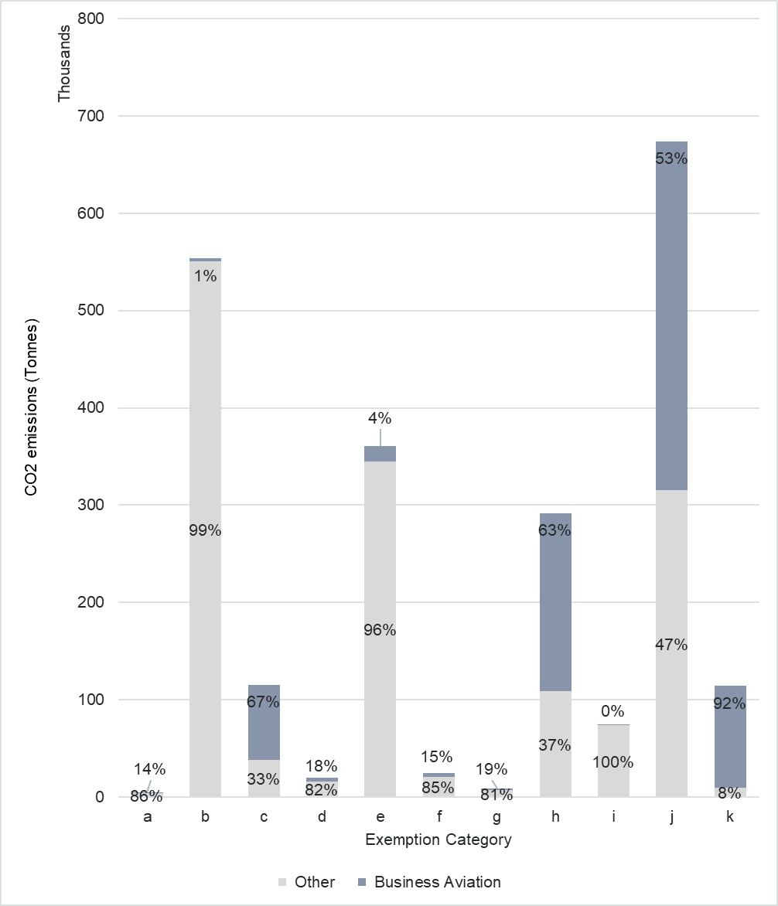
Source: Ricardo analysis of Eurocontrol data
Considering the above, the analysis for inclusion of private and business jets under the EU ETS should first look into setting a new threshold for the exclusion of certain flights/aircraft operators in a way that simplifies the framework, then try to find a definition for the business flights, allowing for an appropriate treatment of these flights, distinct from the ordinary treatment.
  - New threshold
The current exclusion categories for low aviation activity (j) and (k) are also referred to as the “de-minimis thresholds”. Exemption category (j) exempts from the EU ETS commercial aircraft operators that emit less than 10 000 tonnes of CO₂ per year or who operate fewer than 243 flights per 4-month period for three consecutive periods. In addition, exemption category (k) exempts non-commercial aircraft operators operating flights with total annual emissions lower than 1 000 tonnes per year. This exemption applies until the end of 2030. Both of the de-minimis thresholds are based on the full aviation activity as covered by the Annex I to the Directive (i.e. all flights departing or arriving in the EEA).
    - Challenges observed with the current approach and solutions proposed
Commercial status of an aircraft operator does not necessarily indicate the full nature of their activity. Business jets operators may operate as both commercial and non-commercial operators. Non-commercial operators that perform flights other than business flights would generally be exempted due to other exemptions based on the nature of flight. This may lead to situations where it is beneficial for a business aviation operator to start operating as a commercial operator, applying an increased de-minimis threshold and ultimately avoiding the ETS obligation and gaining unfair advantage.
CORSIA is implemented in Member States via the ETS Directive. There is a number of differences between the EU ETS and CORSIA, one being the de-minimis rules. CORSIA has only one exclusion threshold, irrespective of the commercial status of the operator, based solely on annual emissions. The fact, that the EU ETS has two thresholds, one of those based on two different factors (emissions and number of flights), makes the alignment between the two market-based measures more complicated. For market-based measures addressing aviation emissions, solely the level of emissions should be indicative.
Under exemption (j), having the two de-minimis thresholds leads to situations where an operator may be exempted based on their number of flights, while their emissions are relatively high. According to the aviation support study, in 2024, 44 commercial operators (7% of total) were exempted based on the flight number threshold only, emitting on average 48 000 tonnes of CO₂ per operator in Annex I full scope (62% of total exempted emissions under exemption (j)). This led to 83 000 tonnes of CO₂ within the surrender scope not addressed.
The current de-minimis thresholds apply to the full geographical scope under Annex I, while the surrender obligation is based on a different, limited geographical scope, as flights for which allowances have to be surrendered does not include flights outside the EEA (except to Switzerland and the UK). This may lead to situations where an aircraft operator falls under the scope of EU ETS by exceeding the full scope de-minimis thresholds, but at the same time such operator had no flights within the surrender scope or had a very limited number of flights due to diversions or other circumstances. In these cases, the EU ETS compliance obligations (MRV and surrendering) may be disproportionate. According to the Union Registry data for 2024, 5 operators were not excluded based on the thresholds while reporting 0 emissions under the reduced scope, 40 operators reported less than 100 tonnes of CO₂, totalling 2 041 tonnes of CO₂.
To address all of the above challenges, to ensure level playing field, to simplify the exclusion rules and to align with CORSIA, a new threshold should have the following characteristics:
- Eliminate the commercial/non-commercial distinction between aircraft operators;
- Eliminate the threshold based on number of flights;
- Use one common de-minimis threshold for all operators based on their aviation activity as per full scope, expressed in CO₂;
- Introduce a new simplification de-minimis threshold for operators that have very low aviation activity under the surrender scope.
    - Common de-minimis threshold based on full aviation activity
The primary goal of updating this de-minimis threshold is to ensure appropriate internalisation of the climate impacts, especially that of private and business aviation.
Considering this goal, it is appropriate to adjust the new common threshold to, at minimum, the level of the current non-commercial operators’ threshold (1 000 tCO₂), in order to avoid any additional exclusions of non-commercial business operators. Table 21 shows how a new de-minimis threshold would impact on the number of operators additionally included in the EU ETS and their corresponding emissions on full scope as well as the percentage of the total operators and their emissions that are currently excluded. The annual emissions threshold set at 0 shows that currently, 2 808 aircraft operators are excluded from the EU ETS, these operators emitted almost 4 million tCO₂ on full scope and over 800 000 tCO₂ under the current EU ETS surrender scope.
- Emissions and number of aircraft operators (AO) included in EU ETS based on emissions threshold on full scope
Annual Emissions Threshold (tCO2) | Total additional emissions included in current EU ETS (tCO2) AS1 | % of 2024 exempted emissions included in EU ETS | % of 2024 total EU ETS emissions included in EU ETS | Total additional emissions included in EU ETS (tCO2)  full scope | % of 2024 exempted emissions included in EU ETS | % of 2024 total EU ETS emissions included in EU ETS | Total additional number of AO included in EU ETS (tCO2) | % of 2024 exempted AO included in EU ETS
0 | 815k | 100% | 1,3% | 3.939k | 100% | 6,4% | 2808 | 100%
50 | 811k | 99,5% | 1,3% | 3.925k | 99,7% | 6,4% | 2269 | 81%
100 | 803k | 98,6% | 1,3% | 3.895k | 98,9% | 6,3% | 1853 | 66%
200 | 785k | 96,4% | 1,3% | 3.823k | 97,1% | 6,2% | 1356 | 48%
500 | 737k | 90,4% | 1,2% | 3.625k | 92,0% | 5,9% | 739 | 26%
1000 | 667k | 81,8% | 1,1% | 3.379k | 85,8% | 5,5% | 383 | 14%
5000 | 346k | 42,5% | 0,6% | 2.538k | 64,4% | 4,1% | 12 | 0%
10000 | -2 | -0,2% | 0,0% | 1.780k | 45,2% | 2,9% | -97 | -3%
Source: Eurocontrol
Increasing the emissions threshold above 1 000 tCO₂ consistently reduces the number of commercial AOs included in the ETS and increases the number of non-commercial AOs exempted. When the annual emissions threshold rises from 1 000 to 5 000 tCO₂, the number of additional commercial AOs included in the ETS decreases, while the number of non-commercial operators exempted increases. The resulting net inclusion drops sharply from 382 to only 12 operators. At an emissions threshold of above 5 000 tCO₂, the resulting number of additional non-commercial aircraft operators exempted always exceeds the number of commercial Aircraft Operators brought within the EU ETS. This demonstrates why setting the new common threshold above 1 000 tCO₂ is not coherent with the goal of covering business aviation and fully implementing the polluter pays principle.
The new common thresholds set at 1 000 tCO₂ or 500 tCO₂ both ensure completing the set goal and maintaining justified exclusion for aircraft operators with very low aviation activity and avoiding disproportionate administrative burden on competent authorities. However, these thresholds may nevertheless present a challenge of increased administrative effort, therefore a new exclusion simplification threshold, based on the surrender scope, is described in the next subsection and is accompanied by substantial further simplification, which is more closely described and analysed in subsection 7.2.
    - New simplification threshold based on surrender scope
The single exemption threshold introduced above ensures the polluter pays principle. However, it is important to note that this threshold is based on the full scope, which is not the current scope of surrender obligation, nor is this scope analysed in either policy options. Therefore, it would still be possible that an aircraft operator is included in EU ETS based on this single threshold, while having only very few flights, hence very low total emissions, within the geographic scope with surrender obligation.
It may therefore be appropriate to introduce a new simplification de-minimis threshold that fully excludes operators from EU ETS that have very little surrender obligation.
Tables 22 and 23 show how much emissions and how many operators would be excluded due to this new simplification threshold considering the current full scope thresholds and the new common full scope threshold, set at 500 tCO2 and 1 000 tCO2 respectively. It is important to consider the new common threshold in order to first identify the total pool of additional operators included in EU ETS and identify the operators that would be excluded from this pool based on their emissions within the surrender obligation scope as a second step. Both tables show results for the surrender obligation scope considered under the policy options – AS1: clean cut and AS2: departing flights.
For example, under the clean-cut geographical scope (AS1), Table 22 shows that this simplification threshold set at 200 tCO₂/year would in 2024 exclude 121 aircraft operators (with the current exclusion thresholds), emitting 7 kt CO₂. Considering the new common full scope threshold at 500 tCO2, 331 additional AO would get excluded, out of the 739 additionally added due to the new common threshold (from Table 21), based on this simplification threshold, corresponding to 25 kt CO₂ emissions. In total, under option AS1 considering a 200 tCO₂ minimum surrender threshold, a total of 452 AO would get excluded with emissions of 32 ktCO₂. Under the departing flights scope (AS2), the same simplification threshold would in 2024 exclude 1 aircraft operator, corresponding to 140 tCO₂. Under the new common threshold 500 tCO₂, 3 additional AO would get excluded corresponding to 164 tCO₂. In total, under option AS2 and 200 tCO₂ simplification threshold, 4 AO would get excluded corresponding to 304 tCO₂.
- Emissions and number of AOs exempted based on the new simplification de-minimis threshold based on surrender scope – figures for new common full scope threshold set at 500 tCO₂
 |  | AS1 |  | AS2
Annual Emissions Threshold (tCO₂) |  | AO in EU ETS based on old full scope threshold | AO newly in EU ETS due to new full scope threshold | AO in EU ETS based on old full scope threshold | AO newly in EU ETS due to new full scope threshold
0 | tCO2 excluded | 0 | 0 | 0 | 0
 | AO excluded | 24 | 42 | 0 | 0
50 | tCO2 excluded | 1k | 3k | 0 | Negl.
 | AO excluded | 60 | 131 | 0 | 2
100 | tCO2 excluded | 3k | 9k | 0 | Negl.
 | AO excluded | 93 | 224 | 0 | 2
200 | tCO2 excluded | 7k | 25k | 140 | Negl.
 | AO excluded | 121 | 331 | 1 | 3
500 | tCO2 excluded | 21k | 60k | 1k | 102k
 | AO excluded | 161 | 438 | 2 | 277
1000 | tCO2 excluded | 54k | 140k | 47k | 208k
 | AO excluded | 207 | 551 | 65 | 431
Source: Eurocontrol
- Emissions and number of AOs exempted based on the new simplification de-minimis threshold based on surrender scope: figures for new common full scope threshold of 1000 tCO₂
 |  | AS1 |  | AS2
Annual Emissions Threshold (tCO₂) |  | AO in EU ETS based on old full scope threshold | AO newly in EU ETS due to new full scope threshold | AO in EU ETS based on old full scope threshold | AO newly in EU ETS due to new full scope threshold
0 | tCO2 excluded | 0 | 0 | 0 | 0
 | AO excluded | 24 | 24 | 0 | 0
50 | tCO2 excluded | 1k | Negl | 0 | Negl.
 | AO excluded | 60 | 42 | 0 | 2
100 | tCO2 excluded | 3k | 1k | 0 | Negl
 | AO excluded | 93 | 54 | 0 | 2
200 | tCO2 excluded | 7k | 5k | Negl. | Negl.
 | AO excluded | 121 | 80 | 1 | 2
500 | tCO2 excluded | 20k | 19k | 1k | 1k
 | AO excluded | 161 | 125 | 2 | 5
1000 | tCO2 excluded | 54k | 70k | 47k | 54k
 | AO excluded | 207 | 194 | 65 | 74
Source: Eurocontrol
      - Administrative cost
To assess which threshold corresponds to a very low aviation activity that would justify exclusion from EU ETS and thus avoidance of surrender obligation for those emissions, this analysis compares the administrative cost associated with the monitoring, reporting and verification of the emissions as well as other fees associated with the EU ETS obligation, weighted against the EU ETS compliance revenues brought into the system. The ETS compliance cost is not included in the definition of administrative cost, as the compliance cost is a consequence of emitting CO₂ and the application of the polluter pays principle. However, it is understood that should the administrative cost associated with the compliance be higher than the compliance cost itself, it would constitute an unjustified burden.
As also stated in the impact assessments of 2017 and 2021, the Commission published in 2014 a study by PWC et al. (the small emitters study) that investigated the costs and benefits of the inclusion of small emitters in the EU ETS. It revealed amongst other things that the obligations with regard to MRV generate relatively higher administrative costs for small than large operators. The study also stated that compared to the level of EU ETS revenues raised from a small emitter, the administrative cost can be up to 4 times higher.
As per the aviation support study initial setup and onboarding (preparing monitoring plans, registration in the Union Registry, software adjustments) typically ranges for small operators between EUR 3 000–EUR 10 000, depending on operational complexity and data systems.
The ongoing MRV costs (annual data collection, reporting, verifier fees):
- Very small emitters (<1 000 tCO₂ full scope / < 300 tCO₂ surrender scope): EUR 1 000–EUR 5 000 per year.
- Small emitters (<25 000 tCO₂ full scope / < 3 000 tCO₂ surrender scope): EUR 2 000–EUR 7 000 per year.
The 2014 Small emitter study, as well as the figures included above, must be considered also taking into account the following developments:
- Regulation 2017/2392 simplified the MRV requirements for operators emitting less than 25 000 tCO₂ per year on full scope or 3 000 tCO₂ per year under the surrender scope of the EU ETS, allowing the use of EMIS Support Facility without the need for reporting or verification. Aircraft operators can purchase this service from Eurocontrol for an annual fee of EUR 400. Being able to use this derogation essentially eliminates the ongoing MRV costs above. However, certain resources are still necessary for the download of the EMIS report as well as the submission.
- New entrants may face unavoidable cost related to set up and onboarding. However, Commission Implementing Regulation 2018/2066 provides for simplified procedures including simplified monitoring plan requirements for small emitters. Even further simplification on this point is foreseen as part of this design element and is described in more detail in subsection 7.2.
- Additionally, to the set up cost and specifically the Union Registry registration, it is important to note that there are currently 1 334 aircraft operators with an open Union Registry account, while in 2024 there was only 375 aircraft operators falling under the EU ETS scope and reporting their emissions. It is therefore assumed that most of the newly added aircraft operators do, in fact, already own an open but excluded Union Registry account.
- The two previous points significantly lower the initial setup and onboarding costs.
- In general, the cost figures included in the small emitters study are largely outdated based on first years of entirely new compliance. In 2025, majority of aircraft operators, both EEA and extra-EEA, have in place sophisticated monitoring of their fuel use, not only for the purpose of EU ETS or other market-base measures, but also because fuel represents a large expenditure in their total operational costs and for safety reasons.
- The conclusions of the small emitters study on the comparison of the EU ETS revenues against the administrative cost for small emitters were based on the 2012 price of the EU ETS allowances varying between EUR 4 and EUR 5 per tCO2. In 2024, the average auction price per ETS emissions allowance as published on the common auction platform was EUR 64,74. This price is assumed to be increasing up to EUR 140 by 2035 due to the continuously tightening ETS cap. On the other hand, significant increase of the administrative cost, apart from inflation, is not assumed nor justified in the view of continuous simplification.
- No new comprehensive study including broad survey of the actual costs has been performed since the small emitters study.
Considering these points and ensuring this analysis does not underestimate the administrative costs, the following adjusted average costs are used:
- For initial setup and onboarding: EUR 3 000
- Ongoing MRV costs for very small emitters: EUR 700
- Ongoing MRV costs for small emitters: EUR 1 000
- Comparison of administrative costs and associated minimum ETS revenue for each simplification threshold in Tables 22 and 23.
Annual Emissions Threshold (tCO2) | Administrative cost | Minimum ETS revenue (EUR at 2024 EUA price) | Minimum ETS revenue (EUR at 2035 EUA price)
0 | 3 700 | 0 | 0
50 | 3 700 | 3 237 | 7 000
100 | 3 700 | 6 474 | 14 000
200 | 3 700 | 12 948 | 28 000
500 | 4 000 | 32 370 | 70 000
1000 | 4 000 | 64 740 | 140 000
Source: Commission analysis
Table 24 shows that the simplification threshold of 0 tCO2 (current) is the only threshold that would result in higher administrative cost for the operator than the corresponding minimum ETS revenues stemming from their participation considering both the ETS revenues with known 2024 EUA price and projected 2035 EUA price. At 50 tCO2 simplification threshold, the administrative cost would be higher than the 2024-based ETS revenues, but would be equal at an allowance price of 74 EUR. However, already at 100 tCO2 simplification threshold the 2024-based ETS revenues are 75% higher than the administrative cost, while the 2035-based ETS revenues are almost four times higher.
Member States also incur costs to administer compliance for small emitters. As per the small emitters study, these amounted to EUR 1 070 per operator in 2011 and EUR 970 in 2012, with projected costs stabilising at approximately EUR 821 per year from 2013 onwards. While the underlying data are outdated, they can provide a proxy for assessing the potential administrative cost on Member States associated with expanding ETS coverage with more focus on business aviation operators. As per these estimates, all reviewed simplification threshold would deliver ETS revenues significantly higher than the administrative costs incurred by the Member States, except for the current 0 tCO2 threshold.
  - Simplification
    - Small emitters and use of EMIS
Implementing Regulation 2018/2066 defines ‘small emitters’ as aircraft operators operating fewer than 243 flights per period for three consecutive four-month periods and aircraft operators operating flights with a total annual emissions in full scope lower than 25 000 tCO₂. Small emitters as well as aircraft operators that have total annual emissions in surrender scope lower than 3 000 tCO2 are allowed to estimate the fuel consumption using tools implemented by Eurocontrol. Moreover, Article 28a(4) of the ETS Directive provides for a derogation for these low-emitting operators meaning that the reported emissions are considered verified if determined using the Eurocontrol EMIS. Small emitters can also take advantage of simplified monitoring plan requirements. Member States have been using EMIS successfully as a tool to perform order of magnitude checks and assess inclusion of operators in the EU ETS. According to the ETS Evaluation Report (see Annex 15), 90% of small emitters use the Eurocontrol EMIS for their reporting.
While the Small Emitters Tool (SET) can be downloaded free of charge and used by eligible aircraft operator by inputting aircraft type and distance per flight, aircraft operators may also purchase the EMIS annual data for a fee of EUR 400. This gives them access to their detailed data as collected by Eurocontrol (departure and arrival aerodrome, date and time, aircraft type, distance flown, exemption code, etc.) as well as filled in ETS Annual Emissions Report (AER), which the aircraft operators only need to finalise by including their identification and contact details. Using EMIS significantly simplifies, if not eliminates, the monitoring and reporting obligation of aircraft operators, if eligible, it also eliminates the need for external verification and it allows the Member States to approve submitted AER swiftly lowering their administrative efforts as well.
It was identified that covering more emissions under the EU ETS also means having more aircraft operators covered by the system where most of the newly added operators would fall within the small emitter definition or below the 3 000 tCO₂ surrender threshold. However, it seems appropriate to increase the threshold for eligibility to use SET, EMIS and the verification derogation, in order to ensure a smooth onboarding of all new operators while maintaining accuracy of the reported emissions.
Table 25 shows that currently there are 193 aircraft operators reporting under EU ETS with full scope emissions below 25 000 tCO₂ and therefore identifying as small emitter and being eligible to use simplified procedures including EMIS without verification. Considering the new common full scope threshold set at 1 000 tCO₂, total of 543 operators would fall within the small emitter definition and under this scope being set at 500 tCO₂, would include a total of 900 operators. The table shows corresponding full scope emissions for these operators as well as their emissions under surrender scopes AS1 and AS2.
- Emissions and number of AOs eligible to use simplified procedures based on the full scope threshold
Scope |  | AO in EU ETS based on old full scope threshold | AO in EU ETS based on new full scope threshold- 1,000tCO₂ | AO in EU ETS based on new full scope threshold- 500tCO₂
Full scope | tCO₂ eligible | 1,156,501 | 2,574,776 | 2,822,333
Full scope | AO eligible | 193 | 543 | 900
AS1 | tCO₂ eligible | 452,904 | 1,070,202 | 1,140,594
AS2 | tCO₂ eligible | 788,109 | 1,749,978 | 1,903,812
Source: Eurocontrol
Additionally, this simplification also includes big emitters (operators not identified as small emitters), that have a low aviation activity under their surrender scope. This threshold is currently set at 3 000 tCO2, which allows those emitters to also benefit from using SET and EMIS without verification. Table 26 shows how many operators can benefit from these simplified procedures in addition to the operators identified in Table 25. At the current threshold and surrender scope, it is an additional 120 operators. This means that already under current conditions, a total of 313 aircraft operators can benefit from these procedures that help reduce administrative efforts in terms of both time spent and costs associated. Increasing this threshold to 5 000 tCO2 and 10 000 tCO2 would increase the number by another 13 and 37 operators respectively. Under the surrender obligation scope AS2, this threshold does not increase the number of operators that can use simplified procedures significantly above the operators already identified in Table 22. This is because in Table 26 only operators with full scope emissions above 25 000 tCO2 are considered where one can assume a large part is due to flights falling within AS2 (intra-EEA and departing flights).
- Additional (to table 23) emissions and number of AOs eligible to use simplified procedures based on the threshold on surrender scope
Annual Emissions Threshold (tCO₂) |  | AS1 | AS2
3000 | tCO₂ eligible | 51,526 | 0
 | AO eligible | 120 | 0
5000 | tCO₂ eligible | 103,076 | 3,898
 | AO eligible | 133 | 1
10000 | tCO₂ eligible | 278,665 | 3,898
 | AO eligible | 157 | 1
Source: Eurocontrol
    - Aircraft operator identification
One of the challenges in including more small emitters and especially business aviation operators is the identification of aircraft operators. Implementing Regulation 2018/2066 provides for rules to identify the aircraft operator responsible for a flight based on the filled-out flight plan. The identification of an aircraft operator for the purpose of EU ETS (ETS ID) follows the identification for the purposes of Eurocontrol Central Route Charging Office (CRCO). In most cases (certainly for scheduled commercial operations), the identification of the aircraft operator is identical to the entity paying for the route charges. However, for aircraft operators without an assigned ICAO designator or where they do not use this designator for certain flights for various commercial reasons, it may become significantly more complicated to identify the aircraft operator using for example the fleet list declaration. In some of these cases, the entity having the CRCO account may be a service management company which may or may not actually operate the flight. This potential split of the CRCO invoices between several aircraft operators has been also used in past in order to avoid compliance with EU ETS, by ensuring each aircraft operator falls under the de-minimis threshold individually even if the total CRCO traffic would place them above the threshold. According to Eurocontrol, who receives the fleet declaration lists and identifies the ETS aircraft operators, situations arise where the management company was unable to share the contact details of the owner of the aircraft due to confidentiality agreements in their contracts.
In order to eliminate this rather complicated and untransparent identification practises and to further simplify the overall EU ETS compliance, the aircraft operator for the purposes of EU ETS should be identified as the entity billed for the Eurocontrol route charges. This simplification would not cause any difference in current practice and identification of aircraft operators that perform scheduled commercial operations using their ICAO designator, but it would significantly simplify the identification of smaller aircraft operators and where service management companies are used. The entity in charge of the CRCO invoices should be identified as ETS aircraft operator, de-minimis thresholds should be assessed based on this Eurocontrol data and should the operator fall within the EU ETS, the entity will have obligations under the EU ETS (MRV and surrender obligation). This entity should then ensure their own arrangements on potential re-invoicing the EU ETS compliance costs, as well as the CRCO charges, to the entities they deem responsible for the emissions. However, this burden should no longer fall onto Eurocontrol or the Member States.
Any further simplifications concerning monitoring plans and submission of annual emission reports for operators using EMIS would be covered in a revision of the Implementing Regulation 2018/2066 following the revision of the ETS Directive.
  - Summary of the design element on business aviation
To ensure the appropriate internalisation of climate impacts of most, if not all aviation, this element explored setting a new threshold for inclusion of aircraft operators in the EU ETS. The practical examples showed that different treatment between commercial and non-commercial operators is not justified and that using number of flights as an exclusion threshold for commercial operators is inefficient. Moreover, neither of these specific points is included in CORSIA. Therefore, eliminating both of these points constitutes a first step for an updated threshold.
Once the commercial status of the operator and number of flights is eliminated, the new common de-minimis threshold on full scope was explored. However, it was also identified that while a common de-minimis full scope threshold will offer significant simplification in identifying whether an operator is or is not covered by EU ETS, minimising potential for compliance avoidance, this will inevitably bring in more aircraft operators into the EU ETS whose emissions based on the surrender scope (AS1 and AS2) may be significantly lower. The assessment therefore explores setting up a new simplification de-minimis threshold based on the surrender scope, exempting operators below this threshold from EU ETS. To further lower or eliminate the administrative burden on aircraft operators and Competent Authorities, it explored how the small emitters threshold as well as eligibility to use Eurocontrol EMIS without the need for verification could be further extended.
The common full scope threshold at 500 tCO2 and 1 000 tCO₂ were identified as the most balanced options. Additionally, the administrative cost comparison allowing to identify the right balance between the administrative cost and the ETS revenues identified the simplification threshold at 100 tCO₂ as the most appropriate and balanced. Following these conclusions, at a 100 tCO₂ simplification threshold, under policy option AS1, the common full scope threshold of 500 tCO2 results in net 422 additional aircraft operators and 1 000 tCO₂ results in net 235 additional aircraft operators. However, all of these new operators can benefit from the small emitter identification and further simplification by using EMIS without the need for verification with the eligibility threshold increased to 5 000 CO₂ on surrender scope. In terms of administrative effort and ETS revenues each of the additional aircraft operators will bring in additional ETS revenues higher than the administrative cost associated with ETS compliance while ensuring aviation appropriately contributes to the EU decarbonisation. Detailed summary of this element can be found in the Table 27.
- Final summary and comparison of threshold options and policy options
 | 500/AS1 | 500/AS2 | 1 000/AS1 | 1 000/AS2
Net additional AO | 422 | 737 | 235 | 380
Total AO covered by EU ETS | 867 | 1182 | 680 | 825
Total AO eligible for simplified procedures (% of total) | 716  (83%) | 899  (76%) | 529  (78%) | 542  (66%)
Net additional emissions in million tCO2 | 0.7 | 2 | 0.7 | 2
Net additional ETS revenues (million EUR based on 2024 EUA price) | 47 | 139 | 43 | 129
Net additional ETS revenues (million EUR based on 2035 EUA price) | 102 | 300 | 93 | 279i
  - Business flight definition
As noted, there is no universally agreed definition of business aviation or business flight. For the purposes for the ETS, it is necessary to have such a definition in order to continue the analysis on the inclusion of private and business aviation which is included in the aviation support study as well as to ensure that these flights can be easily identified in case of specific targeting of these flights.
There is a number of existing approaches to identify business flights which are reviewed in more details in the aviation support study. The Eurocontrol Market Segment Rules classification system offers an operationally applicable framework, combining conceptual clarity with practical rules that facilitate regulatory compliance under the EU ETS. It includes two types of identification – first, based solely on aircraft type (typical business jets) and second, aircraft types that are larger and usually used in scheduled air transport (but that can be reconverted into business aviation aircraft) identified in combination with the ICAO flight type ‘N’ for non-schedule air transport operations or ‘G’ for general aviation as included in item 4 of the flight plan. This is fully implementable in practice as using the aircraft types identified in flight plans is aligned with other identifications used in EU ETS (such as identification of aircraft operator) and is already included in Eurocontrol EMIS.
  - Other impacts
The previous subsections analysing the inclusion of private and business aviation provide a comprehensive analysis of the environmental, climate, economic and financial impacts of this inclusion as well as solutions where this impact might be disproportionate (new simplification de-minimis threshold and further simplification). This subsection will focus on other impacts this inclusion may have.
Social impacts: The revenue generated from the inclusion of previously exempted flights in the EU ETS within the business aviation segment would primarily benefit the national governments of the Member States through the auctioning of allowances. Member States are required to use all of their auction revenues for climate- and energy-related purposes. Business aviation is not used by wide public but only by a very limited group of citizens, therefore the overall social impact is positive.
Connectivity: Private and business aviation is not used for scheduled commercial operators; therefore, this inclusion has limited impact on the overall connectivity .
- SAF support analysis
The 2023 revision of the ETS Directive provides a support mechanism for the use of certain aviation fuels. To incentivise early uptake of the best-performing alternative fuels in terms of emissions reduction potential, 20 million EU ETS allowances, estimated at around EUR 1.5 billion, are set aside from 1 January 2024 until 31 December 2030. The Directive also states that the allocation of these allowances may take into account possible support from other schemes at national level.
The allowances cover all or part of the remaining price differential between fossil kerosene and the specified aviation fuels used by commercial aircraft operators on flights covered by effective carbon pricing through the EU ETS. A level playing field is ensured, with all airlines treated equally that operate on these routes.
In order to operationalise this support mechanism, Commission Delegated Regulation (EU) 2025/723 establishes rules for the yearly calculation of the price difference between eligible aviation fuels and fossil kerosene, taking into account incentives from the price of carbon, from harmonised minimum levels of taxation, and the rules for allocating the resulting allowances.
  - Current support
The current mechanism is in place until 2030 or until the reserve of 20 million allowances is exhausted. Aircraft operators can apply for support related to sub-sonic flights falling under the surrender scope and flights between an outermost region and an airport in the same Member State. In 2024, according to the prices published by the Commission, the support per tonne of eligible fuel was up to EUR 7 526 for an RFNBO with 100% support and EUR 573 for biofuel uplifted at a Union airport, with no reduction from other national support schemes. This resulted in allocation to 53 commercial aircraft operators of 1.3 million allowances (EUR 100 million) for the use of total 110 000 t of eligible fuels in 2024 (0.7% of total aviation fuel reported under EU ETS in 2024).
The aviation industry as well as non-governmental organisations welcome this mechanism and the incentive for first movers it offers and are united in the belief that this mechanism should continue and be expanded.
The current EU ETS mechanism has 18.7 million allowances still available. According to Commission estimates, as well as the aviation support study, unless supplemented, the allowances under the current mechanism could run out in 2028.
  - Extension of the support
This section presents an assessment of alternative design variations for the SAF support mechanism for the period from 2028 up to 2035, and in section 8.2.5. also analyses longer support. Several factors influence the amount of EU ETS allowances allocated and are a matter of this analysis. These include the volume of SAF used, the availability of allowances, fuel prices of fossil fuels and SAF (current and future) and level of direct ETS SAF support.
    - Assumptions
This analysis uses SAF use assumptions and SAF prices different from those used in the general modelling approach described in Annex 4. This includes the following reasons:
- PRIMES organises SAF sub-categories as bio-kerosene and synthetic kerosene, however for this analysis more granular identification of biofuels is needed. It is necessary to distinguish between advanced biofuels and other biofuels (in this section referred to as ‘biofuels’) as those have different levels of support.
- For the SAF support analysis, it is crucial to use conservative SAF prices (realistic or overestimated) rather than too optimistic and underestimated. This is because the support is based on the actual price difference between fossil kerosene and SAF, therefore the smaller that difference is (low SAF prices) the longer any amount of reserved allowances for this purpose would last. However, the approach using lower SAF prices may result in a recommendation to reserve an insufficient amount of allowances. It is therefore appropriate to be prudent and use higher SAF prices and hence higher price differences, which will result in an amount of allowances that would not run out prematurely.
The SAF projections use the following principles:
- Overall share of SAF used corresponds to the ReFuelEU Aviation mandate in 2025, 2030 and 2035. Biofuels intermediate values are interpolated. Only the minimum mandated shares for RFNBOs are assumed (2028-29: 0%; 2030-31: 1.2%, 2032-34: 2%, 2035: 5%).
Advanced biofuels scale up to 15% of total biofuels by 2030. Post-2030, advanced biofuels scale linearly with the aim of reaching 85% of all biofuels by 2040.
Table 28 presents projected fuel prices for the three SAF types and fossil kerosene. These are built on the following assumptions (for the full list see the aviation support study):
- Fossil fuel price projections based on PRIMES model post-2030 scenarios.
- RFNBOs prices considered constant until 2035 under a conservative estimate.
- SAF price projections, by SAF type, 2028 to 2035 (EUR per tonne)
 | 2028 | 2029 | 2030 | 2031 | 2032 | 2033 | 2034 | 2035
Fossil Kerosene | 799 | 811 | 824 | 835 | 847 | 859 | 870 | 882
Biofuels | 2,291 | 2,280 | 2,269 | 2,259 | 2,248 | 2,238 | 2,228 | 2,217
Advanced biofuels | 2,705 | 2,636 | 2,566 | 2,515 | 2,464 | 2,413 | 2,361 | 2,310
RFNBOs | 8,465 | 8,465 | 8,465 | 8,465 | 8,465 | 8,465 | 8,465 | 8,465
Source: Aviation support study
Moreover, this analysis focuses only on the three types of SAF that are most likely to be uplifted during the lifetime of the support mechanism. However, other types of SAF would continue to be eligible for the support with direct support level aligned. Electric aviation should also be included, with direct support at least equal to that of RFNBOs.
    - Support level alternatives
The assessment considers the current ETS support mechanism direct support levels (Alternative 0) and other options (Alternatives A, B and C) with distinct coverage of the fuel price differential between SAF and fossil fuel. These are presented in Table 29.
Across all alternatives, the support level for a fuel type reflects its market and technology readiness, where the nascent RFNBOs are eligible for the highest support, followed by advanced biofuels and lastly biofuels. Alternatives 0 and A apply fixed support levels for all fuels for 2028-2035, although Alternative A applies lower levels given increasing SAF market maturity. For RFNBOs, the lower support level is also desirable in order to allow for other support and incentives as presented in the Sustainable Transport Investment Plan or other national measures to eventually complement the ETS support. Alternative B features lower support levels for all fuels and phases out eligibility for biofuels from 2030 onwards, favouring advanced biofuels. Alternative C defines the support level as fixed financial incentive per tonne of fuel rather than as a percentage of price differential, in order to enhance predictability. These are presented in table 29.
- Value of fuel price differential covered, by SAF type and support mechanism option
 | Biofuels | Advanced biofuels | RFNBOs
Alternative 0 | 2028-2035: 50% | 2028-2035: 70% | 2028-2035: 95%
Alternative A | 2028-2035: 20% | 2028-2035: 60% | 2028-2035: 70%
Alternative B | 2028-2029: 30%  2030-2035: 0% | 2028-2035: 50% | 2028-2035: 60%
Alternative C | 2028-2029:  EUR 500 per tonne  2030-2035:  EUR 250 per tonne | 2028-2035:  EUR 750 per tonne | 2028-2035:  EUR 4 000 per tonne
In 2030, these alternative designs would lead to the effective fuel prices presented in Table 30. With lowering prices of advanced biofuels and their higher support over biofuels, their effective price would be lower than that of biofuels which is desirable. Except for Alternative 0, the effective price for RFNBOs stays somewhat elevated.
- Effective fuel prices in 2030 after considering ETS cost and the ETS support mechanism
Fuel price 2030 (EUR/tonne) | Fossil kerosene | Biofuels | Advanced biofuels | RFNBOs
Alternative 0 | EUR 1,165 | EUR 1,717 | EUR 1,585 | EUR 1,530
Alternative A | EUR 1,165 | EUR 2,048 | EUR 1,726 | EUR 3,355
Alternative B | EUR 1,165 | EUR 2,269 | EUR 1,866 | EUR 4,085
Alternative C | EUR 1,165 | EUR 2,019 | EUR 1,816 | EUR 4,465
    - Analysis of results
The amount of allocated EU ETS allowances under the alternative SAF support mechanism options was analysed for each SAF type and support year. Table 31 shows the cumulative number of EU ETS allowances allocated under the different alternatives of the support mechanism from 2028 to 2035 for the geographical scope AS2.
The results in Table 31 also show that the cumulative number of allowances needed by the support mechanism decreases by alternative, with Alternative 0 requiring the highest number of allowances, and Alternative C the lowest. The requirement under these alternatives is compared to the cumulative availability of allowances under the ETS aviation cap for years 2028-2035, as shown in the second part of the table. The results show that for Alternative 0 and A with comparably high levels of support granted, the number of allocated EU ETS allowances exceeds the number of allowances made available to the sector already in 2033 under Alternative 0 and in 2035 under Alternative A, making these two alternatives unattainable. Alternative B and C stay under this limit.
- Cumulative number of allocated EU ETS allowances
 | 2028 | 2029 | 2030 | 2031 | 2032 | 2033 | 2034 | 2035
Cumulative total number of allowances in million EUAs
Alternative 0 | 14 | 29 | 78 | 131 | 208 | 286 | 366 | 511
Alternative A | 6 | 14 | 47 | 83 | 136 | 191 | 247 | 351
Alternative B | 8 | 18 | 43 | 69 | 109 | 151 | 194 | 280
Alternative C | 7 | 14 | 39 | 67 | 107 | 150 | 193 | 275
Corresponding share of the cumulative aviation cap
Alternative 0 | 28% | 30% | 55% | 72% | 95% | 113% | 128% | 162%
Alternative A | 13% | 14% | 34% | 46% | 62% | 75% | 86% | 112%
Alternative B | 17% | 18% | 31% | 38% | 50% | 60% | 68% | 89%
Alternative C | 14% | 15% | 28% | 37% | 49% | 59% | 68% | 87%
      - Alternatives comparison
As per the previous subsection, the support levels in the current ETS support mechanism as well as support under Alternative A are discarded at this stage, as there aren’t enough ETS allowances for this purpose. Only Alternatives B and C can be considered and they come with distinct advantages and drawbacks.
 | Advantages | Drawbacks
Alternative B | - flexibility to adjust to fluctuating fossil fuel/SAF prices mostly avoiding distortions  - support will last longer should SAF and kerosene price gap decrease | - difficult long-term predictability about the level of support received and the number of allowances;  - early exhaustion of allowances in case of higher SAF prices and/or optimistic SAF uptake scenario
Alternative C | - price certainty and predictability for industry  - incentivises cost reductions for SAF production, as the payment per tonne of SAF will remain stable  - increased SAF competitiveness in case of lowering prices | - in case of significant SAF price reductions, this could result in over-subsidy  - no mechanism to adjust support levels to volatile prices of SAF and fossil fuel  - early exhaustion of allowances in case of optimistic SAF scenario  - Biofuels support reduces availability of support for e-fuels
    - Preferred alternative
Both Alternatives B and C result in similar effective SAF prices in 2030. Alternative C continues to incentivise biofuels post-2030, whereas Alternative B favours advanced biofuels and e-fuels. The most requested improvement to the current SAF support mechanism by stakeholders was the increase of predictability of the support both for the aircraft operators and the fuel producers. Moreover, stakeholders voiced concerns with using a uniform SAF price for the mechanism as the prices vary across the EU depending on the location of delivery, as well as on individual contract terms.
At the same time, as SAF and e-SAF uptake gradually increase, it is important to provide the strongest incentive to drive down SAF prices and support the largest amount of (e-)SAF with the limited resources available. Alternative B provides these incentives, as it adjusts to price fluctuations and enables longer lasting support if (e-)SAF prices decrease. Market operators are experienced in dealing with price uncertainty of fossil kerosene and SAF. Alternative B operates in the same way as the current SAF support mechanism, so market participants and national competent authorities have the relevant administrative experience.
The prices for fossil fuel and SAF will continue being published in the EASA Technical Report. The SAF support would go further if other incentives, such as the harmonised minimum level taxation proposed on fossil kerosene or other Union-wide or national incentives are taken into account.
    - Total amount of allowances
Policy measures SAF1 and SAF2 extend ETS-financed SAF support by medium and higher amounts of allowances respectively. Besides that, the two options apply to the same geographic scope AS2– intra-EEA plus departing flights. The analysis considers the same SAF uplift in line with the ReFuelEU Aviation mandates under both options. While ETS-financed SAF support may incentivise higher uptake of SAF, this is not modelled given large uncertainties in this nascent market, high price differentials with fossil kerosene, and to avoid overestimating available supply. Therefore, the different amounts of allowances reserved for the SAF support mechanism will solely result in different years when the reserved allowances will be exhausted.
Reserving a medium amount of allowances under SAF1 will mean that a higher amount of allowances will go to auctioning, resulting in higher ETS revenues for Member States to use for tackling climate change in aviation or other sectors. The medium amount is established as 140m allowances. Without limitations in the SAF mechanism, the medium amount of allowances would cover all SAF uplifted until 2032 (including 80% of the uplift in 2032) giving more than 5years of continuous support. This amount would also fully cover all SAF uplift on flights covered by AS1.
SAF2, the higher amount of allowances, would draw on most of the aviation cap and support SAF uplifted in line with ReFuelEU mandates until and including 2035. Using Alternative B for the design of the support, 280 million allowances would be used for this purpose. Consequently, reserving 280 million allowances for the extension of the SAF support mechanism is proposed, while noting that this amount would use 89% of the current cumulative aviation cap up until 2035.
When looking at support for the period 2028-40, even using the full amount of the aviation cap for that period, support levels would have to be significantly reduced to last for the whole period or would run out shortly after 2035. This is mainly because the ReFuelEU blending mandate for fuel suppliers goes from 6% to 20% in 2035, and prices for SAF and e-SAF are not projected to decrease significantly. If support levels were to be kept the same as in alternative B, the cumulative aviation cap for 2028-40 would be spent before the end of 2036.Alternative B could also be followed until 2035, followed by an approximately 70% reduction of support levels to enable continued support until 2040. Else, continuous support at about 48% below alternative B would be feasible from 2028-40 if the entire aviation cap is used.
    - Conditionalities
The current SAF support system has very few conditionalities. Any extension should evolve and support overall aviation decarbonisation further. Future conditionalities could be based on input from the Sustainable Transport Investment Plan and stakeholder feedback in the open public consultation. These include but are not limited to:
- Existing conditionalities:
  - Only flights covered by the surrender obligation are eligible for the support.
  - Business flights are excluded from the support due to their polluting nature and superior resources available to be used for SAF uptake.
  - ‘First come, first served’ principle to incentivise first movers.
- Consistency with Regulation (EU) 2024/1735 establishing a common legal framework aimed at strengthening the Union’s resilience and security of supply of net-zero technologies
- Long-term offtake agreement in place:
  - Aircraft operators would provide a long-term SAF offtake agreement. This is necessary for predictability of the support where support would be granted based on the multi-year agreement and crucially for the fuel producers and technology providers in order to reach Final Investment Decision. This condition would therefore incentivise uplift as well as production of these fuels.
  - Differentiated support could be introduced based on the agreement length (5-year contract leading to bigger support than 2-year contract).
  - As long-term contracts may relate to a significant amount of fuel, volumes of allocated allowances for SAF uplift would be adjusted annually based on the volumes actually used as per the annual emissions report. Any unused allowances would be put back in the reserved pool and would be reused.
- Climate-neutrality plan
  - As established in EU ETS for installations, aircraft operators could be required to submit and follow climate-neutrality plans outlying their commitment to decarbonisation, including measurable actions and green investments.
- Other considerations
The Global Solidarity Levies Taskforce: For People and the Planet (GSLTF) was launched at COP28 in 2023 to explore progressive tax measures that generate predictable revenue for climate and development, while ideally also discouraging greenhouse gas emissions. The European Commission is an observer to the taskforce since its launch, supporting the efforts to identify and develop innovative sources of funding for climate action, especially for the most vulnerable countries.
In early 2025, the GSLTF identified the aviation sector on premium air travel and private jet fuel as among the measures that are socially fair and have the greatest potential for adoption. The following data illustrates the focus on aviation, and specifically luxury travel:
- Emissions are highly concentrated among a small share of the population at the upper end of the income spectrum. Studies suggest that only 2–4% of the global population flies internationally each year, and that just 1% of people are responsible for roughly half of global aviation emissions.
- Premium-class seating is estimated to be 2.6 to 4.3 times more carbon intensive than economy class seating, depending on aircraft class due to the greater space and weight per passenger.
- Private aviation (i.e. private jets) produces 5 to 14 times more emissions per passenger-kilometre than commercial flights.
Furthermore, analysis shows aviation taxation is limited compared to other sectors such as road or rail transport, and insufficiently internalises aviation’s externalities, ranging from climate impacts of emissions to noise and air pollution. A GSLTF study found that premium flyer levies could contribute to significant CO₂ emission reductions (4 to 10% below the baseline under middle rate, global coverage scenarios) and generate substantial revenues (EUR 62 to 84 billion annually).
A Premium Flyers Solidarity Coalition was launched at the UN Fourth Financing for Development Conference in Sevilla in June 2025, with the support of the GSLTF Secretariat. The coalition calls for participating countries to introduce a ticket levy on premium flyers, or if they have one, make their ticket levy more progressive for upward harmonisation. It calls for participating countries to introduce taxation of kerosene for private jets.

Annex 11: Maritime

List of Tables
Table 1: Possible design elements for a sustainable maritime propulsion mechanism 265
Table 2: Key aspects of a SAF-like sustainable maritime propulsion mechanism 266
Table 3: Economic impacts of different possible sustainable maritime propulsion mechanism variations 268
Table 4: Comparison of selected monitoring and reporting requirements under EU MRV/ETS and FuelEU Maritime 281
Table 5: Potential cost reduction by cost driver 285
Table 6: Derogations in 2024 by ship type 289
Table 7: Design options for the adjustment mechanism: Metric of the adjustment mechanism 298
Table 8: Design options for the adjustment mechanism: Process to determine GFI 298
Table 9: Design options for the adjustment mechanism: Well-to-wake (WTW) or tank-to-wake (TTW) approach 299
Table 10: Design options for the adjustment mechanism: Treatment of emissions from fuels that are zero-rated under the EU ETS 300
Table 11: Variations of the deduction to be assessed 300
Table 12: Estimated CO₂ emissions (tons) for selected candidate countries, based on 2024 port-call data (MRV scope) 304
Table 13: CO2 emissions (ktons), under EU ETS from selected candidate countries (PM3) 305
Table 14: GHG emissions from vessels between 400 and 4999 GT in 2023 under the geographical scope of the EU ETS (i.e. 100% of intra-EU and at berth emissions and 50% of extra-EU emissions, considering potential derogations) and under the extension of the scope of the EU ETS to all non-exempt categories of small vessels plus fishing vessels (MSS2) 307
Table 15: Impacts from measure MSS2 on GHG emissions (in MtCO2e) of smaller vessels 309
Table 16: Impact on shipping costs for smaller vessels from policy measure MSS2 310
Table 17: Additional administrative costs for shipping companies under MSS1 (PO2) and MSS2 (PO3) 312
Table 18: Additional administrative and enforcement costs for national authorities under MSS1 (PO2) and MSS2 (PO3) 313

List of Figures
Figure 1: Projects supported by the Innovation Fund since 2020 263
Figure 2: Illustration of the revision of the list of neighbouring transhipment ports with a 50% transhipment incidence threshold. Vertical axis shows transhipment incidence in %, while horizontal axis shows distance to closest EU port in nautical miles (nm). Size of the bubble shows annual transhipment traffic in TEUs. 275
Figure 3: Current MRV/ETS/FuelEU compliance cycle, main steps 279
Figure 4: GHG emissions trajectory (emissions measured as MtCO₂e) for the extension to smaller vessels (MSS2) compared to the default policy scenario (PO1) 309
Figure 5: Trends in the demand of renewable fuels (RFNBOs, biofuels and electricity) for smaller vessels as share of total fuel use for smaller vessels under the default policy scenario (PO1) and MSS2 310

- Support for emissions reduction in the shipping sector
  - Scoping
Several technological options exist to decarbonise maritime transport, ranging from energy-efficiency improvements to electrification, wind propulsion assistance or the use of emerging renewable and low-carbon fuels. For instance, a recent study has found that energy efficiency measures can reduce ship emissions by up to 40% and that about half of emissions savings from energy efficiency measures are considered cost-effective in 2030. Another study showed that existing battery technology could cover the fuel needs of about one-third of the entire EU ferry fleet and that wind assistance propulsion is an effective fuel savings measure applicable to several vessel types and with ample market growth potential to 2050.
However, the uptake of these decarbonisation options is still being hampered by various barriers, which can be technological, but are mostly economic and market-related (e.g. shipowners making CAPEX and OPEX investments in low-carbon solutions that do not always capture the benefit). Recent analysis highlights the need for a more integrated and supportive financial framework to support the decarbonisation of the maritime industry, which is a sector characterised by high capital intensity, long asset lifetimes, and extended production lead time. Some of the key financing-related obstacles, include:
- Limited access to financing for innovative activities and technologies;
- Lack of financial instruments suited to the sector’s characteristics;
- Insufficient financing tools to support EU shipbuilding activities.
According to high-level estimates based on the TRL of investment technologies, the annual volume of green finance required for the decarbonisation of the EU maritime sector is estimated from EUR 10.9 billion to EUR 44.0 billion, covering vessel fleet decarbonisation (EUR 2.4 - 8.5 billion) and infrastructure (EUR 8.5 – 35.5 billion).
When it comes to renewable or low-carbon fuels, the maritime sector can use a broad mix of possible decarbonisation alternatives (different fuel technologies as well as different possibilities for blending with conventional fuels for existing and emerging powertrains). However, the market maturity of these alternative fuels today remains limited. According to the EU’s Sustainable Transport Investment Plan (STIP), one of the main hurdles for ramping up the market is the significant price difference compared with conventional fuels. Current price differentials range from approximately 1,5 to 5 times the cost of conventional fuels. The STIP estimates that the induced production of bio-SMF and e-SMF will require investment of between EUR 34.7 billion and EUR 46.7 billion by 2035.
Current use of ETS revenues
From 2013 to the end of 2025, the EU ETS has raised over EUR 258 billion through the sale of emission allowances since its launch. In 2025, ETS revenues reached EUR 43 billion. This went primarily to national budgets, alongside funding ETS programmes for a clean transition (i.e. the Innovation Fund and the Modernisation Fund) as well as part of the Recovery and Resilience Facility in line with the REPowerEU Plan.
National revenues generated from the EU ETS must be used for the purposes outlined in the ETS Directive, with a focus on decarbonisation. Member States must spend all of their ETS revenues on eligible climate-related expenditure. The ETS Directive thus already foresees the possibility for Member States to use their revenues to support measures to decarbonise the maritime sector (e.g. improvement of the energy efficiency of ships, ports, innovative technologies and infrastructure, and sustainable alternative fuels, such as hydrogen and ammonia that are produced from renewables, and zero-emission propulsion technologies). Although decisions on allocation remain the responsibility of individual Member States, the Commission strongly encourage them to allocate a part of their ETS revenues to maritime decarbonisation investments across the maritime cluster in Europe. Member States directed most of their 2024 ETS revenues to projects in the deployment of renewable energy sources, grids and storage (20%), the improvement of energy efficiency in industries and buildings (20%) and the development of clean public transport and mobility including maritime projects (22%).
Since shipping was only included in the ETS starting in 2024, many Member States are just beginning to incorporate the maritime sector into their plans for utilising ETS revenues. So far, activities funded or planned to be funded in the maritime sector through ETS revenues encompass a wide range of interventions, such as the construction of onshore power supply systems in ports, the greening of port areas, the development of climate-neutral vessels, modernisation of transport fleets, and the implementation of innovative technologies like semi-autonomous navigation
Innovation Fund supports the maritime transport sector
The Innovation Fund is one of the world’s largest programmes supporting the scale-up of net-zero and low-carbon technologies. Established under the EU ETS Directive, it plays a central role in the European Green Deal and channels revenues from the EU Emissions Trading System into deployment of clean, competitive solutions across the European Economic Area.
Between 2020 and 2030, the Fund has an estimated budget EUR 40 billion sourced from the EU ETS. From 2020 to 2025, the Innovation Fund has given over EUR 4,8 bn in support of projects that decarbonise the transport sector, representing more than 35% of the funds committed. These projects support the production and use of sustainable fuels, the electrification of transport systems, the manufacturing and recycling of batteries for electric vehicles, the building and/or retrofitting of low- and zero carbon ships, airplanes and heavy-duty vehicles.
The largest share of mobility projects in the Innovation Fund portfolio is related to fuel production (47 projects). Over 45 % of these projects are expected to exclusively supply their production to the transport sector, while the rest plan to have multiple potential off-takers, transport being among the key beneficiaries. Notably, the Innovation Fund supports hydrogen production, a key fuel and feedstock to produce eFuels and other synthetic fuels. While the Innovation Fund is open in principle to all companies around the world, the production of fuels is supported exclusively within the EU. Therefore, the Innovation Fund is not suited to support projects of Just and Equitable transition in SIDS and LDCs.
- Projects supported by the Innovation Fund since 2020
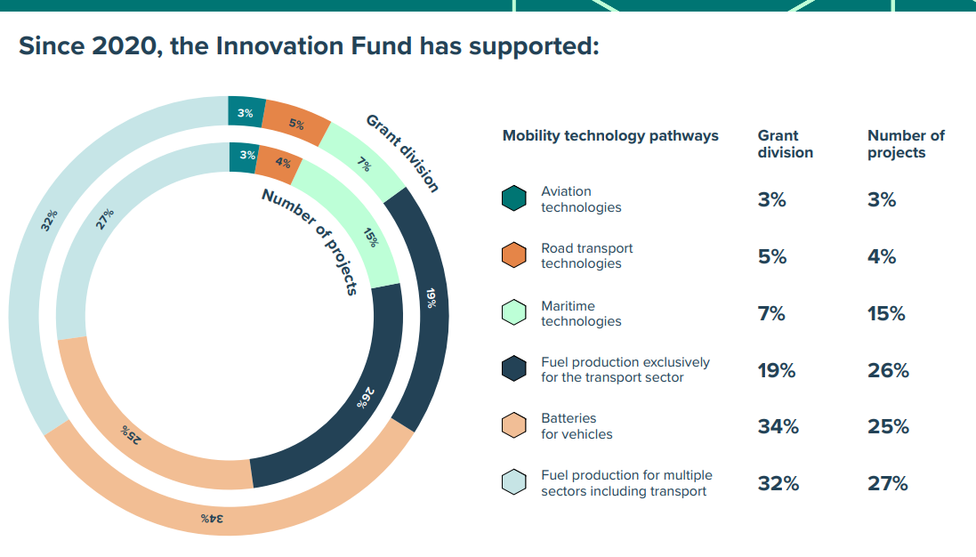
Source: EC, Innovation Fund – Mobility factsheet
For the maritime sector which has only become explicitly eligible to IF calls since the last EU ETS Revision, the Fund covers, among others, the production and use of sustainable fuels, the electrification of the maritime transport system, and the building and/or retrofitting of low- and zero carbon vessels. In this context, 20 million allowances will be deployed up to 2030 to support the decarbonisation of the sector through the Innovation Fund. Until the beginning of 2026, the Commission already supports 21 maritime related projects with a total of EUR 1,03 bn, including EUR 365,3 million through auctions for hydrogen-based fuels and EUR 202,3 million for projects related to construction/retrofitting of vessels.
Additionally, the Commission established the “auction as a service” and the “grants as a service” mechanism, which enables Member States to use their national budget resources to award support to projects (including maritime) located on their territory, while leveraging on the EU-wide competition and Innovation Fund evaluation and selection mechanism to identify the most competitive projects.
Summary of stakeholder views from the OPC
Thirty-one stakeholders mentioned the use of ETS revenues to support maritime decarbonisation. Stakeholders highlighted several areas where EU ETS revenues could be used to drive decarbonisation, including:
  - Support the maritime sector in reducing GHG emissions, including companies, vessels and operations.
  - Invest in clean fuels, technologies and infrastructure to enable the transition to low and zero emission shipping.
  - Ensure EU ETS revenues are specifically and reliably used for maritime decarbonisation, so the funds support the sector’s transition and allow long-term planning.
Twenty-three stakeholders highlighted the importance of bridging fuel cost gaps. Stakeholders highlighted that alternative fuels are currently significantly more expensive than conventional marine fuels, creating a financial barrier that hinders their adoption. Key suggestions to tackle this included:
  - Reduce the financial burden on shipowners and operators by making alternative fuels more economically viable until they reach price parity with conventional fuels.
  - Provide targeted support for early-stage uptake of sustainable fuels, ensuring that incentives help overcome initial market barriers.
Fourteen stakeholders also mentioned the use of financial mechanisms, including the use of the Innovation Fund, to support maritime decarbonisation and six stakeholders proposed measures to support fleet renewal, retrofitting, and deployment of clean technologies.
  - Policy measures
Establishment of an EU ETS support mechanism for Sustainable Maritime Alternative Propulsion (SMAP)
This policy measure considers whether a similar but broader approach to the ETS SAF mechanism could be used to effectively support the uptake of renewable and low-carbon maritime propulsion, as well as the uptake of appropriate low-carbon technologies. The aviation mechanism is established under the EU ETS Directive (Article 3c(6)). It uses allowances to incentivise the uptake of SAF by airlines on ETS flights by covering the price gap between SAF and fossil kerosene.
As a first step, it is necessary to acknowledge that the situation in maritime differs from aviation as there is a wider range of clean propulsion options, renewable and low-carbon fuels in maritime transport, whereas in aviation there is broadly only green kerosene (though produced via different routes and feedstocks) alongside electrification in the coming years. This range of propulsion pathways for the maritime sector should be supported, though this can add complexity to a support mechanism.
A future Sustainable Maritime Alternative Propulsion (SMAP) mechanism could have various aims, primarily to support the production of renewable and low-carbon maritime fuels in Europe by reducing the price gap compared to fossil fuels and support the production and manufacture of sustainable maritime clean propulsion in Europe, including the full range of Net Zero maritime propulsion technologies listed in Union legislation. In addition to contributing to the decarbonisation of the maritime transport sector, such a mechanism could also support the EU’s strategic autonomy by diversifying energy supplies, spurring innovation, and contributing to creating new opportunities for industrial growth and job creation in the EU.
In terms of design elements, different options could be considered, depending ultimately on the chosen aim of the mechanism.
- Possible design elements for a sustainable maritime alternative propulsion mechanism
Design element | Options
Eligible fuels or technologies | - Fuels produced and bunkered in the EU, and  - Fuels zero-rated under EU ETS, or  - Only certain types of fuels such as RFNBOs, or  - Depending on what is (not) supported by a possible IMO mid-term measure (e.g. reward mechanism)  - Low carbon technologies such as wind propulsion assistance or ship electrification:
  - Flettner rotors
  - Suction wing sails
  - Towing kites
  - Rigid and semi-rigid wing sails
  - Electric propulsion systems for waterborne transport
Beneficiaries | - Support could be received by shipping companies. Such an option would be in line with the existing support design, and it would ensure consistency with the logic of the ETS where the responsible entities are the shipping companies.  - Support could be directed to fuel/ propulsion mechanism producers. Supporting the production side would entail a different design compared to the existing ETS mechanism.  - When linked to other technologies, support could be directed to intermediaries providing performance-based services to decarbonise shipping, e.g. Energy Service Companies offering performance-based contracts to finance, install and maintain low-carbon solutions leading to guaranteed fuel savings.
How the price difference could be calculated | price difference = eligible fuel price - (fossil fuel price + ETS price + FuelEU over-compliance reward through pooling + FuelEU avoided penalties + possible carbon pricing or reward from an IMO mid-term measure + [other relevant monetary benefits])
Level of support | - Level of support could be differentiated by type of fuel or propulsion technology.  - Priority could be given to EU origin (targeted EU preference criteria)  - Another basis for differentiation could be the level of technology readiness and commercial availability, with alternative fuels with high decarbonization potential but currently low readiness receiving higher level of support, and fuels with limited market but high potential receiving priority support until a more liquid market develops.  - A phased-approach could also be implemented with alternative propulsion receiving a higher level of support in the first years, which is then reduced over time and phased out eventually.  - Another basis for differentiation could be location, so as not to discourage remote areas or specific situations.
Type of incentive | - EUAs could be provided to shipping companies to cover a certain part of the price gap between eligible activity and fossil reference. A potential formula to allocate the allowances to shipping companies could be the following:  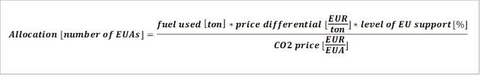  - Direct financial subsidy through e.g. bidding / auctioning system
Timeline: | - Built on the compliance cycle of EU ETS;  - Depending on timeline linked to a possible IMO mid-term measure; or,  - Until reserve of allowances is exhausted.
Scope | - In line with the EU ETS scope; or,  - EU MRV scope
Designing a future mechanism along the characteristics of SAF support would certainly bring some benefits. It would ensure policy consistency and bring a coherent set of demand certainty for technology and fuel producers. Current EU ETS SAF support is also a well-understood system, and stakeholders seem to favour such an approach. However, to be effective, such a mechanism needs to reflect the many particularities of maritime transport, including the many propulsion options available to the sector. In this context, a possible mechanism could be characterised by the following main elements:
- Key aspects of a SAF-like sustainable maritime alternative propulsion mechanism
Key aspects | Description
Main purpose | Incentivising fuel switch and other low-carbon propulsion technologies by partially covering the price gap compared to the use of fossil fuel.  Incentivising EU technology fuel production (NZIA).
Beneficiary | Shipping company – ETS/MRV responsible entity.
Scope | EU ETS scope:  - 100% of fuels/energy used/avoided for intra-EU voyages, or when the ship is within EU ports;  - 50% of fuels/energy used/avoided for extra-EU voyages.
Type of incentive | EUAs
Eligible fuels or technologies | Sustainable propulsion mechanisms and certified sustainable renewable and low-carbon fuels produced and bunkered in Europe, as and if applicable subject to zero-rating under the EU ETS and that fulfil specific life-cycle GHG intensity limit to be determined.
Price difference covered | The share of price difference covered would take into account the criteria set out in the above table, including the level of support envisaged for different situations, E.g.  - 50% of the price gap for non-advanced biofuels or RFBNO fulfilling the Renewable Energy Directive criteria, except for feed-based biofuels;  - 70% for advanced biofuels;  - 90% for RFNBOs.
Timeline | - Implementation harmonised with the ETS compliance mechanism (e.g. monitoring, reporting and verification of fuel use embedded in the EU MRV process and transfer of EUA through the ETS registry done by Administering Authority).
Other measures: Payments to IMO Fund for the benefit of Just and Equitable Transition in SIDS and LDCs.
This measure would imply reserving a certain share of revenues from auctioning allowances concerning maritime emissions for payments on behalf of the EU to a possible future IMO Fund to support the decarbonisation of the maritime sector. The payments would be paid to such a future IMO Fund under the condition of benefitting projects in SIDS and LDC countries to invest in shipping’s energy transition and to pursue a Just and Equitable Transition. Such payments could also help to frontload a future IMO Fund in the first years, to ensure support for SIDS and LDC countries at an early stage.
However, since the IMO adjourned its decision regarding the adoption of the IMO Net Zero Framework until autumn 2026, it is not possible to establish the impact any potential payments to such an IMO Fund would have nor how the payments would be distributed, and which countries would benefit. In turn, it is not possible to assess how possible payments to the IMO Fund would benefit the Just and Equitable Transition.
Other measures: Further mobilising financing for the decarbonisation of maritime transport through the Innovation Fund
While the maritime sector already benefits from the Innovation Fund support to scale-up net-zero and low-carbon technologies, the fund could further focus on the need of the sector, e.g. by continuing proposing dedicated windows for maritime decarbonisation. In that respect, the Commission already announced that it will open, in 2027, a dedicated maritime call. The budget and scope of this call will be determined as appropriate by the Commission notably based on the remaining Innovation Fund budget and the ETS pricing.
In practice, the Fund could continue to support the retrofitting of existing vessels and the construction of new low or zero emission ships. It could allow supporting a wide range of technologies, including alternative fuels (e.g. hydrogen, ammonia, methanol, biofuels), propulsion systems (e.g. wind-assisted, battery-electric, hybrid) or energy efficiency measures (e.g. waste heat recovery, hull design, air lubrication, optimisation tools). In addition, when combined with the concept of “grant-as-a-service” or “auction-as-a-service”, dedicated Innovation Fund windows for maritime would help mobilising additional national resources to support the decarbonisation of the sector, including ETS auctioning revenues. It is not always easy for Member States’ authorities to develop their own national programmes to support the green transition of the shipping sector due to e.g. the cross-border nature of shipping (benefits may occur outside the Member State providing support), the need to fulfil State aid rules, the lack of precedent, the limited administrative capacity and technical expertise, the complexity of the sector which entails different needs and solutions (e.g. short sea shipping vs deep sea shipping) or the high technology diversity and uncertainty. For all these reasons, dedicated maritime support under the Innovation Fund used as a vehicle for “grant-as-a-service” have the potential to accelerate national action on shipping decarbonisation. They would allow Member States to “plug into” a well-established EU system and to externalise the administering complexity linked to the management of dedicated support programmes. Considering that shipping is a pan-European and international industry, such a measure would also avoid fragmentation and distortions in the market. It could also help address the risk of non-compliance with State-aid rules.
In addition, the Industrial Decarbonisation Bank is expected to play an important role in supporting the production of sustainable maritime fuels. It will support projects with carbon emission reduction as a metric to enable technology-neutral support across industrial sectors, including through carbon contracts for difference. It will be designed to ensure a competitive selection and a fair distribution of support across Member States. It will complement the ETS price signal and help bridge the funding gap in both capital and operational expenditures.
  - Assessment of policy measures
    - Economic impacts
Increasing the recycling of EU ETS revenues in the maritime sector through a new sustainable maritime alternative propulsion mechanism would improve the economic viability and attractiveness of shipping decarbonisation solutions.
However, such economic impacts would largely depend on the funding volume allocated to the mechanism. For this analysis, two different approaches have been considered. The first approach aims to support the uptake of RFNBO as additional support to reach the levels in FuelEU maritime (reaching at least 2%/year as from 2034). The second approach considers a volume of funding estimated based on a SAF-like share approach as used in the current ETS Directive.
The table below shows the estimated economic impacts of each option, assuming a sustainable maritime alternative propulsion mechanism designed in coherence with the current EU ETS support (see table above on key aspects). Establishing a sustainable maritime alternative propulsion mechanism to directly support the uptake of RFNBOs as additional support to reach the levels of FuelEU maritime objectives would require around 26 million EUAs over 2031-2040 to support the use and the production of EU sustainable propulsion. If a funding rate similar to the current SAF was applied, it would lead to around 46 million EUAs being attributed to bridge the price gap between sustainable propulsion and fossil fuels over 2031-2040.
- Economic impacts of different possible sustainable maritime propulsion mechanism variations
SMAP mechanism variations | Key assumptions | Period | Support in M EUAs
Supporting RFNBOs uptake to meet FuelEU’s objectives | - average maximum funding rate of the price gap of 90% for RFNBOs  - ETS scope coverage (EEA) | 2028-2030 | 11
Supporting RFNBOs uptake to meet FuelEU’s objectives |  | 2031-2040 | 26
SAF -like share of cap | - overall funding volume corresponding to initial SAF support {12%}. | 2028-2030 | 21
SAF -like share of cap |  | 2031-2040 | 46
The amount of financial support in the form of EUAs would vary across the years, influenced by several elements, such as the ETS price (i.e. the higher the ETS price, the lower the price gap), or the objectives to be achieved in terms of sustainable propulsion uptake.
The additional administrative burden for shipping companies, administrative authorities and the EU is likely to be low as a sustainable maritime alternative propulsion mechanism could be built on existing reporting requirements and compliance cycles. Additional administrative burden could for instance come from the need to monitor, report and verify the origin of eligible fuels (e.g. bunkered and produced in the EU).
Depending on the funding volume attributed to the mechanism, it could support from around 0,5 Mtoe to 3 Mtoe of sustainable maritime fuels annually by 2035, which could significantly contribute to building-up sustainable maritime capacity in the EU.
Another approach that could be considered as a starting point to determine the volume of a SMAP mechanism is to cover the price gap to meet e.g. the GHG Fuel intensity trajectory under discussion at IMO. Such an approach would potentially require a total of up to 200 million allowances, just for fuels, if one assumes full funding of the price gap and no IMO rewards.
    - Environmental impacts
In terms of environmental impacts, the establishment of a sustainable maritime propulsion mechanism would directly support the increased use of sustainable maritime fuels and propulsion systems, which are key to unlock the decarbonisation of the maritime sector.
By 2035, it could help deliver an annual GHG emissions reduction in the range of 1,7 to 9 MtCO2, depending on the funding volume made available.
However, this effect is not directly visible in the PRIMES maritime model since the different scenarios have all been modelled with the objective to achieve a certain level of GHG Fuel Intensity reduction.
    - Social impacts
By building up sustainable propulsion and renewable and low-carbon fuels capacity in the EU for maritime transport, a sustainable maritime propulsion mechanism would offer substantial opportunities for industrial growth and job creation in the EU, including in ports as energy hubs, in raw materials, refineries and the distribution network.
It could also help unlock the employment potential linked to the manufacturing and installation/retrofit of wind propulsion assistance in Europe, estimated at over 5,800 jobs in 2030, or the employment potential behind the use of electric ferries and RoPax vessels in Europe (around 800 jobs in 2024-2030).
The upscaling of Europe’s sustainable maritime fuels and propulsion technology industry will also lead to the EU being more energy independent, including in case of external menaces hampering the energy supply. These key benefits are nevertheless not quantified.
- Measures to further mitigate the risk of evasion
  - Scoping
Evasive behaviours can be defined in a broad sense as operational adjustments from shipping companies that avoid GHG emissions under ETS scope, other than due to improvements in energy-efficiency or use of alternative fuels/cleaner ships.
Potential evasion risks include:
- Relocation of transhipment operations: The risk that vessel operators may decide to relocate container transhipment activities in non-EU ports to reduce EU ETS costs. The risk may depend on the container traffic flows at an individual port; it may be higher if the port is mainly used for the transhipment of containers that are not intended to enter the EU market.
- Addition of evasive port calls at nearby non-EU ports or changes in order of port calls: The risk that operators may add extra port calls to their routes (or change order of port calls) to reduce the length of the last leg before calling at an EU port (or the length of the first leg after leaving an EU port) and hence reduce their EU ETS compliance costs.
- Shifting demand to other transport modes with higher environmental impacts: The risk that freight companies may move freight transport from maritime to other modes, which have higher emissions than maritime.
- Assigning best performing vessels to EU routes: The risk that vessel operators may elect to use their most efficient vessels (with lowest emissions per tonne-mile) to routes that include calls at EU ports and use their less well-performing vessels on other routes.
- Use of ships below size threshold: The risk that vessel operators, particularly those that operate smaller vessels (but still above 5 000 GT), may choose to use vessels below the 5 000 GT threshold to avoid the need to surrender EU ETS allowances for their emissions. Using smaller vessels would result in more voyages being needed to deliver the same quantity of freight and thus likely overall higher emissions, having a negative impact on the environmental effectiveness of the policy.
- Evasion linked to offshore service operations: current MRV rules define a “port of call” in a way that may unintentionally incentivise use of non-EU bases by offshore vessels to evade ETS obligations.
The main driver of evasive behaviour is the financial incentive for shipping companies to minimise ETS compliance costs (including ETS payments or GHG mitigation costs) when these exceed the costs of evasion (additional costs related to vessel operations and port calls). This incentive may also depend on the companies’ ability to pass compliance costs to final consumers and on the application of other policies in third countries, which could result in other carbon pricing signals. Beyond economic considerations, other factors are likely to influence decision-making, including impacts on services (e.g. deviation or waiting times), feasibility of evasion (e.g. accessibility of non-EU ports, berth availability, network compatibility, investment policies), and specific risks (e.g. reputational concerns, geopolitics, global trade patterns).
Evasive behaviours from shipping companies are problematic in three main ways. First, they can undermine the environmental integrity of the EU ETS, as companies may surrender less allowances without actually reducing emissions. In some cases, evasion can even increase GHG emissions for equivalent transport activity (e.g. longer sailing distances or shifting operations to higher-emission transport modes). Second, evasive behaviours can reduce traffic and connectivity at EU container transhipment hubs, with wider economic impacts such as higher costs or reduced access to key overseas markets. Third, evasion can lower ETS revenues, reducing funds available to support maritime decarbonisation and broader climate objectives.
The application of the EU ETS to offshore vessels of 5 000 GT or above from 2027 may create evasion risks for this segment. Current EU MRV rules define a “port of call” as a stop for cargo loading/unloading, passenger embarkation/disembarkation, or crew changes for offshore vessels. This definition may not fully capture the activities of offshore vessels. Consequently, operators could re-route through non-EU ports to avoid triggering “port of call” requirements and EU ETS obligations. This could create a competitive disadvantage for vessels calling at EU ports, which must account for emissions during offshore activities, compared with vessels avoiding EU ports despite operating in EU EEZs.
Current measures to address evasion risks
To mitigate evasion risks, the ETS Directive includes a strict “port of call” definition (i.e. obligation to load/unload or embark/disembark cargo and passenger), which prevents companies from making artificial port calls for evasion purposes. In addition, “neighbouring container transhipment ports” are excluded from the “port of call” definition. This means that stops at these non-EU ports cannot be considered under the Directive as the beginning or the end of a voyage, reducing incentives to stop at these non-EU hubs before or after calling EU ports. Based on the criteria set out in the ETS Directive, the Commission has established the list of neighbouring container transhipment ports, which is to be updated biennially, and which currently includes important transhipment hubs such as the ports of East Port Said in Egypt and Tanger Med in Morocco. More recent data available to the Commission at the time of preparing this impact assessment indicates that two additional ports, Abu Qir and Damietta, in Egypt, also meet the criteria for neighbouring container transhipment ports and will be considered for the revision of the list.
However, the current anti-evasion measures may present several limitations:
- They may not cover adequately neighbouring transhipment ports that pose a risk but are below the current thresholds.
- Ships performing extra-EU journeys with an intermediary stop at a “neighbouring non-EU container transhipment ports” benefit from a lower ETS scope coverage for the leg to and from the EU, compared to ships doing similar journeys but with an intermediary stop in the EU.
- They do not apply to container ships doing journeys from and to non-EU ports, with an intermediary stop at a competing neighbouring non-EU port (such voyages fall outside the EU scope).
- They do not completely address the risk of companies using feeder vessels operating from neighbouring non-EU hub ports.
- They do not prevent containerships from adding an extra port call in ports not reaching the thresholds (e.g. in the UK) before entering or just after leaving the EU, with the objective to reduce their ETS exposure. Similarly, operators may change the order of calls to minimise their ETS costs.
Monitoring of evasion risks
The EU ETS Directive (Article 3gg) mandates the Commission to monitor the implementation of the ETS extension to maritime transport and report its findings biennially. One of the objectives of this monitoring clause is to detect possible changes in shipping companies’ behaviours, notably implementing or seeking alternatives to evade the requirements of the EU ETS Directive, with the aim to prevent such behaviours at an early stage.
The first report on the implementation of the ETS for maritime transport analysed key indicators for Q1–Q3 2024 related to potential evasive behaviours (transhipment relocation, evasive port calls, modal shift and shifts to smaller vessels). It found no evidence of major market changes attributable to the ETS. Traffic data showed no general trend in transhipment relocation or additional stops at neighbouring non-EU ports. The analysis also found no signs of modal shift to road transport or increased use of smaller vessels. Forward-looking indicators (route announcements and planned port investments) similarly showed no broader behavioural changes, aside from a few isolated cases of possible circumvention. No evidence was found of reduced services to EU islands or outermost regions. However, these findings should be interpreted with caution due to the analysis’ limitations and notably:
- the significant impacts of the Red Sea crisis on maritime traffic, which resulted in many shipping companies deviating their routes around South Africa, via the Cape of Good Hope. This created a large distortion in maritime traffic indicators in 2024 (compared to previous years), which made it more difficult to disentangle effects of EU ETS.
- the fact that 2024 was the first year of the ETS phase-in period, where only 40% of emissions were subject to ETS compliance costs, which reduces financial incentives of evasive behaviours.
- the limited time since its introduction. Given the high volatility of maritime traffic, particularly in transhipment operations, this partial coverage limits the ability to reach definitive conclusions from traffic data analysis. In addition, companies have limited experience in the implementation of the system for maritime emissions.
- data limitations, particularly data on transhipment operations, which is not publicly available in a consistent manner for all ports.
The risk of evasive behaviours needs to continue being monitored closely, notably considering the end of the ETS maritime phase-in period in 2026 (i.e. 100% of emissions subject to EU ETS surrender obligations as from 2026), the entry into application of the FuelEU Maritime Regulation from January 2025 and the current lack of mid-term measures applied via the IMO.
Summary of stakeholder views from the OPC
A total of 29 out of 184 respondents rather agreed (11%) or strongly agreed (4%) that the current measures are effective in preventing shipping companies from evading the requirements of the EU ETS Directive. A further 23 respondents expressed a neutral view (13%). Smaller shares of respondents rather disagreed or strongly disagreed (24; 13%). The largest group indicated do not know (108, 59%).
Regarding specific suggestions, the most frequently mentioned view was the need for stronger monitoring and enforcement to prevent circumvention, including addressing rerouting, transshipment, and port call issues (11 mentions). Several stakeholders called for alignment with the IMO NZF and international harmonisation to maintain a level playing field (5 mentions), and enhanced coordination among authorities, including EU ports and third countries (5 mentions). Others highlighted the importance of stricter and proportionate penalties for non-compliance (4 mentions), use of digital tools and registries to improve tracking and transparency (3 mentions), and regular reviews and updates of ETS scope and measures (3 mentions).
Additional suggestions included clearer definitions of ports, transshipment, offshore, and exemptions to reduce loopholes (2 mentions) and exemptions or compensations for regions with unique logistical challenges (1 mention).
  - Policy measures
    - RE1: Revise the list of neighbouring container transhipment ports
This measure RE1, aims to revise the criteria used to identify “neighbouring container transhipment ports” under the ETS Directive. The revision could involve, for instance, lowering the current transhipment incidence threshold or increasing the minimum distance criterion. The objective is to ensure that the methodology adequately captures the non-EU ports where the risk of relocation of container transhipment activities is the highest.
Article 3ga(2) of the EU ETS Directive sets out the conditions for identifying neighbouring container transhipment ports. According to this provision, a port qualifies as a neighbouring container transhipment port when it meets several criteria. The port’s share of transhipment of containers must exceed 65 % of the total container traffic of that port during the most recent twelve-month period for which relevant data are available. The port must also be located outside the EU but less than 300 nautical miles from a port under the jurisdiction of a Member State. However, ports located in a third country where measures equivalent to the EU ETS Directive are effectively applied should not be identified as a “neighbouring container transhipment port”.
The revision of the list of neighbouring container transhipment ports is expected to further mitigate the risk of transhipment relocation by reducing the incentive to stop at non-EU hubs before or after calling at EU ports. At the same time, the revision seeks to ensure the proportionality of the measure.
In order to achieve these objectives, the revision may involve adjustments to one or more of the following elements:
- Increase distance threshold: Raising the distance threshold beyond 300 nautical miles could, in principle, extend coverage to additional non-EU ports that might benefit from evasion practices. However, as illustrated in the figure below, the vast majority of ports with a significant transhipment incidence are located within 300 nautical miles of the nearest EU port. The sole potential exceptions are the port of Ain Shukna (Egypt) and the port of Caucedo in the Dominican Republic (close to Guadeloupe), where container transhipment incidence is estimated at around 40%. On this basis, expanding the distance threshold would not result in a meaningful revision of the list. It is therefore proposed to maintain the current distance threshold.
- Lower transhipment incidence threshold: Transhipment incidence may be reduced below the current 65% level to cover additional non-EU ports, which still have a high potential to attract transhipment activities from EU ports. It is proposed to lower transhipment incidence threshold to 50%. This follows a port hub definition in the literature and it would safeguard the proportionality of the measure as the exclusion from the definition of ‘port of call’ would continue applying to certain non-Union ports, where the transhipment of containers accounts for most container traffic. As per the analysis in Figure 2, this change of threshold could lead, in the short-term, to the identification of one additional “neighbouring container transhipment port” (besides the two ports already on the list and the two additional ports identified by virtue of recent available data) namely the port of Tekirdağ in Türkiye.
- Increase list review frequency: The list of neighbouring container transhipment ports is currently updated every two years. This frequency may be insufficient to capture major disruptions in the shipping market, which can rapidly alter transhipment patterns. One option would be to review the list on an annual basis, to ensure that it remains fully aligned with market developments. More frequent, or ad-hoc updates based on shorter time series than the current two-year period, would also ensure enough flexibility to swiftly consider neighbouring ports under development or subject to major expansions and destined to become major transhipment hubs. Examples of ports/terminals under development that could attract transhipment activities in the near future include e.g. the ports of Nador West Med (Morrocco), the port of Cherchell (Algeria) and the port of Dakhla (Morrocco). At the same time, if the review does not lead to a change of the list, it is proposed that no amendment of the corresponding legal act is needed.

- Illustration of the revision of the list of neighbouring transhipment ports with a 50% transhipment incidence threshold. .
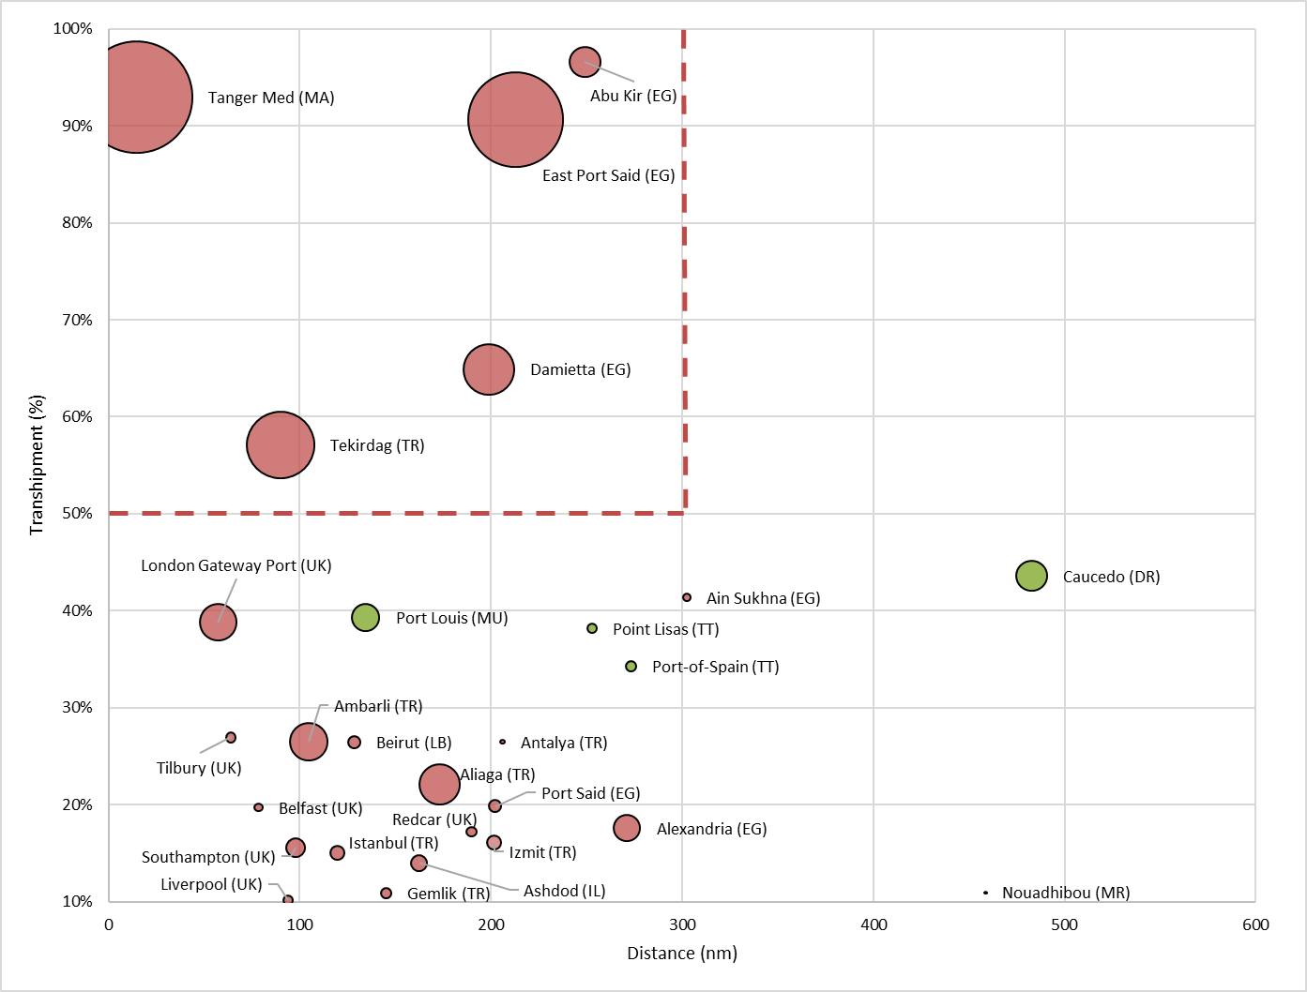
Note: Vertical axis shows transhipment incidence in %, while horizontal axis shows distance to closest EU port in nautical miles (nm). Size of the bubble shows annual transhipment traffic in TEUs. Bubbles in green represent the neighbouring ports identified based on the distance to closest EU outermost regions
Source: Commission’s analysis based on data from EconDB and port traffic statistics
    - RE2: Ensuring that offshore activities by ships operating in EU waters are covered, independently from their port of origin.
EU MRV and ETS elements may be amended to address the specific nature of offshore activities occurring in EU waters. Elements that may be looked at include, among others, the definition of ‘port of call’ or the definition of ‘voyage’. This measure would ensure that vessels providing offshore services (e.g. by virtue of a contract, permit or licence or a UN/LOCODE designator) in Member States’ territorial waters or Exclusive Economic Zones (EEZs) are subject to the EU ETS, independently from where they come from or where they go to after they conclude the activity. The implementation of this measure could rely on explicit permits or licences issued by Member States to precisely identify the geographical locations of the offshore activities, as in the case where a UN/LOCODE has not been formally designated for a site, and the duration of such activities. Other aspects that may need to be addressed include having clear criteria for identifying relevant offshore activities; having robust geolocation and activity data to ensure reporting accuracy and reliable verification of emissions; and making updates to Thetis-MRV to reflect the new definition and its implementation.

  - Assessment of policy measures
    - Economic impacts
2.3.1.1. Policy measure RE1
The two main economic impacts of the possible relocation of transhipment activities could be (i) lower port-related economic activities and (ii) higher import/export prices due to lower connectivity. First, if lower port traffic occurs due to the relocation of transhipment activities, it could translate into decreased gross value added and employment across port-related sectors, with broader spillover effects in the hinterland economy. Second, the relocation of transhipment activities from EU ports to non-EU ports could also have a negative impact on connectivity, because of the reduction in frequency of direct services by container ships at EU container transhipment ports. The reduction in the frequency of direct services might lead to an increase in transit time and container shipping costs, and, in turn, this can lead to higher import and export prices.
In case the relocation of transhipment activities from EU ports to non-EU ports occurs, it would likely have different economic impacts across Member States and regions. For instance, the impact on the economy might be more severe for regions and countries where port activity represents a significant share of GDP and employment. In Member States and regions whose economies are highly dependent on maritime transport services and where the number of ports is limited, the relocation of transhipment activities might have a more severe impact on connectivity and import/export prices than in Member States and regions with a greater number of ports.
Should RE1 effectively reduce transhipment relocation risks, it is also expected to limit the broader economic impact associated with the relocation of transhipment activities from EU ports to non-EU ports.
In relation to competitiveness impacts on EU container transhipment ports, RE1 should lead to the identification of additional “neighbouring container transhipment ports” under the ETS Directive. According to present data and assuming no major changes in ports’ activities, RE1 could lead to the identification of the port of Tekirdağ in Türkiye, which represents a yearly container transhipment volume of around 1.2 million TEU.
When considered together with the other “neighbouring container transhipment port, the scope of the current anti-evasion would cover more than 80% of the container transhipment activities taking place in non-EU Mediterranean countries.
RE1 could also help better address the risk of evasion linked to future transhipment hubs, such as the port of Cherchell in Algeria, the Port of Dakhla or Nador West Med in Morocco. By reducing the attractiveness of relocating transhipment activities to non-EU transhipment ports, RE1 should help maintain the market shares of EU container transhipment ports and contribute to preserve their competitiveness.
2.3.1.2. Policy measure RE2
Measure RE2 ensures that all ships involved in relevant offshore activities in Member States’ territorial waters or Exclusive Economic Zones (EEZs) are subject to emissions regulation, regardless of their flag or port of origin. This promotes more level playing field across the sector and it would help safeguard the competitiveness of EU offshore operators based in the EU. It should be noted that the EU offshore shipping fleet is a strategic asset for the European Union, being a category of vessels that includes specialised vessels working, among others, on offshore wind installation and maintenance, cable-laying and subsea construction. These vessels provide services underpinning the EU’s energy security and digital connectivity and are essential for the deployment of the EU’s offshore renewable capacity and telecommunications infrastructure. Maintaining a strong and competitive EU-based offshore fleet safeguards industrial know-how, high-skilled maritime jobs and strategic autonomy, while reducing dependence on non-EU operators for critical offshore services.
    - Environmental impacts
2.3.2.1. Policy measure RE1
RE1 would result, based on data at the time of preparing this impact assessment, in the inclusion of one additional port, the port of Tekirdağ in Türkiye in addition to the four other ports on the current list or not yet added.
Under the ETS Directive calls at ports identified as “neighbouring container transhipment ports” cannot be considered as the starting or ending point of a voyage. Including these additional ports would therefore alter the scope of EU ETS emissions. Compared to the current list of neighbouring container transhipment ports (East Port Said and Tanger Med), the ports of Abu Qir, Damietta and Tekirdağ have lower connectivity with EU ports and shorter voyages, so emissions added to the EU ETS scope by virtue of adding these three ports to the list would be relatively small (<0.3% of EU ETS maritime emissions). This suggests that, based on existing traffic, their inclusion would have a lower effect than the currently listed ports. The two ports already in the list of neighbouring container transhipment ports between them account for more than 90% of additional emissions relating to an expanded list of neighbouring container transhipment ports. Among other potential ports for future consideration, particularly if the threshold is lowered, London Gateway would contribute most to EU ETS emissions due to its strong connectivity with EU ports.
2.3.2.2. Policy measure RE2
By covering emissions from all ships involved in relevant offshore activities in Member States’ territorial waters or EEZs , the following changes in the scope of emissions under the EU ETS could occur:
- Case 1: for offshore vessels based in EU ports but performing offshore activities outside MS’ territorial waters or EEZ, there would be reduction in in-scope emissions;
- Case 2: for offshore vessels performing voyages between non-EU ports and offshore sites inside MS’ territorial waters or EEZs, there would be an increase in in-scope emissions.
The resulting change in covered ETS emissions would therefore depend on the frequency of each case and their weighting in terms of total emissions that would fall under those cases.
Analysis of offshore operators indicates that an absolute majority (77%) of calls by offshore ships at EU ports are operated by EU-registered companies; the share of offshore ships operated by EU companies and calling non-EU ports is also significant (42%). It may follow that the likelihood of the change in scope represented by case 1 is greater, and therefore a net reduction in emissions (from offshore activities) falling within EU ETS scope may occur.
    - Social impacts
Measures RE1 and RE2 should reduce potential negative social impacts from evasive behaviours.
In 2022, the port activities sector (including cargo and warehousing and port and water projects) directly employed 423 000 people, while the maritime transport sector (including freight and passenger transport and services for transport) employed 392 800 people. Ports are vital gateways for Europe, with 74% of goods entering or leaving Europe being transported by sea and around 395 million passengers each year. Similarly, ports facilitate the exchange of goods within the EU internal market and provide crucial links for islands and peripheral regions with the rest of mainland Europe.
The magnitude and distribution of port-related socio-economic impacts linked to the risk of evasion depend on structural and contextual factors. Even between EU transhipment ports, the social impact of transhipment relocation can vary widely. The negative social impact is likely to be more severe for regions whose economies are highly dependent on maritime transport services via transhipment ports, because they lack alternative gateway ports.
Offshore vessels provide critical, specialised services to other important sectors, including, for example, the EU offshore wind energy sector which in 2022 employed 17 300 people, a figure that is expected to continue growing. This in turn provides opportunities for highly skilled labour. Evasive behaviour in the offshore vessels sector that leads to competitive disadvantages for EU-based operators could have wider consequential socio-economic negative impacts, including loss of employment opportunities with a knock-on effect on communities reliant on offshore vessel operations. Complementary measures to RE2, such as incentives to invest in alternative fuels for offshore vessels could also be beneficial to prevent social impacts in the long term.

- Simplification and other measures to enhance robustness and effectiveness of the implementation system for maritime
  - Scoping
The co-existence of different regulatory frameworks to decarbonise shipping at EU and global level have introduced a set of parallel and sometimes overlapping requirements on shipping companies. At the EU level, the EU ETS system was extended to maritime transport activities starting in 2024 and, since 2025, a greenhouse gas intensity standard for energy used by ships was introduced through the FuelEU Maritime Regulation. The IMO introduced a system starting in 2019, mandating the monitoring and reporting of fuel consumption data, as a basis to support IMO decarbonisation measures.
The implementation of both the EU ETS maritime and of FuelEU Maritime is based on the underlying EU MRV system, established in 2015 to prepare for the EU ETS, upon which FuelEU Maritime has also introduced additional requirements in 2023. As a consequence, the MRV system required under ETS (i.e. MRV/ETS) and the one applicable under FuelEU currently share many similarities in design, processes and involved actors, but remain formally distinct and present some overlaps and divergences, thus causing operators the duplication of compliance actions and interactions with relevant authorities. Even tough synergies are currently possible, those are limited to data collection onboard the ship and only partially leveraged by shared functionalities in the IT reporting tool THETIS-MRV, acting as a “one-stop shop” for shipping companies.
- Current MRV/ETS/FuelEU compliance cycle, main steps
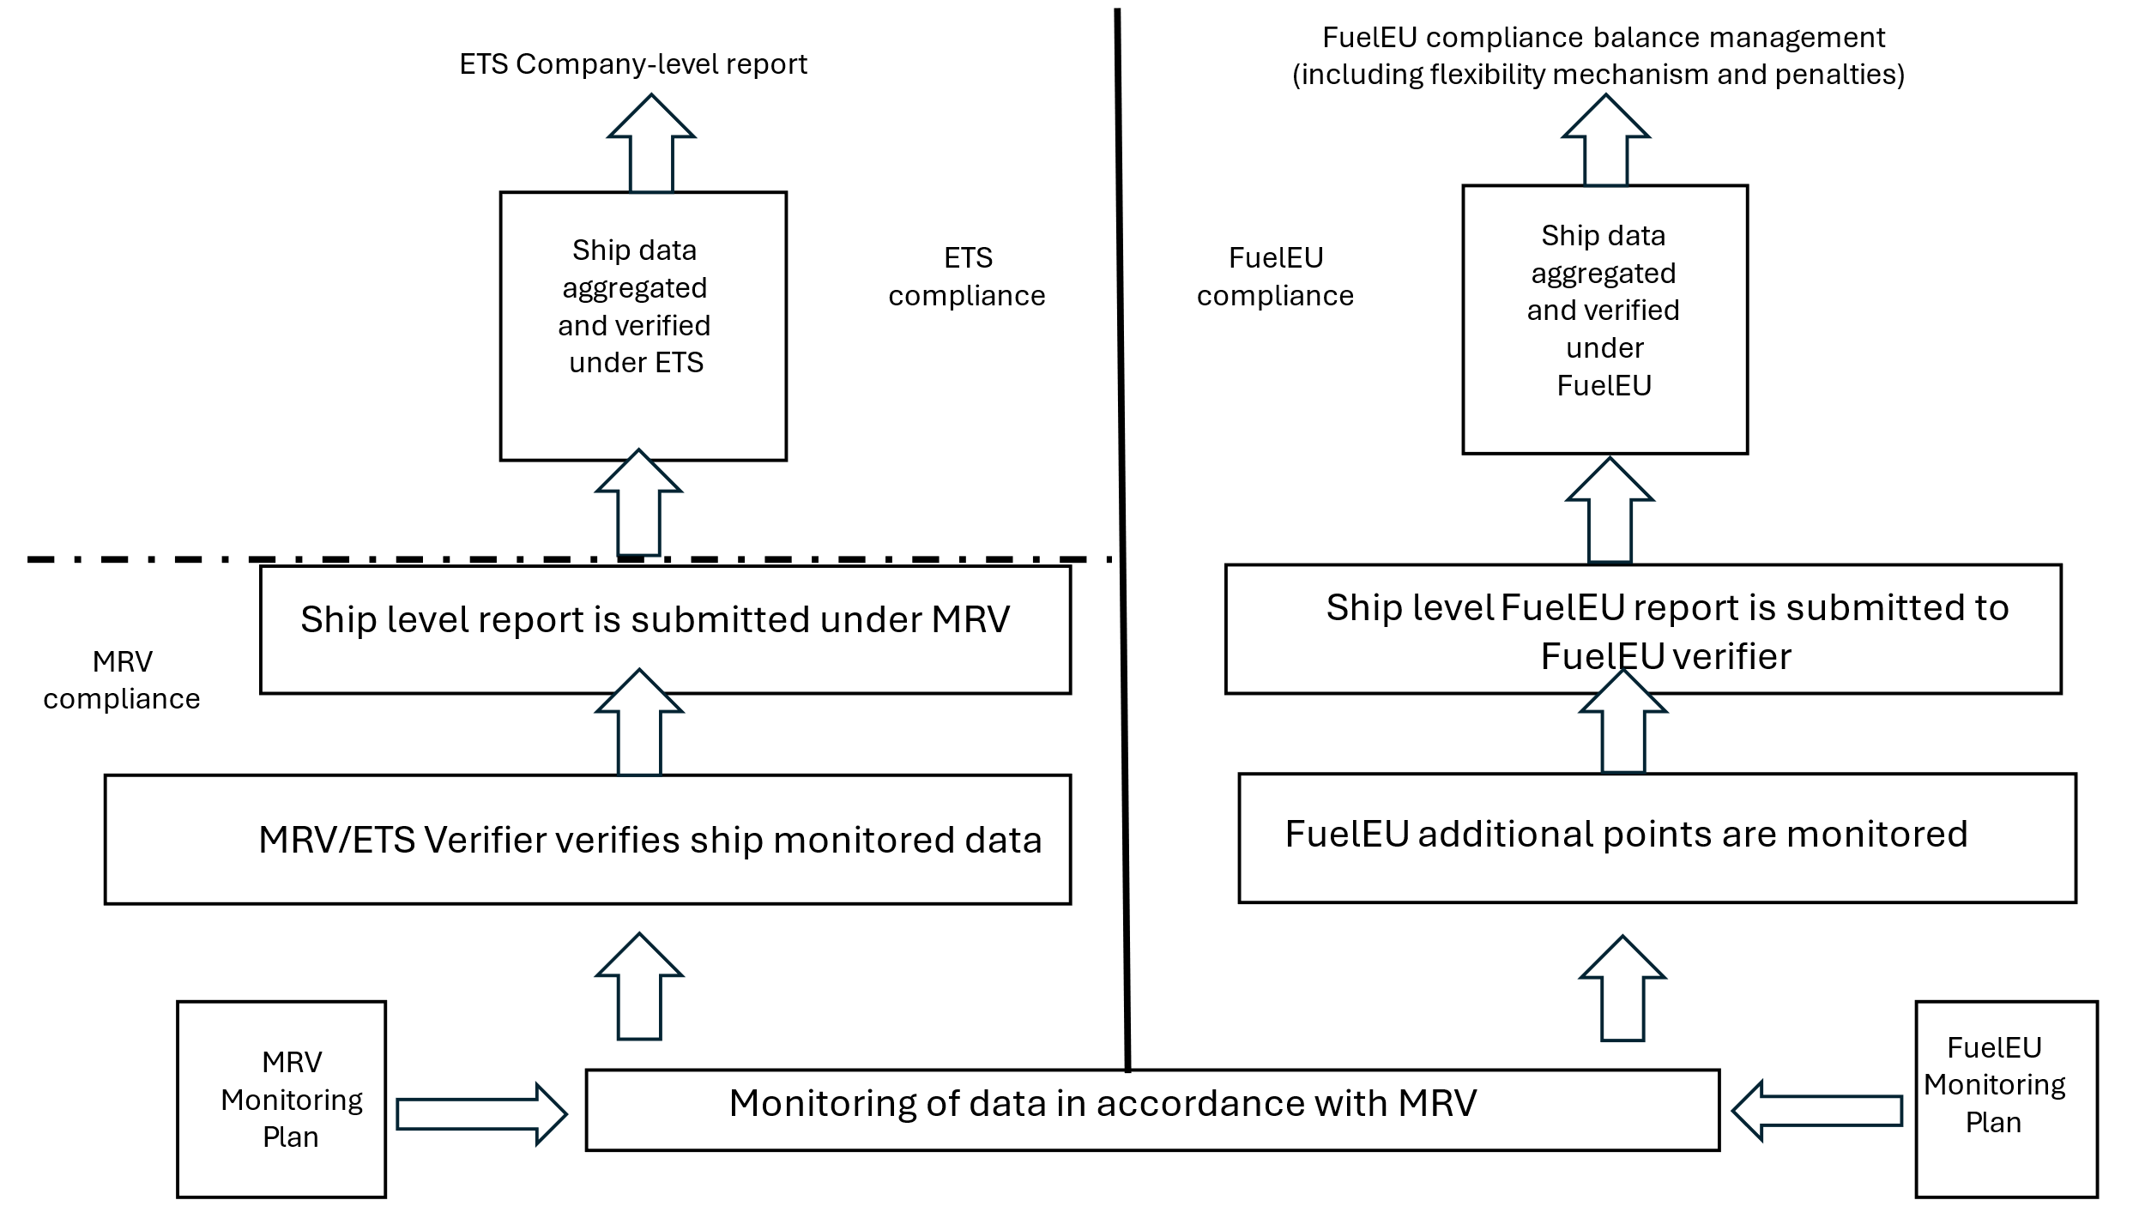
Source: Own illustration
The different approaches to the regulated entity between EU MRV/EU ETS and FuelEU Maritime may result into two different entities being responsible for the same ship under EU MRV/ETS and FuelEU.
The implementation of the EU ETS has also highlighted potential opportunities to increase the robustness and effectiveness of the implementation system, both in respect of the role of Administering Authorities in ensuring enforcement and of the compliance actions by shipping companies.
Summary of stakeholder views from the OPC
When asked whether the administrative costs linked to the implementation of the ETS extension to maritime transport are proportionate and reasonable, 16% (30 of 186) agreed with the statement, while 25% (47 of 186) disagreed. A further 10% (19 of 186) were neutral and 48% (90 of 186) did not know. When asked to suggest possible improvements or simplifications to streamline administrative costs, the most frequently cited view was that EU ETS rules should be aligned with IMO NZF and FuelEU Maritime to avoid double regulation (20 mentions). Closely related, stakeholders highlighted the need for standardising data collection methodologies and reporting templates across EU MRV and IMO DCS (17 mentions) and the establishment of a single EU-level digital system to simplify reporting and compliance (15 mentions). Several stakeholders stressed that clear and harmonised EU guidance is essential to reduce interpretation risks (10 mentions), while others called for simplified or tiered compliance frameworks for SMEs and small emitters (4 mentions), administrative requirements to be simplified by reducing paperwork and procedural burdens (4 mentions), and administrative fees and verification costs to be reduced and standardised across Member States (4 mentions).
When asked whether the ETS should further incentivise the uptake of renewable and low-carbon maritime fuels based on Well-to-Wake emissions, 44 respondents (23%) strongly agreed and 43 (23%) rather agreed. Nine respondents (5%) were neutral, 16 (8%) rather disagreed, 8 (4%) strongly disagreed, and 71 (37%) indicated “do not know.” Stakeholders emphasised that incentives must reflect full well-to-wake lifecycle emissions and exclude unsustainable biofuels (17 mentions). Several stakeholders also emphasised that renewable and low-carbon fuels need cost support to compete with conventional fuels (12 mentions) and that fuel incentives should remain technology-neutral to support multiple low-carbon options (11 mentions). An equal number of stakeholders highlighted the need for EU ETS rules to be aligned with FuelEU Maritime, RED III, and IMO frameworks to reduce overlap (11 mentions). Other frequently mentioned views included that ETS revenues should be reinvested to de-risk clean fuel deployment and infrastructure (8 mentions), sustainability certification should be standardised and centralised at the EU level (6 mentions), and reporting and compliance processes should be simplified, digitalised, and streamlined (4 mentions).
  - Policy measures
Policy measure EL1: simplification of the MRV/ETS regulatory framework for companies
This measure aims at upholding coherence across existing EU and IMO frameworks (MRV/ETS/FuelEU/IMO DCS) for shipping decarbonisation through reducing existing gaps, divergences, and duplications. As a consequence, shipping companies complying with those frameworks will be able to exploit synergies, minimise undue burden, and ultimately reduce administrative compliance costs. This measure is composed by the following elements:
- Redefine the compliance process for ETS and FuelEU, to be based on one single MRV system limited to data collection, verification, and reporting distinct from further requirements in respect of EU ETS and FuelEU obligations. To this end, the additional monitoring requirements introduced by the FuelEU Maritime Regulation should be brought under the MRV Regulation, so that companies monitor and report only once in respect of the same ship. These include the requirement to monitor the following parameters: the energy provided by on-shore power supply (OPS), the energy provided by Zero-emission technology (ZET), the installation of wind assisted propulsion (WASP), the applied well-to-tank emissions factors, the date, time and position when entering and leaving the ice conditions and the distance travelled when sailing in ice conditions, and the time spent at quayside and anchorage.
- Minimise existing discrepancies and misalignments on monitoring and reporting requirements between EU MRV/ETS and FuelEU. Main elements for consideration to this end should include the following elements:
- Comparison of selected monitoring and reporting requirements under EU MRV/ETS and FuelEU Maritime
Element | EU MRV/ETS | FuelEU
Per-voyage reporting | Possible through THETIS-MRV but not mandatory | Mandatory
Derogation to per-voyage monitoring (i.e. aggregate annual monitoring) | Possible for ships that only perform intra-EU voyages and undertake more than 300 voyages each year | Not possible. All ships shall monitor on a per-voyage basis
Definition of ‘port of call’ applicable to offshore ships | Offshore ships trigger a port of call when making stops to relieve crew, in addition to stops for loading/unloading cargo and embarking/disembarking passengers | Offshore ships trigger a port of call only when stopping in port for loading/unloading cargo and embarking/disembarking passengers
Timeline for reporting | Administering Authorities can anticipate the deadline of 31 March for reports submission to an earlier date, but not earlier than 28 February (Article 11(1) EU MRV). | Submission of the FuelEU report by the verifier in the FuelEU database by 31 March. It is not possible for the Administering State to set earlier deadlines
Deadline for companies to submit data to verifiers | Not foreseen. The responsibility to meet the reporting deadline for reports submission is only in respect of Administering Authorities, the European Commission, and the Flag State. | Companies shall submit data by 31 January to their verifier through the FuelEU draft report
Reporting requirements in case of change of company during the reporting period | Under MRV the previous company is required to submit a partial emissions report at ship level, covering the emissions under MRV and ETS scope occurred during the period under which the ship was under its responsibility. The company responsible at the end of the reporting period is required to submit an end of year report which shall include the emissions under MRV scope for the entire reporting period. Both companies are responsible for ETS compliance only in respect of the ship’s activities occurred over the period during which the ship was under their respective responsibility. | The previous company is required to submit a ship-specific FuelEU report, covering the energy used under FuelEU scope occurred during the period under which the ship was under its responsibility. Only the company responsible for the ship at the end of the reporting period is accountable for compliance in respect of the ship’s activities occurred during the entire year.
Deadline for Monitoring Plan submission for new companies | No later than three months after each ship’s first call in a port under scope (Article 6(7) of EU MRV). | No later than two months after each ship’s first call in a port under scope
- Further align, and possibly merge, the relevant MRV documents into one unique template (i.e. monitoring plans, emissions reports), so that companies can submit one unique document under the revised MRV compliance cycle common to ETS and FuelEU Maritime, thus maximising the implementation of the reporting-only-once principle.
- Establish one unique verification and accreditation framework for MRV, EU ETS and FuelEU under one single legal instrument.
- Alignment of some EU MRV and IMO DCS requirements insofar definitions and monitoring and reporting parameters (e.g. distance travelled, time spent at sea, split of consumption by consumer type) without compromising the policy objectives of the EU measures.
Policy measure EL2: enhance the robustness and effectiveness of the ETS maritime implementation and enforcement system
The ETS maritime implementation since the latest (2023) revision has highlighted opportunities to further support the role of Administering Authorities as enforcers of the system. Further clarifying the role of the Administering Authority in respect of implementing the MRV system, including with respect to those shipping companies which are only active under MRV scope but not under the ETS/FuelEU scope, and establishing an ex officio automatic attribution for non-compliant companies would represent key elements to support Member States role in the system.
As far as shipping companies are concerned, a mechanism to give to those entities responsible for fewer emissions the possibility to form a pool to comply with their ETS obligations could reduce the related administrative compliance cost. Further administrative costs reduction could originate from derogating small ships (400-5000 gross tonnage) from the obligation to monitor their emission on a per-voyage basis if they solely perform intra-EU activities over a given reporting period, regardless of the number of journeys per year and independently from pre-established schedule.
Policy measure EL3: The regulated entity in EU MRV and EU ETS is either the shipowner or the ISM Company (distinct from the shipowner)
Under EL3, the current approach to the regulated entity in EU MRV and EU ETS is maintained.
The current definition of ‘shipping company’ in the EU ETS Directive and EU MRV Regulation remains unchanged and provides for flexibility as regards the entity responsible for compliance with the EU ETS and EU MRV requirements in respect of the GHG emissions of a ship. The regulated entity is either (i) the shipowner or (ii) the company that is distinct from the shipowner and that is responsible for compliance with the International Management Code for the Safe Operation of Ships and for Pollution Prevention (the ‘ISM Code’). The entity responsible for compliance with the ISM Code is hereinafter referred to as the ‘ISM Company’.
Under EL3, an alignment of the regulated entity in EU MRV, EU ETS and FuelEU Maritime would require a change in the definition of ‘company’ in FuelEU Maritime. The definition of ‘company’ in the FuelEU Maritime Regulation should be amended (i) to refer to the definition of ‘shipping company’ under the EU ETS Directive and (ii) to clarify that the entity responsible for compliance under FuelEU Maritime must be the same as the one responsible for compliance under EU ETS and EU MRV.
The non-legally binding FAQs on FuelEU Maritime would also need to be amended, because the FAQs explain that the ISM Company distinct from the shipowner is the entity responsible for compliance with FuelEU Maritime.
Such alignment of the regulated entity in EU MRV, EU ETS and FuelEU Maritime under EL3 means that the same Member State is responsible for the enforcement of EU MRV, EU ETS and FuelEU Maritime in respect of the emissions of a given ship, which would create synergies with the simplification elements under EL1.
Other policy measures: the challenge of using a well-to-wake approach in the ETS
Maritime emissions reported under the EU ETS scope are those occurring on-board ships, also called downstream emissions (Tank-to-Wake, TTW). Up-stream emissions from marine fuels are hence not considered under the EU ETS, except if these fuels are produced in Europe, through an installation falling under the ETS scope, such as a refinery. This situation may create wrong incentives for shipping companies, encouraging the use of marine fuels with low downstream emissions but potentially high up-stream emissions (e.g. grey ammonia).
In the current EU policy framework, this risk is mitigated by the interplay between the EU ETS and other policies. Notably, GHG Fuel intensity obligations stemming from the FuelEU Maritime Regulation are based on lifecycle accounting, comprising both upstream and downstream emissions. The interaction between the Renewable Energy Directive and the EU ETS also helps address this concern, since RED requires that fuels meet specific lifecycle GHG emissions to be qualified as renewable fuels. For instance, the zero-rating of sustainable biofuels and other renewable fuels under the ETS can only happen if these fuels comply with the sustainability and life-cycle GHG savings criteria established by the RED. Furthermore, a possible ETS support system could take the life-cycle emissions into due account.
While in theory the ETS scope could be extended to cover up-stream emissions, such a change would be very difficult to implement in practice. It would for instance lead to a risk of double counting (i.e. in relation to the upstream emissions already covered under the ETS such as in refineries or ammonia plants). It would also require additional monitoring, reporting and verification rules, and create some unclarities in terms of responsibility. Furthermore, covering upstream emissions only for maritime, would also create incoherence with the rest of the sectors covered by the EU ETS. For these reasons, the possible extension of the ETS scope to up-stream emissions is not further considered in the following sections.
  - Assessment of policy measures
    - Economic impacts
The simplification elements of policy measure EL1 are expected to positively impact the administrative costs for the different stakeholders involved in the MRV/ETS cycle, with shipping companies being the main beneficiaries of the resulting costs reductions.
The evaluation of the MRV Maritime system collected relevant and updated inputs from stakeholders, building on targeted questions on MRV cost components for operators. The evaluation estimated total annual MRV compliance cost for shipping companies to be around EUR 47 million, with a median value per vessel at 3 150 euro. Respondents stressed that the costs incurred are to a considerable extent shared with those to comply with overlapping regulatory frameworks, indicating that synergies are very high in respect of FuelEU duties and costs (above 70%) and high in respect of IMO DCS ones (above 50%). This confirms the room for potential further, yet limited, synergies across systems, provided that the same regulated entity is responsible in respect of a given ship, mostly in regard to data collection and data aggregation (50% and more) and, to a smaller extent, for monitoring plan preparation, exchanges with verifiers, and use of IT systems.
Most of the elements covered under policy measure EL1 are expected to positively impact the different main cost drivers of the MRV compliance process, but the quantification of the relative contribution from each element remains particularly challenging. Still, on the basis of the ranking provided by stakeholders on the (six) different cost drivers’ contribution to total MRV compliance costs, refered to above, and of their linkage to the different elements under policy measure EL1, a conservative estimate of cost reduction indicates that the full implementation of the elements under EL1 could lead to savings for recurrent MRV compliance costs incurred by companies between 10% and 20% compared to the current situation, as described in the following table:
- Potential cost reduction by cost driver
MRV cost driver | Total annual MRV admin cost reductions [EUR million] |  | Per vessel [EUR]
 | Lower bound | Upper bound | Lower bound | Upper bound
Staff time (including dedicated training) | -0.9 | -1.8 | -62 | -124
Data collection and management (onboard and company systems) | -0.8 | -1.7 | -56 | -111
Verification fees | -0.8 | -1.6 | -54 | -108
IT systems / digital tools for MRV reporting (excluding THETIS MRV) | -0.8 | -1.6 | -53 | -106
Preparation and revision of monitoring plans | -0.7 | -1.4 | -47 | -94
Administrative coordination/ interactions with Member State authorities in charge of MRV/ETS implementation | -0.7 | -1.3 | -44 | -88
Total | -4.7 | -9.4 | -315 | -630
Source: own analysis based on literature review and inputs collected during the evaluation of the MRV maritime system as described above. Cost drivers are listed in order of importance, on the basis of average ranking by respondents.
Relevant cost reductions are further expected to also positively affect the administrative compliance costs incurred under FuelEU Maritime, as those have a significant MRV-related component which will be impacted by policy measure EL1.
Policy measure EL2 is expected to drive administrative costs reduction for Administering Authorities (AA), due to efficiency gains resulting from the clearer identification of the roles and responsibilities of the AA under the MRV cycle and the association of the same shipping company to a given AA under both MRV/ETS and FuelEU, thus reducing potential divergences. A positive economic (and environmental impact) is also expected from an increase in the overall compliance rate (i.e. reduction of non-compliant shipping companies) due to the faster and clearer attribution of non-compliant companies.
Policy measure EL2 further bears potential for MRV administrative costs reduction for certain operators, in so far it could give to certain small ships the possibility to monitor and report on an annual aggregated basis, thus derogating from the general obligation to monitor relevant parameters for each voyages. In 2023, approximately a third (32%, i.e. 2 100 ships) of the small ships fleet sailed only intra-EU (Ricardo, 2025). The vast majority of these smaller vessels wouldn’t be able to benefit from the present exemption rule, as they perform less than 300 voyages per year. Vessel categories with the highest share and absolute number of intra-EU voyages, such as RoPax, tug and dredgers, and passenger vessels are expected to benefit the most from such a simplification measure. A simplified data collection and management system could reduce by half the average relevant compliance cost component for operators.
A pooling mechanism to provide additional flexibility in the compliance process, as envisaged under EL 2, could further reduce the costs for those shipping companies responsible for fewer emissions. Depending on the exact design of the pooling mechanism, it could decrease the ETS compliance costs related to registry elements, for instance by centralising those through a trustee acting for multiple small emitters, or positively impact other drivers of administrative costs for companies (e.g. in terms of staff cost) by delegating data and reporting compilation to a centralised third party. Responses to the light MRV evaluation show indeed that currently larger fleets achieve lower per-vessel cost via shared systems and staff, while SMEs bear a higher cost proportional to their fleet size.
An assessment from the previous impact assessment by Pons et al. (2021) identified that a pooling mechanism might potentially lower the administrative effort by companies in the pool. However, a pooling system applied only to the ETS compliance phase would not significantly impact the MRV compliance cost, which represents the main component for small emitters overall ETS participation costs, in particular when participants were already active under the MRV and ETS scope before the introduction of the pooling mechanism and therefore have already incurred into one-off costs to comply. In addition to this, even the application of a pooling mechanism to MRV compliance would only bring limited MRV cost reduction to companies, as many of those are already relying on third-party services for compliance.
The economic impacts of EL3 are mostly expected to relate to the regulatory costs for regulated entities and public authorities of Member States. With EL3, no increase or decrease in the current EU MRV and EU ETS administrative costs is expected for regulated entities and for public authorities of Member States that are responsible for the enforcement of the EU MRV and EU ETS.
As regards the overall administrative costs for regulated entities under EU MRV, EU ETS and FuelEU Maritime, EL3 is expected to contribute to a reduction in these administrative costs thanks to the synergies produced and the consequent reduction in work hours need to complete the different steps of the compliance cycle, especially when combined with EL1 and EL2.
As regards the overall costs for public authorities in respect of the combined enforcement of EU MRV, EU ETS and FuelEU Maritime, EL3 is expected to contribute to a reduction in these costs. Under the current situation, one Member State might be responsible for enforcing the EU MRV and EU ETS requirements in respect of one shipping company, while another Member State might be responsible for enforcing the FuelEU requirements in respect of the same shipping company, thus leading to some duplications. EL3 would remove such duplications and lead to a decrease in the overall regulatory costs.
    - Environmental impacts
Policy measures EL1, EL2 and EL3 do not change the scope of GHG emissions covered by the EU MRV and EU ETS.
Yet, EL1, EL2 and EL3 are expected to enhance the robustness and effectiveness of the EU MRV and EU ETS. Compared to the current situation, some positive environmental impacts could derive from the increase of the compliance rates deriving from a more efficient enforcement system by administering authorities (e.g. through ex officio attribution of companies active under scope) and from the additional flexibilities provided to companies, in particular small emitters.
    - Social impacts
No significant impact on employment can be expected because of the implementation of policy measures EL1, EL2 and EL3.
- Maritime derogations
  - Scoping
The EU ETS Directive provides for some derogations concerning the surrendering obligation of allowances until the end of 2030. These include:
- A temporary derogation for Ice-Class Ships (ICS, Article 12(3-e)), which may surrender 5% fewer allowances than their verified emissions, provided that ships have the ice class IA or IA Super or an equivalent ice class, established based on HELCOM Recommendation 25/7;
- A temporary derogation for voyages between a port of a Member State and its Outermost Region port (OMR, Article 12(3-b));
- The possibility for a Member State to request a temporary derogation for:
  - Voyages for passenger transport between a Member State with no land connection and other closest Member State in the context of a transnational Public Service Contract/Obligation (PSC/O, Article 12(3c));
  - Voyages for passenger transport between (small) island ports of a Member State with no road or rail link with the mainland and with less than 200,000 permanent residents (SIP, Article 12(3-d)).
The reasoning behind the different treatment of ice-class ships is that such ships, due to their design, require more fuel to cover the same distance when compared to non-ice class ships. As a consequence of their design, they tend to consume more fuel than comparable non-ice-class vessels in ice-free waters. This results in proportionally higher emissions that are not due to inefficiency but to essential safety and design requirements. A GHG emissions increase of around 5% is generally assumed in comparison to purely open water designs. In addition, when operating in ice-conditions, analysis shows that fuel consumption and emissions per distance travelled may be up to 60% higher during periods of ice conditions compared to open water, depending on factors such as ice thickness, ice concentration, the availability of icebreaker support, and the proportion of the voyage taking place in ice-covered waters.
However, recent analysis shows that these impacts can vary between different vessel types. A multivariable regression analysis covering seven vessel types and using EU MRV maritime data over the period 2018–2022 showed that ice classification does not systematically correspond to higher annual mean fuel consumption across all categories. More specifically, according to this analysis, ice class has a statistically significant negative effect on fuel consumption for bulk carriers, chemical tankers, and RoPax vessels, a significant positive effect for general cargo ships and ro-ro vessels, and no clear or consistent effect for container ships and oil tankers.
The derogations for certain voyages stem from the particular circumstances of the routes/regions (remoteness, connectivity issues). For example, outermost regions and islands depend heavily on maritime transport for territorial continuity, economic activity, access to essential products and social and regional cohesion.
The derogations are of a time-limited nature, allowing operators in affected routes and regions sufficient time to adapt to the requirements of the system and invest in low and zero-emission technologies suitable for their specific operating conditions. This transition can already be supported by ETS revenues. For instance, Greece is leveraging specific ETS revenues to support the decarbonisation of islands through the Islands Decarbonisation Fund (IDF), which should finance a range of energy transition projects including cold ironing infrastructures in island ports, for a direct reduction of maritime emissions in the Greek islands. The temporary nature of these derogations is important as permanent derogations would reduce the ETS’s environmental coverage and integrity, distort competition and operational efficiency.
The electrification of ferry routes serving small islands is increasingly recognised as a feasible and strategically important opportunity for decarbonising regional maritime transport because these routes are typically short and operate on predictable schedules, making them well suited for electrification, which has already reached a high level of technological maturity. Coupled with falling technology costs and the gradual expansion of onshore charging infrastructure, carbon pricing would create a clear business case for investment in electric ferries on selected island connections. Electrification could reduce emissions, stabilise operating costs, improve service reliability, and support local maritime industries, thereby contributing to the long-term economic resilience and connectivity of island communities. A timely and well-coordinated transition towards these low-carbon solutions is therefore essential to secure the multiple benefits of cleaner, more reliable, and cost-effective ferry services.
As a basis for assessing the impact of the measures, it is important to understand the current volume of the derogations. Thetis-MRV data on verified GHG emissions covered under the EU ETS and the number of derogations in 2024 have been used in terms of different criteria.
According to the table below, in 2024, all derogations together amounted to 4.86 Mt CO2. This corresponds to around 5% of the verified emissions for maritime transport under the EU ETS in 2024 (90 Mt CO2). Half of the derogations were due to traffic linked to outermost regions (50.8%) and more than one third was linked to the small islands derogation (37.2%). Derogations related to ice-class ships amounted to 11,6%, while derogations for PSC/O were negligible. Considering the average price of EU allowances in 2024 (EUR 65 per allowance in 2025) and the application of the phase-in approach (surrendering obligation for 40% of the verified emissions in 2024), it can be estimated that these derogations lead to a cost exemption of around EUR 126 million in 2024 for shipping companies, EUR 64 million due to OMR and EUR 47 million to SIP. Once shipping companies have to surrender allowances for 100% of the verified emissions, the revenues forgone will amount to approximately EUR 320 million, approximately EUR (165 million due to OMR and some EUR 120 million due to SIP).
- Derogations in 2024 by ship type
Ship type [kt CO₂] | OMR | SIP | ICS | PSC/O | Total | Share
Ro-pax ship | 737 | 1,795 | 95 | 16 | 2,643 | 54.4%
Container ship | 1,001 |  | 119 |  | 1,120 | 23.1%
Passenger ship | 220 | 13 | 5 |  | 239 | 4.9%
Ro-ro ship | 131 |  | 67 |  | 198 | 4.1%
Oil tanker | 81 |  | 50 |  | 131 | 2.7%
Chemical tanker | 72 |  | 57 |  | 129 | 2.7%
General cargo ship | 20 |  | 76 |  | 96 | 2.0%
Other ship types | 45 |  | 24 |  | 69 | 1.4%
Container/ro-ro cargo ship | 46 |  | 13 |  | 60 | 1.2%
Refrigerated cargo carrier | 58 |  | 1 |  | 59 | 1.2%
LNG carrier | 1 |  | 42 |  | 43 | 0.9%
Vehicle carrier | 25 |  | 5 |  | 31 | 0.6%
Bulk carrier | 19 |  | 0 |  | 19 | 0.4%
Cruise Passenger ship | 11 |  | 5 |  | 16 | 0.3%
Gas carrier | 0 |  | 3 |  | 4 | 0.1%
Combination carrier |  |  | 0 |  | 0 | 0.0%
Offshore
Total | 2,469 | 1,808 | 563 | 16 | 4,856 | 100%
Share | 50.8% | 37.2% | 11.6% | 0.3% | 100.0%
Source: EMSA, Oeko’s calculations
In terms of ship types, Ro-pax ships (54%) and container ships (23%) profited the most from the derogations. For all other ship types the share of total derogations was below 5% and for most types even much smaller.
In terms of ship size, more than half of the derogations went to medium sized ships (from 5 000 to 24 999 GT), while large sized ships received one third of the derogations. Very large ships (> 75 000 GT) only received 11.5% of total derogations. The number of ships that benefitted from existing derogations is also unevenly distributed among the size categories with 71% of the ships which received derogations being medium sized, 21% being large and 8% for the very large ships.
While the OMR derogation accounted for half of the total derogations in terms of tCO2, only around 30% of the ships who received derogations, received them due to OMR. Conversely, derogations for ICS were much lower in terms of emissions (12% of the total derogation) but more than two thirds of the ships which received derogations, received them due to their ICS status.
Summary of stakeholder views from the OPC
Through the position papers as part of the OPC, 14 stakeholders (out of which 8 were from maritime industry/associations, the rest from NGOs and public authorities) supported extending derogations for routes serving outermost regions, islands, and peripheral territories. Nine stakeholders (out of which 6 were from maritime industry/associations) recommended targeted exemptions for specific vessel types, including Ro-Pax, Ro-Ro, ferries, and vessels under public service contracts, alongside compensatory mechanisms where needed.
  - Policy measures
Policy measure DE0: Not extending the derogations:
All present temporary derogations related to ice-class ships, outermost regions, small islands and PSC/PSO stop as from 2031.
Policy measure DE1: Extension of derogations for a limited time: Extension of existing derogations for a limited time (e.g. until 2035) within the ETS.
  - Assessment of the measures
    - Environmental impacts
      - Policy measure DE0: Not extending the derogations
Pursuant to the ETS directive, the derogations would end in 2030. Accordingly, additional 4.86 Mt CO2 would then be covered by the ETS surrendering obligation from 2031 onwards, leading to an increase demand for EU allowances, without an increase of the cap. 2.5 Mt CO2 would be due to the inclusion of exempted OMR emissions, while 1.8 and 0.6 Mt CO2, respectively would be due to SIP and ICS emissions. The emissions due to PSC/O would be very small (0.02 Mt CO2).
The end of the derogations for ice-class ships would also lead to less allowances being cancelled every year (around 0.5 Mt CO2) per year, counterbalancing somehow the possible positive environmental impact linked to the end of the derogation for ice-class ships.
The end of the derogations would in general reinforce the contribution of the maritime transport sector to EU’s climate targets. By exposing operators serving small islands, PSOs, or outermost regions to the ETS carbon price signal, it would encourage greater energy efficiency through operational measures (speed optimisation, route planning, hull maintenance), the use of renewable and low-carbon fuels, electrification or it could accelerate the renewal of older, less efficient vessels.
      - Policy measure DE1: Extension of derogations for limited time
The impact of extending the existing derogations (OMR, SIP, ICS, PSC/O) until 2035 would lead to around 24 MtCO2 being exempted from the obligation to surrender EU allowances over the period 2031-2035. At the same time, it would lead to the cancellation of around 2,8 MtCO2 allowances over the same period, as a result of the application of the cancellation mechanism for the ice-class ships derogation.
Over time, the volume of exempted maritime emissions would increase in relative importance, representing a growing share of the ETS cap increase linked to the ETS maritime extension.
From an environmental point of view, the extension of the present derogations could slow down the green transition of shipping on certain routes and hinder the achievement of the EU 2050 climate objectives. Shipping companies would continue facing no financial incentive to improve energy efficiency or adopt low-carbon solutions.
    - Economic impacts
These policy measures could have different economic impacts. They could change the compliance and operating costs for individual companies, and they could affect the revenues from the auctioning of EUAs.
      - Policy measure DE0: Not extending the derogations
Not extending the derogations beyond 2030 would increase the cost for shipping companies as it would increase their surrendering obligations by around 5 million EUAs. The impact on shipping companies would vary with factors such as route coverage, carbon price, distance, ship type, and fuel efficiency, but all operators currently benefiting from derogations would face higher ETS compliance costs once this end. Given these additional burdens, DE0 would likely result in slight increase transport prices for the end consumers, especially affecting small islands and outermost regions that rely heavily on maritime links. In addition, the higher compliance burden may have a detrimental effect on the viability of services on niche routes, in case companies face challenges to reduce their emissions and cannot pass through the costs.
Ending derogations would generate limited extra ETS revenues, linked to the end of the cancellation mechanism for the ice-class ships derogation. Member States could mitigate some of the economic impacts induced by the end of derogation by allocating part of their ETS revenues specifically to support the decarbonisation of maritime links serving islands and outermost regions. This targeted reinvestment could reduce cost impacts, improve the resilience of local economies and ensure that the transition contributes directly to cleaner, more efficient transport in these regions.
The competent authorities face modest additional administrative burdens, primarily related to verifying compliance through allowance surrender and enforcement activities. This is because MRV for maritime emissions is already required due to the MRV regulation.
      - Policy measure DE1: Extension of derogations for limited time
Policy measure DE1, as the opposite of DE0, would generate identical economic effects but in reverse, and no increase in ETS revenues. For ice-class ships, extending derogations would help preserve affordability on icy northern routes and contribute to limit public icebreaking costs, which in Finland alone amount to EUR 35–60 million annually. It would also allow operators serving small islands and outermost regions to continue avoiding ETS compliance costs, supporting route viability and giving more time to deploy OPS, bunkering infrastructure, and energy-efficient vessels. DE1 would further help contain short-term inflation in island economies and support regional cohesion.
However, under DE1 shipping companies would lack financial incentives to cut GHG emissions until 2035, making efficiency improvements, the use of low-carbon fuels, and electrification less attractive. This may lock operators into fossil-fuel-based fleets and delay clean-energy port investments. Overall, prolonged derogations risk slowing climate action and increasing long-term decarbonisation costs in the affected regions.
    - Social Impacts
      - Policy measure DE0: Not extending the derogations
Outermost regions and small islands depend on reliable and frequent maritime transport services. Changes in transport cost may hamper the connectivity of these regions and thus impact the access to essential services such as healthcare, education and employment, inducing implications for the quality of life or impact tourism flows.
At the same time, fuel prices have already fluctuated significantly in the past and the carbon price signal could have an effect comparable to the cost impact of fuel-price volatility. Based on data from the IEA on bunker fuel prices the standard deviation in the period October 2020 to September 2025 was 35%. Even before the COVID pandemic (January 2014 to December 2019) the standard deviation was 28%. Given a fuel price of EUR 500 per tonne of fuel, this is equivalent to EUR 175/140 per tonne of fuel or an allowance price of approximately EUR 56/45 per EUA. Even though the current allowance price is higher than the standard deviation of fuel prices, the difference between the lowest and highest fuel prices is higher than then current EUA price of approximately EUR 70-80 per EUA. Still, removing derogations would mean that sudden increases in fuel or carbon prices could pose a risk to stable, predictable maritime connectivity for these EU regions.
For the connectivity of small islands and outermost regions, this cost increase could undermine the affordability and frequency of maritime links. These regions already face challenges due to remoteness and limited transport options, and higher shipping costs might discourage both passenger and cargo operators from serving them regularly or at competitive rates. EU’s outermost regions are more vulnerable due to significantly longer voyage legs than other intra-EU journeys and, on average, have lower GDP per capita compared to their national and wider EU averages. Increased cost for essential transport services could thus contribute to widen the GDP gap.
Since ensuring connections is essential for small islands and outermost regions, some of the transport services are conducted under public service obligations (PSO). Under these obligations contracted shipping companies have to provide a determined transport service (frequency, capacity, etc.) at a fixed price. Since the price is lower than the cost of supplying these services, the price gap is closed through public funding pursuant to Council Regulation (EEC) No 3577/92. Nevertheless, services covered by PSO may not be directly impacted but only in the longer-term if governments might have to reduce the capacity under PSO due to limited budgets.
Shipping is essential for connecting geographically isolated regions, such as islands and remote coastal communities, to their mainland and other major hubs. When it occurs, mobility poverty can perpetuate the core-periphery socioeconomic structure of these regions, leading to a lack of attractiveness, coupled with a poor organisation of transport services and thus, barriers to accessing education and jobs (Maucorps, et al., 2025). Hence, to the extent that additional cost due to the end of derogation pose a risk that service providers might reduce the frequency of their operations or increase prices for passengers and cargo – even in the context of PSOs-, this could possibly have indirect negative impacts on healthcare, education and jobs. It could also increase the pressure to migrate for work or education.
Furthermore, ice class ships are of pivotal importance in facilitating year-round maritime connectivity and supply for regions with ports that experience sea ice or adverse winter conditions. Not continuing ICS derogations could be detrimental for critical logistics and regular services when ice conditions would otherwise prevent conventional vessels from reaching these locations. However, in a recent study it was concluded that not all of the assessed ICS ship types have higher annual mean fuel consumption and thus emissions (see above).
While the supply of goods and certain services relies on maritime transport, tourism often relies more on aviation. However, maritime tourism, especially cruise, could also possibly face route changes in order to avoid ETS costs, which may negatively impact specific ports and regional communities. (In addition, ending derogations would expose ships such as Ro-pax, passenger and Ro-ro ships, “which have high average per-vessel emissions within the scope” . Tourism demand is highly price-sensitive in aviation and moderate in maritime tourism, but the risk of competitive disadvantage is notable for both if cost differentials between EU and non-EU destinations grow. For instance, stakeholders foresee “an additional cost of close to EUR 30 000 for each port of call for large liners in the Caribbean Sea”, which “will reduce the competitiveness of the outermost regions’ cruise and container ship sectors compared to neighbouring territories that do not apply such requirements”. Martinique, for example, “is an expensive place in comparison to neighbouring islands (e.g. Sainte-Lucia, Barbados) that use weaker currencies and apply lower taxes,” leading to reduced attractiveness (Maucorps, et al., 2025).
      - Policy measure DE1: Extension of derogations for limited time
If the derogations and specific rules were to continue beyond 2030, the social impacts described in the previous section would not apply. Stakeholders who currently benefit from exemptions would continue to do so, meaning that the situation in the affected regions would remain largely unchanged in terms of traffic patterns, income, connectivity, and related aspects.
- Coherence with the implementation of the global IMO measure
  - Scoping
To address GHG emissions from international maritime activities globally, the EU has actively supported the adoption of the revised IMO 2023 Strategy as well as of IMO mid-term measures, in particular the Net Zero Framework (NZF). At the Marine Environment Protection Committee (MEPC) 83rd meeting in April 2025, the International Maritime Organization (IMO) reached an agreement on the core elements of its Net-Zero Framework .
In October 2025, the IMO's Marine Environment Protection Committee decided to adjourn discussions on the adoption of the Net-Zero Framework for one year. Whether the IMO NZF is adopted (in its entirety or partially) remains open.
This Impact Assessment acknowledges that the IMO NZF is currently the only agreed IMO mid-term measure, and that no environmentally more ambitious measures are being considered at IMO. A review of the ETS Directive in relation to an IMO mid-term measure is required by Article 3gg, with certain conditions.
This section aims to assess possible measures that would ensure coherence between the implementation of the ETS and the implementation of an IMO mid-term measure, in a way that preserves the effectiveness and environmental integrity of the EU ETS, while maximising their regulatory efficiency (e.g. avoiding any significant double burden).
Drivers to the problem
Several differences between the ETS Maritime and an IMO mid-term measure could lead to possible lack of coherence:
- System type: The EU framework combines a cap-and-trade Emissions Trading System with a GHG fuel intensity regulation (FuelEU). The EU ETS provides high certainty of emissions reduction since the ETS cap sets the overall volume of greenhouse gases that can be emitted by installations and operators under the system. However, the emissions reduction under the ETS will happen first in sectors where they are most cost-effective and this is why the EU ETS is combined with a GHG fuel intensity regulation at EU level to support the decarbonisation of shipping. Although no measure is yet adopted at IMO, it is unlikely that a future global measure will include a cap-and–trade system. The measures contemplated so far (such as the NZF) represented a combination of a fuel standard with an economic element.
- GHG price formation and scope: Under the EU ETS, every tonne of CO₂e emitted must be matched with an allowance. Additionally, the price formation in the EU ETS is market-driven and expressed in EUR. The measures considered so far by IMO, involved fixed GHG prices expressed in USD.
- Enforcement: Under MARPOL Annex VI, the primary responsibility for implementation and enforcement lies with the Administration of the flag States which ratified and implemented the amendments. Unlike the EU MRV system, the IMO framework sets only basic roles for the IMO Registry and the flag states but does not (yet) provide detailed rules for independent third-party verification. Specific guidelines on reporting and verification of the annual GFI of fuels used by ships are still under development at IMO level.
- Scope:
- The IMO 2023 Strategy considers a well-to-tank (WTW) scope for GHG emissions (carbon dioxide emissions (CO₂), methane emissions (CH₄) as well as nitrous oxide (N₂O) emissions), while the EU ETS considers a tank-to-wake (TTW) scope, with a zero-rating mechanism acting as an incentive to GHG savings resulting from bio-sourced and other types of alternative fuels that are certified compliant with the sustainability requirements of the Renewable Energy Directive (Directive 2018/2001).

- In terms of geographical scope, the IMO measures apply to 100% of fuel consumed over the calendar year, irrespective of the geographical location of port calls whereas EU ETS applies to 100% of GHG emissions that occur between two EU ports and when ships are within EU ports, but 50% of emissions from voyages starting or ending outside of the EU.
- Timing: while the EU ETS applies to maritime transport emissions since January 2024, the current review of the EU ETS is going to set the cap until 2040 along with the Climate Law targets. An IMO measure would not apply (and is implemented) before 2029. Once adopted, an IMO measure will only enter into force, if at least one third of the IMO Member States or Member States, which combined merchant fleets constitutes not less than 50 per cent of the gross tonnage of the world's merchant fleet, does not notify objections to the IMO within 10 months from adoption.
- Levels of GHG emissions reductions: The EU has legally committed to reducing economy-wide GHG emissions by at least 55% by 2030, and a 90% reduction (with a domestic target of 85% and up to 5% of international carbon credits) has been agreed for 2040, both relative to 1990 levels. Although there is no formal sectoral target for maritime transport, the sector has been included in the EU ETS, which is expected to achieve a 62% emissions reduction by 2030 compared to 2005 levels, consistent with the broader economy-wide trajectory.
- Level of participation: Participation to any IMO mid-term measure implementing the 2023 Strategy, generally, will depend on whether a vessel's flag State has ratified MARPOL convention and specifically Annex VI. Ships registered in the 88 states that have not ratified MARPOL Annex VI account for around 3.3% of the world’s merchant fleet by gross tonnage​ (IMO, 2020)​. Although port control activities act as an important safeguard, substantial risk would arise if multiple high-volume jurisdictions decide not to implement the IMO mid-term measure, resulting in a significant number of voyages fully excluded from the system at both ends. By contrast, the EU ETS applies, irrespective of flag, ensuring consistent application on the basis of port activity rather than flag State ratification.
- Risk of low enforceability: Even with broad legal implementation, enforcement of the IMO mid-term measure will remain decentralised, potentially leading to inconsistencies across jurisdictions. Until the respective guidelines are adopted, there remains uncertainty about how verification will be conducted in practice across flag States, creating potential inconsistencies in enforcement. However, enforcement in practice will also depend heavily on port States, as they hold direct jurisdiction over vessels calling at their ports.
Beyond the above-mentioned differences, the implementation of an IMO mid-term measure together with the EU ETS and EU maritime MRV, without any changes, could lead to the following inefficiencies:
- Double administrative burden: Ships above 5 000GT performing voyages from/to EU ports would have to comply with both the EU ETS and the IMO mid-term measure. In 2024, some 3 300 companies, operating around 13 000 active vessels were subject to compliance under the EU ETS. These figures provide therefore an upper-bound estimate of the number of entities and ships potentially exposed to both policies. Without changes, the application of the EU ETS and the IMO mid-term measure could entail some double regulation, in the sense that a share of the shipping emissions could eventually be subject to GHG pricing under both the ETS and the IMO mid-term measure. In addition, this situation could entail additional administrative burden for companies as they would have to implement two parallel monitoring, reporting, verification obligations. However, to a certain extent, companies already have two separate MRV systems, with the co-existence of the EU maritime MRV and the IMO Data Collection System. These two systems create some additional administrative burden due to e.g. differences in data granularity, verification rules or system design but they also allow for some operational synergies. EU Member States’ authorities could also face some additional administrative burden linked to different enforcement rules. This administrative burden dimension is assessed further in the part on simplification.
- Double financial burden: to a certain extent, EU legislators intended that a double financial burden exists between the EU ETS and FuelEU. This is namely the case for the most polluting ships not in compliance with FuelEU trajectory that pay a FuelEU penalty for non-compliance in parallel to the EU ETS surrendering obligation. An IMO mid-term measure could add additional burden to ships already subject to FuelEU and ETS maritime without the relationship being clarified. The extent to which there is a double burden will depend on the environmental performance of the vessel and whether the vessel has performed activities eligible under the ETS.
Summary of stakeholder views from the OPC
In the OPC, 107 respondents provided views on the coherence between the EU ETS and a potential IMO global market-based measure for maritime transport. The most frequently cited concern was the need to avoid duplication or double administrative burdens arising from parallel EU and IMO systems (75 mentions), followed by calls for potential harmonisation between EU and IMO measures (70 mentions). 45 stakeholders supported phasing out or replacing the EU ETS with an IMO-based system once operational, while 15 emphasised retaining the EU ETS to maintain environmental ambition and ensure EU leadership on decarbonisation. 8 respondents raised concerns about competitiveness risks such as flagging out or investment diversion, and six supported mutual recognition of compliance mechanisms between the EU and IMO frameworks. A smaller group (3 respondents) called for early coordination and transitional support during any phase-out, and 2 proposed differentiated or simplified rules to reduce administrative burdens for specific vessel types. Overall, stakeholders broadly agreed that the EU should work toward coherence with an IMO global measure while ensuring high environmental integrity and avoiding duplicative costs or regulatory overlap.
  - Policy measures
Policy measure IMO: Deduction to avoid a significant double burden for shipping companies when complying with both the EU ETS and an IMO mid-term measure.
This measure proposes to allow for a reduction of the amount of allowances to be surrendered by shipping companies under the EU ETS on the basis of the emissions that are both covered by the ETS and subject to regulation and GHG pricing under a future IMO mid-term measure. Such a deduction would have to meet several criteria to avoid a significant double burden for shipping companies, while safeguarding the environmental credibility of the EU framework. In this context, it would have to be accompanied by the cancellation of an equivalent amount of allowances under the ETS.
This section describes possible design configurations for a potential deduction mechanism, namely in relation to:
- The metric of the deduction mechanism
- The process to determine the GFI to be considered for calculating the amount of emissions to be deducted
- Well-to-wake (WTW) or tank-to-wake (TTW) approach
- Treatment of emissions from fuels that are zero-rated under the EU ETS
  - Analysis of design options and their assessment
    - Metric of the deduction mechanism (Design Option 1)
The IMO mid-term measure and the EU ETS regulate different emissions scopes. They are subject to different price formation mechanisms, which could ultimately lead to different compliance costs for regulated vessels and shipping companies. To avoid significant double burden, two options are analysed regarding the possible deduction of ETS emissions, in case they are regulated and priced under the IMO global measure: with and without a minimum carbon price.
As a first option, the deduction would allow shipping companies to surrender fewer ETS allowances on the basis of the emissions (in tCO2e) priced both under the IMO mid-term measure and the EU ETS, and independently from the carbon price signal imposed in the IMO. This option would leave to the IMO the responsibility for pricing these emissions and ensure that there is no double regulation in terms of GHG pricing.
A second option would be to allow shipping companies to surrender fewer allowances on the basis of the emissions (in tCO2e) priced both under the IMO mid-term measure and the EU ETS, but this time with a safeguard mechanism to ensure a minimum carbon price signal in line with the EU ETS price. This mechanism would ensure that when GHG pricing from the IMO mid-term measure is lower than the EU ETS average yearly price, the amount of emissions to be exempted is corrected by multiplying it by the ratio between the IMO GHG price and the EU ETS annual average price. This option would still leave to IMO the responsibility for pricing these emissions but it would add a condition to safeguard a minimum carbon price level.

- Design options for the adjustment mechanism: Metric of the adjustment mechanism
Design option | Advantages | Disadvantages
1a Deduction approach: Adjust the EU ETS surrendering obligation by deducting all the EU ETS scope emissions priced under IMO mid-term measure | Simple, can be incorporated as a derogation in the legislation.  It would ensure no double regulation in terms of GHG pricing.  It would not involve exposure to the USD-EUR exchange rates. | Risk of excessive derogations if the IMO verification and enforcement processes are not sufficiently robust.  Lower compliance costs under the IMO would weaken the incentives of the EU framework to reduce emissions.
1b Deduction as 1 a but taking into account the price difference between the ETS and IMO measure | Same as for 1a, and could prevent IMO price signal from dropping below the EU ETS price, which would weaken the price signal for investors and shipping companies. | Risk of excessive derogations if IMO verification and enforcement processes are not sufficiently robust. The correction mechanism may cause additional administrative costs.
    - Process to determine GFI to be considered to determine the deduction (Design Option 2)
Determining the amount of emissions subject to both ETS and IMO pricing could require assuming an attained GFI on voyages subject to a double burden. There are several options for obtaining this value.
The first option is to use the attained GFI when reported under the IMO via the company’s Statement of Compliance (reported annually). The underlying assumption is that the global GFI also applies to voyages under the EU ETS. Since the global GFI is expected to be higher than EU-specific GFI (due to existing EU decarbonisation policies), emissions/costs eligible for the deduction may be higher, i.e., the deductions could potentially overcompensate shipping companies.
A second option is to use the FuelEU / MRV GFI (based on EU methodology). This would reflect the actual GFI attained on voyages subject to a double burden, relying only on existing EU-specific data. However, different accounting systems between Fuel EU/MRV and IMO may lead to substantial differences with the attained GFI under the IMO rules. In principle, the emissions/costs to be deducted would be smaller, avoiding overcompensation.
Finally, the third option is to simulate the equivalent IMO GFI using data reported through the EU MRV system (but using the IMO methodology to estimate the attained GFI). This would reflect only EU-specific data, and the accounting system would fully match that of the IMO, avoiding different results and overcompensation.
- Design options for the adjustment mechanism: Process to determine GFI
Design option | Advantages | Disadvantages
2a IMO NZF GFI: Use the attained GFI reported under the IMO via the company’s Statement of Compliance | Simple, reduced need for additional administrative steps. | Possible over-compensation if voyages subject to EU ETS requirements operate with cleaner fuels than the vessel’s annual, global average. Relying on the IMO NZF compliance cycle may also require timeline adjustments of the EU ETS or imply delays in deductions.
2b FuelEU Maritime GFI: Use the FuelEU / MRV GFI | Use of data already available under EU MRV to obtain results specific to voyages subject to EU ETS. | Potential differences in the GHG calculation methods under EU ETS and IMO NZF could lead to over- or underestimating the portion of IMO NZF compliance costs attributable to voyages also subject to the EU ETS
2c Simulated GFI: Simulate the equivalent IMO GFI using data reported through the EU MRV system | Precise estimates of the incurred double burden on voyages subject to both frameworks. | Distinct reporting requirements under EU MRV for FuelEU Maritime and EU ETS for voyages between ports in and outside the EU may result in misalignment of estimates.²⁴
    - Well-to-wake (WTW) or tank-to-wake (TTW) approach (Design Option 3)
A key difference between the IMO mid-term measures implementing the 2023 Strategy and the EU ETS is that the IMO 2023 Strategy refers to Well-to-Wake (WtW) emissions, while the EU ETS only considers tailpipe emissions (tank-to-wake, TtW). There are two options for accounting for this difference in the design of the IMO deduction measure:
- deduct from the surrendering obligations emissions priced under both the EU ETS and the IMO mid-term measure, based on TtW emissions.
- deduct from the surrendering obligations emissions priced under both the EU ETS and the IMO mid-term measure, based on WtW emissions.
Table provides an overview of both options and their advantages and disadvantages.
- Design options for the adjustment mechanism: Well-to-wake (WTW) or tank-to-wake (TTW) approach
Design option | Advantages | Disadvantages
3a TTW: Only the proportion of TTW emissions falling under IMO can be deducted | Ensures better alignment with the scope of emissions under the EU ETS maritime transport extension. | Requires recalculating the attained GFI value to reflect only TTW emissions.  Does not reflect the fact that some upstream emissions linked to the production of marine fuels in the EU could also fall under the scope of the ETS.
3b WTW: All emissions (on a WTW basis) falling under IMO can be deducted | Simple approach. Compatible with 3a.  Ensures better alignment with the double burden perceived by shipping companies.  Reflect the fact that some upstream emissions are also covered under the EU ETS linked to the production of marine fuels. | This option could lead to overcompensation as the adjustment mechanism would apply to WTT emissions, which are not necessarily subject to the EU ETS and therefore face no double burden.
    - Treatment of emissions from fuels that are zero-rated under the EU ETS (Design Option 4)
An additional aspect of the deduction closely related to the process to determine the attained GFI is how to treat emissions from fuels that are zero-rated under the EU ETS, meaning that they do not incur ETS compliance requirements. By contrast, these fuels may not be zero-rated under an IMO mid-term measure and their use may count into the attained GFI of a vessel. There are two options on how to treat compliance costs related to these fuels in the deduction.
The first option is to discount IMO compliance requirements arising from the use of fuels zero-rated under the EU ETS when determining the applicable deduction, as the absence of EU ETS requirements for these emissions means that there is no double burden.
As second option, the deduction could also account for emissions from fuels that are zero-rated under the EU ETS, meaning that these fuels would still be considered within the deductible even though they are not subject to double charging.
- Design options for the adjustment mechanism: Treatment of emissions from fuels that are zero-rated under the EU ETS
Design option | Advantages | Disadvantages
4a Discount emissions from zero-rated fuels from deductible: The portion of emissions from zero-rated fuels is not eligible for deduction | Avoid compensation for IMO compliance costs related to emissions that are not subject to a double burden. | Requires detailed information on the fuel use of a vessel to calculate the share of emissions from fuels zero-rated under the EU ETS, available from EU MRV.
4b Include emissions from zero-rated fuels in deductible: The portion of emissions from zero-rated fuels is eligible for deduction | Simple approach. Compatible with 3a. Provide additional incentives to deploy fuels that are zero-rated under the EU ETS. | Leads to overcompensation as the adjustment mechanism would cover a portion of emissions not subject to the double burden.
  - Economic analysis
    - Configuration of deduction design variations
Based on the deduction design variables presented above, four distinct variations of the deduction design were defined for further assessment. The variable selection of the four variations reflect their expected capacity to perform against the objective of the deduction, i.e. to reduce any significant double burden faced by shipping companies for compliance requirements under any IMO mid-term measure and the EU ETS related to emissions that fall under the scope of both systems.
- Variations of the deduction to be assessed
Variant | 1. Metric | 2.Process to determine GFI | 3. TtW vs WtW | 4. ETS zero-rated emissions
IMO0 No adjustment mechanism | n/a | n/a | n/a | n/a
IMO1-a Deduction approach – Price corrected (WTW) | 1b | 2c Simulated GFI or 3a IMO NZF GFI | 3b: WtW | 4b Included
IMO1-b Deduction approach – Price corrected (TTW) | 1b | 2c Simulated GFI or 3a IMO NZF GFI | 3a: TtW | 4b Included
The selection for design option 1 faces a trade-off between administrative burden and the risk of weakening the resulting carbon price signal. The deduction approach (1a) may lead to excessive pricing risk if IMO carbon pricing is lower than the EU ETS price. Based on these grounds, the price-corrected deduction approach (1b) would be the preferred option. For design option 2, option 2c or option 2a appear preferable as they avoid possible differences between the GFI calculations of FuelEU and IMO. For selecting design option 3, TtW (3a) may be preferable, because it is aligned with the EU ETS scope, however the WtW approach (3b) is chosen as it is likely to have a higher acceptability, higher deduction from EU ETS and imply less of administrative burden. For design option 4, option 4b was chosen, as including emissions related to fuels that are zero-rated under the EU ETS would be easier to implement and provide additional incentives to support their deployment.
    - Administrative costs
In addition to direct compliance costs, implementation of an IMO mid-term measure would generate additional administrative costs, as various actors, including shipping companies and administrators, would be required to undertake additional reporting, verification and compliance-related activities. In some cases, these activities would overlap with processes already required under the EU ETS or the EU maritime MRV, thereby creating a double administrative burden in case there is no potential synergies with existing processes. See the section on simplification for a comparison of the processes and options to simplify and align them.
      - ETS revenues
The application of the cancellation mechanism accompanying the IMO deduction measure would lead to reduced ETS revenues. The scope of this reduction will depend on the stringency of the IMO mid-measure and the use of fuels by ships subject to this measure.
  - Environmental impacts
The introduction of a deduction mechanism is intended to reduce the additional compliance burden created by the overlap between the EU ETS and a possible future IMO mid-term measure. By lowering the effective compliance costs for vessels subject to both systems, the mechanism aims to prevent double charging of emissions. However, this raises questions regarding its potential impact on environmental integrity. In practice, the cancellation of allowances that would accompany the deduction mechanism would address such a risk.
The deduction mechanism (with the price safeguard system) would not lead to a substantial reduction in the total carbon price faced by operators, since the reduction in ETS carbon price signal would be compensated by the carbon price signal coming from the IMO mid-term measures. Therefore, it would not weaken the economic incentive to abate emissions or invest in low- and zero-carbon technologies and operations.
Overall, the mechanism primarily affects the distribution of compliance costs across regimes, without measurable effects on total abatement levels or the strength of decarbonisation incentives.
  - Social impacts
Since the measures considered in this chapter are replacing EU ETS payments with IMO contributions, no social impacts are expected beyond those identified in the general report.
- ETS or MRV as a Service
  - Scoping
To help achieving the global emission reductions to meet the 1.5 degrees target of the Paris Agreement, the EU engages with countries outside the EU to promote the green transition and the development of carbon pricing and carbon markets worldwide.
The EU has been at the forefront of shipping decarbonisation, adopting in 2015 its own system to Monitor, Report and Verify emissions from maritime transport activities (EU MRV), thereby applying reporting requirements for large ships calling at EU ports already in 2018. Building on eight years of experience under the MRV Framework, the EU can share its knowledge and IT tools with third countries interested in developing their own MRV, as a first step to collect robust verified emissions data to inform policy measures to decarbonise the sector.
From 2024, the EU ETS system has applied to large ships calling at EU ports, irrespective of the flag they fly. Especially, in the event that the IMO market-based measure is not applied, to promote the adoption of consistent carbon pricing mechanisms in non-EU countries, the EU could offer the EU MRV/ETS as a service and contribute to standardised administrative procedures and stable stream of revenues to decarbonise shipping.
  - Policy measures
Policy measure 1 (PM1): “Offer the use of EU MRV implementation tools and expertise to non-EU countries”: it would allow third countries to use EU MRV implementation tools and procedures for the implementation of their own MRV system, where appropriate with regard to costs. Third countries could:
- Have access to the IT system THETIS-MRV developed by the European Maritime Safety Agency (EMSA) for the implementation of EU MRV requirements. The IT system could be updated with the introduction of dedicated user function for the authorities of non-EU countries, so that shipping companies could report once through the same system.
- Benefit from technical support from EU authorities, Member States, and agencies in developing their own national MRV system, including through exchange of best practices and capacity building support, with the objective of maximising synergies across EU and non-EU MRV systems.
This measure would lead to considerable resource savings for third countries, while enhancing the coherence and harmonisation of different MRV systems for maritime, thus supporting the emergence of coordinated regional approaches, which would ultimately reduce administrative burden for shipping companies operating internationally.
Policy measure 2 (PM2) “MRV/ETS as a service - Extending the MRV/ETS scope to widen carbon pricing”: to use existing infrastructure to benefit third countries from having their 50% share of maritime transport emissions from voyages to/from EEA ports directly in the ETS, with their share of revenues from carbon pricing going directly to them (‘fair share’ approach). This is an alternative to third countries establishing their own distinct MRV/ETS, by which the EU would use its tools and capabilities for the MRV/ETS implementation affecting the share of maritime transport emissions outside the current EU ETS scope i.e. the 50% not covered by EU ETS currently. As a result, the 50% revenues from the third countries’ share of emissions would go directly to third countries to finance green transition.
This approach would involve amending the ETS Directive, to adjust the ETS scope to implement this approach for specific third countries not covered under the current scope. Such an extension could rely on the data currently reported under EU MRV, which requires since 2018 the reporting of 100% of emissions for extra-EEA voyages. As in the current EU MRV, emissions between two non-EEA ports and within non-EEA ports would not be covered.
Policy measure 3 (PM3) “EU ETS as a facilitator - facilitating the establishment of carbon pricing mechanisms for shipping in third countries by sharing tools or experience”:
The EU could help third countries to establish their own national ETS or GHG levy for shipping. PM1 offering the use of MRV implementation tools is included in PM3. PM3 includes sharing ETS implementation knowledge and EU experience, with the view of implementing carbon price mechanism with harmonised procedures and stream of revenues to support shipping decarbonisation. PM3 could lead to third countries who established their own ETS or GHG levy for shipping to link up with the EU maritime ETS. Each ETS would cover its respective emissions, thereby generating revenues for each separate ETS system. Emissions between two non-EEA ports and within non-EEA ports would be covered in this option as well. In the case of candidate countries, they could be fully integrated in the EU ETS, without the need to establish national ETS system for maritime before completion of accession. Emissions between two non-EEA ports and within non-EEA ports would be covered in this option as well.
  - Assessment of policy measures
    - Economic impacts
PM1 which aims at giving access to EU MRV tools and procedures to third countries for their own system would lead to minimal positive economic impacts. It would lead to harmonised MRV standards, easier processes for shipping companies through harmonised platforms, and knowledge sharing.
PM2 is expected to lead to positive economic impacts for EU ports, through an increased level playing field in the sector. There would also be no new monitoring requirements for shipping companies in terms of MRV. However, shipping companies would need to report separately the amounts of emissions linked to voyages between the EU and related third countries.
PM3 is also expected to lead to positive economic impacts. Candidate countries joining the ETS would lead to an increased cap and thus generate more revenues. It would also help address potential risk of evasion and carbon leakage.
    - Environmental impacts
This analysis considers emissions for Montenegro, Albania, Moldova, Ukraine and Georgia. The emissions analysis for these countries draws on port-call data for vessels above 5,000 GT within the scope of the EU ETS. Using shortest-route distances and ship-type specific CO₂ intensity curves derived from MRV data (tonnes of CO₂ per NM per DWT), all voyages were classified into three categories with the following rules:
- ‘Country ↔ World’ are treated and added as Inbound/Outbound voyage (meaning that 50% of emissions are to be considered)
- ‘Country ↔ EEA’ are subtracted from the old Inbound/Outbound totals and added to Intra-EEA voyages (100% of the emissions are to be included)
- ‘Intra country’ voyages are added to Intra-EEA voyages totals (100% of the emissions are to be included).
The results, as shown in the table below, indicate that the five candidate countries would collectively add approximately 1.13 Mton of CO₂ emissions to the EU MRV scope. Ukraine accounts for the largest share (70%), followed by Georgia (12%) and Albania (11%), while Montenegro contributes 6% and Moldova’s share is under 1%.
- Estimated CO₂ emissions (tons) for selected candidate countries, based on 2024 port-call data (MRV scope)
Route category | Montenegro | Albania | Moldova | Ukraine | Georgia | Total CO₂ (Tonne)
Country ↔ World | 19,555 | 59,264 | 1,635 | 1,358,488 | 191,467 | 1,630,408
Country ↔ EEA | 138,739 | 225,613 | 642 | 341,322 | 107,055 | 813,372
Intra-Country voyages |  | 349 |  | 43,487 | 1,167 | 45,002
Within port emissions | 9,537 | 17,185 | 137 | 105,033 | 18,056 | 149,949
Total | 167,831 | 302,410 | 2,415 | 1,848,330 | 317,745 | 2,638,731
% | 6% | 11% | 0% | 70% | 12% | 100%
Source: EMSA’s estimates and calculations
Depending on the design of the policy measure, environmental impacts may vary. Policy measure 1 of offering the use of EU MRV implementation tools to a third country is not expected to lead to significant emission reduction on the short-term.
Policy measure 2 of extending the scope of GHG emissions under the ETS to match the current MRV coverage and cover the 50% of extra-EEA emissions not covered under the current scope of ETS (i.e. voyage emissions from the candidate country ports to EEA ports) is expected to lead to positive environmental impacts. Based on 2024 estimated emissions, this approach would add to the EU ETS scope 0.41 MtCO₂ (i.e. 50% of 813,372 tCO₂) from the voyages between EEA ports and candidate country ports (see Table 12).
Policy measure 3 application to candidate countries would lead to represent an estimated increase of only 1.51% (i.e. around 1.42 Mt CO₂) to the emissions currently under EU ETS scope, resulting from the addition of emissions both from international voyages starting or ending from the ports of candidate countries (i.e. 50% of 2,443,780 tCO₂ ), emissions from voyages between ports of the candidate country (i.e. 45,002 tCO₂ as in Table 12) and from emissions within the ports of those candidate countries (149,949 tCO₂ as in Table 12). Overall, these figures indicate that incorporating emissions from these five countries would have a very limited impact on the functioning of the EU ETS for maritime transport, while having a strong positive environmental impact by addressing candidate countries’ fair share of emissions.

- CO2 emissions (ktons), under EU ETS from selected candidate countries (PM3)
Route category | Emissions under EU ETS 2024 | Emissions under EU ETS 2024 (with selected candidate countries) | % increase
Extra-EU voyages | 50,700 | 51,109 | 0.81%
Intra-EU voyages | 34,700 | 35,558 | 2.47%
Within port emissions | 8,200 | 8,350 | 1.83%
Total | 93,600 | 95,017 | 1.51%
Source: MRV 2024 data provided by EMSA
    - Social impacts
PM1 is not expected to lead to any social impacts. PM2 and PM3 are expected to lead to some positive social impacts. With revenues from ETS, governments could support the decarbonisation of their economy, leading e.g. to job creation, greater resilience, or reduced energy bills.
- Inclusion of emissions from ships below 5000 Gross Tonnage
  - Scoping
The ETS Directive requires the Commission to examine the feasibility and economic, environmental and social impacts of including smaller vessels (400-4,999 GT) in the ETS by no later than 31 December 2026. Since 2025, the EU MRV Regulation has been expanded to cover both general cargo vessels between 400 and 4,999 GT and offshore ships of and above 400 GT as these vessel categories are the top emitters within this segment.
Vessels between 400 and 4,999 GT calling at EU ports in 2023 emitted around 19 MtCO₂e under the MRV scope, compared to a total of 126.7 MtCO₂e reported under MRV in the same year. This means that smaller vessels account for approximately 15% of total CO2e emissions reported under EU MRV in 2023. Smaller vessel categories currently included in MRV represents 6.1% of total emissions, the categories currently included under MRV but only as large vessels above 5,000 GT represent 5.8% of total emissions, and categories completely exempted from MRV accounts for 2.9% of total emissions. Excluding these GHG emissions from the scope of the EU ETS (in the absence of other similar regulatory or carbon pricing measures) means that this market segment is not properly internalising its climate impacts. This is also problematic given that low and zero carbon technologies and fuels are often piloted and implemented first in smaller vessels.
The use of operational energy efficiency measures or the uptake of low and zero carbon fuels in smaller vessels is not being incentivised by the global policy framework as smaller vessels above 400 GT but less than 5,000 GT are excluded from relevant instruments at IMO level.
It is to be noted tough that several EU Member States have already taken measures to decarbonise smaller vessels segment, including for instance taxation-related measures or voluntary ‘opt-ins’ within the ‘ETS2’ for buildings, road transport and additional sectors e.g. for fishing, leisure boats or inland navigation. However, these ETS2 voluntary “opt-ins” would not necessarily overlap with an extension of the EU ETS to smaller vessels considering that they presently either focus on inland navigation or exclude commercial navigation. Including smaller vessels under ETS2 would present both potential benefits and drawbacks. On the one hand, it would significantly expand the share of maritime greenhouse gas emissions subject to carbon pricing against a minimal administrative burden for shipping companies, as the compliance obligations, including reporting or verification tasks, would be placed on fuel suppliers. Furthermore, an extension under ETS2 would close the current policy gap on EU carbon pricing for smaller vessels, ensuring fair treatment across the sector while supporting the uptake of low- and zero-emission technologies in a segment which is often used to test and demonstrate new technologies before they are adopted by larger ships. On the other hand, including smaller vessels under ETS2 may bring implementation challenges with respect to bunkering activities, in terms of evasive practices and because of the need to differentiate bunkering tariffs depending on a ship’s gross tonnage.
Summary of stakeholder views from the OPC
Through the OPC, stakeholders shared views on the inclusion of smaller vessels in EU ETS Maritime provisions. Among 189 respondents, 26 (14%) strongly agreed and 31 (16%) rather agreed with the extension, 30 (16%) were neutral, 23 (12%) rather disagreed, 19 (10%) strongly disagreed, and 60 (32%) indicated “do not know”. Supporters highlighted that this vessel segment represents a significant share of emissions and is already largely covered under MRV rules. Some respondents suggested phased inclusion, simplified MRV reporting for small vessels, and using revenues generated to fund maritime decarbonisation measures. Concerns were raised regarding potential negative impacts on outermost regions, including route diversion, higher costs and competitive disadvantages.
  - Policy measures
Policy measure MSS1: Extension of the scope of the EU ETS to include ship categories emitting the most among small ship categories
This measure prioritises those categories of smaller vessels under the MRV with the highest contribution in terms of GHG emissions with the aim to optimise the trade-off between bringing additional GHG emissions under ETS scope and administrative costs. The top emitting categories considered for the extension under this measure would be: general cargo, offshore vessels, tankers, RoPax ships and passenger ships, between 400 and 4 999 GT. Under this measure, a total of 5 455 new vessels would be added to the scope, corresponding to 1 171 new shipping companies brought under the EU ETS.
Policy measure MSS2: Extension of the scope of the EU ETS to all vessel types under MRV, plus fishing vessels and non-commercial yachts
This measure foresees the expansion of the EU ETS scope to all ships between 400 and 4 999 GT falling under the categories currently under MRV (i.e. all ships transporting cargo or passengers for commercial purposes as well as offshore ships), plus fishing ships and non-commercial yachts. This scenario maximises the coverage of GHG emissions among smaller vessels. Under this measure, 7 638 new vessels would be covered, representing 2 312 new companies newly subject to the ETS obligations.
  - Assessment of policy measures
    - Environmental impacts
Emissions under ETS scope
The extension of the EU ETS to smaller vessels under the policy measures under consideration would increase the amount of GHG emissions under the EU ETS scope, as detailed in the table below. Policy measure MSS1 would capture around 11.3 MtCO₂e (13.2% of in-scope ETS CO2e emissions), while policy measure MSS2 would capture 14.6 MtCO₂e (17% of ETS in-scope CO2e emissions). MSS2 would for instance address the significant climate impact of yachts, characterised by high-carbon intensity operational profile.
- GHG emissions from vessels between 400 and 4999 GT in 2023 under the geographical scope of the EU ETS (i.e. 100% of intra-EU and at berth emissions and 50% of extra-EU emissions, considering potential derogations) and under the extension of the scope of the EU ETS to all non-exempt categories of small vessels plus fishing vessels (MSS2)
Vessel type^{[1]} | In-scope GHG emissions from smaller vessels (MtCO₂e) | Share of in-scope EU ETS emissions | Number of vessels
General cargo | 3.37 | 3.9% | 2,296
Offshore | 3.13 | 3.6% | 921
Miscellaneous - fishing | 2.11 | 2.5% | 1,065
Chemical tanker | 1.94 | 2.3% | 756
Ferry-RoPax | 1.22 | 1.4% | 571
Yacht (non-commercial) | 0.72 | 0.8% | 896
Cruise | 0.52 | 0.6% | 217
Liquefied gas tanker | 0.38 | 0.4% | 143
Oil & Product tanker | 0.36 | 0.4% | 256
Ferry-pax only | 0.32 | 0.4% | 253
Bulk carrier | 0.22 | 0.3% | 111
Refrigerated bulk | 0.09 | 0.1% | 53
Container | 0.08 | 0.1% | 38
Other liquids tankers | 0.09 | 0.1% | 42
Ro-Ro | 0.03 | 0.0% | 20
Total | 14.60 | 17.0% | 7,638
Source: Commission analysis based on AIS data from Marine Benchmark
Note [1]: vessel categories shown in the table are the categories provided by Marine Benchmarking.
GHG emissions savings
Direct environmental impacts of measure MSS2 in terms of GHG emission reduction, fuel mix, energy efficiency were modelled in PRIMES-Maritime. Results from MSS2 (All_SV scenario) are compared against the default policy scenario that keeps the current EU ETS scope (i.e. no ETS extension to small ships).
Under the default policy scenario PO1 (i.e. current EU ETS scope without changes insofar smaller vessels), GHG emissions from smaller vessels are expected to decrease by 28% over the period 2030-2050, from around 19.3 MtCO2e in 2030 to 13.9 MtCO2e in 2050. In the absence of smaller vessels inclusion under EU or global climate policies the main driver of such a decrease are the energy efficiency improvements in the sector, combined with the availability and therefore lower costs of low carbon fuels driven by the regulatory pressure applied in the larger vessel segment. The adoption of policy measure MSS2 would lead to a further reduction in GHG emissions, particularly from 2035 onwards, leading to 4.1 MtCO2 of residual GHG emissions in 2050, which would amount to a 79% reduction on 2030 levels. This is mostly driven by a significantly higher uptake of low carbon and renewable fuels incentivised by the ETS price signal in the segment.
The resulting emissions trajectories and impacts on GHG emissions from smaller vessels are shown in Figure 4 and Table 15 below.
- GHG emissions trajectory (emissions measured as MtCO₂e) for the extension to smaller vessels (MSS2) compared to the default policy scenario (PO1)

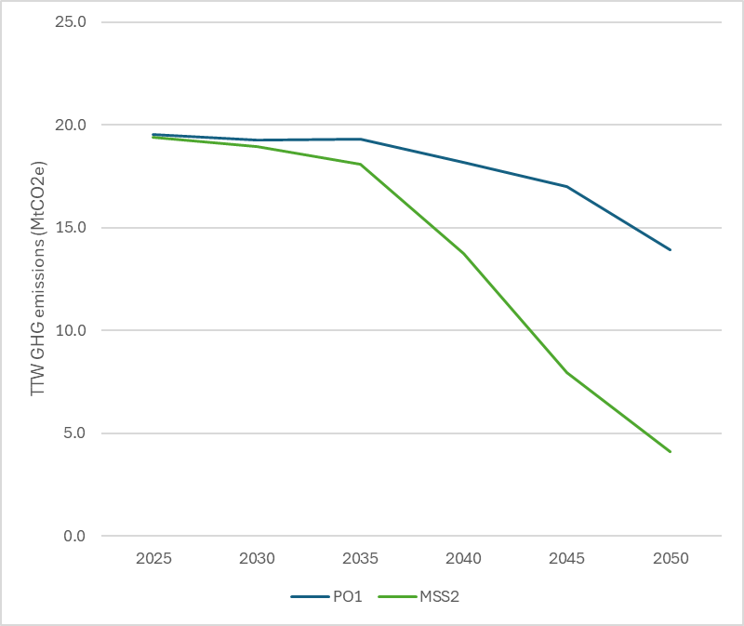
Source: PRIMES-Maritime modelling. Smaller vessels (i.e. between 400 and 5000 GT) in scope are those included in MSS2.
- Impacts from measure MSS2 on GHG emissions (in MtCO2e) of smaller vessels
Scenario | Indicator | 2030 | 2040 | 2050 | Total 2030-2050
Baseline (PO1) | GHG emissions (MtCO₂e) | 19.3 | 18.2 | 13.9 | 438.5
MSS2 | Change wrt PO1 (MtCO₂e) | -0.3 | -4.5 | -9.8 | -124.3
MSS2 | % Change wrt PO1 | -1.5% | -24.5% | -70.4% | -28.3%
Source: PRIMES-Maritime modelling
Energy efficiency
In the default policy scenario, some energy efficiency improvements are expected for smaller vessels, following technological developments for the overall fleet. Measure MSS2 is expected to lead to small additional improvements in the energy efficiency of smaller vessels (energy intensity is expected to drop by 1% in 2050 compared to PO1), driven by higher fuels costs compared to the default policy scenario. Similar trends are expected in MSS1.
Fuel mix
In the default policy scenario (PO1) the uptake of renewable fuels for smaller vessels would be quite limited, as smaller vessels would face no incentive in replacing traditional fossil fuels with more expansive renewable fuels. Renewable fuels would only represent 26% of the total energy demand for smaller vessels by 2050. The expansion of EU ETS to smaller vessels (under measure MSS2), due to the price signal of carbon pricing, would lead to a significantly higher uptake of renewable fuels for smaller vessels, particularly from 2040 onwards, reaching 77% of total energy demand by 2050. Similar trends would be expected for measure MSS1.
- Trends in the demand of renewable fuels (RFNBOs, biofuels and electricity) for smaller vessels as share of total fuel use for smaller vessels under the default policy scenario (PO1) and MSS2
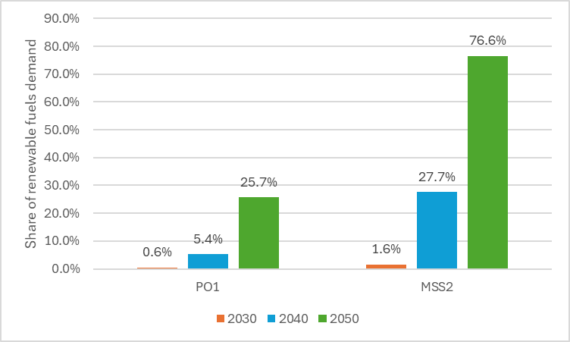
Source: PRIMES-Maritime modelling. Smaller vessels (i.e. between 400 and 5000 GT) in scope are those included in MSS2.
    - Economic impacts
Shipping costs
Similar to environmental impacts, PRIMES-Maritime was used to model direct cost impacts from measure MSS2, while a dedicated scenario for MSS1 was not considered. Further to administrative costs, the model shows that the extension of the scope of EU ETS to smaller vessels in MSS2 is expected to represent additional costs for shipping companies responsible for smaller vessels in the form of ETS payments but also fuel costs and capital expenditure associated with decarbonisation measures within the segment, representing avoided ETS payments. Total shipping cost increases from policy measure MSS2 were estimated at 5.1% on average during the period 2030-2050, compared to the default policy scenario, as shown in the following table:
- Impact on shipping costs for smaller vessels from policy measure MSS2
Scenario | Indicator | 2030 | 2040 | 2050 | Total 2030-2050
PO1/default | Total shipping costs (million EUR) | 23,158 | 28,382 | 33,967 | 707,915
MSS2 | Change wrt PO1 (million EUR) | 1,492 | 1,942 | 489 | 36,100
MSS2 | % Change wrt PO1 | 6.4% | 6.8% | 1.4% | 5.1%
Source: PRIMES-Maritime modelling. Smaller vessels (i.e. between 400 and 5000 GT) in scope are those included in MSS2.
It should further be noted that smaller vessels are also eligible to benefit from existing maritime derogations under ETS (i.e. OMR, PSC/PSO/ICS), which would at least partially offset the expected additional shipping costs.
Level-playing field
The extension of the ETS scope to smaller vessels would be expected to have a positive impact on the level playing field by ensuring similar regulatory requirements for vessels just above or below the 5 000 GT threshold, which might be competing for similar market segments. An analysis of vessel data segmented by size suggests that smaller vessels between 4 000 and 4 999 GT would represent 32% of the considered fleet under MSS1 and 19% under MSS2. The extension of the ETS scope to smaller vessels would also address the risk of evasion consisting of using smaller vessels to avoid EU ETS obligations. By addressing this risk, policy measures MSS1 and MSS2 would avoid negative economic impacts (e.g. lack of level playing field) as well as possible negative environmental impacts (e.g. using smaller vessels instead of larger ones would result in more voyages being needed to deliver the same quantity of freight and would thus likely lead to higher emissions).
Impact on the EU maritime shipping industry
Extending the ETS to smaller vessels is expected to provide a strong and consistent incentive for the adoption of low and zero emission technologies particularly suited to this segment of the fleet. Smaller vessels operating on short and predictable routes are especially well placed to benefit from electrification, as battery-electric propulsion has reached a high level of technological maturity and aligns well with their operational characteristics. Including these ships in the ETS would enhance the economic attractiveness of clean technologies and encourage investment in supporting infrastructure such as onshore power supply. Over time, the resulting market signals are likely to accelerate fleet renewal, stimulate innovation, and strengthen industrial capabilities in advanced maritime technologies, ultimately contributing to industrial growth and job creation, reinforcing the competitiveness of shipyards and equipment manufacturers in Europe.
Administrative costs for shipping companies
As for other sectors under the EU ETS, the main administrative costs of participation in the system for regulated entities are related to the MRV processes, the opening and operation of an account in the Union Registry, and the purchase and possible trade of allowances. The supporting study to the Commission report assessing the potential inclusion of additional smaller ships under the scope of the EU MRV Regulation (European Commission, 2025) estimated recurrent annual MRV-compliance administrative costs per vessel for smaller vessels at EUR 3,690, similar or slightly higher than those of vessels currently subject to MRV obligations (estimated at EUR 3,390 per vessel on average). Staff limitations and increased frequency of voyages of smaller vessels have been quoted by some shipping companies as the main reasons for higher monitoring costs. One-off costs related to MRV implementation (i.e. costs to set up the MRV system for each new vessel) were estimated at EUR 3,193 per vessel. Besides MRV processes, shipping companies controlling smaller vessels, and not already operating other vessels under EU ETS, would incur additional ETS administrative costs, estimated by the previous impact assessment by the Commission (European Commission, 2021) to be around EUR 18,300 (one-off) and EUR 6,100 (annual). The following table present the resulting additional administrative costs from MSS1 and MSS2:
- Additional administrative costs for shipping companies under MSS1 (PO2) and MSS2 (PO3)
Measure | Number of new vessels to MRV⁽¹⁾ | Number of new companies to ETS ⁽²⁾ | Total additional one-off administrative costs (MEUR) | Total additional recurrent administrative costs (MEUR per year) | Net present value of additional administrative costs (MEUR) ⁽³⁾
MSS1 (PO2) | 2,238 | 1,171 | 29 | 15 | 435
MSS2 (PO3) | 4,421 | 2,312 | 56 | 30 | 860
Source: Commission analysis
(1) Excluding general cargo and offshore vessels, already under MRV
(2) Estimated based on analysis of shipping companies for smaller vessels not already on THETIS-MRV from (European Commission, 2025)
(3) 3% social discount rate applied for administrative costs over the period 2030-2050
Administrative and enforcement costs for public authorities
The extension of the EU ETS to smaller vessels would lead to additional administrative and enforcement costs for national authorities related to both MRV and ETS processes. A recent study (European Commission, 2025) estimated MRV related costs for authorities at 21.1 EUR/vessel for Port State Control obligations and 186.1 EUR/vessel for Flag State obligations. Obligations for national authorities with regard to ETS compliance include setting up and maintaining the Union Registry for shipping companies, processing notifications, compliance auditing, and providing general support to implementation (e.g. through helpdesk). On the basis of recent estimates (European Commission, 2021), ETS-related one-off and annual costs per shipping company were estimated at EUR 470 and EUR 540, respectively. The resulting costs under MSS1 and MSS2 are shown in the following table:
- Additional administrative and enforcement costs for national authorities under MSS1 (PO2) and MSS2 (PO3)
Measure | Number of new vessels under MRV⁽¹⁾ | Number of new flagged vessels⁽²⁾ | Number of new companies to ETS ⁽³⁾ | Total additional one-off administrative costs (MEUR) | Total additional recurrent administrative costs (MEUR per year) | Net present value of additional administrative costs (MEUR) ⁽⁴⁾
MSS1 (PO2) | 2,238 | 316 | 1,171 | 0.55 | 0.74 | 17
MSS2 (PO3) | 4,421 | 625 | 2,312 | 1.09 | 1.46 | 33
Source: Commission analysis
⁽¹⁾ Excluding general cargo and offshore vessels, already under MRV
⁽²⁾ This assumes that the share of vessels flagged in EU Member States compared to total vessels under MRV in 2023 (14%) also applies to this subset of vessels
⁽³⁾ Estimated based on analysis of shipping companies for smaller vessels not already on THETIS-MRV from (European Commission, 2025)
⁽⁴⁾ 3% social discount rate applied for administrative costs over the period 2030-2050
    - Social impacts
The extension of the EU ETS to smaller vessels introduces increased shipping costs for operators under both MSS1 and MSS2, depending on the emissions reduction measures implemented by shipping companies. This poses a risk that certain service providers might reduce the frequency of their operations, withdraw from or merge less profitable routes, or increase prices for passengers and cargo, therefore undermining the accessibility and affordability of essential services, particularly for vulnerable populations. In many Member States, these services are not only essential for personal mobility but also for the delivery of food, medical supplies, and other basic goods. It should also be noted, however, that services to small islands and remote areas are often protected by public service obligations Public Service Contract or Public Service Obligation (PSO-PSC), which, by fixing the maximum price and minimum supply of these services already safeguard connectivity from cost pressures. Additionally, EU ETS derogations for PSO-PSC, outermost regions, and small islands, if extended, would further mitigate the impact.

Smaller extensions for Maritime offshore vessels, at the scale of a few Mt in 2027, are ignored in below estimates, as they are not significant, and the precise amount is uncertain.
Commission implementing regulation C(2026) 4372 final
Articles 10a (5a) and 10a (5b) of the ETS Directive
SWD(2024) 63 final
IPCC, 2022e, ‘Chapter 3: Mitigation Pathways Compatible with Long-term Goals’, in: Climate Change 2022: Mitigation of Climate Change. Contribution of Working Group III to the Sixth Assessment Report of the Intergovernmental Panel on Climate Change, and “Scaling up carbon dioxide removals – Recommendations for navigating opportunities and risks in the EU” from the European Scientific Advisory Board on Climate Change. In the near term, removals can further reduce net GHG emissions. This would accelerate the transition to net zero and reduce cumulative emissions before reaching, thereby reducing peak warming, the risk of tipping points and irreversible climate impacts. In the medium term, they are needed to counterbalance residual CO2 emissions to halt CO2-induced warming. Thereafter, achieving and sustaining net-negative CO2 emissions to achieve overall net zero greenhouse GHG emissions would reverse warming in the medium-term. In the longer term, removals might be needed to sustain overall net-negative GHG emissions, to further reduce global temperatures.
In this case ‘removals trading system’ refers to a system based on an obligation to remove carbon imposed on different entities, or partly different entities, from those in the ETS1, and where the obligation is not connected to the emissions produced under the ETS1.
In those integration models in which the emissions space is guaranteed (1-in-1-out/MSR/public authority- see section 2.1 for detailed description) financing removals will still be essential, in that case to ensure the removals are purchased to compensate for the additional emissions that are issued, so the ETS achieves its net target.
If not subsidised, in the integration options on top of the cap (see section 2.1 for full description) the ETS sectors will have the same emission space they would have without removals in the economy, as only few BECCS removals would be purchased in the late 2030s (see Table 3).
DIRECTIVE (EU) 2023/959 OF THE EUROPEAN PARLIAMENT AND OF THE COUNCIL amending Directive 2003/87/EC establishing a system for greenhouse gas emission allowance trading within the Union and Decision (EU) 2015/1814 concerning the establishment and operation of a market stability reserve for the Union greenhouse gas emission trading system
CRCF Regulation 2024/3012 https://eur-lex.europa.eu/legal-content/EN/TXT/?uri=OJ:L_202403012
Brussels, 3.2.2026 C(2026) 553 final COMMISSION DELEGATED REGULATION (EU) 2024/3012 of 3.2.2026 supplementing Regulation (EU) 2024/3012 of the European Parliament and of the Council by establishing the certification methodologies for permanent carbon removals activities, OJ L, 2024/3012, 6.12.2024
The measures are designed assuming the private sector integration is carried out mainly by ETS regulated entities. However, the private sector integration can be envisaged more broadly, with a range of options that extend from the integration to certain financial market participants (credit institutions, investment firms, and commodity traders) when acting on behalf of clients; to those financial market participants when acting for their own accounts; to anyone with a Union Registry account; or also to suppliers. Section 4.3 examines the integration options for private entities.
Section 4.6 explores how the purchasing of removals could operate
‘Net emissions’ refers to releases of GHG minus removals by anthropogenic sinks. In an ETS, since the use of conventional allowances enables unabated emissions to reach the atmosphere, the ETS cap (as the sum of conventional allowances) sets the limit on net emissions from ETS regulated entities. Contrast this with removal units, whose use in an ETS would lead to net zero emissions.
‘Gross emissions’ refers to releases of GHG before accounting for removals by sinks. In an ETS, gross emissions are limited by the total volume of compliance units (e.g. conventional allowances and removal units) in circulation.
This measure could be designed as ‘on top of the cap’ if the auctioning of removals-backed allowances was made conditional on the delivery of the removals and the removal-back allowances would be auctioned on top of the net cap. However, the measure is designed so the public authority bears the risk of being able to buy the right amount of removals, making it an ‘under the cap’ measure where the integration happens indirectly by the purchase by the authority of the removal units necessary to compensate the allowances previously added to the net cap.
Although the main feature of this measure is the integration by the public authority with a prior increase of the cap based on the amount of removals that are planned to be purchased, it can be combined with the integration by the ETS regulated entities that generate removals. This option could be introduced to give these more flexibility, would these installations prefer to use the removals they generate themselves, instead of selling them to the public authority. The decision would be uneconomical is most cases, given the expected price differential. To respect the gross emissions limit that is determined by the pre-increased cap in CR4, any removals used by regulated entities would lead to the cancellation of a removal-backed allowance, as in the CR3 one-in-one-out approach.
This would not apply in case the removals trading obligation would be imposed also on entities that are directly involved in the polluting activity, such as the fossil fuel providers for the carbon embedded in their products.
CONCITO and CarbonGap’s analysis of a removals trading system is an example of studies that should continue being developed to gain further understanding of the potential functioning of such systems: https://concito.dk/files/media/document/Modelling%20a%20Removal%20Compliance%20System%20in%20the%20EU.pdf
See e.g. Cames et al. 2016a; de Bruyn et al. 2016, Schneider and Kollmuss 2015; Schneider L.R. 2011, Zhang and Wang 2011, European Commission (2011) Cames et al. 2016. Cames, M., Harthan, R.O., Fussler, J., Lazarus, M., Lee, C.M., Erickson, P. and R. Spalding-Fecher (2016b), How Additional is the Clean Development Mechanism? Analysis of the application of current tools and proposed alternatives, Prepared for DG Clima (CLlMA.B.3/SERl2013/0026r.) by Oko-Institut, INFRAS and Stockholm Environment Institute de Bruyn S, Schep E, Cherif S, Huigen T (2016) Calculation of additional profits of sectors and firms from the EU ETS 2008–2015, Delft: CE Delft Schneider L, Kollmuss A (2015). Perverse effects of carbon markets on HFC-23 and SF6 abatement projects in Russia. Nat Clim Chang 5:1061–1063 Zhang and Wang (2011). Zhang J, Wang C (2011) Co-benefits and additionality of the clean development mechanism: An empirical analysis. J Environ Econ Manag 62(2):140–154 European Commission (2011). Study on the Integrity of the Clean Development Mechanism.
European Commission: Directorate-General for Climate Action, Ramboll Management Consulting, Witteveen, E., Marton, C., Bert, N. et al., Carbon removals in the EU – Review of current carbon removal projects and early-stage financing, Publications Office of the European Union, 2025, https://data.europa.eu/doi/10.2834/0004994
The cost of DACCS and BECCS follow a complex structure subject to many factors, as shown in the following report on CCUS in the EU: European Commission: Joint Research Centre, Clean Energy Technology Observatory, Carbon capture utilisation and storage in the European Union – Status report on technology development, trends, value chains and markets. – 2025, Publications Office of the European Union, 2025, https://data.europa.eu/doi/10.2760/0214409
JRC, 2025, “Clean Energy Technology Observatory: Carbon Capture, Utilisation and Storage in the European Union - 2025 Status Report on Technology Development, Trends, Value Chains and Markets”, https://publications.jrc.ec.europa.eu/repository/handle/JRC144142
The form of this financial support varied but contract for differences was the most often cited as a financial instrument that could help to address the current gap that exists between the ETS price signal and the higher abatement cost associated with the more early-stage removal technologies. In addition, other financial instruments supported involved such as state aid and grants and other financial measures to de-risk the investments necessary to scale up carbon removals. A distinction was made in the categorisation when respondents specifically mentioned R&D support (34 responses) that was more linked to innovation funding to help bring down the costs of these technologies over the medium to longer term. The need for financial support for building up the infrastructure required to support carbon removals in terms of both the storage and transportation of CO2 was frequently raised by the respondents. Demand side measures to help ensure a market for carbon removals was strongly supported by the respondents with 52 responses. Amongst the range of proposals on what demand side measures would be most suitable to scale up carbon removals, the need for procurement of CDR credits by governments was often suggested alongside specific targets for removal use to further help stimulate demand.
See ‘Route to market’ under: https://assets.publishing.service.gov.uk/media/687f61598adf4250705c9765/uk-ets-ggrs-main-response.pdf
See footnote 18
The final outcome depends on if the decrease in prices is counterbalanced sufficiently by the increase in supply, such that the overall the auction revenues remain equal or are even higher despite the lower prices.
See footnote 21. The cost estimates for the CDR technologies are based on a comprehensive literature review, supplemented by survey findings and conducted interviews. Literature sources provided baseline estimates for current and future costs, while survey responses provided a means for partial validation and refinement. Given the uncertainty surrounding the current and future costs of all CDR technologies, costs were represented as ranges, with most likely upper- and lower bound limits. These uncertainties make precise forecasting challenging. Reliable cost estimates are only available for BECCS. For other BioCCS technologies, there is limited and less reliable data on TRL, costs and scalability, resulting in a broader and more uncertain cost range. For this reason we assume BECCS costs to be equivalent to BioCCS costs for this exercise.
Abatement deterrence relates to expected impacts on reduced or delayed abatement action by ETS covered entities due to the introduction or expectation of carbon removals and the uncertainty in their costs and availability.
Excluding non-compliance demand (eg towards voluntary carbon neutrality claims) and noting that expectations of future CDR volume and costs can impact EUA banking and investment behaviour before cost parity.
Dynamic, market-based pricing can reward lower-cost and higher-performing CDR providers, thereby supporting incremental efficiency gains. However, for capital‑intensive technologies such as bioCCS and DACCS, this signal is very likely insufficient to unlock investment.
CDR serves as an effective price ceiling if CDR supply is elastic and at scale; otherwise deterrence stems from expectations rather than realised ceilings.
Demand side measures to help ensure a market for carbon removals was strongly supported by the respondents with 52 responses. Amongst the range of proposals on what demand side measures would be most suitable to scale up carbon removals, the need for procurement of CDR credits by governments was often suggested alongside specific targets for removal use to further help stimulate demand. Others commented specifically that in the short to medium term, a central EU body could act as a buyer, offering offtake agreements to help CDR developers secure predictable revenue and reach investment-grade scale.
Vermeulen, Hanne and Rasmussen, Martin Birk, Concito 2024, ”Towards a sustainable deployment of BioCCS in the EU”
Lara-Sophie Wähling, Mathias Fridahl, Tobias Heimann, Christine Merk, “The sequence matters: Expert opinions on policy mechanisms for bioenergy with carbon capture and storage”, Energy Research & Social Science, https://doi.org/10.1016/j.erss.2023.103215
BioCCS is defined in the draft CRCF methodology as “a carbon removal activity in which biogenic CO2 produced by the oxidation of carbon in biomass is captured and transferred for permanent storage.”
Where the biochar meets all necessary requirements, the most widely used application of biochar for soil amendment is considered as permanent carbon removal under the CRCF as well as under several private carbon standards such as Verra, Puro or Isometric voluntary.
This would be similar to the CDM approach which requires replacement of units issued for forestry projects to account for non-permanence. These non-permanent units, however, accounted for less than 1% of all issued CERs.
Section 1.2.2.2 Monitoring period of draft Delegated Regulation Annex: Carbon removals and carbon farming – methodologies for certifying permanent carbon removals
See meta-review on the TRLs reported for the various technology types of DAC and BECCS, showing the average, minimum and maximum levels: European Commission: Joint Research Centre, Clean Energy Technology Observatory, Carbon capture utilisation and storage in the European Union – Status report on technology development, trends, value chains and markets. – 2025, Publications Office of the European Union, 2025, https://data.europa.eu/doi/10.2760/0214409
Concretely, according to the study from European Commission: Directorate-General for Climate Action and Ramboll Management Consulting, Carbon removals in the EU – Review of current carbon removal projects and early-stage financing (Publications Office of the European Union, 2025, https://data.europa.eu/doi/10.2834/0004994), on a global level, the estimated biochar carbon removal capacity is projected to continue expanding. The State of Carbon Dioxide Removal 2024 (Pongratz et al., 2024) suggests an increase from 0.2 MtCO₂ per year in 2021 to 0.8 MtCO₂ per year in 2023, with an annual growth rate of approximately 0.3 MtCO₂. If this trend persists, global biochar carbon removal capacity could reach approximately 2.8 MtCO₂ per year by 2030 and 4.3 MtCO₂ per year by 2035. This growth does not constraints e.g., available land, biomass) from McKinsey (2023) and Babiker et al. (2023) for potential scaling of carbon removal technologies by 2050, suggesting that these capacities are plausible. In Europe, the current capacity of 0.2 MtCO₂/a in 2023 is expected to increase to 2.3 MtCO₂/a by 2030, according to the European Biochar Industry Consortium (2024). If growth continues in line with the estimated capacities for 2023 and 2030, and assuming an exponential trajectory, EU biochar carbon removal capacity could reach 5–7 MtCO₂ per year by 2035. These projections are consistent with those of the Rocky Mountain Institute (2023), which also anticipates significant scaling of biochar carbon removal capacity in the coming decades, albeit on a global scale. In the survey conducted for the study, European biochar companies indicated they aim to remove 2.4 MtCO₂ per year by 2030 and 5.3 MtCO₂ per year by 2035, however, the extent to which this estimated future capacity is feasible, remains to be seen. These estimates provided by stakeholders might be too optimistic, meaning these could reflect ambitions rather than realistic expectations.
The arguments put forward refer to a model in which operators buy removals in the VCM and bring them into the ETS. The exchange would be simpler if the public authority would integrate removals within the ETS. This option does not seem feasible to the moment (public v private integration is part of the impact assessment analysis).
See https://www.mynativeforest.com/carbon-price-nz
See https://ww2.arb.ca.gov/our-work/programs/compliance-offset-program/arb-offset-credit-issuance
Note that this does not apply in case of reversals, which are managed primarily through buffer accounts.
We distinguish ‘conventional’ allowances from e.g. removal-backed allowances. Present-day EUAs are conventional allowances in that they represent the right to emit one tCO2e under the scope of application of the EU ETS. While the scarcity imposed by the ETS drives emission reductions, the use of a conventional allowance for compliance enables a tCO2e to reach the atmosphere unabated.
It is worth noting that removal unit price premiums that rely on voluntary demand would require an understanding of what claims regulated entities can make by using removal units inside the ETS. E.g. in a situation where some operators regulated by the ETS would like, in addition to complying with their ETS obligations, to make a voluntary carbon neutrality claim by purchasing only removal units. This ‘dual purpose’ of removal units in the ETS could boost demand and drive up their price vis-à-vis conventional allowances. It is unclear, however, in what situations operators would have a legitimate carbon neutrality claim. It seems likely that in most cases, the regulated entity would be able to make a legitimate claim of carbon neutrality. In some cases, however, it seems possible that a waterbed effect could negate a true carbon neutrality claim. It seems that a waterbed effect could exist in a situation where removal units are cost-competitive in the ETS and where there are limits on CDR units entering the ETS (that is, supply-side limits rather than demand-side limits – see section on considerations of limits). In that case, entities wishing to make voluntary claims would have a higher willingness to pay for the removal units – thus potentially increasing their market price, but nevertheless leaving the same number of compliance units for other operators in the market. It seems that in this situation, operators willing to pay a premium for removal units would consume the (limited) removal units supply and that CDR suppliers would get more income than they otherwise would, but that total net emissions from ETS regulated entities would remain unchanged as compared to a counterfactual where the operator did not make the carbon neutrality claim. This relates crucially, also, to defining what constitutes truthful and not misleading carbon neutrality claims – which is also related to ongoing discussions related to the Green Claims Directive. We recommend more analysis on this issue.
See https://www.gov.uk/government/consultations/integrating-greenhouse-gas-removals-in-the-uk-emissions-trading-scheme
https://assets.publishing.service.gov.uk/media/687f61598adf4250705c9765/uk-ets-ggrs-main-response.pdf
It also noted that corporate net-zero claims using ETS removal allowances must follow best-practice guidance, with the UK Government proposing endorsement of the Voluntary Carbon Market Initiative's code in its consultation on voluntary carbon and nature markets
It is unclear whether this would have material effects (e.g. on liquidity) on the primary market, as trades would likely respond primarily to the cost-competitiveness of removal units in the ETS.
Auctions could also be organized to allow for differentiation of conventional and removal-backed allowances. The UK, for example, is currently planning for multi-product auctions as a means of delivering removal-backed allowances into the UK ETS. Whether removal-backed allowances auctions clear at the same price as conventional allowances depends among others on auction design and risk premiums for different units.
The timing risk could potentially be addressed through a pre-surrender ‘booking’ of the CDR limit, e.g. through a pre-surrender CDR account that would guarantee the ‘space’ within the limit to operators.
Veyt, 2024 Year in Review EU ETS: Flattening out, 2024 Year in Review EU ETS: Flattening out | Veyt
Following the same timeline as for maritime in the July 2021 proposal, which was challenging and where transposition is still pending.
Danish Ministry of Climate, Energy and Utilities. Denmark’s position paper on integrating permanent carbon dioxide removals in the EU ETS.
See https://frontierclimate.com/apply/offtake
https://www.klimaschutzvertraege.info/thema/informationen_fuer_unternehmen_konkret
Decision (EU) 2015/1814 of the European Parliament and of the Council of 6 October 2015 concerning the establishment and operation of a market stability reserve for the Union greenhouse gas emission trading scheme and amending Directive 2003/87/EC, OJ L 264, 9.10.2015, p. 1.
See Ellerman et al (2016)
See the Official MSR Indicator announcements in 2018 and 2024 for the reported TNAC values. The reported invalidation value is from the announcement in 2023.
See the Official MSR Indicator announcement in 2025 for the reported TNAC values in 2024. The reported invalidation values in 2024 and 2025 are from the announcements in 2024 and 2025 respectively. If an Article 29a release is not triggered during 2025, further 276 million allowances will be invalidated on 1 January 2026.
The value for invalidations in 2026 based on the current data should therefore be considered provisional.
In accordance with article 10 (6) of the ETS Directive, the European Securities and Markets Authority (ESMA) was given a mandate for market oversight. ESMA (2022) finds no evidence of current problems but acknowledges the need for continues monitoring of EU carbon markets. The consecutive annual reports from ESMA on carbon markets from 2024 and 2025 confirm these findings.
See European Commission (2021), Borghesi et al (2023) and European Commission (2025). For simplicity, the rest of this Annex refers to European Commission (2021) as ‘the 2021 MSR Review’.
See European Commission (2025) which includes an extensive literature review and stakeholder consultation.
For the current project, 13 MSR-focused stakeholder interviews were conducted. Five of these were with academic experts, two with market exchanges, three with public official working on MSR, three with industry associations. Additionally, several industry groups (six) and NGOs (three) responded to a few targeted MSR questions in interviews conducted for other thematic areas.
See European Commission (2021), Borghesi et al (2023) and European Commission (2025).
See European Commission (2014).
The review’s discussion of potential CBAM‑related effects predated the Commission’s CBAM proposal and the version which was eventually adopted.
European Commission (2025) also cautions that increased participation by non-compliance (financial) actors can exacerbate liquidity frictions and price volatility if technical trading and heterogeneous strategies driving short-term moves become less anchored in fundamentals. It recommends closer monitoring and possible safeguards (e.g., better trading data, volatility/liquidity indicators, and position/holding constraints) to preserve market integrity and stability.
See European Commission (2014a), European Commission (2014b), Taschini & Kollerberg (2019) and Osario et al (2021).
In the future, a potential introduction of a lower buffer zone would also affect this duration.
These measures are designed and assessed with the aid of the POLES-Enerdata model. While the quantitative assessment under the MSR does not include removals integration through the MSR, one such measure is assessed qualitatively in Annex 8 sub-section on removals.
All policy options assume at some extent an expansion in scope covering removals, waste, CCU, aviation, and maritime. These are treated as an exogenous addition to both to supply and demand. Because these segments still make up only a small share of the overall ETS market, they are not expected to have a major effect on carbon prices. Therefore, significant change in hedging behaviour is considered unlikely due to the expansion of the scope.
An additional correction could consist in adjusting the TNAC to reflect allowances used for flexibility purposes under Article 6 of Regulation (EU) 2018/842 (the Effort Sharing Regulation). The 2025 TNAC Communication estimated a cumulative volume of such allowances at approximately 36 million in 2025, with potential for a further increase until 2030. This adjustment has not been included in the present measure level assessment. The mechanics of such an adjustment on the distinct MSR options are expected to be similar to the adjustment for aviation, though smaller in magnitude, as the size of this adjustment would be limited, depending on the amount of cumulative allowances used by the Member States flexibility under the Effort Sharing Regulation.
See the European Commission Publication of the TNAC Communication 2025.
The difference between the price trajectories obtained from POLES-Enerdata and those used in the initial PRIMES-based 90% scenario are analysed and explained in Annex 4.
Since the chart is expressed in index terms, higher indexed curve for MSR0+ than MSR0 after 2032 does not indicate higher absolute carbon prices. Instead, it reflects a faster rate of price increase relative to the base year. In other words, MSR0+ shows a steeper upward trajectory, meaning prices grow more rapidly over time, even though they remain below the absolute price levels observed under MSR0.
The effects of the timing of supply of free allowances are further assessed in section 5.5.
Note that PO1 also assumes that 1) no invalidations take place after 2028 which implies that a balance of allowances builds up in the MSR; 2) a lower buffer is introduced from 2028; and 3) both upper and lower buffers are adjusted as needed to avoid threshold effects.
PO2 and PO3 also include the changes described in the previous footnote.
See also in Annex 3.
See the European Commission Publication of the TNAC Communication 2025.
Articles 10a (5a) and 10a (5b) of the ETS Directive
Commission implementing regulation C(2026) 4372 final
Results may be similar to those observed under the S1 or S4 MSR sensitivities set out in the Appendix 1 below, as both present a shock regarding a lower emissions reduction than expected, whether occurring as a one-off event or as a progressive trajectory, affecting MSR operations and ETS prices.
As per the analysis for the measures options, sensitivity scenarios are constructed with an adjusted ETS cap trajectory meeting a 90% economy-wide emission reduction target in 2040 and featuring the inclusion of 50% of the international extra-EEA aviation in the ETS scope in addition to the current scope.
The curve profile is not monotone and represents the difference in removals due to the four-year delay assumed here. For example, the value in 2030 corresponds to the difference between the baseline assumption for removals development in the PRIMES scenario and that for 2026.
The increase in the price gap between 2037 and 2040 is due to the effect of the MSR, which will release for the first time in S1 2037 (as shown in Figure 39, where the MSR reserve begins to decline in 2037). Consequently, the increase in prices would slow down between 2037 and 2040 for MSR3-S1.
“Baseline” in this section denotes the no-shock scenario for the respective measure (MSR1 and MSR3) and is distinct from baseline references in the report.
Eurostat
Impact assessment accompanying the 2040 Climate Target proposal. SWD(2023) 63 final.
Estimated at approximately EUR 300 billion annually, covering essential resources such as clean electricity, and hydrogen in Impact assessment accompanying the 2040 Climate Target proposal. SWD(2023) 63 final.
The IF evaluation report also recommends that a more focused support for innovative decarbonisation projects could be achieved by application and evaluation process simplification, introduction of completion bonds/penalties, award criteria revision, possibility to cover a larger share of the funding gap, support for existing investments, targeted support for SMEs and start-ups.
Communication from the Commission – Framework for State Aid measures to support the Clean Industrial Deal (Clean Industrial Deal State Aid Framework) (C/2025/3602)
European Commission, The Future of European Competitiveness: Part A: A competitiveness strategy for Europe,2024,https://commission.europa.eu/document/download/97e481fd-2dc3-412d-be4c-f152a8232961_en?filename=The%20future%20of%20European%20competitiveness%20_%20A%20competitiveness%20strategy%20for%20Europe.pdf.
Communication from the Commission – Clean Industrial Deal: A joint roadmap for competitiveness and decarbonisation COM/2025/85 final
https://ec.europa.eu/commission/presscorner/detail/en/statement_26_663
EEA, see: https://www.eea.europa.eu/en/analysis/indicators/use-of-auctioning-revenues-generated
See the Terms and Conditions of the heat auction here: https://climate.ec.europa.eu/document/download/b55d8315-2eef-4618-aa4c-75f72abb4e95_en?filename=news_20251010_tc_heat_auction_en.pdf
Further technologies may also emerge from current research work as indicated in the IEA reports, see: https://www.iea.org/reports/clean-energy-innovation
Bruegel, 2025. “Clean industrial transformation: where does Europe stand?”, https://www.bruegel.org/sites/default/files/2026-04/clean-industrial-transformation%3A-where-does-europe-stand%3F-10687.pdf
Mission Possible Partnership (MPP), E3G and the Industrial Transition Accelerator (ITA) (2025). Building the EU’s Clean Industrial Future: Unlocking Investment through Lead Markets.
VUB Brussels School of Governance (2024).Public procurement of steel and cement for construction, assessing the potential of lead markets for green steel and cement in the EU.
Some projects have funding gap in early years that can be compensated by revenues in later years (that could be addressed by loans or equity-taking).
Because of the limited budget available, the IF calls have been largely oversubscribed. Due to high competition many projects do not obtain IF funding despite meeting the quality requirements in the IF evaluation. To support those projects with alternative means, MS can set up national schemes to grant national funding. In this way, the national authorities can use the IF selection process ‘as a service’. This reduces the national checks to the minimum and maximise synergies between the IF and national funding possibilities. The results of IF assessment are passed on to the national authorities and MS would remain responsible for disbursing the national funding and for monitoring the project implementation. ‘As-a-service’ has been operationalised for three IF auctions so far and new streamlined rules for it have been presented for ‘regular’ grants in the CISAF.
SWD/2025/555 final accompanying the proposal for a Regulation of the European Parliament and of the Council on establishing the European Competitiveness Fund ('ECF’).
IF can provide support via (1) ‘regular’ grants based on the evaluation of multiple award criteria and in form of the lump sum payments linked to reaching project’s milestones as early as of Financial Close and (2) auctions based on the price-only competition and in the form of unit cost contribution as of Entry into Operation and (3) financial instruments such as loans or guarantees.
In one-sided auctions, awardees are either on the supply or on the demand side. Ensuring the offtake (or respectively supply) of the defined good is left to auction participants. In double-sided auctions, both the production and demand side participate in the competitive bidding procedure. Next to determining strike prices, the double-sided auction also serves to make matches between supply and demand.
E.g. T&Cs of the IF hydrogen auction or T&Cs of the IF heat auction.
The revision of State aid guidelines in 2014 implied a transition towards auction based support
For example, the US IRA 45Q tax credit provides a tax credit of 85$/tonne for every tonne of CO2 captured and permanently stored in geological formations
https://cinea.ec.europa.eu/funding-opportunities/calls-proposals/cef-transport-alternative-fuels-infrastructure-facility-afif-call-proposal_en
There needs to be the system that shows the ‘application queue’ of projects that are eligible and can claim the support once they meet a pre-defined milestone. Once such an ‘application queue’ exhausts the budget, projects are put on the reserve list. There could be still many changes to the ‘application queue’ but it is guaranteed that once project is part of the queue and reaches the pre-defined milestone, it will receive the support. For project on the reserve list, they would only receive support if there are dropouts from the queue.
If not conditional to certain performance requirements, grants do not guarantee long-term viability or operational performance and hence their effectiveness regarding GHG emission reduction is limited. If performance requirements are included, their effectiveness can be improved, which comes with additional complexity for MRV.
Abatement is calculated with automatic formula that applies emission factors to amount of the electricity produced (using ETS heat benchmark or emission factors of fossil fuels in case of proven decommissioning)
In the German CCfDs the indexation to electricity and hydrogen prices was foreseen for projects (and more for the conventional reference) acknowledging that the costs of energy vectors cannot be fully passed through to consumers. Pass-through is impossible considering that most of the projects compete on the global markets.
Commission Delegated Regulation (EU) 2025/723 of 6 February 2025 supplementing Directive 2003/87/EC of the European Parliament and of the Council by laying down detailed rules for the yearly calculation of price differences between eligible aviation fuels and fossil kerosene and for the EU ETS allocation of allowances for the use of eligible aviation fuel.
Discounting is performed with the use of WACC (weighted average cost of capital) that was calculated by Fraunhofer with the use of IF Relevant Costs methodology and gives differentiated results across MS.
Technology diffusion was not assumed because of relatively short time span considered in the assessment. The technology diffusion impacts would come once a larger cohort of projects funded by the IDB come into operation and with an inevitable time-lag of at least few years between the launch of the instrument and projects becoming operational.
Additional challenge is often assessing credibility of the statement made by applicants (e.g. regarding stated counterfactuals).
To be noted that investments eligible under the conditional Free Allocation would be similar to ones eligible for IDB support. In such case, it could be envisaged that the installation that receives the IDB support is considered to automatically fulfil the Free Allocation conditionality.
https://ec.europa.eu/commission/presscorner/detail/en/statement_26_663
As defined by the United Nations, except for States with a GDP per capita equal or exceeding Union average.
This approach has been noted as a practical way to solve the issue of Common but Differentiated Responsibilities and Respective Capabilities, which has been a longstanding challenge in the UNFCCC context. See example here.
CORSIA and the EU ETS exempt flights involving Least Developed Countries and Small Island Developing States. From January 2027, CORSIA should become mandatory for flights between 34 countries (resulting in offsetting above the baseline). Unless they voluntarily participate, flights involving other countries are not covered by CORSIA. As of 2025 and the latest list applicable to 2026, 130 countries voluntarily participate in CORSIA, accounting for 51% of emissions from international aviation.
As of 2024, the CORSIA baseline is 85% of 2019 CO₂ emissions, meaning around 500 Mt CO₂ per year are not addressed by CORSIA. See: ICAO CORSIA Central Registry: Information and Data for Transparency, Part II: Total CO₂ emissions for 2019 Aggregated for all Aeroplane Operators on each State Pair, 2022.
ICAO Assembly Resolution A42-22.
Refers to EU ETS coverage for EEA countries, departing flights to Switzerland and the UK, and EU ETS exemption for around 75 Least Developed Countries or Small Island Developing States.
The UN currently recognises 193 countries: removing the countries in the footnote above leaves 86 countries. ICAO members in 2026 are the same, except that Liechtenstein is not a member, and Cook Islands are a member of ICAO but not the UN.
As foreseen by the ETS Directive Article 3c(6), penultimate paragraph.
As defined by the United Nations, except for those States with a GDP per capita equal or exceeding Union average.
The EU ETS carbon price would apply to any airline flying on that route.
French Guiana, Guadeloupe, Martinique, Mayotte, Reunion Island and Saint-Martin (France), Azores, Madeira (Portugal), The Canary Islands (Spain).
Within the meaning of Article 349 of the Treaty on the Functioning of the European Union.
In 2024, the EU ETS covered 64Mt CO2 of aviation emissions, compared to 0.013 Mt CO2 emissions from flights between outermost regions of the same member state (exempted until December 2030) and 4.3Mt CO2 emissions from flights to/from outermost regions from/to their respective Member State (considered as domestic, exempted until December 2030).
Other than Domestic.
This corresponds approximately to one return flight a day.
Decision (EC) No 2009/450 of 8 June 2009 on the detailed interpretation of the aviation activities listed in Annex I to Directive 2003/87/EC of the European Parliament and of the Council provides that commercial aircraft operators are those that hold and air operator’s certificate (AOC) and the characteristic of being commercial is linked to the operator and not to the flights in question. This means that a commercial operator (one holding an AOC) may perform non-commercial flights, but those would be considered commercial under the EU ETS.
Transport & Environment,Private jets: can the super rich supercharge zero-emission aviation?, 2025, And Carbon Market Watch, Sky polluters, time to chip in... Citizens, time to cash in!, 2025.
Political Guidelines 2019-2024.
Inside Europe: domestic and non-domestic and departing flights to Switzerland and the UK, outside Europe: non-domestic only.
Support for the review by the Commission concerning the implementation of ICAO’s CORSIA, and for Commission reports on certain types of flights, social impacts, and air connectivity of islands, remote territories and Iceland, by WSP July 2026 forthcoming. Referred to as “aviation support study”.
Following some airlines paying fines for non-compliance for their flights within the EU, all major airlines have maintained compliance with the system.
CE Delft, Giving wings to emissions trading: inclusion of aviation under the European emissions trading scheme (ETS): design and impacts, 2005; CE Delft and MVA. Implications of EU emissions trading scheme for competition between EU and non-EU airlines, 2007. These studies have not been updated since, but continue to be referenced in relevant literature.
Verma, T., Rebelo, L., Araujo, N., Impact of Inter-Country Distances on International Tourism, 2019.
E.g., SEO & NLR, Aviation Fit For 55 – Ticket Prices, Demand and Carbon Leakage, 2022.
Wei, T., Kallbekken, S., Carbon leakage from aviation under the European Union Fit for 55 policies, 2024.
ICF et al., Assessment of ICAO’s global market-based measure (CORSIA) pursuant to Article 28b and for studying cost pass through pursuant to Article 3d of the EU ETS Directive, 2020, p. 236.
For instance, zero-rated Hydroprocessed Esters and Fatty Acids (HEFA) results in 65 to 69% of GHG emissions savings, Alcohols to Jet (AtJ) in 65% to 70% and Biomass Gasification + Fischer Tropsch (Gas + FT) in 85% to 95%. Source: Study supporting the impact assessment of the ReFuelEU Aviation initiative – Final report, 2021, p. 154.
The difference is that the ETS exempts flights to Least Developed Countries and Small Island Developing States, whereas ReFuel still applies to flights to these destinations.
This includes cost of fossil kerosene, SAF, and the carbon price.
The Destination 2050 Roadmap 2025, table 14, describes some measures as cost neutral (operations), whereas others are estimated in billions (e.g. fleet renewal).
The maritime sector can use a broad mix of decarbonisation alternatives (different fuel technologies or blending with conventional fuels). However, the market maturity of these alternative fuels remains limited today. While hydrogen is also an option for aviation decarbonisation (and eligible for ETS-financed support), its use and thus cost structure are different for aviation.
Please see section 2 for more details on impacts on airlines and tourist destinations.
These could be related to climate policy, but equally to other policies such as labour laws or passenger rights. The latter are out of the scope of this assessment. Note that itinerary choice is a function of journey time, cost, number flight segments, available flight frequency and characteristics of the origin and destination airports.
In the EU’s 2025 Carbon Market Report, carbon leakage is defined as a situation that could occur if ETS-regulated activities were moved to non-EU countries with less ambitious climate policies, leading to an increase in overall greenhouse gas emissions.
Case studies are built on an average EEA hub, based on selected airports: Amsterdam Schipol, Frankfurt Main, Paris CDG, Munich, Madrid Barajas, Rome Fiumicino, Athens, and Vienna Schwechat. For the analyses of flights to and from EEA hub airports, averages were taken across all relevant routes. For the analyses of flights to and from the non-EEA airports, averages were taken across relevant routes to/from that airport. Please see the support study for more information.
Not considering value of change in flight time.
ICAO, Assembly Resolution A41-22, point 11, 2022.
Originally, individual growth was supposed to taken into account from 2030 with 20% weight and from 2033 with 70%, but at the ICAO Assembly in 2022 the application was delayed to 2033 with 15% weight.
2021: CORSIA Annual Sector Growth Factor (SGF); 2022: 2022 CORSIA Annual Sector Growth Factor (SGF); 2023: 2023 CORSIA Annual Sector Growth Factor (SGF).
CORSIA-Annual-SGF2024-4ed-Rev1-2025.pdf.
Countries had the largest share of international aviation activity in 2018 measured in ‘revenue tonne kilometres’, meaning how much paying cargo or passengers an airline moved, and how far. These 34 States are listed in International-RTK-rankings_2018_SIDS_LDC_LLDC.pdf.
CORSIA’s route-based approach means that wherever the airline is based, it should always be subject to offsetting requirement on routes between two participating states. The airline’s ‘home country’ is the only responsible for the airline’s CORSIA compliance. For example: Airline A from country A which is exempt from CORSIA should still participate in offsetting when it flies covered routes between participating countries B and C. Country A is meant to be responsible to ensure airline A’s compliance on these flights, for there to be a level-playing field.
The ICAO Secretariat publishes this document on an annual basis. For 2024, it was published in October, entitled “Total Annual CO2 Emissions and Information for Aeroplane Operators” Part III.
SBSTA63-ICAO-submission_Final2.pdf.
2016 Reservation: China_en.pdf.
2019 Reservation: china_EN.pdf.
Submission of China and Russia to the 40th session of the ICAO Assembly, 2019 Perspectives on the fair and equitable CORSIA implementation pathway, 2019.
Text not publicly available, but referred to in China’s 2019 Reservation.
2022 Reservation: China_EN.pdf.
Submission of China to the 42nd session of the ICAO Assembly 2025: The Assembly is invited to recognize that international aviation emissions reduction is an important part of global effort to address climate change, and it should follow the principles of equity, common but differentiated responsibilities, and respective capabilities, with States making national determined contributions based on their national circumstances and stages of development”.
DGCA/60 - DP/07/14
2025 Reservation: China_EN.pdf
Notice of CORSIA Monitoring, Reporting, and Verification Program: “Use of the term “will” in this document is aspirational only and is not intended to be read as imposing any obligation or right on either the FAA or Program Participants.”
“The requirement to monitor, report, and verify CO₂ emissions is independent from offsetting,” and “offsetting of emissions under CORSIA, which may require rulemaking or other action, will be addressed at a future time.”
2013 Reservation: United_States_en.pdf.
2016 Reservation: United_States_en.pdf.
2019 Reservation: USA_en.pdf.
HarmonyHub at 2:11:10 and ICAO minutes.
U.S. Transportation Secretary Sean P. Duffy to Deliver Speech Highlighting U.S. Priorities at ICAO | US Department of Transportation
2025-National-Security-Strategy.pdf
2016 Reservation: Russian_Federation_en.pdf.
2019 Reservation: russia_EN.pdf.
2022 Reservation: Russia_EN.pdf.
ICAO,CORSIA Central Registry (CCR): Information and Data for Transparency, PART III: Total Annual CO2 Emissions and Information for Aeroplane Operators, Reporting year: 2024
ICAO’s Chapter 3 State Pairs lists 126 States for 2024, while Commission Implementing Regulation (EU) 2024/2850 of 11 November 2024 on the list of States which are considered to be applying CORSIA for the purposes of Directive 2003/87/EC in 2024 lists 93 states.
SWD(2021) 603 final.
ICAO document - CORSIA Emissions Unit Eligibility Criteria, March 2019.
CORSIA Periodic Review.
Clarifications_March-2025.pdf .
ICAO document - CORSIA Emissions Unit Eligibility Criteria, March 2019.
Guidelines for Criteria Interpretation is available in the Application Form, Appendix A - Supplementary Information on the TAB.
The attestations should specify any steps taken, to prevent mitigation associated with units used by operators under CORSIA from also being claimed toward a host country’s national mitigation target(s)/pledge(s).
The eligible programmes for the first phase are: American Carbon Registry (ACR), Architecture for REDD+ Transactions (ART), BioCarbon Fund Initiative for Sustainable Forest Landscapes (ISFL), Climate Action Reserve (CAR), Forest Carbon Partnership Facility (FCPF), Global Carbon Council (GCC), Gold Standard (GS), Isometric, Thailand Verified Emissions Reductions Programme (T-VER), Verra Verified Carbon Standard (VCS).
American Carbon Registry (ACR), Architecture for REDD+ Transactions (ART), Gold Standard (GS), Verra Verified Carbon Standard (VCS). More information here: CORSIA Eligible Emissions Units, April 2026.
Reducing emissions from deforestation and forest degradation.
Guyana Announces World’s First Carbon Credits for Use in UN Airline Compliance Programme.
Gold Standard Labels First Credits as Eligible for CORSIA Compliance | GS.; Verra Applies First CORSIA Labels to Credits - Verra
ART Winter 2025 Newsletter - ART Architecture for REDD+ Transactions.
Mitigation activities that started their first crediting period on or after 1 January 2016, in respect of mitigation outcomes that occur between 1 January 2021 and 31 December 2026.
CENVI model is developed under the Horizon Europe project “ACHIEVE – Achieving High-Integrity Voluntary Climate Action”, Home ‣ ACHIEVE and focuses on additionality, robust quantification of emission reductions or removals, permanence, and avoiding double issuance. The CENVI criteria are derived from the criteria established under CORSIA, the ICVCM (Integrity Council for the Voluntary Carbon Market) ICVCM Leading the way to a high integrity Voluntary Carbon Market and the CCQI (Carbon Credit Quality Initiative) The Carbon Credit Quality Initiative - Home.
The ICAO publicly available material related to CORSIA and TAB; the UNFCCC Technical expert reviews under Article 6.2.
Gold Standard | GS
UNFCCC, Report on the technical expert review under Article 6, paragraph 2, of the Paris Agreement, 2025.
The support study assesses the integrity risks for 39 out of the 252 carbon credit categories as eligible under CORSIA. They correspond to 56% of the issuance potential for CORSIA’s first phase. None of the carbon credit categories are assessed to have low integrity risks. Only 15% of the issuance potential is classified as medium risk and 15% is classified as high risk. The majority of the issuance potential (70%) is classified in the support study as very high risk.
ICAO, Resolution A41-21: Consolidated statement of continuing ICAO policies and practices related to environmental protection - Climate Change, 2023.
ICAO CAEP, Report on the feasibility of a long-term aspirational goal (LTAG) for international civil aviation CO2 emission reductions, 2022.
ICAO, Resolution A42-21: Consolidated statement of continuing ICAO policies and practices related to environmental protection - Climate change, 2025.
The Paris-aligned carbon budget for international aviation has been estimated based on alternative aviation’s shares to the Paris-aligned carbon budgets (2%, 2.4%, 3.9%) and a 60–65 % range for the share of international aviation in total aviation CO₂. Please see the support study for detail.
ICAO Executive Committee, Assembly - 42nd session Agenda Item 17: Environmental Protection – Carbon Offsetting and Reduction Scheme for International Aviation (CORSIA), 2025
See subsection 6.1.1.5 of the Impact Assessment for a price comparison. While the uptake of CORSIA eligible fuels (CEFs) is expected to contribute to up to 30% of the overall neutralisation of CO₂ emissions (~0.4 Gt CO₂ in the highest CEF deployment scenario compatible with LTAG’s IS3) required by CORSIA between 2024 and 2035, the effectiveness and credibility of the mechanism relies on the availability and integrity of offsets, with the cheapest LTAG decarbonisation pathway exclusively relying on offsets for neutralising emissions.
Sustainability themes and related criteria are found in ICAO official document “CORSIA Sustainability Criteria for CEF”.
https://www.icao.int/CORSIA/corsia-eligible-fuels
For a comparison between the Environmental Sustainability Themes in CORSIA and the European legal framework for SAF, please refer to the support study.
SARPs are the technical specifications adopted by the ICAO Council in accordance with Article 37 of the Chicago Convention in order to achieve "the highest practicable degree of uniformity in regulations, standards, procedures and organization in relation to aircraft, personnel, airways and auxiliary services in all matters in which such uniformity will facilitate and improve air navigation". Annex 16 of the Chicago Convention is dealing with Environmental Protection, and its Volume IV, with CORSIA. Today, ICAO manages not less than 12,000 SARPs across the 19 Annexes of the Chicago Convention.
SWD(2021) 603 final.
Study for the Directorate General Climate Action of the EU Commission, Possible legal arrangements to implement a global market based measure for international aviation emissions, 2025.
Mauritius withdrew from voluntary participation in CORSIA from 1 January 2026: CORSIA States for Chapter 3 State Pairs
ICAO International Standards and Recommended Practices, Point 1.3.2. Annex 16 to the Convention on International Civil Aviation -Environmental Protection-Volume IV, July 2023.
ICAO Resolution A41-22 states in point 9.e.: “Second phase applies from 2027 through 2035 to all States that have an individual share of international aviation activities in RTKs in year 2018 above 0.5 per cent of total RTKs or whose cumulative share in the list of States from the highest to the lowest amount of RTKs reaches 90 per cent of total RTKs, except Least Developed Countries (LDCs), Small Island Developing States (SIDS) and Land Locked Developing Countries (LLDCs)
These elements are mentioned in the SARPs as “Note”, and Notes do not constitute part of the SARPs, as stated in the SARPs themselves.
Aviation ETS Impact Assessment (SWD(2021)603).
Influencemap.org, Corporate Capture and the UN International Civil Aviation Organization; Continued Corporate Influence at the United Nations’ Aviation Agency: An Update of InfluenceMap’s 2022 Report, 2025.
Exchange rate on 21/11/2025
International Maritime Organization, Attending IMO Meetings.
Source: support study.
ICAO submission to UNFCCC SBSTA63.
Source: support study.
The share of airports counting more than 80% of their flights being shorter than 1,000km is 54% for small airports and 13% for larger airports. “Smaller airport” here refers to an airport that is not defined as a “Union airport” as set out in Article 3 of Regulation (EU) 2023/2405 (ReFuelEU Aviation).
Kang, Yicheng & Liao, Sha & Jiang, Changmin & D’Alfonso, Tiziana, Transportation Research Part A: Policy and Practice, Elsevier, vol. 162(C), pages 236-252, Synthetic control methods for policy analysis: Evaluating the effect of the European Emission Trading System on aviation supply, 2022. Fageda, X., & Teixidó, J. J., Journal of Environmental Economics and Management, 111, 102591, Pricing carbon in the aviation sector: Evidence from the European emissions trading system, 2022.
See Commission response to Aarhus review request ref. IR/2024/870406.
The high-speed rail plan sets out concrete actions, such as: removing cross-border bottlenecks, with options for speeds above 250 km/h; developing a coordinated financing strategy enhancing cross-border ticketing and booking systems; EU-level harmonised standards and processes.
More fuel efficient technologies and aircraft also reduce SAF use, although fleet renewal may result in a global increase of the fleet, resulting in higher emissions.
Mukhopadhaya, Graver, International Council on Clean Transportation, Performance analysis of regional electric aircraft, July 2022.
Apostolidis A, Donckers S, Peijnenburg D, Stamoulis KP, Electric Aircraft Operations: An Interisland Mobility Case Study, Aerospace. 2024; 11(3):170, 2024.
World Economic Forum, How hybrid planes could make aviation more sustainable, 2024.
Busch, A., Gülzow, A., & Hanke-Rauschenbach, R., Hydrogen-powered aircraft: Energy demand and performance estimates for 2035 and 2050. DLR Institute of Engineering Thermodynamics, 2021.
Chen, H., Rutherford, D., Wolfram, P., & Pavlenko, N. (2022), International Council on Clean Transportation, Performance analysis of regional electric aircraft, 2022. Braun, C., Grimme, W., & Oesingmann, N., Life cycle assessment of hybrid-electric aircraft technologies: A review. DLR – German Aerospace Center, 2024.
International Energy Agency. (2023). Global hydrogen review 2023. IEA. https://www.iea.org/reports/global-hydrogen-review-2023 Ricks, W., Xu, Q., & Jenkins, J. D. (2023). Minimizing emissions from grid-based hydrogen production in the United States. Environmental Research Letters, 18(1), Article 014025. https://doi.org/10.1088/1748-9326/acacb5
Zheng, W., Li, Y., Rutherford, D., & Pavlenko, N., International Council on Clean Transportation, Hydrogen fuel-cell retrofits for regional aviation, 2023. Clean Sky & Fuel Cells and Hydrogen Joint Undertaking, Hydrogen-powered aviation: A fact-based study of hydrogen technology, economics, and climate impact, 2020. Ablon, D. J., & Sinnett, M., The Aeronautical Journal, Abating CO₂ and non-CO₂ emissions with hydrogen propulsion, 2024.
IPCC, Summary for Policymakers. In: Climate Change 2022: Mitigation of Climate Change. Contribution of Working Group III to the Sixth Assessment Report of the Intergovernmental Panel on Climate Change [P.R. Shukla, J. Skea, R. Slade et al. (eds.)], Cambridge University Press. DOI: 10.1017/9781009157926.001, 2022.
See ETS Directive, Article 28a: Flights between an outermost region of a Member State and the same Member State outside that outermost region, flights within the same outermost region, and flights between different outermost regions in the same Member State are exempted from the requirements of Article 12(3), Article 14(3), and Article 16 of the ETS Directive until 31 December 2030. Such derogations were established in the 2023 amendments of the ETS Directive (Directive (EU) 2023/958); before January 2024, flights to/from outermost regions and EEA countries were excluded, while flights within outermost regions were included.
Source: Ricardo aviation support study.
Official Journal of the European Union, COMMISSION NOTICE Interpretative guidelines on Regulation (EC) No 1008/2008 - Public Service Obligations (PSO) (2017/C 194/01), 2017 .
Interisland routes involving all eight airports of the Canary Islands are covered by PSOs. Airlines operating some PSO interisland routes receive direct financial compensation, and island residents are eligible for a 75% government airfare subsidy. In the French OMRs, all airports except Mayotte and Saint Martin offer routes subject to PSOs that mainly connect to Paris. In the Portuguese OMRs, a PSO covers 15 interisland routes in the Azores and connections between Madeira and the Azores. In addition, a mobility aid is available for residents for flights to/from the Azores and Madeira. Source: Commission analysis based on Eurocontrol data.
Flights departing from airports on islands smaller than 10,000 km² without a road or rail link to the mainland or airports that do not qualify as Union airports (i.e. airports in outermost regions and small airports with less than 800 thousand passengers or 100 thousand tonnes of cargo annually). ETS Directive Article 3c.
In French outermost regions and Corsica the number of flights has decreased by 17% and 8%, respectively.
Airport Council International (ACI) Europe, Airport Industry Connectivity Report 2025, 2025,
Commission’s own calculations based on Eurocontrol monitoring.
Before January 2024 flights within outermost regions were included in the EU ETS.
NEF and T&E, Chapman, A., Pot, F., New Economics Foundation, The economics of air transport in Europe, 2025.
Extra-EEA destinations (other than Switzerland and the UK), which are not covered by the ETS carbon price.
Dublin Airport (ICAO: EIDW) and Keflavík Airport (ICAO: BIKF) are the only airports within these regions with significant hub operations. Source: support study.
European Council Council of the European Union ; Economic and Financial Affairs Council, Economic and Financial Affairs Council - Consilium, November 2025.
ICCT, Sitompul, D., Rutherford, D., https://theicct.org/publication/air-and-ghg-pollution-from-private-jets-2023-jun25/Air and greenhouse gas pollution from private jets , 2023.
Honeywell, 2025 Global Business Aviation Outlook , 2025.
Eurocontrol, Eurocontrol Aviation Long-Term Outlook: Flights and CO₂ emissions forecast 2024-2050 , 2024.
ICCT, Sitompul, D., Rutherford, D., Air and greenhouse gas pollution from private jets, 2023.
Carbon Market Watch, Policy Brief, August 2025.
Exemption (h) of the entry ‘Aviation’ of Annex I.
Exemption (k) of the entry ‘Aviation’ of Annex I.
Exemption (j) of the entry ‘Aviation’ of Annex I.
Flights related to search and rescue, fire-fighting flights, humanitarian flights and emergency medical service flights authorised by the appropriate competent authority. In his category, while the flights might be operated by smaller aircraft traditionally used by business aviation, the purpose of the flight has a positive social impact.
Military flights, search and rescue, fire-fighting flights, humanitarian flights, emergency medical service flights, flights performed under visual flights rules, or public service obligation flights.
PWC et al., ETS Aviation small emitters, 2014.
SWD(2017) 31 final.
SWD(2021) 603 final.
PWC et al., ETS Aviation small emitters, 2014.
Formerly known as the EU ETS Support Facility. This service falls under the Eurocontrol Environment Management Information Service (EMIS) available to aircraft operators for purchase and to Member States.
EUROCONTROL, Emissions trading system support facility (ETS SF).
Majority (1 000) of the OPEN accounts were opened in 2012 when aviation was included in the EU ETS. Initially, the surrender obligation scope matched the geographic scope of Annex I and there was no derogation for non-commercial operators bellow 1 000 tCO₂ requiring many aircraft operators to open a Union Registry account at the time. Following the reduction of the geographical scope, many of these operators either do not report emissions since 2013 or may fall in and out of the scope from one year to another.
Commission Notice on the publication of the details for the calculation of the price difference between kerosene and relevant eligible aviation fuels and for the allocation of allowances for the use of eligible fuels under the EU Emissions Trading System established by Directive 2003/87/EC
EASA, European Aviation Environmental Report, 2025.
EUROCONTROL, Effective cost-recovery system.
The designator consists of three-letter indicator for use on the international aeronautical telecommunication service and for aircraft identification by air traffic control (ATC). The designators are listed in ICAO Document 8585/214.
EUROCONTROL, Fleet declaration, 2024.
Service management companies offer a variety of services from filing a flight plan and paying route charges on behalf of the operators to providing crew and full flight operations services. Some management companies also provide services related to the ETS obligations on behalf of their clients. Depending on the actual service provided, a service management company may be considered an aircraft operator under the current legislation. However, identification of these services from flight plans and CRCO invoices is not possible.
This is a net amount of aircraft operators brought into EU ETS as this value considers the additional operators brought in due to the new common threshold but it also takes into account the exempted operators under the new simplification de-minimis threshold which is excluding also operators currently covered by EU ETS.
Eurocontrol, Market Segment Rules, 2022. In 2025, Eurocontrol conducted a partial review of the market segment rules, covering All-Cargo and making minor revisions to Business Aviation and Low-Cost. The updated rules have been applied retroactively, effective from January 2025.
Article 3c(6), fourth paragraph.
Official Journal of the European Union, Commission Delegated Regulation (EU) 2025/723 of 6 February 2025 supplementing Directive 2003/87/EC of the European Parliament and of the Council by laying down detailed rules for the yearly calculation of price differences between eligible aviation fuels and fossil kerosene and for the EU ETS allocation of allowances for the use of eligible aviation fuels, OJ L, 2025/723, 16.4.2025, ELI, 2025.
Official Journal of the European Union Commission, Notice on the publication of the details for the calculation of the price difference between kerosene and relevant eligible aviation fuels and for the allocation of allowances for the use of eligible fuels under the EU Emissions Trading System established by Directive 2003/87/EC, OJ C, C/2025/2934, 27.5.2025, ELI, 2025.
Drop-in renewable fuels of non-biological origin as defined in Article 2, point (36), of Directive (EU) 2018/2001 and that are certified in compliance with Article 30 of that Directive.
Aviation biofuels produced from feedstock listed in Part B of Annex IX to Directive (EU) 2018/2001 and that are certified in compliance with Article 30 of that Directive.
Official Journal of the European Union, Commission Decision of 12 September 2025 on instructing the central administrator to enter changes to the national aviation allocation tables of Member States into the Union Registry to account for the use of eligible aviation fuels in the year 2024, OJ C, C/2025/5004, 16.9.2025, ELI, 2025.
For instance, EasyJet advocates for an extension of the SAF support mechanism until at least 2040 in its response to the Call for Evidence for an evaluation and impact assessment on the EU ETS, similarly to SkyNRG. Business & Science Poland advocates for an extension of the FEETS mechanism to 2050 (BSP, Sustainable Transport Investment Plan Business & Science Poland position, 2025).
Biofuels produced from the feedstock listed in Part A of Annex IX to Directive (EU) 2018/2001 and that are certified in compliance with Article 30 of that Directive.
EASA, SAF Market, 2025. Skynrg, SkyNRG & ICF release Sustainable Aviation Fuel Market Outlook, 2025.
As per assumptions of SAF usage used for 2040 within the PRIMES model post-2030 projections
Based on the conservative assumption that the first volumes of RFNBO will be produced in 2030 and will be scaling up too slowly for the price to decrease within 5 years.
All SAF subcategories as included in Annex to the Commission Delegated Regulation (EU) 2025/723.
European Commission Directorate-General for Mobility and Transport, Commission unveils the Sustainable Transport Investment Plan: a strategic approach to boost renewable and low-carbon fuels for aviation and waterborne transport, November 2025.
The Regulation lists relevant technologies including plants for renewable fuels of non-biological origin (RFNBO), plants for sustainable alternative fuels and electric propulsion systems for air transport. Regulation (EU) 2024/1735 of the European Parliament and of the Council of 13 June 2024 on establishing a framework of measures for strengthening Europe’s net-zero technology manufacturing ecosystem and amending Regulation (EU) 2018/1724, OJ L, 2024/1735, 28.6.2024, ELI: http://data.europa.eu/eli/reg/2024/1735/oj.
General Secretariat of the Council of the European Union, Conclusions on climate finance in view of the 2025 UN Climate Change Conference (COP30) (Belém, 10-21 November 2025), October 2025.
Global Solidarity Levies Task, Force Synthesis of responses to the consultation on straw-man options for solidarity levies, April 2025.
Gossling, Humpe, Global Environmental Change, The global scale, distribution and growth of aviation: Implications for climate change, November 2020.
Zheng, Shen, Kellogg, International Council on Clean Transportation, Designing an equitable aviation climate levy, March 2025.
Transport & Environment, Private jets: can the super rich supercharge zero-emission aviation?, 2021.
Analysis showing that after increases to the aviation solidarity tax rates in France, the after-tax pricing of aviation represented only 34% of the cost of the sector’s externalities in France in 2025, and this figure dropped to just 22% for long haul flights.
Litschgy A., Direction générale du Trésor, Air Transport Pricing and Taxation, France, July 2025.
CE Delft, A Fair Share from Aviation: Solidarity Levies in Aviation: Options for a Coalition of the Willing, 2025.
The Coalition includes Benin, Djibouti, France, Kenya, Nigeria, Sierra Leone, Somalia, South Sudan, and Spain. Antigua and Barbuda, Brazil, Fiji, and Vanuatu are observers.
Consult the current membership here: https://solidaritylevies.org/eight-countries-launch-solidarity-coalition-for-levies-on-premium-flyers/https://solidaritylevies.org/sector-spotlight/.
Further detail in Ricardo (forthcoming) “Support for the 2026 review of the ETS maritime study” of (member of WSP)
World Bank, 2025. “Keys to Energy-Efficient Shipping. World Bank”. http://hdl.handle.net/10986/43773 License: CC BY-NC 3.0 IGO.”
European Commission: Directorate-General for Climate Action and Ricardo, Electric vessels and wind-assisted propulsion systems- opportunities for the EU maritime industry and value chain – Final report, Publications Office of the European Union, 2026, https://data.europa.eu/doi/10.2834/7505429
Support study for the development of a living inventory of relevant instruments to support investments in the shipping sector, study for DG MOVE, Ricardo, December 2024, https://op.europa.eu/publication-detail/-/publication/7e43a280-c0e5-11ef-91ed-01aa75ed71a1
Waterborne Days 2025– Funding and financing for the European Waterborne Sector workshop, RICARDO’s presentation
COM(2026) 111 final COMMUNICATION FROM THE COMMISSION TO THE EUROPEAN PARLIAMENT, THE COUNCIL, THE EUROPEAN ECONOMIC AND SOCIAL COMMITTEE AND THE COMMITTEE OF THE REGIONS on the EU Industrial Maritime Strategy
EU Climate Action Progress Report 2025: Strengthening competitiveness on the road to climate neutrality Chapter 2 - The EU Emission Trading System - Climate Action
European Commission: European Climate, Infrastructure and Environment Executive Agency, Driving decarbonisation in mobility through the Innovation Fund, Digital publications, 5 November 2025.
See Commission Implementing Regulation (EU) 2025/1178 of 23 May 2025 on laying down rules for the application of Regulation (EU) 2024/1735 of the European Parliament and of the Council as regards the list of net-zero technology final products and their main specific components for the purposes of assessing the contribution to resilience.
RICARDO, 2026, Opportunities of the green transition for the EU maritime industry and value chain (forthcoming) – figures for low scenario covering both direct and indirect jobs
Defined in Article 3ga(2) of the EU ETS Directive as ports where 1) the share of transhipment of containers exceeds 65% of the port’s total container traffic during the most recent twelve-month period for which relevant data are available, 2) the port’s location is outside the EU but less than 300 nautical miles from a port under the jurisdiction of a Member State, 3) the port is located in a non-EU country for which that non-EU country does not effectively apply measures equivalent to this Directive.
Commission Implementing Regulation (EU) 2023/2297 of 26 October 2023 identifying neighbouring container transhipment ports pursuant to Directive 2003/87/EC of the European Parliament and of the Council, OJ L, 2023/2297, 27.10.2023, ELI: http://data.europa.eu/eli/reg_impl/2023/2297/oj
European Commission (2025), REPORT FROM THE COMMISSION Monitoring of the implementation of Directive 2003/87/EC in relation to maritime transport, available at: https://eur-lex.europa.eu/legal-content/EN/TXT/?uri=celex:52025DC0110
Notteboom, T., A. Pallis and J-P Rodrigue (2022) Port Economics, Management and Policy, New York: Routledge. https://doi.org/10.4324/9780429318184
Due to be fully operational in 2027.
Major ‘El-Hamdania’ megaport expansion project relaunched in September 2025, completion date currently unknown.
Due to be completed in 2028.
In these Member States and regions that are highly dependent on maritime transport services and where the number of ports is limited, the relocation of container transhipment activities may affect trading activities and increase import and export prices, e.g. for time-sensitive commodities like electronics, perishables, and automotive parts routed through Mediterranean arcs.
For example, for a journey starting at an EU port call and ending at an EU port call via a ‘neighbouring container transhipment port’, 100% of the emissions are subject to surrender obligations in accordance with Article 3ga of the EU ETS Directive.
European Commission: Directorate-General for Maritime Affairs and Fisheries, Borriello, A., Calvo Santos, A., Feyen, L., Ghiani, M. et al., The EU blue economy report 2025, Publications Office of the European Union, 2025, https://data.europa.eu/doi/10.2771/2333701
Rodrigue, J-P. & Notteboom, T. (2022). Port Economics, Management and Policy, Chapter 11 “Ports and Economic Development”, PortEconomics.eu.
Such as the economic structure of the surrounding region, hinterland integration (presence of rail, road, and multimodal logistics corridors), or the type of ports (e.g. gateway ports vs. transhipment ports).
Through Regulation (EU) 2015/757 of the European Parliament and of the Council of 29 April 2015 on the monitoring, reporting and verification of carbon dioxide emissions from maritime transport and amending Directive 2009/16/EC (OJ L 123, 19.5.2015, pp. 55–76, ELI: http://data.europa.eu/eli/reg/2015/757/oj).
Synergies are currently already possible but mostly limited to data collection onboard the ship and only partially mitigated by shared functionalities in the common IT reporting tool THETIS-MRV.
The definitions of the regulated entity under EU ETS/EU MRV and FuelEU Maritime are aligned. The legally non-binding FAQs of FuelEU Maritime explain that the ‘ISM Company’ distinct from the shipowner is the entity responsible for compliance with FuelEU Maritime. By contrast, under EU ETS and EU MRV, the regulated entity can be either the shipowner or the ISM Company, with the shipowner being the regulated entity by default. The ISM Company refers to the entity responsible for the compliance of a ship with the requirements of the International Management Code for the Safe Operation of Ships and for Pollution Prevention.
Monitoring and reporting requirements affecting offshore ships will have to be assessed considering parallel revision of the offshore ship approach under ETS.
In the current implementation framework shipping companies, which are not on the attribution list published by the European Commission have to request attribution as they start activities under scope. Establishing ex officio attribution on the basis of best available activity data would ensure that all companies active under MRV scope are promptly put under the responsibility of an Administering Authority.
Between 400 and 5000 gross tonnages.
https://transport.ec.europa.eu/transport-modes/maritime/decarbonising-maritime-transport-fueleu-maritime/questions-and-answers-regulation-eu-20231805-use-renewable-and-low-carbon-fuels-maritime-transport_en?mc_cid=0487626adf#general. The Q&A was drafted by the services of the Directorate-General for Mobility and Transport of the European Commission and does not have legal effect as regards the interpretation of FuelEUMaritime. “[i]n cases when the shipowner has delegated the responsibilities to comply with the ISM Code to any other organisation or person, then that organisation or person will become the ‘ISM company’ and it is also the entity responsible for compliance with the FuelEU.”
Further details in RICARDO, 2026, Support study for the evaluation of the EU Maritime MRV system in the context of the ETS Directive review (forthcoming).
Total MRV annual compliance cost are estimated at 47 EUR million with 3,150 EUR average cost per vessel.
On the basis of the compliance cost estimates under the 2021 Impact Assessment accompanying the FuelEU Maritime proposal by the Commission (SWD(2021) 635 final), the additional administrative cost reduction for shipping companies can be expected to be up to EUR 22.4 million at 2025 prices (assuming yearly average total administrative compliance cost for companies under FuelEU of around EUR 34.4 million and a reduction of 65% from MRV-cost elements on total FuelEU costs).
Oeko’s compilation based Pons et al. (2021: Study on EU ETS for maritime transport and possible alternative options of combinations to reduce greenhouse gas emissions, https://op.europa.eu/o/opportal-service/download-handler?identifier=ba865136-353b-11ec-bd8e-01aa75ed71a1&format=pdf&language=en&productionSystem=cellar&part=.
The 2021 Impact assessment estimated annual recurrent annual ETS administrative costs per company at EUR 5,000 and one-off costs at around EUR 15,000.
38% SME respondents to the light MRV evaluation stated that they are already using third party support for monitoring and reporting under MRV and over 80% of these SME use third parties also for monitoring and reporting support for EU ETS, FuelEU and IMO DCS at the same time.
Solakivi, T., Kiiski, T. & Ojala, L. On the cost of ice: estimating the premium of Ice Class container ships. Marit Econ Logist 21, 207–222 (2019). https://doi.org/10.1057/s41278-017-0077-5
MEPC 76/INF.67, Annex titled "Effects of sailing in ice conditions on the fuel oil consumption and attained CII of ice-classed ships"
Mikko Heikkilä, Tiia Grönholm, Elisa Majamäki, Jukka-Pekka Jalkanen “Effect of ice class to vessel fuel consumption based on real-life MRV data”, Transport Policy, Volume 148, 2024
RICARDO’ study on the opportunities of the green transition for shipping (forthcoming)
German Emissions Trading Authority (DEHSt) at the German Environment Agency. (2025). German auctioning of emission allowances - Annual report 2024. In D. Lewandrowski & N. Pauly (Eds.), German Auctioning of Emission Allowances. https://www.dehst.de/SharedDocs/downloads/EN/auctioning/2025/2025_report_Q4.pdf?__blob=publicationFile&v=2
Council Regulation (EEC) No 3577/92 of 7 December 1992 applying the principle of freedom to provide services to maritime transport within Member States (maritime cabotage) Official Journal L 364, 12/12/1992 P. 0007 - 0010
Heikkilä, M., Grönholm, T., Majamäki, E., & Jalkanen, J. (2024). Effect of ice class to vessel fuel consumption based on real-life MRV data. Transport Policy, 148, 168–180. https://doi.org/10.1016/j.tranpol.2024.01.014
CE Delft & DLR 2021, Research for TRAN Committee – Maritime shipping, aviation and the EU ETS: challenges and impacts, Final report, European Parliament, Policy Department for Structural and Cohesion Policies, Brussels.
Maucorps, A., Martín, J., Dentinho, T., Ranély Vergé-Dépré, C., Picazo Peral, P., & Fortuna, M. (2025). Research for TRAN Committee – Transport and Tourism in Outermost Regions. Brussels: European Parliament, Policy Department for Transport, Employment and Social Affairs. https://www.europarl.europa.eu/RegData/etudes/STUD/2025/759311/CASP_STU(2025)759311_EN.pdf
The favourable treatment (zero-rating) is restricted to emissions stemming from the use of bio-sourced and other types of alternative fuels that are certified compliant with the sustainability requirements of the Renewable Energy Directive (Directive 2018/2001).
Estimated CO₂ emissions for Ukraine are based on 2019 port-call data, to adjust for the disruption of activity levels determined by the Russian war of aggression since 2022.
The analysis for the ETS scope builds on the report from the Commission assessing the potential inclusion of additional smaller ships under the scope of the EU MRV Regulation published in March 2025: https://climate.ec.europa.eu/document/download/dc0e2810-b32c-4366-86d5-9b7ef97ad785_en?filename=Review%20of%20the%20EU%20maritime%20MRV%20regulation%20on%20the%20possible%20inclusion%20of%20smaller%20ships.pdf
Smaller (400–4999 GT) General Cargo and Offshore vessels, included in the scope from 2025. The supporting study to the Report referred to in footnote no.54 contains further details on the contribution to total emissions by vessel type.
Such as the Carbon Intensity Indicator and monitoring and reporting of fuel oil consumption data through the IMO Data Collection System.
Following Article 30j of the revised EU ETS Directive, Member States may opt to include under the scope of ETS2 fuel used by the shipping sector that is not already covered by ETS1 obligations (such as for inland waterway navigation and/or for small vessels not included in ETS1). However, in such a case the requirements to monitor, report and surrender emission allowances would not fall on ship operators but on fuel suppliers.
Austria would cover emissions from fuels used to propel water-borne vessels, including hovercraft and hydrofoils, but excluding commercial activities on the Danube River and on the international lakes (Constance and Neusiedl). The Netherlands would cover emissions from fuels used to propel water-borne vessels on inland waters, including hovercraft and hydrofoils, but excluding fishing vessels. Sweden intends to cover emissions from fuels used in leisure boats, excluding commercial waterborne navigation, and from fishing related fuel use. Finland would cover emissions from fuels used to propel water-borne vessels, including hovercraft and hydrofoils, but excluding commercial navigation.
For the purposes of this analysis, the EU ETS geographical scope (100% of intra-EU and 50% of extra-EU emissions) was applied to total emissions from smaller vessels in 2023 as per Marine Benchmark data. The analysis also factored in the share of emissions subject to ETS derogations per vessel type as per THETIS-MRV data, assuming similar shares for smaller vessels would apply. A set of assumptions was required to align the categories presented in the Marine Benchmark data with those of the MRV. For instance, the MRV category “Passenger ships” was considered to comprise the analysis categories “Cruise” and “Passenger-only ferries”.
Total in-scope emissions under EU ETS for 2023 were estimated at 86 MtCO₂, considering derogations.
The difference in terms of in scope EU ETS GHG emissions brought under scope between MSS2 and MSS1 is due to the exclusion under MSS1 of the types Miscellaneous – fishing (2.11 MtCO2e), Yacht (non-commercial) (0.72 MtCO2e), Bulk carrier (0.22 MtCO2e), Refrigerated bulk (0.09 MtCO2e), Container (0.08 MtCO2e ), Other liquids tankers (0.09 MtCO2e), Ro-Ro (0.03 MtCO2e).
All_SV MSS2 represents the extension of the EU ETS to smaller vessels, applied on top of the default policy scenario.
Impacts from measure MSS1 were not modelled in a dedicated scenario, but they are not expected to substantially deviate from those of MSS2. Impacts from MSS1 would be slightly lower (both in terms of GHG emission reductions and cost impacts) as the extension to most emitting categories in MSS1 already covers 79% of total GHG emissions that would be added for MSS2. It can be assumed that GHG emission reductions from MSS1 would be approximately 79% of those of MSS2. GHG emission savings in MSS1 are modelled alongside other measures included in PO2.
These improvements are linked to the uptake of energy-saving technologies and other operational measures such as waste heat recovery systems, improved hull design, air lubrication, and optimisation tools like route planning and engine management systems.
Shipping costs include fuel cost, operating costs, compliance costs and capital expenditure, but exclude administrative costs, which are covered separately in sections below.
Referred below as ‘ETS costs’.
‘Policy Option 1’ (simplified) as referred to in Section 6 represents the default policy scenario.
A detailed analysis of the share of and absolute number of vessels, by ship type and by categories by gross tonnage is available in Figure 4-2 in the supporting study to the Report referred to in footnote no.22.
RICARDO, 2026, Opportunities of the green transition for the EU maritime industry and value chain (to be published)
ETS administrative costs include the costs incurred by companies to familiarise themselves with the EU ETS scheme, set up and manage their Union Registry account, and purchase or manage allowances. The ETS payments, i.e. the financial cost of the purchased EU allowances, are not considered an ETS administrative costs and are included in the ETS costs component of shipping costs previously analysed.
Converted to 2024 prices with EU 27 GDP deflator 2020-2024.
Costs incurred for vessels inspections to ensure that ships visiting national ports adhere to the MRV Regulation and relevant enforcement via a system of penalties.
Costs incurred for the enforcement in respect of MRV obligations for ships flying the flag of the State authority.
There ETS registry and annual fees were assumed to be a good proxy for ETS-related one-off and recurrent administrative costs.
This may in particular be the case for smaller islands or remote areas, where ferries may represent the main link to the mainland, especially in adverse weather or when air connections are limited. Due to the lack of affordable alternatives, even small increases in operating costs resulting from EU ETS obligations could have a visible impact on service affordability or frequency.
In some Member States, PSO contracts also include provisions for fuel cost adjustments or direct subsidies to offset unexpected increases in operating costs, which could help cushion the impact of ETS-related fuel price rises.
Approximately 28% under MSS1 and 26% under MSS2 of voyages undertaken by smaller vessels would fall under an existing derogation. This proportion is driven predominantly by voyages between Small Island Ports (SIP), which represents a significant share in total voyages for RoPax and passenger services.

